NATIONAL COLLEGE OF BUSINESS ADMINISTRATION & ECONOMICS

.
Sub-Campus, Multan
Project Report
On

Face Recognition Attendance System using computer vision
Submitted by:
Umair Raza

Supervised by:
Mr. Ammar Sikandar

BACHELORS OF SCIENCE
IN
INFORMATION TECHNOLOGY

SEPTEMBER -2024
NATIONAL COLLEGE OF BUSINESS ADMINISTRATION & ECONOMICS
MULTAN

Face Recognition Attendance System using computer vision
BY

Umair Raza
__________________________________________________________________________

Project for the School of Computer Sciences, as part of the prerequisites for a degree in Information Technology.

BACHELOR OF SCIENCE
IN
Information Technology

Project Committee:
____________________________
Chairman

____________________________
Member

____________________________
Member

Pro-Rector
National College of Business
Administration & Economics Multan


DECLARATION CERTIFICATE

I Umair Raza S/O Saeed Iqbal do hereby certify that this work entitled Face Recognition Attendance System using computer vision submitted in the partial fulfillments of the degree of Information Technology at NCBA&E Sub-campus Multan is our own and the data, results, ideas, analyses, software and deductions are our own effort and if adapted then the source has been acknowledged.

We also certify that this project work has not been submitted for obtaining similar degree from any other university/college.

Umair Raza

NOVEMBER, 2022
National College of Business Administration & Economics Multan Campus
Northern Bypass Near Wapda Town Phas-II Multan

COURSE COMPLETION CERTIFICATE

Ref. No. 2024/R&D/Multan/ Dated:September-2014

It is certified that Course requirements of Mr. Umair Raza Registration No. 11749 for the program Information Technology has been completed and their current CGPA is 3.25

Mr. Muhammad Asim Rajwana
Chairman Pro-Rector

Copy to:
1. The Rector NCBA&E Lahore
2. The Director NCBA&E Multan Campus.
3. Notification file.

PROJECT COMPLEITION CERTIFICATE

It has been established that Umair Raza completed their BSIT thesis, "Face Recognition Attendance System Using Computer Vision," under my supervision.

Supervisor: Mr.Ammar Sikandar

ACKNOWLEDGEMENT

Let me begin by thanking Allah, the All-Powerful and Omnipotent, the Most Merciful and Benevolent, for creating us and allowing us to pursue our academic goals.
We owe our gratitude to the Prophet Muhammad (PBUH), whose bounties we enjoy to this day.
Parents who worked persistently to lay the framework for our education deserve our deepest gratitude. Thank you to our parents, who have sacrificed everything and even given up some of the most important things in order to help us achieve our dreams. We can't find the right words to express our gratitude. Their prayers provide us the strength we need to do the tasks we set out to complete.
To Mr. Ammar Sikandar, we owe a debt of gratitude for his enthusiastic participation, inspiring leadership, and helpful criticism in helping us complete this study. If it weren't for their passion and support, we wouldn't have considered a graduate career in this sector. Because of him, our lives have been changed for the better. Under his guidance, we narrowed our focus and developed a passion for the Development sector. He mentored us, helped us with technical issues, and became more like a buddy and mentor than a teacher. His perseverance, compassion, and kindness inspired us to pursue graduate studies after we earned our bachelor's degree. Thank you so much for everything you've done for us. In spite of this, we owe him an everlasting debt of thanks.

Umair Raza

DEDICATION

It was an exhausting yet intriguing assignment to do, and we are grateful to Allah for allowing us to do so. We are making this effort in honour of our loved ones, including our parents, siblings, grandparents, teachers, and other group members. We are who we are because of the influence of our parents and other family members. Our tutor teaches us how to deal with a wide range of challenges. Last but not least, group members who have been extremely supportive of us and have given their all to make this project a reality. Finally, a big thank you to all of the professors who supported us tremendously and without whom this would not have been possible.

Abstract
We want to make an Attendance System that's both competitive and cutting-edge with this project. The regularity with which students show up to class is something that educational institutions are increasingly worried about. Attendance at the institute has an effect on a student's overall academic advancement, therefore this is the case. Calling out the roll call and collecting student signatures on paper are the two most common ways of keeping track of attendance. They required more time and effort. A computer-based student attendance management system is therefore required to assist professors in automatically maintaining attendance data. With the help of our project Face Recognition Attendance System using computer vision, we’ll be able to get rid of this difficulty commonly faced by our respected faculty members just by install this project in every class only once. The purpose is to develop a system that is cost effective and easy to use. This project is developed by using the modern technology such as AI and its subdomain such as computer vision a machine's ability to gather and evaluate visual data and afterward predicts some decisions about it as we direct it.

Table of Contents

LIST OF FIGURES
Fig 1.1 Block Diagram 19
Fig 1.2. Activity Diagram 20
Fig 1.3. State Chart Diagram 21
Fig. 2.1. Googlenet 26
Fig. 2.2.VGGNet 27
Fig. 2.3. Xception 28
Fig. 2.4.MRI’s Scan 29
Fig. 2.5. Covid_19 detection 30
Fig. 2.6. Auto motives detection 31
Fig. 2.7. Real time Human Behavior detection 32
Fig. 2.8. Seed Detection 33
Fig. 3.1. Face Mapped Attendance System 34
Fig. 3.2. Flow of Training Part 35
Fig. 3.3. Flow of thr Recognition Part 36
Fig. 3.4. Simple Images in Yale Face DataBase 37
Fig. 3.5. Sample of High Quality Images 37
Fig. 3.6. Sample of low Quality Images 38
Fig. 3.7. Face Model 39
Fig. 3.8. Median Filtering done on three channel 40
Fig. 3.9. Median Filtering done on Single Channel 40
Fig 3.10. Convert to Grey Scale 41
Fig 3.11. Face Detecting 42
Fig 3.12. Attendance Updating 43
Fig 3.13. Incremental Model 44
Fig 4.1.. Proposed System 47
Fig 4.2.. Result Diagram 48
Fig 5.1. Front End 49
Fig 5.2. Data Location 50
Fig 5.3. Enter ID 51
Fig 5.4. Take Pictures 51
Fig 5.5. Training Pictures 52
Fig 5.6. Take Attendance 52
Fig 5.7. Marked Attendance on Front End 53
Fig 5.8. Marked Attendance on Sheet 53

CHAPTER No. 1
INTRODUCTION
1.0 Introduction
An individual's face and features define his or her uniqueness. Attendance is automatically marked based on a person's orientation in this project. It is still customary to manually record attendance by calling out the student's name or registration number. Time is a major consideration with this strategy. On average, it takes up a significant portion of the time spent studying the topic. In order for both the teacher and the student to succeed, it is critical that they both attend school. The importance of maintaining an attendance log cannot be overstated. When we think about the usual practice of going to class, we face a difficulty. For attendance purposes, calling a student's name or number not only costs time, but it also consumes energy. So, an automated assistance system can address all of these issues.
To prevent these issues, an automated technique based on image processing was developed. Face detection and recognition are two of the most important components in this project. Facial recognition and face detection are used to identify a liner's presence in a photograph. When a student's face is recognized as matching one in the database, their attendance is recorded. Attendance management systems can be found in a wide variety of settings, from schools to corporations to government agencies. A biometric data-based attendance system is one of these options. It's a step forward in terms of automation but doesn't satisfy the time constraint because students have to wait in line for registration, which is a time-consuming operation.
Non-compulsory attendance grading is a new feature of our project, and it doesn't contradict with current teaching practices in any manner. Tests and other classroom activities with time limits can also benefit from this method. These students are identified by their initials, rather than by their full names or initials. Verify student identification, which can be an embarrassment or even dangerous. For students in the middle of their schooling, exams might be a challenge.
Traditional teaching approaches are not at odds with this project's non-compulsory attendance grading system. This method can also be applied in situations like tests or other activities in the classroom when efficiency is a top priority. To identify pupils, this strategy replaces more traditional means such as using computers or calling students by name.
In a cost-effective and efficient manner, the suggested system automates the attendance registration procedure. In order to recognize faces, we're proposing a face recognition system based on the same image processing principles utilized by banks and other government entities. Take, for instance, airports. The clock method is used to keep track of attendance, and the data is stored in the system.
1.1 Existing Attendance System
In a learning environment, teachers and students must be present. Therefore, it is essential to track attendance. There are many different types of attendance management systems, each with their own level of complexity and usefulness. They were divided into three groups.
In terms of difficulty, the three levels are simple, intermediate, and advanced.
1.1.1 Basic Attendance Systems
a. Manual Base Attendance System:
The instructor conducts roll calls as part of the manual attendance system. Student acknowledges receipt of the roll call and announces their presence if they are physically in class. Any other circumstance will result in a student being marked absent by the faculty. The instructor conducts roll calls as part of the manual attendance system. There may be times when it is necessary for students to announce their presence in class when they arrive. The faculty will declare the student absent in all other cases.
b. Paper Based Attendance System:
Hand-counting includes paper counting systems. Any kind of support system can make use of it. It is possible to record attendance by writing absent or simply present. Attendances can be taken in any form. It is not uncommon for teachers to compile an honor roll. Student absences or presence, as the case may be.
c. Time Sheet Attendance System:
To keep track of employee attendance, the company uses a timesheet system. Physical or computerized timesheets can be used to keep track of your work time, such as how many hours a student spends in class each week.

d. Token Based Attendance:
When a security token is required to authenticate attendance, token-based attendance is used. For example, a security token (sometimes called a token of authentication) can be used to access a network service by its owner. The device might be tucked away anywhere. For example, it may be built into a key fob or a smart card. A student's identification document is frequently attached to the tab.
1.1.2 Moderate Attendance System
a. Biometric Attendance System:
Two key concepts underpin the biometric attendance system. It starts with taking a picture of the finger. The finger scanner then saves the unique address of each finger as a biometric key. A finger print scanner, in truth, simply saves a series of binary codes rather than photos of a finger. for the sake of confirmation Second, the biometric attendance system determines whether or not a specific attendance pattern exists. This image's hill and valley pattern is similar to that of pre-scanned images.
The following are some of Gesture controlled presentation’s primary goals:
- To develop an easy-to-use system for delivering acquired services to the individuals.
- To design a solo user-controlled system that help the user to have more control on its presentation slides.
- Create a platform that is both cost-effective and easy to use.
- A system that helps the individuals in saving their worthy time.
- Create an Eco-friendly environment.
b. Badge Monitoring Attendance System:
X-ray laboratories, nuclear power plants, and other sites where radioactive materials are handled frequently use credential attendance systems. Radioactive tracer is worn between the neck and waist in front of radiation source, midway between neck and waist.
c. Swipe Card Attendance:
If you have a magnetic card attendance system, you can swipe your card at the door to register your presence or absence. Before a transaction can be completed, the magnetic card must be in contact with the card reader. When the magnetic stripe of the card passes through the portal console, the transaction begins.
d. Access Card Punching Attendance System:
An engraved punched card is a sheet of paper that is flat and hard. In a punch card attendance system, students sign out with a punch or proximity card. In order to verify that the correct individual is checking in or out, students merely wave their punch cards at a reader.
1.1.3 Advanced Attendance System
a. Retinal Scan-Based Attendance System:
The retina scan-based presence system is based on retinal recognition and employs retinal features to track presence. Retina scanners, another name for eye scanners, use a person's unique retinal pattern to verify their identity. Eye Scanner technology utilizes the retina's intricate network of blood arteries (known as the retinal veins) to quickly identify a person, even if they are identical twins. Retinal scanners use light reflected from the retinal vein to scan the retina.
b. Gait Recognition Attendance System:
In order to accurately record and identify a person, the Gait Recognition Attendance System analyses their gait and predicts whether they are walking, walking, walking, or walking.
c. Facial Recognition Based Attendance System:
In order to identify a person's face, face recognition systems take into account a person's facial traits such as their distance between their eyes, their nose width and their eye socket depth. Recognize and confirm your presence.
d. Sensor Detection Attendance System:
(RFID) Readers for radio frequency identification (RFID) tags, which are used to track certain things, collect data from the RFID tags. Using radio waves, the tag communicates with the reader. Barcodes and RFID share many similarities.
1.2 Proposed Attendance System:
The current technique of attendance marking, which involves instructors manually calling out the roll call, has done a fantastic job of accomplishing the purpose. The former method of taking attendance may no longer be sustainable due to changes in the classes and education system and the introduction of newest technology in the classrooms such as virtual use in classrooms. Even with growing number of courses offered by institutions, manually processing attendance can be time intensive. As a result, the goal of our project is to develop a system that takes attendance in classrooms using facial recognition technology, as well as a database to keep track of it.

Block Diagram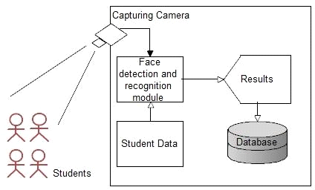

Figure 1.1: Block Diagram

Activity Diagram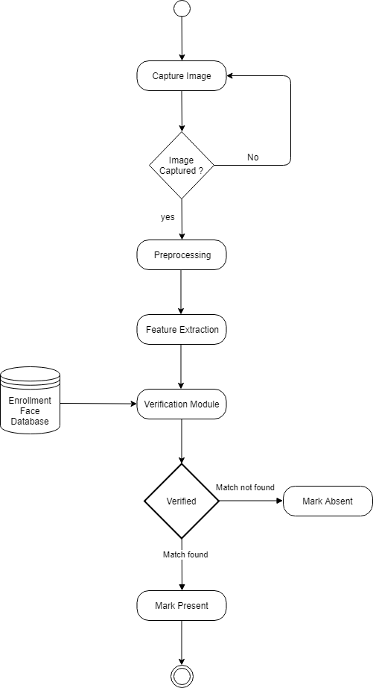

Figure 1.2: Activity Diagram
The image capturing procedure repeats until a good input image for facial identification and detection is obtained. During pre-processing, extraneous data and noise in background are removed from the captured images. The obtained input image is compared to an existing database of facial features captured during the registration of students' information into the system after it has been pre-processed and features of facial extracted. Only students with matching faces are counted as present; otherwise, they are counted as absent. Facial recognition technology powers the entire registration procedure for school attendance.

State Chart Diagram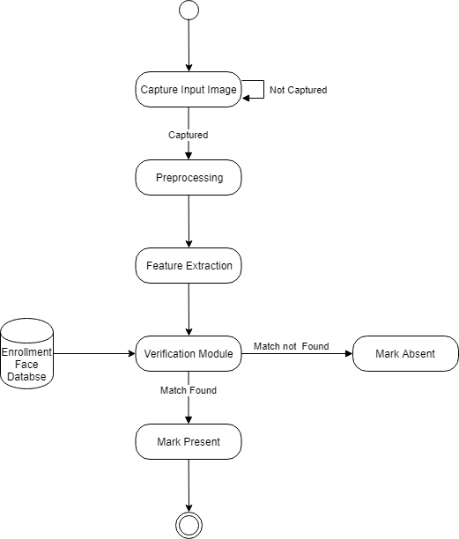
Figure 1.3: State Chart Diagram

The proposed system for a facial recognition-based classroom attendance system is shown in the accompanying block diagram. This approach necessitates the installation of a camera in the classroom, allowing it to take photographs of every student present. When a strategy is put into action, the intended outcomes are achieved. Here's a quick rundown of the process.
- Capturing Camera
In a classroom, a camera is installed to capture the student's face. The camera must be positioned in such a way that it gets all of the students' faces. For extra processing, this camera must be connected to a computer system over a wired or wireless network. We use the laptop's built-in camera in our prototype.
- Image Processing:
A facial recognition system is used to analyses the obtained image. In preparation for future processing, the image is cropped and saved. The module recognizes images of students' faces, as well as their names and ID codes, that have been manually entered into the database. We utilize Anaconda for all image processing and acquisition tasks. To finish the procedure, you'll need to take the steps below.
- Train Data
- Face Detection and Cropping
- Face Recognition
- Attendance Recording
1.3 Requirements Specifications
1.3.1 Software Specifications:
- Window Environment (OS)
- Anaconda Spyder, Jupyter.
1.3.2 Hardware Requirements
- Pentium IV or higher processor is required.
- Hard Drive: A drive with a capacity of at least 500 megabytes is required.
- 2GB of RAM or more
1.3.3 Developer Requirements:
- Windows Environments (Operating System):
- languages used. Python 3.9
- OpenCV 3.4.16, Matplotlib, NumPy, python-csv, Pillow Installer
- The server's basis is called Local Host.
- The current version of the IDE is Django 2.1.7.
- 2 GB RAM is the bare minimum.
- Pentium IV or higher processor is required.

CHAPTER No. 2
LITERATURE REVIEW
A face recognition system is a piece of computer software that can identify a specific individual from an image. Facial traits from an image can be compared to a database of known people's faces as one approach. It is common for customs authorities in Australia and New Zealand to utilize facial recognition technology as part of their automated border processing system, Smart Gate. An electronic passport's microchip contains an image of a person's face that is compared to the person's face. The technology can recognize people amid a throng of people without drawing attention to itself in public settings like airports, multiplexes, and shopping malls. Fingerprints, iris scans, and voice recognition are examples of biometrics that are difficult to identify. Another concern is the safety of ATMs and the information they hold. Instant verification of a user's identification is possible using the software. Customers can consent to have their photos taken by the ATM. As a safeguard against identity theft and other fraudulent actions, Facet uses a photo's facial impression to identify the person. Facial recognition software eliminates the need for a photo ID, a bank card, or a personal identification number to authenticate a customer's identity (PIN). However, it can be used in retail, healthcare, and hospitality environments. Facial recognition software's usefulness in train and airport security, on the other hand, is debatable.
Student attendance tracking and maintenance are becoming increasingly complex as the number of students enrolling in training institutions grows. Thus, human error is a significant factor in this process. The number of RFID (Radio Frequency Identification)-based applications has grown in recent years. Using passive and active passive RFID scanners, wave detection may be automated. To address the issue of frequent conference attendance in developing nations and to accommodate students with unique needs, RFID technology is employed in this study Student attendance surveys using RFID save administrators time by eliminating the need for paper attendance records and giving them access to classroom data that can be used to analyze relevant attendance records and make strategic management decisions. Industrial engineering, health care, agriculture, transportation, and other industries have seen a significant increase in the use of radio frequency identification (RFID) technologies in the recent years. The Internet of Things, on the other hand, is advancing swiftly. Because of this, efforts have been made to employ them in aid control and monitoring. Using Raspberry Pi 3 and RFID technologies, the attendance system is an Internet of Things (IoT) project that helps schools and other organizations gather daily attendance more quickly. Everything becomes automatic when you're in this place. Additionally, an app for Android was developed in an attempt to allow students to check their attendance from any location at any time.
A face-recognition algorithm based on a convolutional neural network (CNN) is presented in this article. We have a SoftMax regression layer as well as three convolutional layers, two pools of data layers, and two layers that are fully coupled to each other. It is possible to train a facial feature extractor and classifier using a stochastic gradient descent technique. Overfitting can be avoided by employing the dropout method. Training and testing are carried out using the Convolutional Architecture for Feature Extraction Framework (Caffe). ENT and AR face databases in this network had recognition rates of 99.82 percent and 99.78 percent, respectively.

S.No | YEAR | AUTHOR | TITLE | TECHNIQUES | ADVANTAGES | DISADVANTAGES
1. | 2017 | T.Saimounika K.Kishore | For the Internet of Things, a Real-Time Locating System employing RFID. | It uses radio-frequency identification (RFID) to keep track of student attendance. | Reduces documents and save time. | It's necessary to spend money at the beginning.
2. | 2017 | Sri Madhu B.M  Kavya Kanagotagi Devansh | An Automated Attendance Tracking System Based on IoT | Students' attendance is recorded using RFID tags attached to the device, which is powered by Raspberry Pi. | Increased security and confidentiality. | Raspberry Pi implementation necessitates the use of a unique operating system.
3. | 2017 | Abhish Ijari Anand Mannikeri Vinod Kumar Gulmikar | The Haarcascade Attendance System: A Face Recognition Approach | Facial recognition is used to track the presence of students in class. | Reduces risk of duplicate entries or manipulations. | For a lengthy period of time, the camera continues to record video.
4. | 2017 | Kewen Yan Shaohui Huang Yaoxian Song  Wei Liu Neng Fan | Using a Convolutional Neural Network to Recognize Faces | Student attendance is marked using facial recognition and CNN-based technology. | Increases accuracy of facial recognition. | CNN requires a dedicated server and is expensive to implement.

Table 2.1: Tabular Representation of the Background Research

GoogleNet (2014)
GoogleNet, commonly known as Inception V1, is built on the LeNet concept. It is built
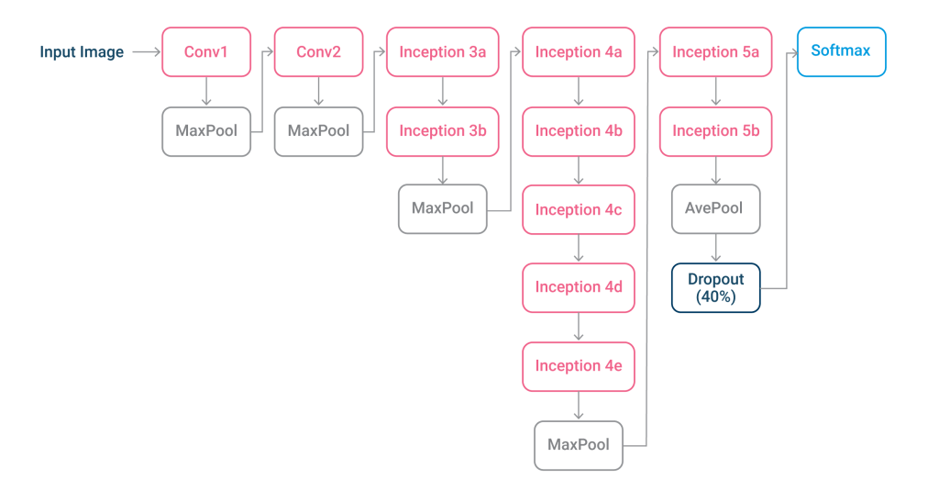

Fig 2.1: GoogleNet

up of 22 layers of inception modules (The Scientific Discipline of Computer Vision, n.d.), which are small convolutional groups. As in [Fig. 2.2]
These inception modules employ batch normalization and RMSprop to reduce the number of parameters GoogleNet must process. RMSprop is an adaptive learning rate methodology-based learning rate optimization strategy (The Scientific Discipline of Computer Vision, n.d.).

VGGNet (2014)
There are sixteen layers in the VGG architecture (some variants had 19 layers). To construct VGGNet, we used multiple convolutional layers and then added a pooling layer, which was followed by several more convolutional layers and then another pooling layer (The Scientific Discipline of Computer Vision n.d.).

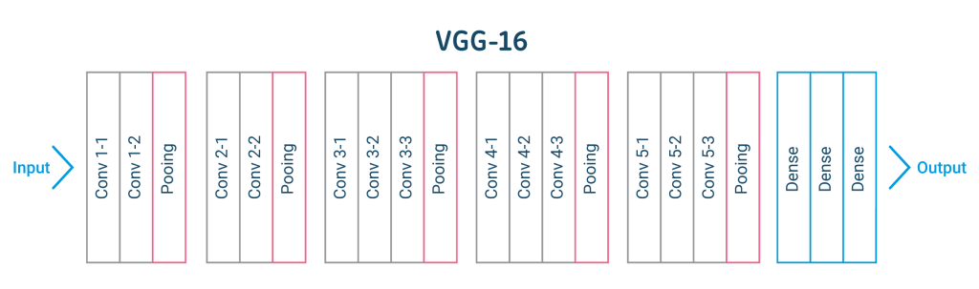

Fig. 2.2: VGGNet
Small filters in very deep networks are the foundation of VGG. Only some of the closest pixels are analysed by this filter, which uses three convolution filters. Because there are fewer parameters, additional layers can be added with modest filters. When compared to a seven-layer convolutional layer, its effective receptive field is the same (The Scientific Discipline of Computer Vision, n.d.). [Fig. 23] shows you what I mean.

Xception (2016)
Xception is an Inception-based architecture that replaces Inception modules with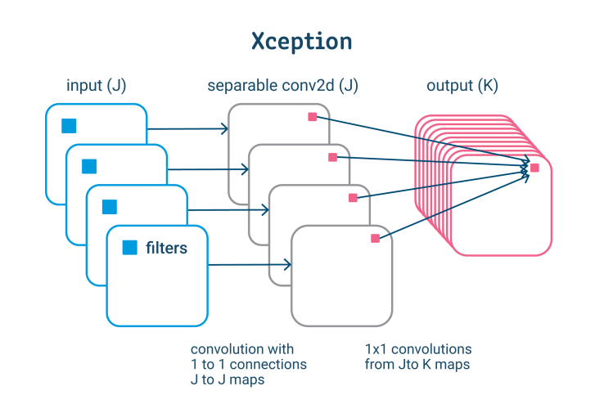
Fig. 2.3: Xception
depth-separable convolutions (depth convolution followed by point convolutions) (Bagi et al., 2020). In fig. 2.4]
Deep learning techniques for machine vision are popular because they fulfill their promises (Voulodimos et al., 2018). Here are the top three benefits of deep learning for a resume:
- The promise of feature learning: Deep learning techniques can automatically learn features from the image data needed to model, rather than requiring an expert to build and define a feature detector (Voulodimos et al., 2018).
- With real-world data, the promise of continual improvement can be realized in computer vision (Voulodimos et al., 2018).
- The end-to-end model promises: Massive-scale end-to-end deep learning models can be applied to large datasets of photographs or videos, resulting in a more complete and efficient solution
Many complex computer vision problems have yet to be addressed, and deep learning is critical to achieving state-of-the-art performance. (Deep Learning for Computer Vision, undated). Models of vision. Machine vision applications are becoming increasingly valuable as these technologies progress.
Some examples of how deep learning can be used to improve computer vision are shown in the following paragraphs.

Healthcare
In healthcare, computer vision is employed extensively. Clinical diagnosis relies heavily on the review of images from scans and other imaging modalities. By analyzing images from routine diagnostic tests like ultrasounds, MRIs, and CT scans, new computer vision technologies promise not only to make things easier but also to prevent mistakes and cut down on the cost of care. no (Dacunha et al., 2021). [Fig. 2.5] shows how the image is checked.
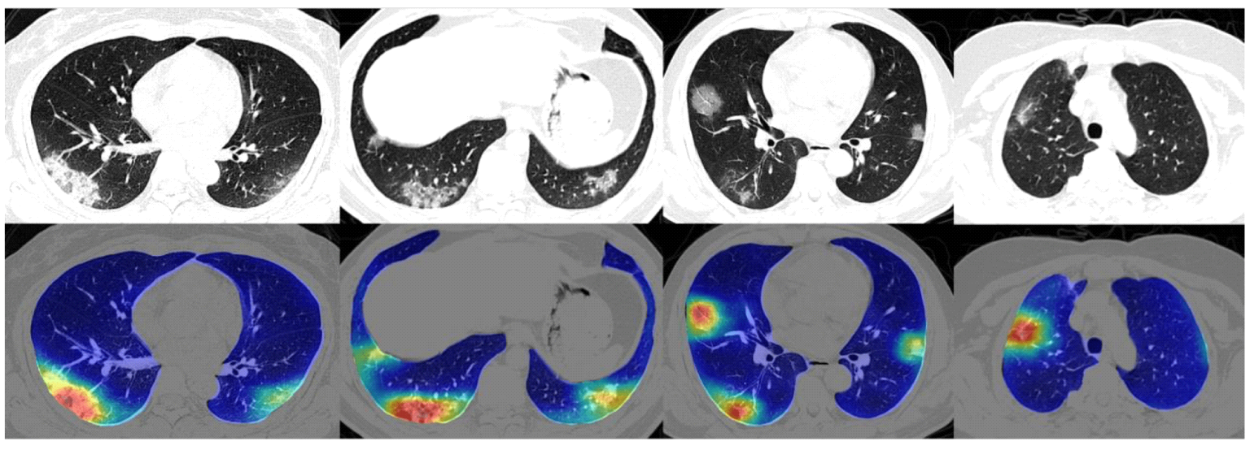
Fig. 2.4: Healthcare

Medical specialists are not meant to use machine vision. Instead, they want to make their work easier and their decisions better. By highlighting the most important areas in 2D or 3D scans, picture segmentation aids in the diagnosis process (Dcunha et al., 2021).
The COVID-19 pandemic is using this technique. Physicians and scientists can use image segmentation to discover COVID-19 and assess and quantify the infection and disease's progression. On CT scans of the lungs, the trained image recognition system detects questionable spots. It assesses their size and volume in order to track the sickness of affected people (Dcunha et al., 2021). In [Fig.2.7]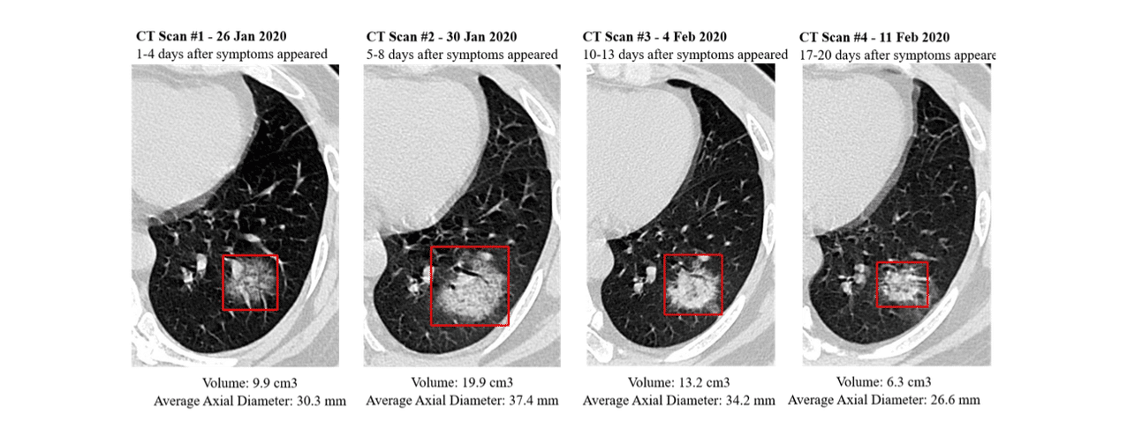
Fig. 2.5: Covid19 detection

Automotive Industry
In recent years, one of the applications of artificial intelligence that has generated the most interest and discussion is self-driving automobiles. Many people have the false impression that autonomous vehicles will arrive in the future far sooner than they actually will. Despite the various obstacles that machine learning faces, machine vision can provide assistance. For instance, the operation of a vehicle needs the use of an algorithm (or "agent") that is constantly aware of the environment it is operating in (Dcunha et al., 2021).
It is essential for an agent to be aware of the condition of the road, the location of other automobiles, the distance to potential obstacles, and the speed at which these things are travelling in order to react to an environment that is continuously changing. As a direct consequence of this, self-driving cars are outfitted with massive cameras that take extremely high-resolution pictures of the world around them (Self-Driving Cars: A Beginner's Guide to Using Python and OpenCV | Yogesh Ojha, n.d.). Methods of real-time image identification require that a system be able to identify significant objects in images that are either static or continually changing.

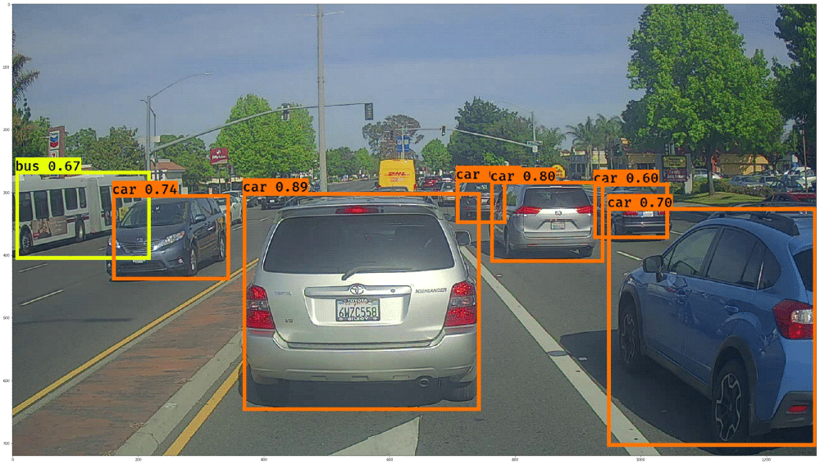
Fig. 2.6: Automotive

Industry already employs this technology. When it comes to training an algorithm so that even the possibility of failure under complex exceptional conditions is eliminated, it is due to road traffic's complexity and volatility (Self Driving Cars—a Beginners Guide to Computer Vision–Finding Simple Lane Lines using Python and OpenCV | by Yogesh Ojha | Medium, undated). Artificial Intelligence (AI) computer vision relies on a tremendous amount of training data and a large amount of money spent on road traffic to be successful.

Retail: Customer Behavior tracking
Amazon, for example, uses the analysis capabilities of its digital platform to examine customer behavior in detail and improve the user experience. Retail is also trying to improve and maximize the customer experience. So far, there are no methods to automatically capture people's interactions with displayed things. For retail, computer vision is now poised to fill this gap (Dcunha et al., 2021). With the use of this technology, retailers can now open up online trade and analyze customer behavior in their branches in detail. This improves sales, reduces the time spent in the store and optimizes customer circulation in the company. In [Fig. 2.8] see how it tracks customer behavior;
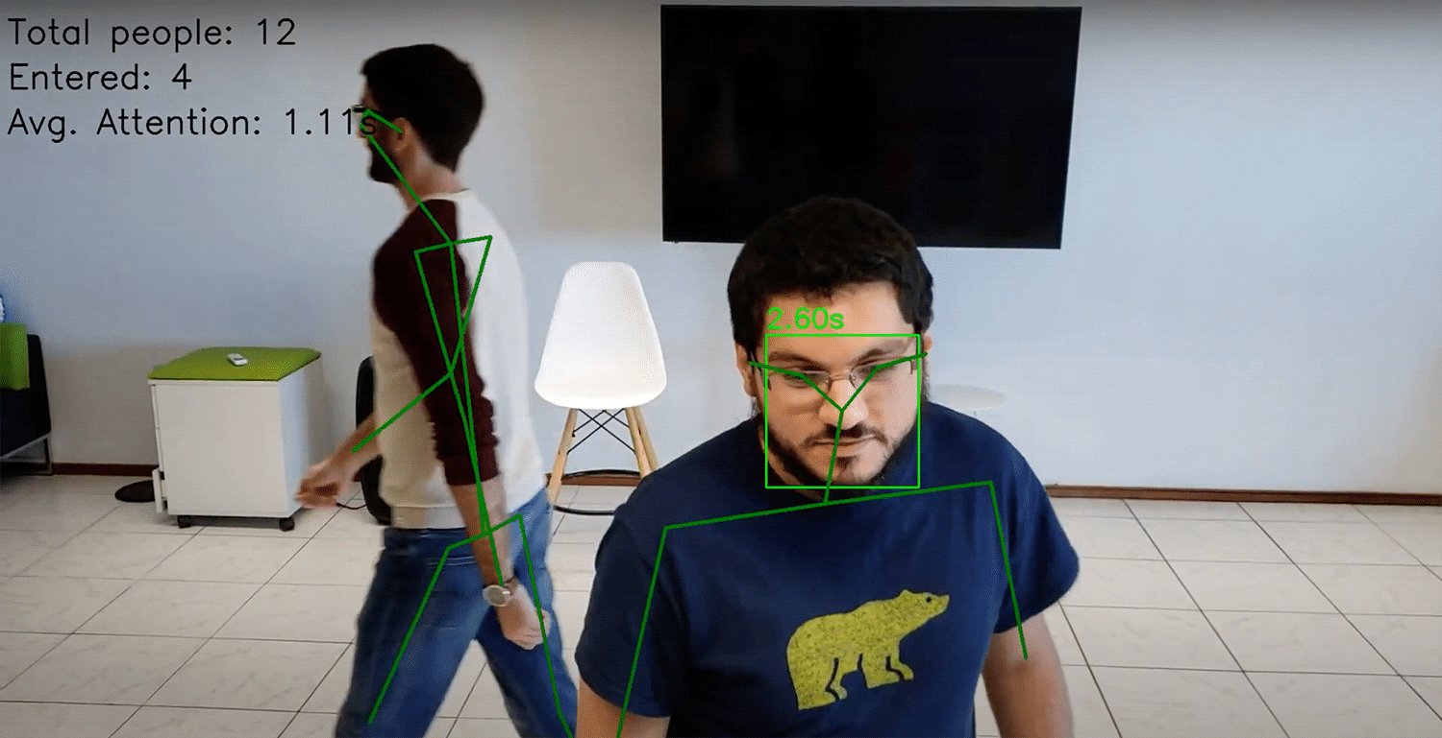

Fig. 2.7: Behaviour Tracking

Agriculture
Modern technology has made it possible for farmers to cultivate larger areas than ever before. These areas must be examined for crop pests and diseases since uncontrolled agricultural diseases can result in costly crop failure and crop failure. When dealing with vast quantities of data collected by remote sensors, such as those on drones, satellites, and other distant sensors, machine learning is incredibly useful. Modern technology enables the automated monitoring of various measurable quantities, parameters, and statistics.
Farms are able to monitor soil conditions and irrigation levels, crop health, and local temperatures 24 hours a day, seven days a week, despite massive plantings on vast fields. This data is analysed by machine learning algorithms so that farmers can respond swiftly to potential problems and manage resources effectively. Using image analysis, it is feasible to detect plant diseases at an early stage. Plant diseases are often discovered years after an epidemic. Through the implementation of computer vision-based early warning systems, it is now possible to reduce crop loss and reduce the cost of countermeasures such as insecticides. Figure 2 demonstrates that it is fairly little (Baghi et al., 2020). .8]
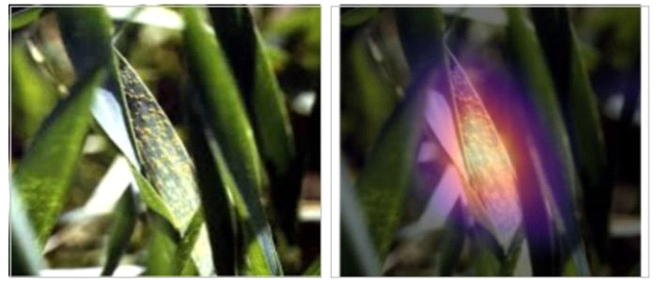
Fig. 2.8: Dead Leaf detection

Summary
This chapter discusses various aspects of gesture recognition and its complexity in applications. The aim of the study was to learn more about hand gesture recognition systems and their design requirements. A literature review covers what is necessary to generate basic concepts during the design and implementation phases. In addition, we will examine the various processes and tools used in project development.

CHAPTER No. 3
METHODOLOGY
3.1 Methodology Flow
This system employs student attendance based on facial recognition. A basic and straightforward user interface is utilized to collect images, which are then subjected to preprocessing, feature extraction, subjective selection, and categorization. Is. In this proposed strategy, LBP and PCA feature extraction techniques are analyzed and compared in depth. By boosting LBP, this approach reduces the effect of light. To improve accuracy, a subjective selection approach using improved LBP and PCA is created. Here, we'll discuss the qualities of each level. This system employs student attendance based on facial recognition. The first stage is to take photographs using a clear and uncomplicated technique.
There are two distinct flowcharts presented in Figures 3.1 and 3.2 for the proposed system.
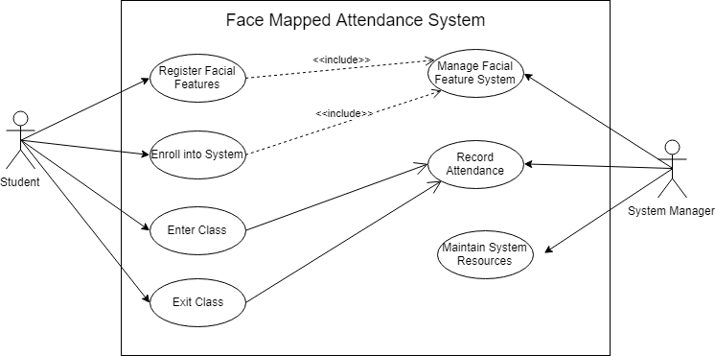

Figure 3.1: Face Mapped Attendance system

Training database

Yes

Grayscale

Figure 3.2: Flow of the Training Part
Recognition

Figure 3.3 Flow of the Recognition Part

3.2 Input Images
A real-time student attendance system with facial recognition can be developed more quickly and effectively with the help of earlier researchers' data sets, which are also useful for evaluation purposes. will be done.
Performance is assessed using the Yale face database as both a training and a testing set. Each person has eleven photographs, each of which depicts him or her in a different state. Temperatures are mild; people are cheerful with their glasses on; they are unhappy, tired, shocked, and winking without their spectacles on. It is possible that the database's variants will ensure that the system continues to function reliably under a variety of various conditions and scenarios.
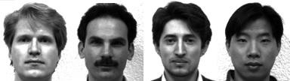

Figure 3.4 Sample Images in Yale Face Database (Cvc.cs.yale.edu, 1997)

Using a built-in camera on a laptop and a camera on a mobile phone, we record and save images of pupils in our database. Each student contributed two images to the training set and two to the exam set. The camera on a laptop is considered to be of poor quality, whereas the camera on a cell phone is considered to be of outstanding quality. In the high-quality shots, seventeen students can be seen, whereas in the low-quality images, there are twenty-six.
In Chapter 4, recognition rates for low- and high-quality photographs are compared in order to analyse the performance of various image quality sets.


Figure 3.5 Sample of High-Quality Images


Figure 3.6 Sample of L6ow-Quality Images
3.2.1 Limitations of the Image
Frontal, vertical, and containing only one face are all requirements for the proposed approach to work. Despite the fact that the system is built to recognize students with and without glasses, students must provide photos of themselves in both glasses and non-glasses configurations. Accuracy can be improved through training. To eliminate quality discrepancies, training and test photos should be captured using the same equipment. To be identified, students must first sign up. The site's user-friendly interface makes it possible to register.
The proposed method will only work if a few conditions are met. These are the prerequisites for finding and keeping a job that meets your needs.

3.3 Dataset Creation
Webcams are used to take pictures of students. Photographs of the same student taken from various angles and positions are compiled. Pre-processed photos are what you see here. Cropping an image creates a ROI, which is then used in the recognition process. Images are then cropped and resized to a precise pixel location. They are then transformed to grayscale from RGB. Afterwards, the photographs are saved in a folder with the students' names on them.
3.4 Face Detection
To recognize faces, OpenCV and the Haar-Cascade Classifier are employed. Before it can be used for face recognition, the Haar Cascade technique needs to be taught to detect human faces. Feature extraction is the name given to this technique. The HairCascade frontal face XML file was used to train HairCascade. Figure 2's hair features are used to extract features.
Each module in this paradigm goes through the requirements, design, implementation, and testing phase. Each subsequent iteration of the module improves upon the features of the one before it. Repetition of this procedure is required until the system has been fully implemented. Figure 3.7 shows this.

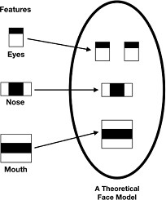

Fig. 3.7 Face Model

OpenCV's Detect Multiscale module is used in this example. To construct a rectangle around an image's faces, this is required. Scale Factor, My Neighbors, and Main Size are all options to consider. This option indicates how much an image should be scaled down at each picture scale. Each candidate rectangle's minimum number of neighbors is specified in the field My Neighbors. Although fewer faces are detected when the value is raised, the image quality is improved. Sets the object's minimum size, in bytes. Assumption by design is (30,30). Scale factor is 1.3 and least neighbor's parameters are 5, respectively, in this system.

3.5 Pre-Processing
The camera captures the photographs of the test and training set. In photos, unwanted noise and varying lighting might occur. As a result, multiple processing stages must be completed before feature extraction may begin.
Preprocessing techniques include scaling, median filtering, transforming colour images to grayscale, and adaptive histogram equalization. These steps are described in depth in the following sections. The camera records the photos of the test and training sets. Images might have unwanted artefacts, such as noise or a lack of equal illumination. Therefore, a number of preprocessing processes are required before feature extraction.
Techniques including upscaling, median filtering, color photo to grayscale conversion, and adaptive histogram equalization are all used.

3.5.1 Scaling of Image
In image processing, scaling images is a common activity. To avoid a loss of spatial information, the image size must be carefully calibrated. The image size must be changed in order to detect a face. It's especially critical for feature extraction, where the dimensions and sizes of the test and training images must be identical to assure accuracy. Because of this, both the test and training images are 250 pixels wide by 250 pixels tall.

3.5.2 Median Filtering
Noise can be reduced effectively using the median filtering method. Because of its capacity to minimize undesirable noise while maintaining important features in images, it is frequently employed in many applications. Because the camera records color images in the RGB format, median filtering is applied to the image's three channels. Figure 3.2 shows the image before and after median filtering in order to reduce noise in three channels. It is possible to conduct median filtering on a grayscale image without separating the individual channels.
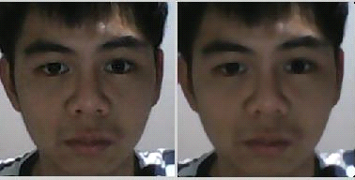

Figure 3.8 Median Filtering Done on Three Channel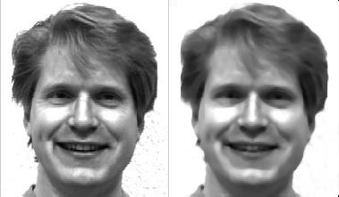

Figure 3.9 Median Filtering Done on a Single Channel
3.5.3 Conversion to Grey Scale Image
CLAHE can only be used on grayscale photographs, despite the fact that the camera can capture colour. The impact of light on the image can be minimized by boosting the contrast. LBP uses an 8-bit texture descriptor to extract grayscale characteristics from contrast-enhanced images (Ojala, T. et al., 2002). Grayscale photos must be created initially before any further processing can begin. The complexity of the technique can be lowered by transforming colour photos to grayscale images, which speeds up calculation (Canaan and Cottrell, 2012). Figure 3.2.1 depicts the shift in image grayscale.
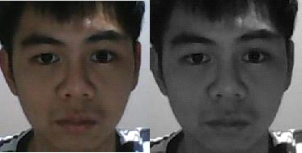

Figure 3.10 Convert to Grey Scale
3.6 Face Recognition
The three steps of the face recognition process include training data preparation, face recognition training, and predictions. The training data is taken from the images in the dataset. They get the full label of the student they belong to. These images are then subjected to facial recognition. The local domain binary model used in this system is called face detection histogram. Initially, a complete set of local binary patterns (LBPs) for the face is compiled. LBPs are transformed to decimal numbers, and histograms of all decimal values are generated. There are histograms for each training image. The histogram of the face to be recognized is calculated throughout the recognition process.
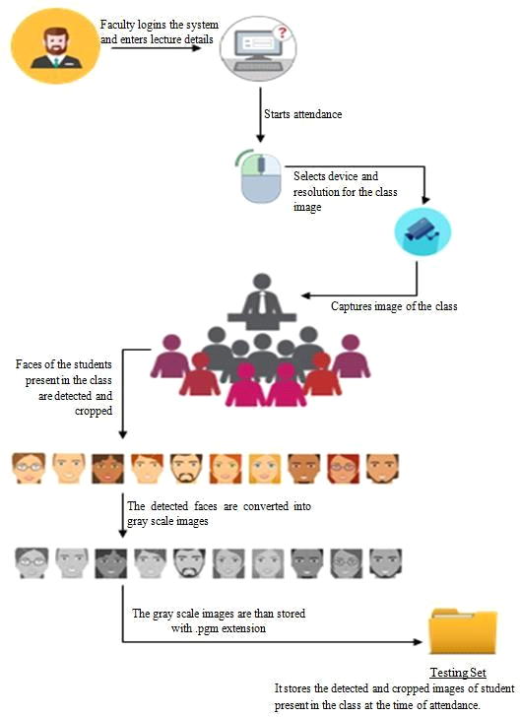
Figure 3.11: Face attendance process
3.7 Attendance Updating
On the Excel sheet, the recognized faces are marked as present, the others as absent, and the list of absentees is emailed to the affected faculties. Faculty members receive a daily attendance sheet at the end of each day. This keeps us up to date on all class activities.
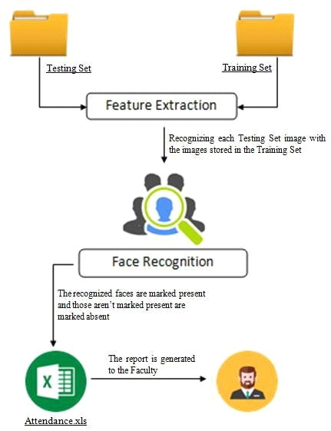
Figure 3.12: Attendance Updating

Each iteration goes through the requirements, design, coding and testing process. And until all system-specific features are achieved, each subsequent version adds features to the previous version.
When the first increment is applied, the system goes into production. An initial enhancement is usually a basic product that meets basic requirements, with additional functionality added in later enhancements (Incremental Model (Software Engineering) - Javatpoint, n.d.). Once the client has analyzed the core product, a strategy is developed for the next addition.
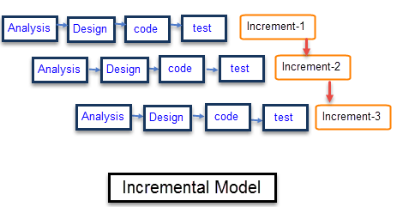
Fig. 3.13: Agile Model
It is critical to ensure that the program functions correctly at each stage and produces the desired result. There is no user engagement during the development process in the incremental model, which focuses on a small number of criteria that will not change during the project. The user is only involved once the final product is completed, as is the case in this project.
Requirements: Experience product analysis identifies requirements in the first phase of the incremental model. The requirements analysis team also understands the functional requirements of the system. This step is important for developing software using incremental methods.
Design and Development: This phase of the engineering incremental SDLC model has been effectively accomplished in terms of functional system design and development. A styling and development phase is used in the incremental model as new features are added to the software.
Testing: In this phase of the incremental SDLC model, the design and development of the system's functionality have been accomplished successfully. When adding new features to a program, the incremental model employs a certain style and phase of development.
Implementation: Once the design process is complete, the suggested system design can be put into action. It is planned to take the actions listed below.
- The algorithm used to capture the image from the camera is put into practice.
- Secondly, the implementation of algorithms that study picture processing.
Evaluation: Finally, the application will be evaluated in relation to the established goals and objectives.
3.8 Implementation methodology
In building this system, we must consider various resources. This section reviews open-source programming languages and libraries used in system design and implementation.
3.8.1 Programming language
Python 3.9.7 is used to write the project program as it has several popular open-source libraries for free.
3.8.2 Open-Source Library
The open-source library used in this project is OpenCV, OS and hand tracking module. These are open-source libraries of programming functionality primarily intended for real-time computer vision and recognition. OpenCV features related to image processing and tracking have been used to develop workable algorithms that meet the objectives of this project.
3.8.3 IDE
Spider (Anaconda 3) is the IDE (Integrated Development Environment) of choice for our project. Spyder is a scientific environment created in Python for Python for scientists, engineers, and data analysts. Full-featured development tools are combined with the fantastic visualization capabilities of a data mining, interactive execution, deep inspection, and scientific package to create a strong tool for analysing, debugging, and profiling (Home: Spider IDE, n.d.). We were able to shorten the time it takes to scan the source code because it is readily available and capable of identifying any grammatical difficulties or errors.
CHAPTER No. 4
Proposed system
Students, teachers, and anyone else who used the current filing system, i. H., served this purpose manually. Virtual classrooms and new technologies in the classroom, such as tablet computers, may make traditional methods of teaching ineffective in the future. Manual submissions take longer to process, even with the increasing number of courses offered by colleges. Hand gesture recognition technology will be used in schools as part of our initiative to develop a presentation creation system, as well as a user interface that is both simple to use and cost-effective.
First, let's have a look at how OpenCV media pipeline can be used for manual detection. In the following block diagram, you can get a quick explanation of it. On the [Fig. 4.1]
Hand detection and manual key computations are separated into their own graphs (ie, benchmarks). I consider MediaPipe's palm detector one of its most crucial features because it only uses it when absolutely necessary (Google AI Blog: On-Device, Real-Time Hand with Media Pipe Tracking, n.d.). This significantly reduces the amount of time needed to process data.

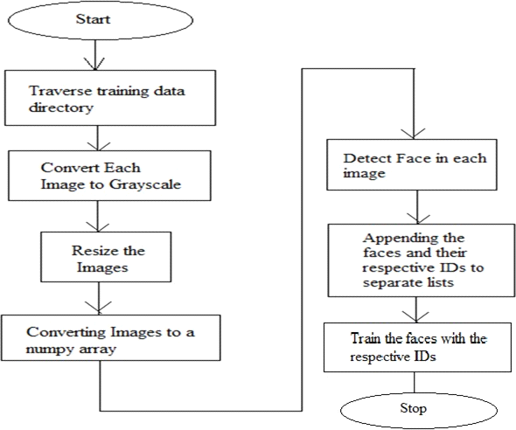
Fig. 4.1 Proposed System

We don't have to relocate the palm detector for each frame since we use the current frame's determined key points to determine the hand's position in subsequent video frames. Using this diagram, you may better comprehend how a webcam can be used for real-time hand detection.
When a webcam recognizes a hand, it processes the commands given by the end user as described in the following flowchart, our next section covers the processing of gesture commands using only feature extraction. Implements and then
The following block diagram shows a step-by-step explanation of how our project works, including how we give commands to our system and how the system recognizes our commands using a digital camera or webcam.

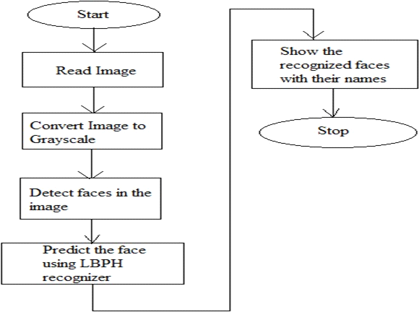

Fig. 4.2 Result Diagram

CHAPTER No. 5
RESULTS AND ANALYSIS
5.1 Graphical User Interface
It has a menu system that may be viewed to gain a complete understanding of the system. The system captures information such as a student's Id and name for the purpose of registration. The 'Take Images' button is used to capture the photographs of the students. The 'Train System' button is used to train the recorded photographs. Using the 'Take Attendance' option, the attendance results are saved in an excel sheet. Figure 5.1 is a representation of the registration page.

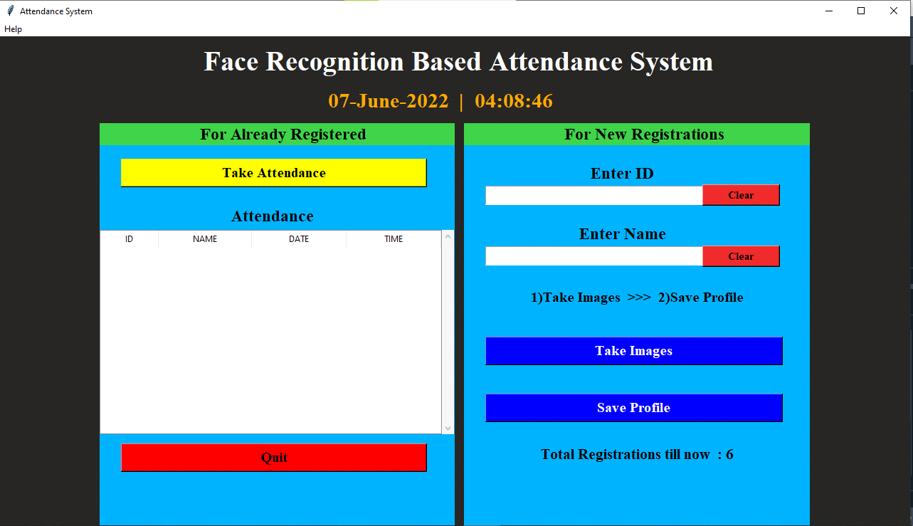
Figure 5.1 Front End

In our first step we can give the Locations of the folder. After that we can enter the Data and take the images for testing
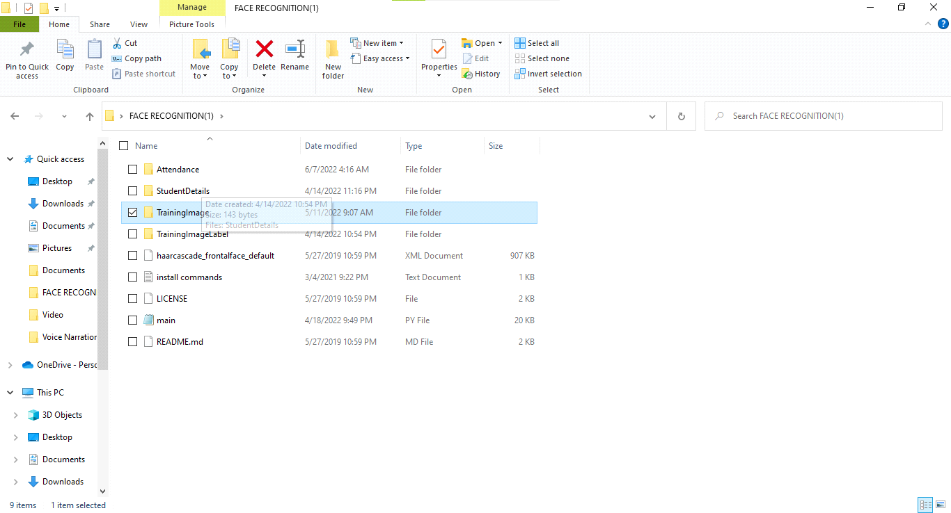

Figure 5.2 Data Location
5.2 Face Detection
Because the software is written in Python, an object-oriented language like Java, RUBY, and C++, it is necessary to use software development in an object-oriented environment to create a quality system. User needs must be identified at the beginning of the project. The software should be stable and bug-free as well as easy to maintain. It should be really easy to use. The software engineering technique used in this project is to define a process that addresses the fulfillment of the criteria and uses verification and validation to ensure that the product produced is stable.

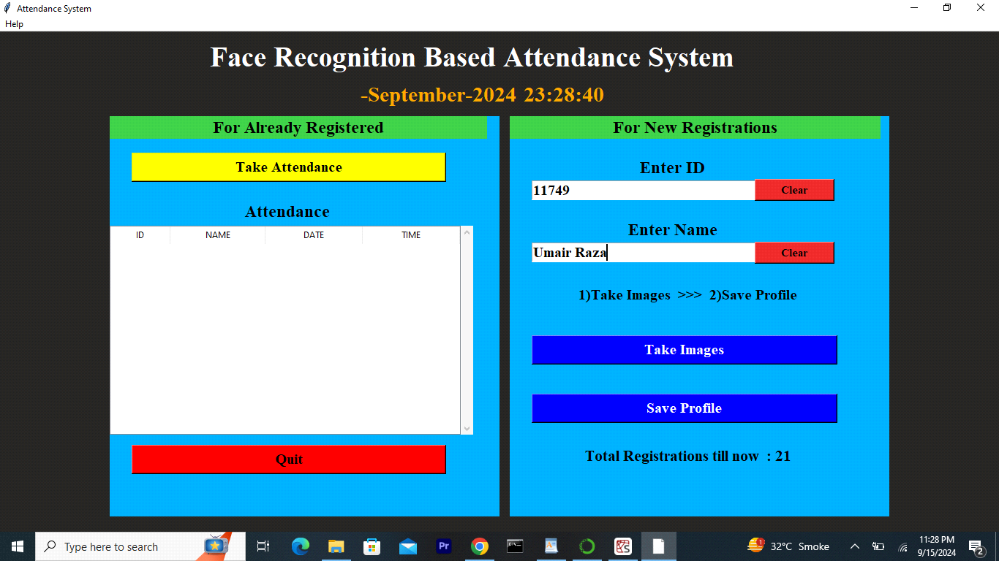

Figure 5.3 Enter ID
In this step we can take the pictures for testing Purpose
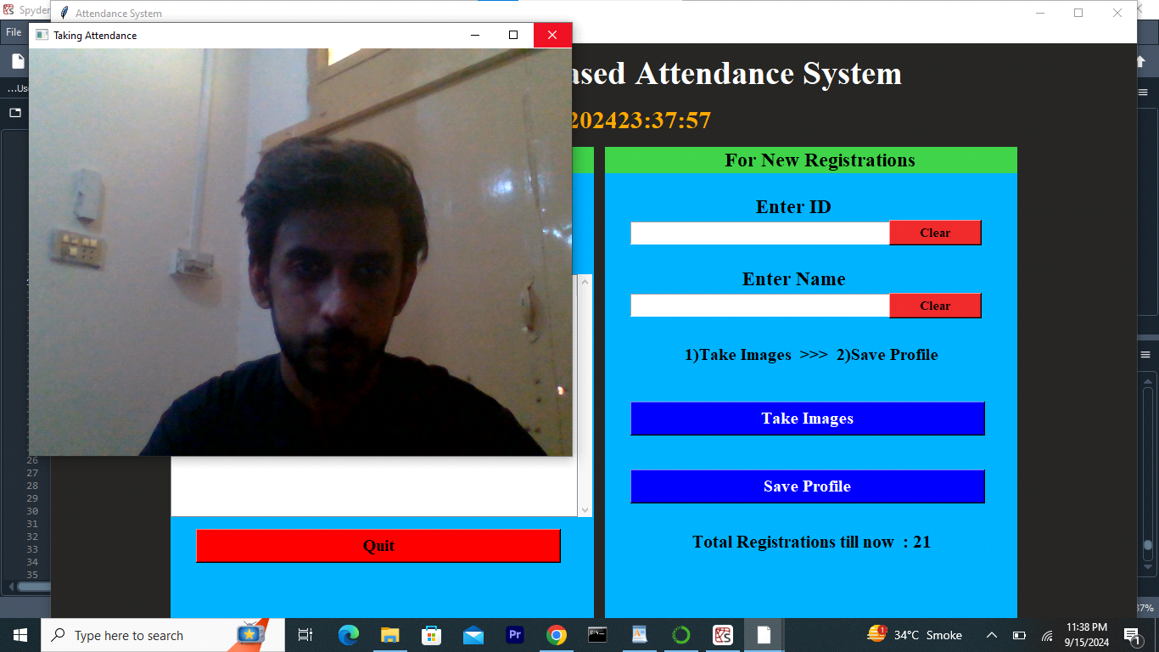

Figure 5.4 Take Pictures
In this step we can take 100 pictures for training and converted it into grey scale.
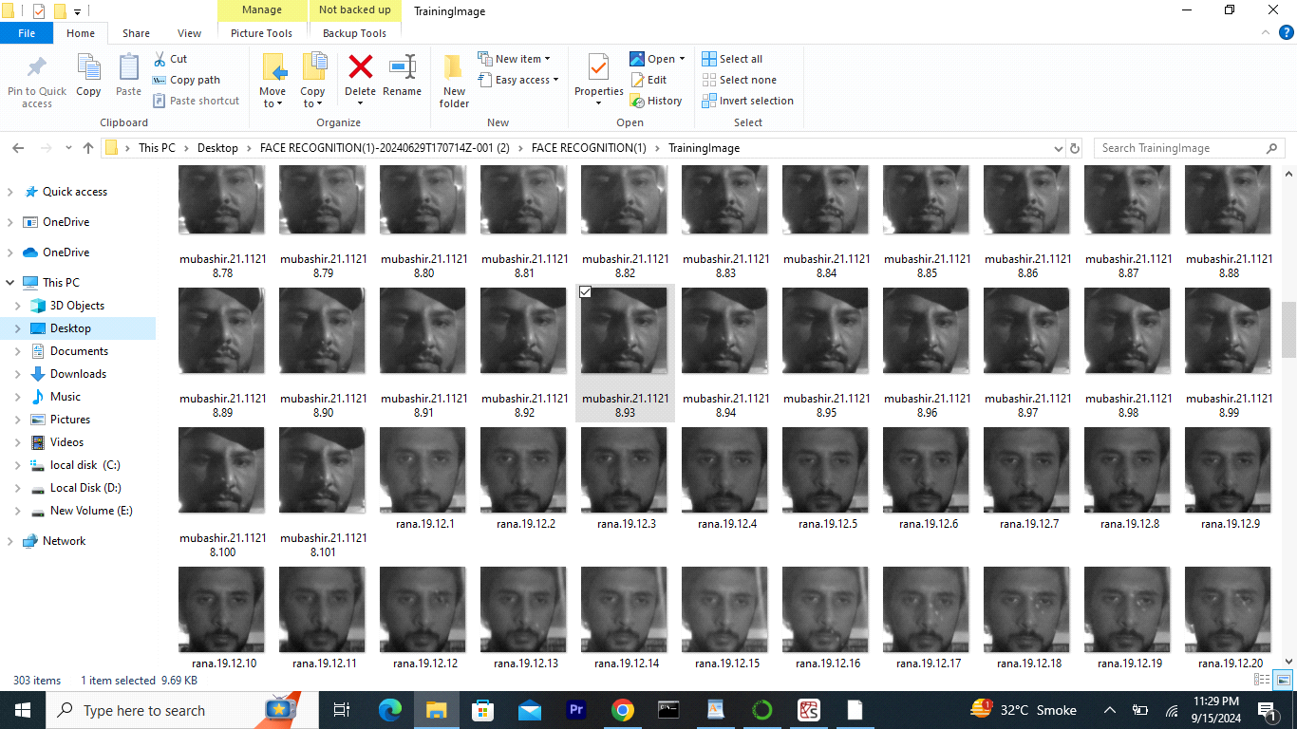

Figure 5.5 Training Pictures

In this we can see that we can get the results and detect the face for Attendance.
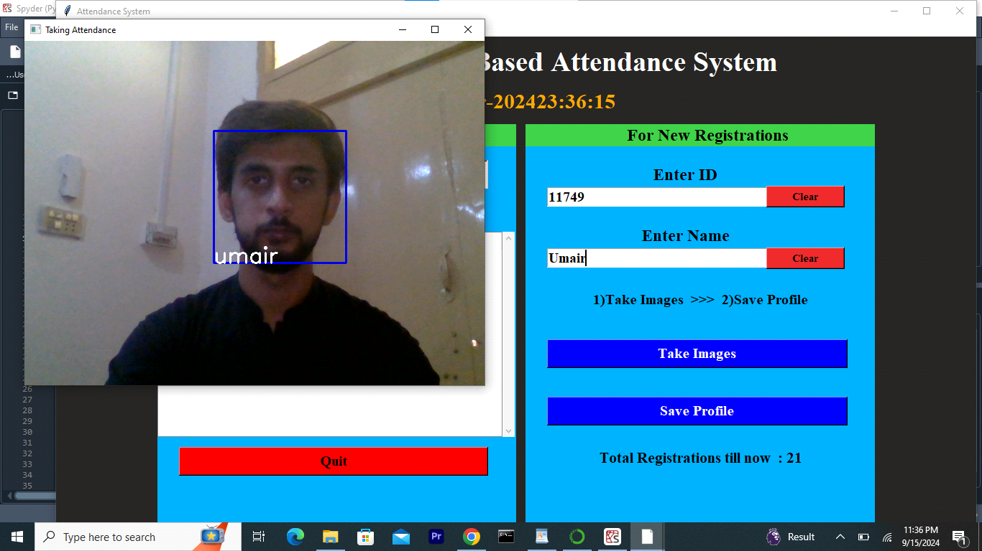

Figure 5.6 Take Attendance
In this step we can see that we also get the marked attendance on our GUI for better interaction.
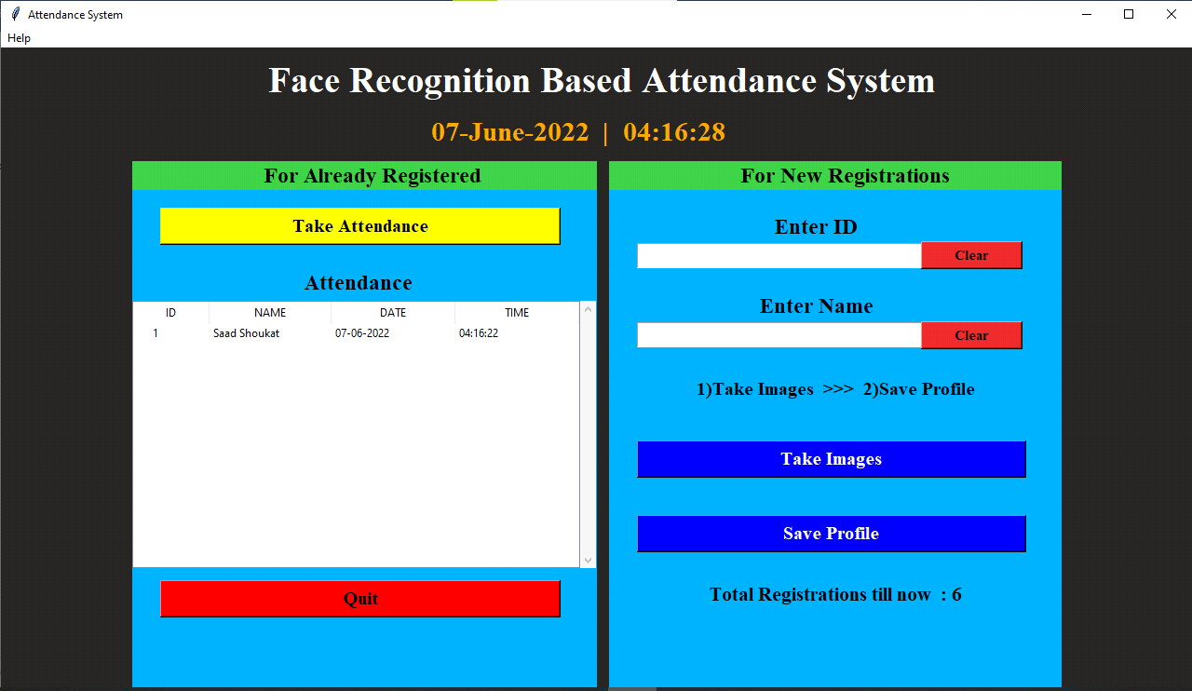

Figure 5.7 Marked Attendance on Front End
So, we can get the final result in our Excel sheet and in excel sheet we can get the Time and Date for every time when we mark Attendance.
Figure 5.8 Marked Attendance of Sheet
CHAPTER No. 6
ADVANTAGES AND APPLICATIONS
1 Maintains Overall Record:
An automatic facial recognition attendance system is used to keep track of all students' presence in the institution. Student absences, leave requests, and days of absence are all tracked by system.
2 Get Rid of Pen and Paper System:
The latest technology helps to effectively replace the old paper entry process. It also saves the organization money that would otherwise have been spent on paper. Face recognition time attendance system provides better data storage as it is compatible with electronic data storage medium. In addition, the system provides a favorable view of the organization to business users and other interested parties.
3 Financial Benefits:
The time attendance system with facial recognition saves time, eliminates manual errors, and keeps track of the entire system. The possibility of inaccuracy is minimized because the facial recognition technology controls every single event electronically. Instructors save time because attendance is recorded electronically, allowing them to spend more time lecturing.
4 Easy Integration:
It is fairly easy to program facial biometric systems with biometrics built into any computer system. They usually work with software that is already installed at the customer's site.
5 High Success Rate:
Thanks to advances in 3D facial recognition technology, facial biometrics are now attaining high success rates. Because it's nearly impossible to game the system, it's safe to use.

6 Proxy Attendance is Eliminated:
There will be no proxy attendance because attendance is automatically recorded by a camera in the classroom.
7 Saves Time:
The instructor calls out each student's name based on their ID in a traditional attendance grading system, which is time consuming. By automatically registering attendance, this method reduces the time it takes to log in.
8 Less Mistakes:
Because the system is computer-based, instructors may make mistakes while hand-marking attendances, but there will be no such problems when recording attendance automatically.
9 Virtual Classroom:
Due to the fact that students learn online, virtual classrooms do not have lecturers. When there are no instructors to take attendance in virtual classrooms, this strategy is especially useful. The attendance of the kids will be managed automatically by the system. Due to the fact that students learn online, virtual classrooms do not have lecturers. When there are no instructors to take attendance in virtual classrooms, this strategy is especially useful. The attendance of the kids will be managed automatically by the system.
10 Simple Algorithm and Flow Charts
Because there are no complicated parts, this system uses a simple algorithm and easy-to-understand flowchart. Since there are fewer hardware components, the flow of information is simple and each part is easy to understand.
We see that the system has many advantages. However, as with other systems, several vulnerabilities were discovered.
- Sensitive to Light:
Face recognition errors are more likely to occur if the lighting conditions in the training photographs and images taken during processing change. The lighting conditions in the classroom must be taken into account when creating a database of students.

CHAPTER No. 7
Future scope & Conclusion
Future Scope
The system we created was able to successfully accomplish the task of automatically marking class attendance and the results were obtained in real time on an Excel sheet. However, a highly efficient algorithm that is unaffected by classroom lighting conditions must be constructed to establish a specialized system that can be used in a classroom. In addition, the system must include a high-resolution camera. Setting up a database of online presence that automatically refreshes presence in light of the growing popularity of the Internet of Things is another key area in which we can engage. Create a separate module to accomplish this.
Conclusion
Teachers and aides can maintain track of student attendance in this system by using an attendance system for each class, section or laboratory. This is especially helpful if there are a lot of pupils in the class. In order to overcome the shortcomings of the prior (manual) technique, an automated assistance method has been implemented. Image processing techniques can be demonstrated using this support system in the classroom. The organization's reputation and support system can benefit from this technique.

References
27+ Most Popular Computer Vision Applications in 2022. (n.d.). Retrieved April 20, 2022, from https://www.v7labs.com/blog/computer-vision-applications
Bagi, R., Dutta, T., & Gupta, H. P. (2020). Deep Learning Architectures for Computer Vision Applications: A Study. Lecture Notes in Networks and Systems, 94, 601–612. https://doi.org/10.1007/978-981-15-0694-9_56
CNN for Deep Learning | Convolutional Neural Networks. (n.d.). Retrieved April 20, 2022, from https://www.analyticsvidhya.com/blog/2021/05/convolutional-neural-networks-cnn/
Computer Vision | How does Computer Vision work. (n.d.). Retrieved April 19, 2022, from https://www.analyticsvidhya.com/blog/2021/06/everything-happening-in-computer-vision-that-you-should-know/
da Silva, E. A. B., & Mendonca, G. V. (2005). Digital Image Processing. The Electrical Engineering Handbook, 891–910. https://doi.org/10.1016/B978-012170960-0/50064-5
Dcunha, M., Naik, N., Francis, I., & Mulla, S. (2021). Pneumonia Detection in X-rays Using OpenCV and Deep Learning. Proceedings - International Conference on Communication, Information and Computing Technology, ICCICT 2021. https://doi.org/10.1109/ICCICT50803.2021.9510180
Deep Learning for Computer Vision. (n.d.). Retrieved April 20, 2022, from https://www.run.ai/guides/deep-learning-for-computer-vision
Google AI Blog: On-Device, Real-Time Hand Tracking with MediaPipe. (n.d.). Retrieved April 22, 2022, from https://ai.googleblog.com/2019/08/on-device-real-time-hand-tracking-with.html
Home — Spyder IDE. (n.d.). Retrieved April 21, 2022, from https://www.spyder-ide.org/
Incremental Model (Software Engineering) - javatpoint. (n.d.). Retrieved April 20, 2022, from https://www.javatpoint.com/software-engineering-incremental-model
Self Driving Cars— a Beginners guide to Computer Vision — Finding Simple Lane Lines using Python and OpenCV | by Yogesh Ojha | Medium. (n.d.). Retrieved April 21, 2022, from https://medium.com/@yogeshojha/self-driving-cars-beginners-guide-to-computer-vision-finding-simple-lane-lines-using-python-a4977015e232
The Achilles’ Heel of AI Computer Vision | Psychology Today. (n.d.). Retrieved April 21, 2022, from https://www.psychologytoday.com/intl/blog/the-future-brain/201901/the-achilles-heel-ai-computer-vision
The Scientific Discipline of Computer Vision. (n.d.). Retrieved April 19, 2022, from https://www.analyticsvidhya.com/blog/2022/03/the-scientific-discipline-of-computer-vision-cv/
Voulodimos, A., Doulamis, N., Doulamis, A., & Protopapadakis, E. (2018). Deep Learning for Computer Vision: A Brief Review. Computational Intelligence and Neuroscience, 2018. https://doi.org/10.1155/2018/7068349
What is Black Box Testing? | Types & Techniques | OpenXcell. (n.d.). Retrieved May 9, 2022, from https://www.openxcell.com/blog/black-box-testing/
What is computer vision – Arm®. (n.d.). Retrieved April 19, 2022, from https://www.arm.com/glossary/computer-vision
What is Software Testing and How Does it Work? | IBM. (n.d.). Retrieved May 9, 2022, from https://www.ibm.com/topics/software-testing
What Is White Box Testing | Types & Techniques for Code Coverage | Imperva. (n.d.). Retrieved May 9, 2022, from https://www.imperva.com/learn/application-security/white-box-testing/

