GradeWise – CGPA Calculator project
Instructions:
Objective
Build a responsive React application where students can:
- Add semester subjects
- Enter credits
- Enter grades
- Calculate SGPA
- Store multiple semesters
- Calculate CGPA
- Edit/Delete subjects
- View statistics
- Save data locally
Functional requirements:
- User can
- Add Subject
- Edit Subject
- Delete Subject
- Add Semester
- Delete Semester
- Calculate SGPA
- Calculate CGPA
- Reset Data
- Save Data
- Export Result (optional)
Folder Structure:
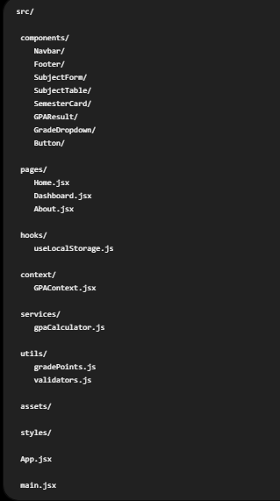

Overall Workflow of project
