QUAID-I-AZAM UNIVERSITY
ISLAMABAD
Department of Computer Science
SOFTWARE REQUIREMENTS SPECIFICATION
for
ECO-DRIVE PLATFORM
CS 322 Software Construction – Assignment #4
Prepared per IEEE Std 830-1998
Version 1.0 | OCT 7, 2026
Prepared By: Group-5
Member 1: Ashar Jabbar (Team Lead)
Member 2: Muhammad Umais
Member 3: Mohsi Mujahid
SUPERVISED BY:
DR. ONAIZA MAQBOOL
Department of Computer Science, Quaid-I-Azam University, Islamabad

SRS Document Approval Signatures
Project Manager
______________________ _______________________
Signature Date
Ashar Jabbar
Student, QAU Islamabad
Member 1
______________________ _______________________
Signature Date
Muhammad Umais
Student, QAU Islamabad
Member 2
______________________ _______________________
Signature Date
Mohsi Mujahid
Student, QAU Islamabad
Stakeholder
______________________ _______________________
Signature Date

Supervisor
______________________ _______________________
Signature Date
Dr. Onaiza Maqbool
Associate Professor, QAU Islamabad

Change History
Version No. | Date | Modified By | Changes
1 | 07/10/2026 | Ashar Jabbar | Original

Remarks

____________________
Signature
Dr. Onaiza Maqbool
Associate Professor, QAU Islamabad

Table of Contents
SRS Document Approval Signatures 2
Change History 3
Remarks 3
Introduction 6
Purpose 6
Scope 6
Project Name 6
Main Functionality 6
Objectives 6
Definitions, Acronyms, and Abbreviations 7
References 7
Overview 7
Overall Description 8
Product Perspective 8
Product Functions 8
User Characteristics 8
Constraints 9
Assumptions and Dependencies 9
Specific Requirements 9
Functional Requirements (Use Cases) 9
Use Case 1: "Establish a framework for an event" 9
Use Case 2: "View event schedule" 10
Use Case 3: "Validate and review events" 10
Use Case 4: "View leader board" 11
Use Case 5: “Join Group" 11
Use Case 6: "Submit member report" 12
Use Case 7: View Activity Media 13
Use Case 8: Login 13
Use Case 9: Request for Group Establishment 14
Use Case 10: "Registration for an event" 14
Use Case 11: "Review Team Member Report" 15
Use Case 12: " Create a Schedule for event " 15
Non-Functional Requirements 16
Performance Requirements 16
Security Requirements 16
Usability Requirements 16
Reliability Requirements 17
System Functions 17
3.3.1 Sub-Functions for Account and Group Management 17
3.3.2 Sub-Functions for Activity Management 17
3.3.3 Sub-Functions for Event Registration and Payment 17
3.3.4 Sub-Functions for Reports and Media 17
3.3.5 Sub-Functions for Ranking and Special Features 18
Performance Requirements 18
Appendices 19
A. Data Dictionary 19
B. Domain Model 22
C. Use-case Diagram 23

Introduction

Purpose
This Software Requirements Specification (SRS) document defines the functional and non-functional requirements for the Eco-Drive Platform, hereafter referred to as "Eco-Drive". Eco-Drive is designed to organize environmental activities such as tree plantations and cleanups by letting people join neighborhoods, form groups, and plan, join and document events. This document is intended for use by the development team, the supervisor, the system users (Site Admin, Group Leaders, Team Members, Group Members) and other stakeholders to ensure a clear understanding of the system's capabilities and limitations.

Scope

- Allow group administrators to establish groups associated with different neighbourhoods.

- Allow administrators to give permissions to users regarding the activity.

- Allow groups to schedule, organize and manage different environmental activities with different items of interest.

- Allow users allowed by administrators to join activities in their neighbourhood as their desired role.

- Allow uploading of media to the activity directory by participants and media teams.

- Establish automated scheduled activity alerts.

- Employ a ranking system of the registered groups and areas based on organized activities and performance of users.

Project Name
Eco-Drive Platform

Main Functionality
- Group and Neighborhood Management:
Areas are defined, people join a neighborhood, and groups are established after site admin approval. Inactive groups can be locked and groups can be retired.
- Activity Framework and Scheduling:
Group leaders establish event frameworks with event items/activities of interest, create schedules, and the system alerts every member when events are scheduled.
- Event Registration and Payment:
Group members register for events and pay by card or choose cash on arrival; the system issues a registration number, receipt and confirmation.
- Reporting and Media:
Team members submit event reports that the group leader reviews; group members and team members upload photos and videos after the event.
- Ranking and Special Features:
Groups and areas are ranked by number and types of events. Special features include activity filtering, automated certificates, an analytics dashboard for the admin and a map view.

Objectives
- Efficient Scheduling and Registration:
Provide efficient scheduling and registration of eco-friendly activities.
- Effective Communication:
Ensure effective communication between the different users and roles through timely alerts and notifications.
- Documented Impact:
Record reports and media of every event so that the impact of groups can be reviewed and ranked.
- User-Friendly Interface:
Develop an intuitive and accessible interface usable by all roles with minimal training.

Definitions, Acronyms, and Abbreviations
Term | Definition
Eco-Drive Platform | The name of the platform for organizing environmental activities.
SRS | Software Requirements Specification.
Area / Neighborhood | A defined region in which people join and groups are formed.
Group | A set of members of a neighborhood organized under a Group Leader.
Event | An environmental activity (e.g., tree plantation, cleanup) organized by a group.
Event Framework | The definition of an activity (type, title, area, items of interest) inside which schedules are created.
Event item/ activity | A user-defined data item recorded for an event (e.g., tree type, plantation date, total trees).
Participant | A registered group member who registers for and attends events .
Team Member | A group member who helps run an event, submits reports and uploads media.
Group Leader | The user who leads a group and manages its events.
Site Admin | The user who administers the platform (areas, inactive groups, validation, analytics). Also has the authority to approve group establishment requests.
Media Directory | Storage for photos and videos uploaded for events.
Ranking System | Ranking of groups and areas by number and types of events organized.
SSD | System Sequence Diagram.
UI | User Interface.
API | Application Programming Interface.

References
- IEEE Standard for Software Requirements Specifications (IEEE Std 830-1998).
- ISO/IEC/IEEE 16326:2019 Guidelines for Life Cycle Processes – Project Management.
- Case Study #4 – Problem Description, CS 322 Software Construction (Fall 2026).

Overview
This document is organized to provide a comprehensive understanding of the Eco-Drive system. The SRS is divided into the following main sections:
1. Introduction: Describes the purpose, scope, definitions, references, and an overview of the SRS.
2. Overall Description: Provides details on the product perspective, functions, user characteristics, constraints, and assumptions.
3. Specific Requirements: Outlines in detail the functional requirements (use cases), non-functional requirements, system functions and performance criteria.
4. Appendices: Includes supporting documentation such as the data dictionary, domain model, and the use-case diagram.

Overall Description

Product Perspective
Eco-Drive is a standalone web-based platform developed to meet the organizing and communication needs of community environmental activities. Unlike generic event or social tools, Eco-Drive is tailored to neighborhood-based groups: it ties groups to areas, lets leaders define activity-specific items of interest, and ranks groups and areas by their activities. The system follows a standard web application architecture with a responsive user interface, a dedicated backend server, a database and a media directory, and interfaces with a payment gateway, an email/SMS service and a map service.

Product Functions
Eco-Drive includes the following key functionalities:
- Account, Area and Group Management:
Users register and log in; the site admin defines areas; people join a neighborhood and groups; group leaders request group establishment and the site admin approves or rejects it; leaders edit or retire groups and the site admin locks inactive groups.
- Event Frameworks and Schedules:
Group leaders establish frameworks with user-defined event items and create validated, conflict-free schedules; alerts are sent to all members.
- Event Registration and Payment:
Group Members register for events, pay by card or cash on arrival, and receive a registration number, receipt and confirmation by email or phone.
- Reports, Review and Validation:
Team members submit reports; leaders approve them or request more information; the site admin validates and reviews events.
- Media Upload and Viewing:
Group members and team members upload photos and videos; users view media of events.
- Ranking, Search and Special Features:
Groups and areas are ranked; activities can be filtered by location, date and type; certificates are generated automatically; the site admin has an analytics dashboard; neighborhoods and activities are shown on a map.

User Characteristics
- Group and Team Members:
Residents with basic computer skills and familiarity with standard web applications. They need an intuitive interface for browsing activities, registering, uploading media and submitting reports.
- Group Leaders:
Community members who manage a group. They need simple forms for frameworks and schedules and an easy way to review reports.

- Site Admin:
Personnel responsible for the system's operation, data integrity and security. They need administrative interfaces for areas, groups, validation, analytics and backups. They also need a clear list of pending group requests and a quick approve/reject action.

Constraints
- Time Constraints:
Development must be completed within the project timeline of about three months (11 weeks) set in the Project Plan.
- Technology Constraints:
The system will be developed using standard web technologies (HTML, CSS, JavaScript) with C++ application logic and a MySQL database. Payment, messaging and map features depend on third-party services.
- User Access and Security:
The application must protect user contact details and payment-related data, and card data must be handled only by the payment gateway.
- Performance Requirements:
The system should respond within three seconds for most user actions and deliver alerts promptly.
- Budget:
Limited budget and resources as stated in the Project Plan.

Assumptions and Dependencies
- Internet Connectivity:
Users are assumed to have reliable internet access and a modern web browser.
- External Services:
A payment gateway, an email/SMS service and a map service are assumed to be available for integration.
- User Contact Details:
Every user can be reached by email or phone number for confirmations and alerts.
- Stakeholder Feedback:
Stakeholders are assumed to provide timely feedback during development, and the areas are assumed to be relatively safe and open to environmental activities.
- System Maintenance:
Regular maintenance, including backups and updates, is assumed to be scheduled during off-peak hours. The inactivity period for locking a group is configurable and to be fixed with stakeholders.

Specific Requirements

Functional Requirements (Use Cases)
The use cases below are divided among the group members (Appendix C). UC 10, 11 and 12 were first specified in Assignment 3; the others are derived from the use-case diagram of Assignment 2. Inputs and outputs are indicated for every use case. All use cases have been developed by the group members and then added to the SRS.

Use Case 1: "Establish a framework for an event"
(Ashar Jabbar, 04072413021)
- Actor: Group Leader.
- Pre-condition: Group Leader must be logged in.
- Pre-condition: A group in the area that group leader has joined must be established.
- Post-condition: Success message for establishment of framework displayed.
- Inputs: Event name, Event location, Event items.
- Outputs: Event Framework.
- Main Success Scenario:
  - Group Leader clicks “Establish an event framework” option.
  - Group Leader enters event details (name, items of interest, location).
  - Group Leader clicks confirm establishment.
- Alternative Flows:
  - Alt Flow 2a: Framework with same details already exists. Group Leader re-enters details or cancels.
- Exception Flows:
  - Exception 3a: Group Leader cancels framework establishment.

Use Case 2: "View event schedule"
(Ashar Jabbar, 04072413021)
- Actors: Group Leader, Group Member, Team member.
- Pre-condition: Event schedule must have been created.
- Pre-condition: Event must not be ended.
- Pre-condition: Schedule must not be deleted.
- Pre-condition: Actor must be in relevant group.
- Post-condition: Event schedule displayed on screen.
- Inputs: None.
- Outputs: Schedule.
- Main Success Scenario:
  - Actor opens desired group.
  - Actor selects desired event.
  - Actor clicks “View event schedule” option.
- Exception Flows:
  - Exception 2a: Event has ended.
  - Exception 3a: Schedule has been deleted.

Use Case 3: "Validate and review events"
(Ashar Jabbar, 04072413021)
- Actor: Site Admin.
- Pre-condition: An event must have been held.
- Pre-condition: Group Leader must have submitted report.
- Post-condition: Validated event report saved in system for ranking purposes.
- Post-condition: Validated event report sent back to group leader.
- Input: Event Reports.
- Output: Approval, feedback, additional information request.
- Main Success Scenario:
  - Site admin opens reports tab.
  - Admin selects a report to review.
  - Admin adds relevant information to event report.
  - Admin approves report.
- Alternative Flows:
  - Alt Flow 3a: Admin asks for additional information from group leader due to an incomplete report.

Use Case 4: "View leader board"
(Muhammad Umais, 04072413005)

- Actor: User( Group member, team member, group leader).
- Pre-condition: User must have registered and logged in to the platform.
- Pre-condition: User must already be a part of a group .
- Post-condition: User can assess where their group stands in the leader board.
- Input: none.
- Output: Leaderboard.
- Main Success Scenario:
  - User selects the view leader board option.
  - The leaderboard of all groups in the neighborhood and their ranking us displayed.
- Exception Flows:
  - Exception 1: System outage, failure or error.

Use Case 5: “Join Group"
(Muhammad Umais, 04072413005)

- Actor: User
- Pre-condition: User must have logged in to the platform.
- Pre-condition: User must not have already joined a group .
- Post-condition: User can view upcoming events of the group and register for them.
- Input: User info, role.
- Output: Confirmation message/email.
- Main Success Scenario:
  - User clicks “Join” on the group he wants to join.
  - User chooses “Group Member” as role.
  - User enters all personal and contact details required to join the group.
  - User successfully joins the group as a Group Member and is shown the confirmation message
- Alternative Flows:
  - Alt Flow 2A: User chooses team member as role. User selects the team he wants to be part of. An interview date is mailed to the user regarding joining that team.
- Exception Flows:
  - Exception 1: User does not enter all required details or enters invalid details
  - Exception 2: System outage or validation error.

Use Case 6: "Submit member report"
(Muhammad Umais, 04072413005)

- Actor: Team member.
- Pre-condition: User must be registered team member in a grou and logged in.
- Pre-condition: User must have been a part of the event regarding which report is to be created .
- Post-condition: User can see the status of the report as submitted
- Input: report data.
- Output: Submission status.
- Main Success Scenario:
  - User selects the event they were part of.
  - User selects submit report of event.
  - User uploads report file containing all valid information including summary of events and other details in accordance with their role in the team.
  - User submits the report.
- Alternative Flows:
  - Alt Flow 3A: User has already submitted a report of the event And wants to upload additional information.
- Exception Flows:
  - Exception 1: Report is submitted in an invalid file format
  - Exception 2: System outage or validation error.

Use Case 7: View Activity Media
(Mohsi Mujahid, 04072413019)
- Actor: Group Leader / Participant / Team Member / Site Admin
- Pre-condition: User is logged in and has access to the activity.
- Input: none
- Output: activity media
- Post-condition: User can view the activity media.
- Main Success Scenario:
- User selects an activity.
- User clicks “View Activity Media.”
- System retrieves available media.
- System displays media thumbnails.
- User selects a media file.
- System displays the selected media.
- Alternative Flow: If multiple files exist, the user can select any file to view.
- Exception: If no media is available, the system displays “No media available for this activity.”

Use Case 8: Login
(Mohsi Mujahid, 04072413019)
- Actor: Group Leader / Participant / Team Member / Site Admin
- Pre-condition: User has a registered account.
- Input: Username/email and password.
- Output: Successful login
- Post-condition: User is authenticated and redirected to the appropriate dashboard.
- Main Success Scenario:
- User opens the login page.
- System displays the login form.
- User enters credentials and clicks “Login.”
- System validates the credentials.
- System identifies the user's role.
- System creates a session and displays the appropriate dashboard.
- Alternative Flow: If credentials are incorrect or fields are empty, the system displays an error message.
- Exception: If the system or database is unavailable, an error message is displayed.
Output: Successful login

Use Case 9: Request for Group Establishment
(Mohsi Mujahid, 04072413019)
- Actor: Group Leader
- Pre-condition: Group Leader is logged in.
- Input: Group name, description, and required details.
- Output: Group.
- Post-condition: Request is submitted and stored for review.
- Main Success Scenario:
- Group Leader selects “Request for Group Establishment.”
- System displays the request form.
- Group Leader enters the required details.
- Group Leader submits the request.
- System validates and stores the request.
- System displays a confirmation message.
- Alternative Flow: If details are missing or invalid, the system asks the Group Leader to correct them.
- Exception: If a system error occurs, the system displays an error message.

Use Case 10: "Registration for an event"
(Ashar Jabbar, 04072413021)
- Actor: Group Member.
- Pre-condition: User must have joined as a member of the group.
- Pre-condition: All required information of the user for the event must be provided.
- Post-condition: Succes message for registration displayed.
- Inputs: User info, payment amount.
- Outputs: Registration number, payment receipt, confirmation email.
- Main Success Scenario:
  - Group Member clicks "Register" on their selected event.
  - Group Member selects payment method.
  - Group Member payment successful.
  - Group Member submits registration application.
  - Confirmation email sent to member.
- Alternative Flows:
  - Alt Flow 5a: If no email is provided then confirmation sent to members phone number.
  - Alt Flow 2a: Group member selects cash on arrival as payment method.
- Exception Flows:
  - Exception 3a: Payment fails due to insufficient funds.
  - Exception 1a: Registration closed.

Use Case 11: "Review Team Member Report"
(Muhammad Umais, 04072413005)
- Actor: Group leader.
- Pre-condition: An event must have been held.
- Pre-condition: Team member must have submitted report.
- Post-condition: Report status changed from submitted to reviewed.
- Input: Reports
- Output: Approval, feedback, additional information request
- Main Success Scenario:
  - Group leader opens reports tab.
  - Group leader selects a report to review.
  - Group leader approves report.
  - Group leader adds relevant information to event report.
- Alternative Flows:
  - Alt Flow 3a: Group leader asks for additional information from team member due to an incomplete report.

Use Case 12: " Create a Schedule for event "
(Mohsi Mujahid, 04072413019)
- Actor: Group leader.
- Pre-condition: the group Leader must be logged in.
- Pre-condition: the event framework must be created.
- Post-condition: Users alerted upon schedule creation.
- Input: Schedule details (date, time, activity, and description).
- Output: Confirmation message displayed and Validation error message if invalid data or time is entered
- Main Success Scenario:
  - Group Leader opens the event framework.
  - Group Leader chooses the option to create a schedule.
  - Group Leader enters the schedule details.
  - Group Leader submits the schedule.
  - The system saves the schedule.
  - The system displays a confirmation message.
- Alternative Flows:
  - Alt Flow 3a: Group Leader enters invalid data or time the system displays validation error and asks the Group Leader to correct the details.

Non-Functional Requirements

Performance Requirements
- The system must process registrations, payments and report submissions within 3 seconds under normal load.
- Media uploads must complete within the time allowed by the connection, with a visible progress indicator.
- Alerts and confirmation messages must be dispatched within 1 minute of the triggering event.
- The system should support concurrent users without performance degradation.

Security Requirements
- Passwords must be stored hashed and all traffic must use HTTPS.
- The system shall implement role-based access control (e.g., only the Site Admin can approve groups, only the Group Leader can review reports of his group).
- Card details must be handled only by the payment gateway and never stored by the system.
- Contact details of users must be visible only to authorized roles.

Usability Requirements
- The user interface shall be intuitive and responsive, with clear navigation for each role.
- All forms must include inline validation and clear confirmation and error messages.
- A new user shall be able to register for an event in at most five steps without training.
- Mobile responsiveness is required so the system can be used on phones and tablets.

Reliability Requirements
- The system should have 99% uptime excluding planned maintenance.
- Automatic daily backups must be performed to prevent data loss.
- Confirmed registrations, reports and media must not be lost.
- Recovery mechanisms must be in place to restore operations quickly in case of system failure.

System Functions

3.3.1 Sub-Functions for Account and Group Management
- ValidateInputDetails():
Checks that all mandatory fields (name, email or phone, password) are provided and meet security standards.
- SubmitGroupRequest():
Captures a prospective leader's request to establish a group in an area.
- ApproveGroupRequest():
Records the Site Admin’s decision, creates the group and notifies the applicant.
- JoinGroup():
Adds a user to a neighborhood group with the desired role.
- LockGroup():
Sets an inactive group to Locked state and notifies its leader.

3.3.2 Sub-Functions for Activity Management
- CreateFramework():
Creates and stores an event framework with its type, title, area and event items/activities.
- CreateSchedule():
Validates and saves schedule details (date, time, activity, description).
- CheckScheduleConflict():
Detects overlapping schedules before saving.
- SendAlert():
Notifies all group members when an event is scheduled or changed.

3.3.3 Sub-Functions for Event Registration and Payment
- StartRegistration():
Starts a registration after checking membership and that registration is open.
- ProcessPayment():
Sends the amount to the payment gateway or records cash on arrival.
- GenerateRegistrationNumber():
Creates a unique registration number and payment receipt.
- SendConfirmation():
Sends the confirmation to the participant's email, or phone if no email exists.

3.3.4 Sub-Functions for Reports and Media
- SubmitReport():
Saves a team member's report with status submitted and notifies the leader.
- ReviewReport():
Let’s the leader approve a report or return it with feedback changing the submitted status to reviewed.
- RequestAdditionalInfo():
Sends the leader's feedback and request for more information to the team member.
- UploadMedia():
Validates file type and size and stores the file in the media directory.

3.3.5 Sub-Functions for Ranking and Special Features
- ComputeRanking():
Ranks groups and areas by number and types of events and group members.
- FilterActivities():
Filters activities by location, date and type.
- GenerateCertificate():
Automatically issues certificates to group and team members.
- ShowAnalytics() :
Displays trends to the admin e.g. most active groups, most common activity types and area-wise participation.
- ShowMapView():
Displays events and areas pinned on a map.

Performance Requirements
- Response Time:
All core operations (registration, scheduling, report submission, media upload start) must complete within 2–3 seconds under normal operating conditions.
- Scalability:
The system must support at least 100 concurrent users, with extra capacity on event registration days, without significant degradation.
- Data Throughput:
Updates to schedules, registrations and rankings must be reflected within 1 minute for all users.
- Backup and Recovery:
Backups must be completed within predefined maintenance windows, and recovery time should not exceed 30 minutes after a critical failure.

Appendices

A. Data Dictionary
Data Element Name | Type | Definition | Data Type | Length | Example | Conditions
User ID | Integer | Unique identifier of each user. | Integer | 6 | 210045 | Auto-generated unique ID.
User Name | Element | Full name of the user. | String | 50 | Ali Khan | Required
User Email | Element | Email of the user. | String | 50 | ali.khan@example.com | Valid email; optional if phone given.
User Phone | Element | Phone number used for fallback confirmation. | String | 13 | +923001234567 | Required if no email.
User Role | Element | Role of the user. | String | 15 | Group Member | Group Member, Team Member, Group Leader, Site Admin.
Area ID | Element | Unique identifier of a neighborhood. | Integer | 4 | 1012 | Auto-generated unique ID.
Area Name | Element | Name of the neighborhood. | String | 40 | Sector F-10 | Required, unique.
Group ID | Element | Unique identifier of a group. | Integer | 5 | 30211 | Auto-generated unique ID.
Group Name | Element | Name of the group. | String | 40 | Green Margalla | Required, unique in the area.
Group Status | Element | State of the group. | String | 10 | Active | Active, Locked, Retired.
Request Status | Element | Status of a group establishment request. | String | 10 | Pending | Submitted, Approved, Rejected.
Approval Date | Element | Date the Governor decided the request. | Date | 10 | 05/10/2026 | DD/MM/YYYY.
Event ID | Element | Unique identifier of an event. | Integer | 6 | 500120 | Auto-generated unique ID.
Event Type | Element | Kind of activity. | String | 20 | Tree plantation | Cleanup, Tree plantation, etc.
Event Title | Element | Title of the event. | String | 50 | Spring Plantation Drive | Required, unique in the group.
Event Status | Element | Life-cycle state of the event. | String | 15 | Scheduled | Framework, Scheduled, Held, Validated.
Item Name | Element | Name of a user-defined event item . | String | 30 | Type of tree | Required
Item Value | Element | Value recorded for an event item . | String | 50 | Neem | Required
Schedule Date | Element | Date of a scheduled activity. | Date | 10 | 12/10/2026 | DD/MM/YYYY; not in the past.
Schedule Time | Element | Start time of a scheduled event . | Time | 5 | 09:00 | HH:MM; no overlap in the event.
Registration No | Element | Unique number issued on registration. | String | 10 | REG-004512 | Auto-generated unique ID.
Payment Amount | Element | Amount paid for registration. | Decimal | 8 | 500.00 | Greater than or equal to 0.
Payment Method | Element | Chosen method of payment. | String | 10 | Card | Card, Cash on arrival.
Payment Status | Element | Outcome of payment. | String | 10 | Paid | Paid, Pending, Failed.
Report Content | Element | Text of an event report. | String | 1000 | Planted 40 saplings. | Required
Report Status | Element | Review state of a report. | String | 10 | Pending | Submitted, Reviewed, Approved, Returned.
Report Feedback | Element | Leader's feedback or information request. | String | 300 | Add photo count. | Optional
Media File | Element | Photo or video of an event. | JPG/PNG/MP4 | Up to 100 MB | plantation01.jpg | Allowed types only; size limits apply.
Upload Date | Element | Date the media was uploaded. | Date | 10 | 13/10/2026 | DD/MM/YYYY.
Certificate Type | Element | Kind of certificate issued. | String | 15 | Group Member | Group Member, Team Member.
Alert Message | Element | Text of an alert sent to members. | String | 200 | Cleanup on 12/10 at 09:00. | Required
Rank | Element | Position of a group or area in the ranking. | Integer | 4 | 3 | Positive integer.

B. Domain Model
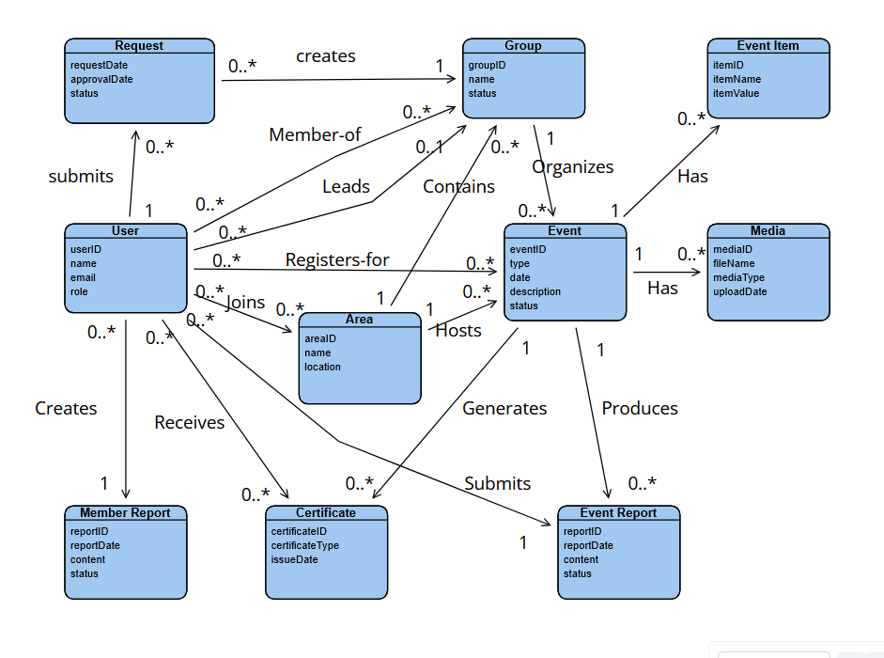
Figure B-1: Domain model of Eco-Drive.

C. Use-case Diagram
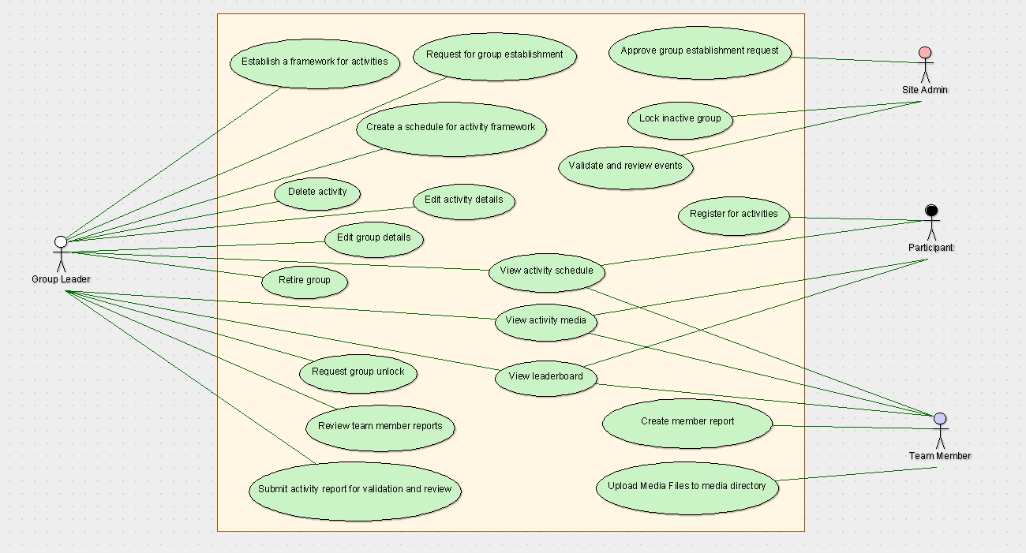
Figure C-1: Use-case diagram of Eco-Drive.

