OS Semester Project (Ludo Game)

Project done by
Umais Nisar and Salar Abbas
i190573 and i190490
Section C

OS Concepts utilized in our Pseudocode
We have used multi-threading on Dice roll. Semaphores are being used for its synchronization. Four threads are made (Because there are four players), each thread accesses the same piece of code and does the dice roll for each player. This process is done without any trouble and smoothly with the use of semaphore.
We didn’t have time to do it but multi-threading could’ve been done on several other things as well. It could have be done to assign numbers to each player at start of the game randomly, who will be able to access the dice first, second, third and fourth. After each dice roll, the resource is released for other players to use dice roll again.

System Specifications
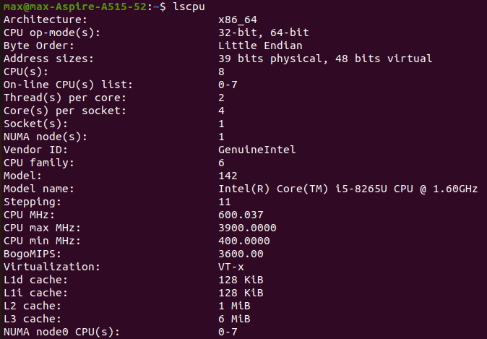
How could we implement these steps in another scenario

