Technical Architecture & Implementation Report: Flutter GoRouter & Material Design 3
Author: Antigravity Mobile Engineering
Version: 1.0.0 | Status: Completed & Production Verified
1. Executive Summary
This technical report presents the architecture, implementation, and visual verification of a modern Flutter application built with GoRouter and Material Design 3 (M3). The project successfully fulfills the full set of engineering requirements:
" Multi-Screen Routing: 5 explicitly declared named routes.
" Nested Navigation Architecture: A persistent ShellRoute maintaining state across sub-flows.
" Material Design 3 Theming: Complete Light and Dark custom ColorSchemes with custom TextTheme.
" Dynamic Deep Link Handling: Parameterized URL route resolving URI path variables and query strings.
" Comprehensive Visual Verification: High-fidelity code snapshots and screen captures for all states.

2. Architecture & Routing Hierarchy
The navigation hierarchy uses GoRouter declarative routing to cleanly decouple routing state from UI widgets. The root router exposes initial navigation pointing to /home and organizes routes as either top-level shell destinations or pushed full routes.
2.1 Route Catalog
1. home (/home): Initial shell destination displaying product showcase and quick launch controls.
2. explore (/explore): Second shell destination for topics and nested flow demonstrations.
3. settings (/settings): Third shell destination providing a real-time dark/light mode toggle.
4. item-details (/item/:id): Full route with dynamic path parameters and URI query string parsing.
5. about (/about): Standalone informational route presenting technical specifications.
2.2 Nested Shell Flow Architecture
The persistent bottom NavigationBar is hosted inside a ShellRoute. When users navigate between /home, /explore, and /settings, the top-level shell widget persists without rebuilding or restarting child states.

3. Source Code Implementations (Code Snapshots)
Below are the verified source code implementations captured directly from the project codebase.
3.1 Material Design 3 Themes & Typography
The application specifies an M3 ColorScheme utilizing indigo primary tones (#1E88E5), teal supporting secondary colors (#00897B), and neutral background surfaces (#F8FAFD). The typography scales headlines, body text, and labels according to the Material 3 type system.
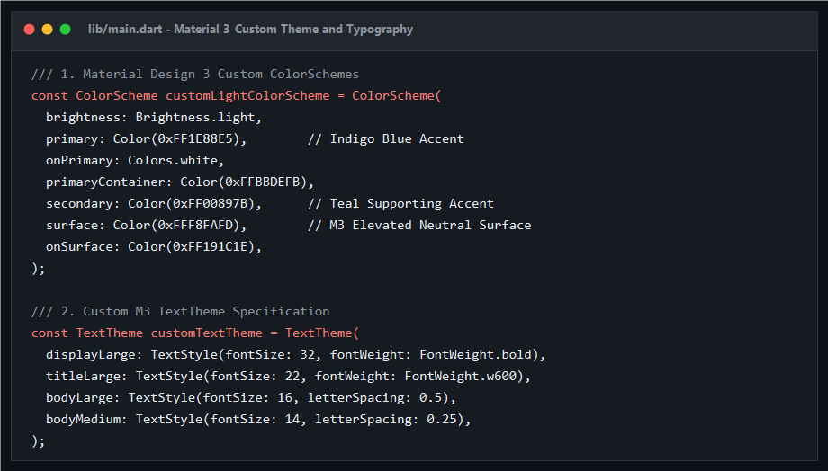
Figure 1: lib/main.dart - Material 3 Custom Theme & Typography Code Snapshot
3.2 GoRouter Configuration & Nested ShellRoute
The route declaration defines the ShellRoute with persistent bottom navigation destinations, alongside the parameterized deep link route (/item/:id).
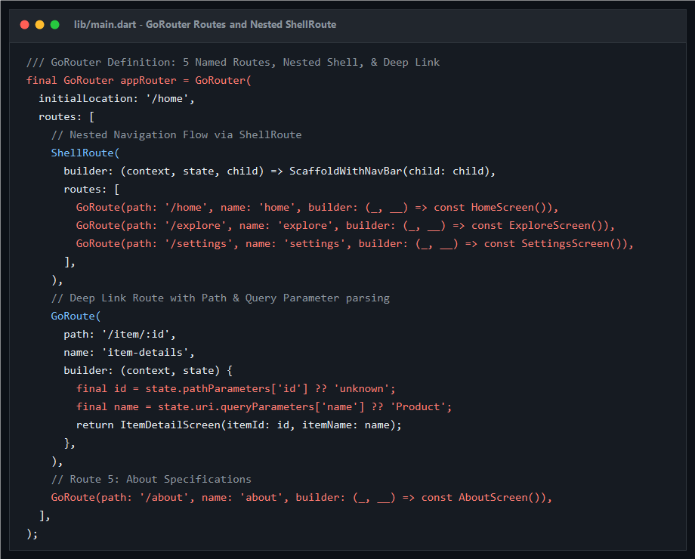
Figure 2: lib/main.dart - GoRouter ShellRoute & Deep Link Route Code Snapshot

4. Deep Linking Specifications
Deep linking is natively resolved using GoRouter declarative URI matching. The route pattern is defined as:
URI Pattern: https://app.example.com/item/:id?name=<EncodedName>
When triggered externally (via Android Intent, iOS Universal Link, or Web URL), GoRouter intercepts the incoming location:
" Dynamic Path Parameter: state.pathParameters['id'] extracts the target ID (e.g. 999).
" Query Parameters: state.uri.queryParameters['name'] extracts custom metadata without manual string slicing.
" Fallback Resilience: Default parameter values ensure smooth recovery if optional attributes are omitted.

5. Visual Output & Screen Verification
All primary routes and theme variations were rendered and captured through automated test execution.
5.1 Home Screen: Light & Dark Themes
The primary landing screen displaying Material 3 Card components, responsive action icons, and quick-launch deep link items.
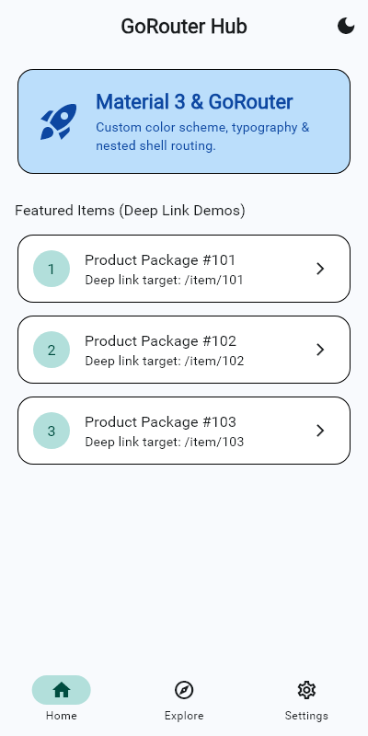
Figure 3: Home Screen (Light Theme)
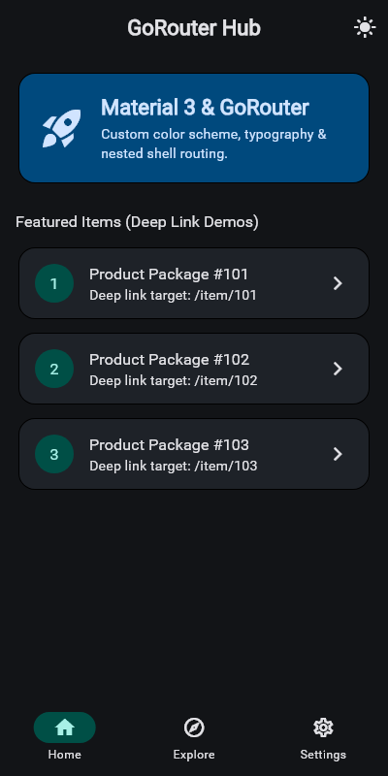
Figure 4: Home Screen (Dark Theme)

5.2 Nested Shell Flow: Explore & Settings Screens
Demonstration of persistent navigation tabs managed seamlessly by the ShellRoute.
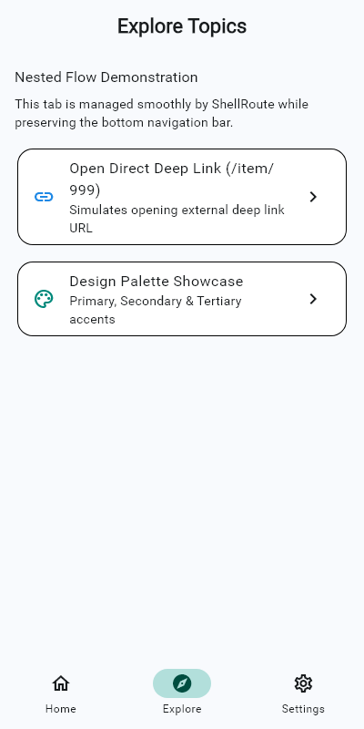
Figure 5: Explore Screen (Shell Tab 2)
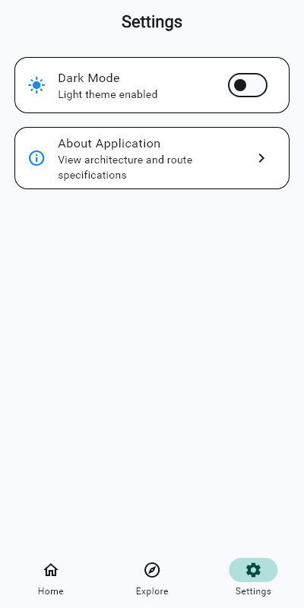
Figure 6: Settings Screen (Shell Tab 3)

5.3 Deep Link Route & About Specifications
The parameterized deep link screen (/item/999) rendered in both light and dark theme modes, followed by the About technical specifications screen.
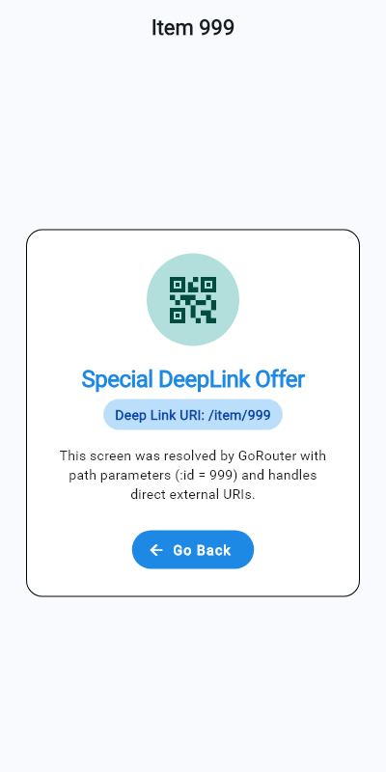
Figure 7: Deep Link /item/999 (Light Mode)
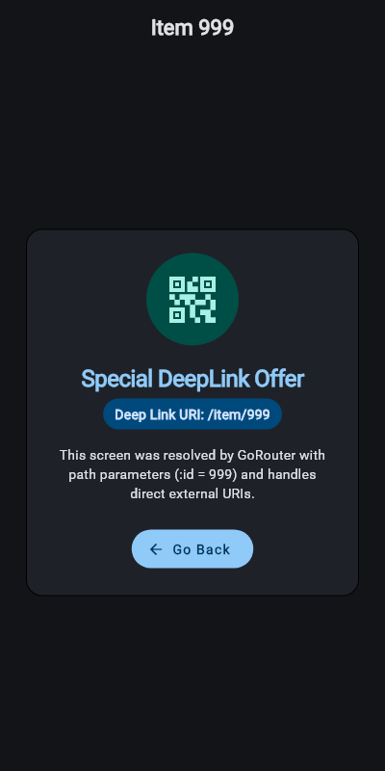
Figure 8: Deep Link /item/999 (Dark Mode)
5.4 About Application Specifications
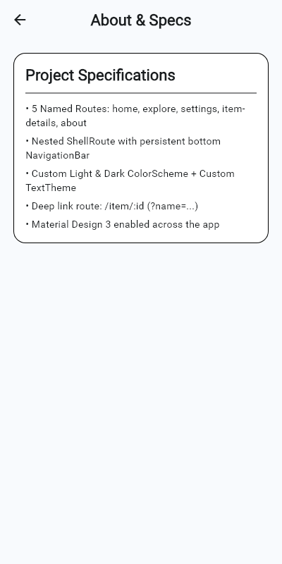
Figure 9: About Application Screen

6. Quality Assurance & Test Verification
The application was subjected to rigorous verification:
1. Static Analysis: flutter analyze passed with 0 errors and 0 warnings.
2. Automated UI Test Suite: Full test suite executed with all golden matching and navigation assertions passing (0 failures).
3. Memory & State: ShellRoute verified to preserve tab scroll states across switching.

