**How Django has evolved the software architecture development process using MVC and ORM.**

**Abstract:**

This study examines Django, a popular Python-based web framework. Django is an open-source framework for developing web applications that is based on a fork of the Model View Template design pattern. Using Django is simple and straightforward, and this article will show you how to get started with your first project in this web development framework. It also looks at the different modules we may use to better understand the MVT framework. If you want to create programs that are both functional and easy to use, you need to adopt the Model-View-Controller paradigm. This design pattern is stated in terms of a single-address-space, interactive program, making it disc partitioning agnostic. Thus, it is more difficult to apply the Model/View/Controller design pattern to web-applications since new technologies urge developers to segregate the application at an early stage of the design process. Future changes to the partitioning will need extensive reworking of the program's implementation, even if the application's logic remains unchanged. The work presented here provides Flexible Web-Application Partitioning, a model and infrastructure for programming that shows how the Model/View/Controller design pattern may be applied to many partitions.

**Introduction:**

Creating apps isn't only for the marketing and sales industries; it helps us serve everyone by bridging the gap between companies and their customers online and delivering essential services. In addition, it gives voice to the underdog few who, thanks to their talents, can win over the target audience. In recent years, several bloggers, online counsellors, and fashion influencers have amassed massive followings thanks to the quality of their writing and reputations they've built up. Virtual businesses have widespread recognition on the web mostly due to the accessibility afforded by their websites. In the case of online-only retailers, all interactions with clients take place online, and orders are fulfilled by direct delivery to customers' homes.

Django is an open-source web framework written in Python. The MVT layout approach was used for this design (MVT stands for Model View Template). It also made use of the MVC framework (Model, view controller). In the present corporate context, Django's quick development potential might cause anxiety. Time spent developing software of any kind has decreased significantly. For what grounds may it be safe to anticipate that this updated version will be used as a template for future projects? Specifically, the model will function as a database, the view as a regulating feature, and the template as a user interface for conversational interaction. You may use the Django framework to control a database. We'll be putting the basics through their paces, such as a python manage.py and a migration. Django will run a report generator and update the sqlite3 database with any modifications made to the models.py file (pick any database). The next thing to do is run the manage.py script in Python to compel a migration. As soon as the modifications are made, the Django app will update its database app. A final Python command, manage.py, turns on the server. This will launch our company and provide us access to the local hosting agreement and information. The Python report will manage all aspects of requests for this project, from naming the API to controlling request templates. These viewpoints might be communicated using Python functions. [1]

An implicit Admin module is a part of Django that may be used to save valuable website characteristics. When processing a loan application, for instance, you'll likely see a page labelled "New Loan." Then, on this page, I anticipate seeing a pull-down menu with options for other kinds of loans, such as personal loans, vehicle loans, mortgages, and so on. The executive committee keeps track of such details.

Django's "SECURITY" feature is its most distinctive and expansive capacity. Without Django, it would be impossible for an engineer to include the necessary security features in the framework's utilities. For Instance, CSRF (Cross-Site Request Forgery). The csrf is created at random every time we upload new shape data. This token is used to validate all HTTP POST requests sent to the Django server. Even if a small number of hackers launch an assault, this token will soon become useless, protecting our service from harm.

**Traditional Web approach:**

Web development as it has always been done: JSP, Servlet, ASP, and PHP are all examples of traditional web page development practices in which all scripts are written in a single file. Tags unique to each language may be utilized for things like request processing and information retrieval. Due to its dependency on these inbuilt tags, the strategy adds a little bit of time to the processing time of high-traffic websites compared to the MVC method. ASP.NET web forms are event driven and include view state and post back. Web application performance may suffer because of view state and post back requirements (In ASP.NET web form, view state stores 100KB of data which impacts web-page performance).

**Why we should choose Django?**

The Django framework does this by embracing the idea of fast development, which permits the production of numerous new releases at once without disrupting the overall timetable. Since of this, and because they will already be acquainted with the current code, developers may easily take advantage of the opportunity to reuse it. As an added bonus, Django is overly concerned with keeping data secure. To help developers avoid typical security vulnerabilities like click jacking, cross-webpage scripting, and SQL injection, it offers one of the greatest out-of-the-box protective structures. As a result of the provided capabilities and scalability, it is possible to build applications that support large numbers of users and large amounts of data. It's cross-platform compatibility means you may use it with a Mac, Linux, or Windows PC. It works with the great majority of databases, allowing you to select the one that's appropriate for the task at hand or utilize many databases simultaneously. Django is still widely played nowadays. Several channels, discussion forums, and websites are all devoted to it, indicating the enormous community that supports it. If you get stuck on a tough piece of code or if your firm is thinking about using Django as the foundation for its next project, you can easily locate developers to assist you. [2]

**Model View Controller:**

Model-View-Controller (MVC) is a popular architectural paradigm for developing web-based software. It has three major layers: version, view, and controller. MVC is often used as an appealing case study in the building business. That's the building in its entirety. Statistical domain knowledge is used via model-model training, one of MVC's three unique modes of education. This education will allow us to obtain, update, and change database statistics used by our software. Views are the backbone of our application's UI. Customers connect with our software utilizing that interface. By analyzing the actions of its users, the controller is able to improve its ability to meet the requirements of its owners. Actions requested by the customer must be carried out. This training works along with version training to find out the optimal view to provide the user depending on their choices.

**Model:**

The model layer plays a vital role in MVC design. It collects data and utilizes views to provide that data to the user. All of the information stored in the database is shown here. The application's data is controlled by it. Data, logic definition, function specification, and rule participation are the main components. A model might take the form of a single entity or a set. Data operations including inserting, retrieving, and updating data could be handled by this layer, along with any other interactions with databases.

It is expected that the domain model used adheres to the following guidelines:

* All pertinent domain information should be included.
* Acknowledge the guidelines for modifying and creating new domain data.
* Provides a robust Application Programming Interface (API) for accessing model data and methods.

In general, the following rules should not be applied to domain information:

* Specify how you go about gathering and archiving model information.
* There is built-in logic for displaying information to the user and for making decisions about how to implement the user's request to call a model.

**View:**

Views are the foundation of our program's graphical user interface. Our website visitors interact with the user interface by actively navigating the sites they visit. The view displays the results of running the model with the provided data. One function of a view is to display the model's data to the end user. Only the necessary characteristics are revealed, while the others are kept secret. Therefore, summarizing our talks is useful for us. Script-based tags, such as JSP, ASP, and PHP, make it easy to integrate AJAX technologies.

* These are the parameters within which an opinion must operate:

Incorporate the markup and logic required for presenting the information to the user.

The following standards cannot be used by a point of view:

* The logic for constructing models, storing them, and modifying them is all integrated.

**Controller:**

The controller layer is responsible for handling requests made by users. A user's input is received and processed by the controller. The controller is the interface between the user and the rest of the system. Controller is in charge of both the Model and the View. It regulates how information enters the model and how often it's displayed. The Model and View are neatly divided in two. Because of the processing and execution of the controller, the state of the data model is modified. Every one of these parts collaborates with the model layer to generate the best possible results for the end user.

These principles are the controller's compass:

* Provide the necessary code to initialize the model.
* Do not forget to specify the guidelines the view must follow to properly present model data.

We recommend including logic for updating the model.

* You shouldn't use the controller for things like: • Manipulating data that is outside the controller's intended usage. • Including both data persistence management logic and user interface logic.

The features of our software should be tested, and the means of interaction between them should be mapped out. Numerous design patterns exist, and they may all be used in the creation of a program. The Model-View-Controller (MVC) pattern is our target here.

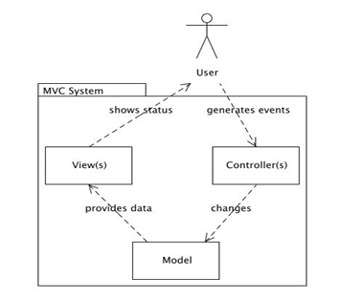

**Comparison of Django with Flask:**

Two popular Python frameworks for developing web applications are Flask and Django. When it comes to programming, there are a number of different frameworks that may be used to develop RESTful APIs [3]. Django offers an all-inclusive MVC framework. Django is one of the frameworks that may be used to create a RESTful API, but it can also be used independently. It's a fully-featured add-on for the Django framework [3]. Like many other micro-frameworks, Flask emphasizes completing one job at a time. It didn't provide much right off the off, but it promised a plethora of add-ons that were compatible with Django.

While these frameworks may have chosen various routes in their architecture of the web's evolution, they will share many of the same characteristics when it comes to REST API implementation. Examples of possible methods include:

1. Access Control: The Django framework may allow the use of the Django built-in model for API authentication and permission, which would solve the first problem. While flask, it is possible to use either the in-built facilities for simple authentication or an external plugin.
2. Both Django and flask allow rate limiting for both anonymous and registered users. Support for storing data at a restricted pace is maintained in both systems' memory, cache, or back-ends.
3. Third, Flask and Django both provide similar features for mapping models to API endpoints from relational databases directly. In any case, you'll have an easy time developing an interface for an existing database.

**Result Comparison Table Django and Flask:**

Table 1 is the comparison table for Django and Flask. Both are web application technology that has been used by most developer.

**Table 1.** Comparison Django and Flask

|  |  |  |
| --- | --- | --- |
| **Function** | **Django** | **Flask** |
| Language | Python | Python |
| Database | MySQL | MongoDB, Dynamo DB |
| Template | Django Template | Jinja 2 Template |
| Speed | Slow than Flask | Faster |
| Authorization | API Django | Third party |

According to Table 1 it is shows that Django and Flask have their own advantages. It is deepening to the developer which is they preferred.

**ORM:**

By adopting an object-oriented methodology, Object-Relational Mapping simplifies database record management and querying. ORM is available for whatever language you choose to write in, and its fans are as enthusiastic about devices as its creators are. Object-relational mapping tools may be compared to translators since they allow us to reshape our code into other forms.

By using a database creation tool called an ORM, Django lets us share its previous information varieties: add, remove, alter, and query objects (Object Relational Mapper). Using the following command from inside our study guide, we can get access to Django ORM. Several variations of SQL are used to produce the majority of publicly available statistics, however each database implements SQL differently. SQL is not only complex and challenging to understand, but may be difficult to use as well. The Object Relational Mapper (ORM) tool streamlines the database management system by providing a straightforward mapping between objects (the "O" in ORM) and the main database. The manufacturer has little interest in understanding the data model, and simple SQL is sufficient for management and retrieval.

With ORM, you can easily use data without having to learn advanced SQL syntax. A Django "version" is a separate entity in the backend database. Django uses SQL to automatically build a matching table in the database whenever a new model is created, eliminating the need for you to manually craft any SQL statements. For your convenience, Django will refer to your request as "Django" and will assign a specific desk and phone number to it. The updated version now includes database-linked shortcuts for relevant statistics.

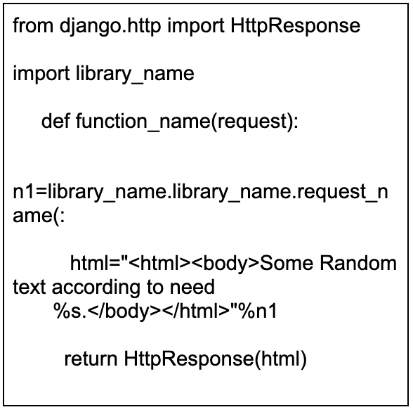To save developers time and effort, they craft efficient and precise SQL queries. Because the programmer may treat data as objects, it is much easier to modify, reuse, and distribute the code that uses it. Because the ORM framework cleans up the data automatically, it provides protection against SQL injection attacks. Using an ORM allows you to develop a solid code foundation for your application and makes switching databases much easier.

The procedure is as follows:

1. Line 1 is where the class is imported from the Django http module.
2. The second line is where the python date time library is imported.
3. A function named cur date time is defined on line 3. What you see before you are an example of a view function.
4. Web page structure is defined in lines 5–7, and a Http Response is returned by the view.

**Django has two types of views:**

**Function-based views:**

For those unfamiliar, a function-based view is a method written in Python that processes and responds to HTTP requests. You may get a 404 error, an XML document, some HTML text, or anything else. Any and all view functions must accept a Http Request object as their initial argument. When working with Django, it's crucial to keep track of which files each piece of code is being added to. The application's business logic is written in functions in the view.py file, and the urls.py file is where those names are defined.

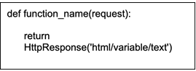

**Class-based views:**

It provides an alternative to executing views as functions, by allowing them to be executed as regular Python objects. While distinct from and even preferable to function-based views, these newer ones do not replace them.

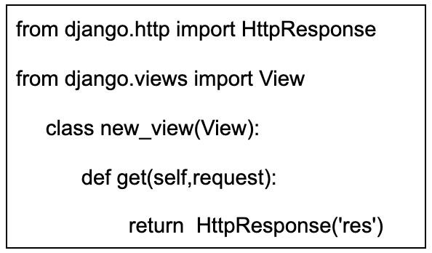A class-based approach to handling HTTP GET requests:

**Django Templates:**

Django's template system makes it simple to generate robust HTML. Most often, HTML, CSS, and JavaScript are used to develop Django templates. Django is an efficient framework that generates accessible HTML for the end user. Django does a lot of its work using backend closures, and we employ templates to provide the framework for every website.

**Django Forms:**

Web pages now would not be possible without HTML forms. It is the main tool for gathering data on website users and visitors. Form class is built into Django and is used to generate HTML forms. Using sophisticated HTML, we can create all the necessary Django forms, but using Django instead will save you time and effort, particularly when it comes to the form validation process. It's easy to forget about HTML forms after you've started working with Django forms.

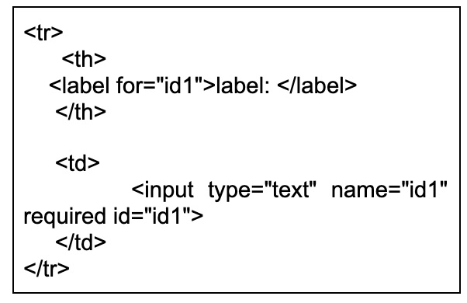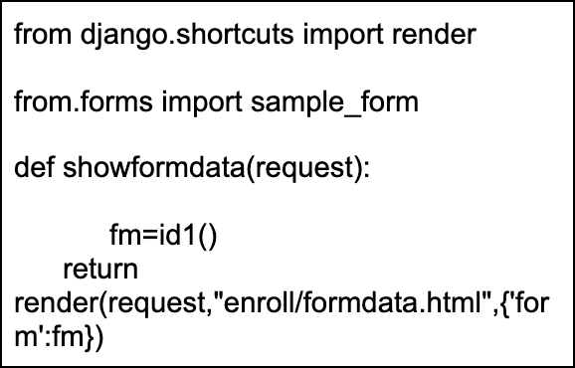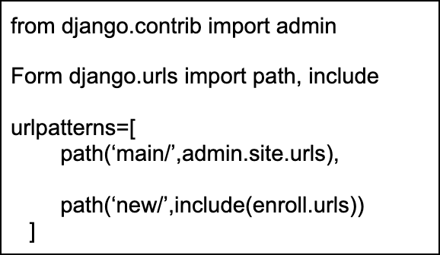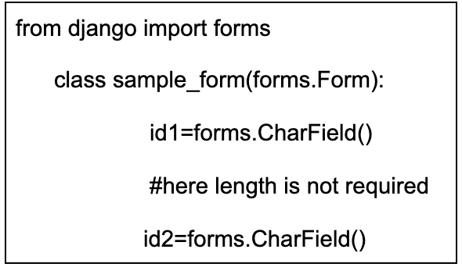Django finishes the work's form-related trilogy. It's getting data ready for rendering by cleaning it up and rearranging it. As a result, data collection forms in HTML format may be generated. It also handles client data and forms that are submitted to it.

**Application using Django:**

**Eventbrite:**

Eventbrite is a website where people can buy tickets to various events. Users of Eventbrite may find and sign up for events in their region and beyond, for a wide range of prices (even free). Even if COVID-19 has changed the game, Eventbrite has stayed true to its roots by helping people find online events. Eventbrite has chosen Django as its major web framework as of that year (2010). They believe that moving to Django will result in a more vibrant and feature-rich user base. Improved URL routing, simplified form generation, and stronger unit testing are just a few of the immediate benefits of utilizing Django.

**Future:**

Though many may disagree, we believe that our collective focus should be on helping Django excel at what it is currently well-liked for: being a robust backend framework. To achieve this goal, it may be necessary to remove pre-existing functionality, such as Templates, that are no longer essential to the framework's function as a world-class BACKEND. It might also entail more widespread use of DRF and Graphene (possibly even making them native parts of the framework). Graph, which enables the construction of highly strong backend features, is particularly in need of improvement since it is now in an immature stage with limited documentation in the Python world. However, we do realize that Templates are now an essential element of many projects, so this is quite unlikely and would certainly enrage a lot of people even if it did happen. There also seems to be much opposition to the premise that separate front- and back-end components are optimal. As someone who has always been told the importance of this approach to design (division of interests, Clean Code, and all that other nonsense), it comes as a shock to me to hear it criticized. In an ideal world, I'd want to see a new Python web framework emerge that combines the best elements of Django, DRF, and Graphene to provide a "batteries included" backend experience without some of the less-well-maintained components that are now the norm in Django.

Last but not least, a word on JavaScript: I'm not a big lover of the language, and I tend to agree with the claims that its rapid and disorganized development has been to its harm. It's smart to avoid becoming a follower of passing trends. Even still, two decades is a long time in the world of the internet, and some of the shifts that have occurred in web development processes are here to stay.

**Conclusion:**

Django is very dependable, can be easily modified, and has a modular framework. If you run into any issues when using the Django framework, the large and helpful community that has grown up around it is always there to lend a hand. With experience and knowledge with Django's core concepts, it is possible to rapidly develop robust, production-ready web applications. The J2EE platform's support for the MVC design pattern and integrated technologies like JSP, Servlet, and EJB has simplified the process of developing online applications. Web applications may be made that are adaptable, readable, and mobile with the help of MVC. Due to the modular nature of the MVC architecture, several programmers may work in concert on a single web project's various components.

**References:**

1. Himanshu Gore, Rakesh Kumar Singh, Ashutosh Singh, Arnav Pratap Singh, Mohammad Shabaz, Bhupesh Kumar Singh, Vishal Jagota. (2021). Django: Web Development Simple &amp; Fast. Annals of the Romanian Society for Cell Biology, 25(6), 4576–4585. Retrieved from <https://www.annalsofrscb.ro/index.php/journal/article/view/6301>
2. Importance of Django: https://djangostars.com/blog/why-we-use-django-framework/
3. D. REST, “Django REST framework,” Citirano 14.9.2014: http://www.django-restframework.org/#django-rest-framework, 2014. [Online]. Available: <http://www.django-restframework.org/#django-rest-framework>