

Lab Journal: 01
Date: January 30, 2026

Student : Umama Hidayat Khan
Enrollment : 01-131232-107

Artificial Intelligence Lab (Spring-2026)
Teacher: Engr. Saad Mazhar

Department of Software Engineering

Bahria University, Islamabad

Task No: | Task Wise Marks |  | Documentation Marks |  | Total Marks  (20)
 | Assigned | Obtained | Assigned | Obtained
1 | 3 |  | 5
2 | 3
3 | 3
4 | 3
5 | 3

Comments:

Signature

Lab No: 1 – Python Installation

Introduction
In this lab, we installed the latest version of python and vs code.

Tools Used
VS Code

Task 1: Accurate Installation of python and compiler

Screenshot
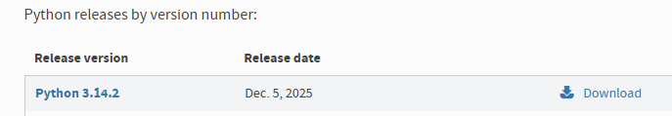
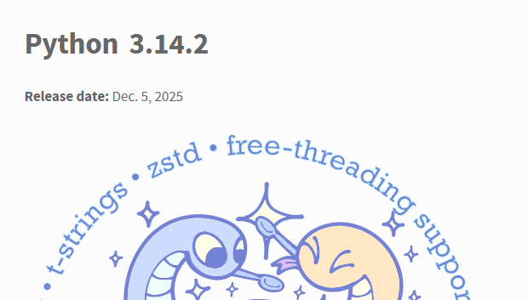
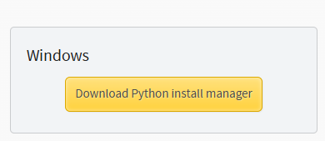
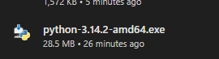
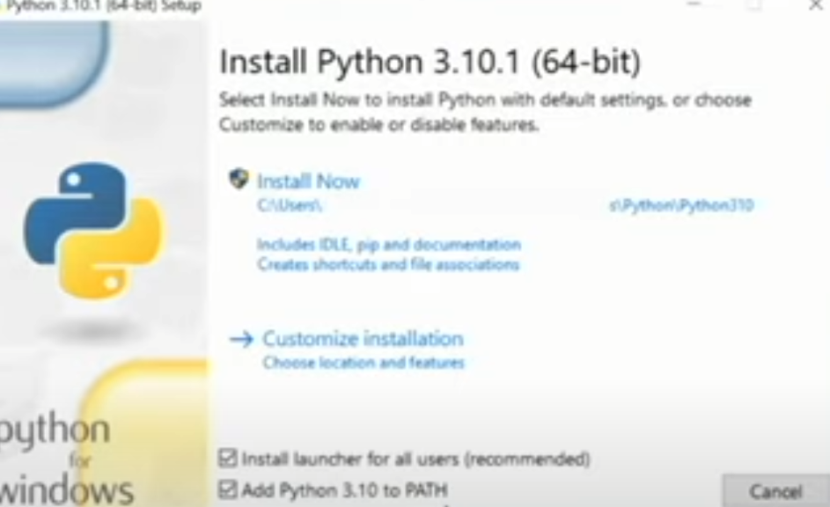
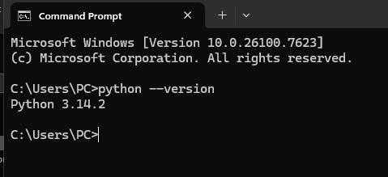
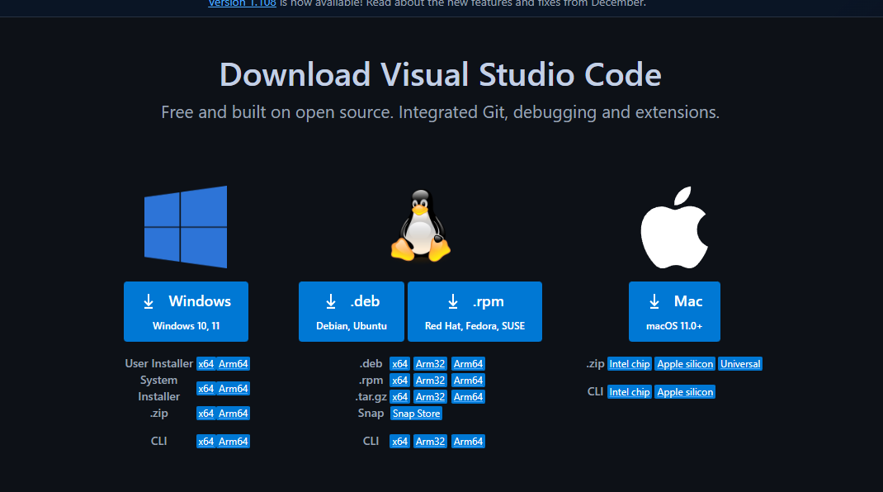

Task 2: Write a Program to evaluate the grade according to marks.

Code
marks = int(input("Enter your marks: "))

if marks <= 100 and marks >= 85:
print("Grade A")
elif marks < 85 and marks >= 70:
print("Grade A-")
elif marks < 70 and marks >= 55:
print("Grade B")
elif marks < 55 and marks >= 45:
print("Grade C")
elif marks < 45 and marks >= 33:
print("Grade D")
elif marks < 33 and marks >= 0:
print("Grade F")
else:
print("Enter valid input")

Screenshot
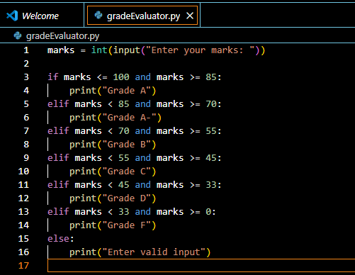
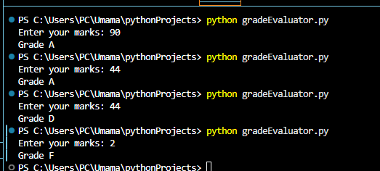

Conclusion

In conclusion, we successfully set up python with visual studio code. Additionally, we programmed and basic grade evaluator to gain hands-on experience with python.

