

Huntington's Disease Detection and Severity Grading using Federated Learning and Agentic AI

Supervised by
Ms. Madiha Jaffar

Final Year Project Report by

Umama Qayum
051-22-137499
Mahnoor Riaz
051-22-137066
Hifsa Shahid
051-22-137046

In Partial Fulfillment
Of the Requirements for the degree
Bachelors of Science in Computer Science (BSCS)

Iqra University H-9 Campus
Islamabad, Pakistan
(2025)
FINAL APPROVAL

It is certified that the work printed in this report entitled “University Campus Chat System” by Umama Qayum (051-22-137499), Mahnoor Riaz(051-22-137066
Hifsa Shahid
051-22-137046 fulfill the requirements for award of degree of BS Computer Science from Department of Computing and Technology, Iqra University H-9 Campus, Islamabad, Pakistan

Viva Voce Committee

Supervisor

Internal Examiner-1: Asadullah Khan

Internal Examiner-2:

External Examiner: Muhammad Rohail Shahzad

Table of Contents
Abstract 5
Chapter 1: Introduction 6
1.1 Research Context and Problem Background 6
1.2 Research Aim, Significance, and Report Structure 8
Chapter 2: Literature Review 10
2.1 Theoretical Background and Key Concepts 10
2.2 Summary of Existing Studies and Methodologies 11
2.3 Gaps and Limitations in Prior Work 12
2.4 Justification for the Present Research 13
2.5 Conceptual Framework Guiding the Research 13
2.6 Comparative Analysis and Gap Analysis 14
2.7 Research Gap 19
Chapter 3: Research Problem & Objectives 23
3.1 Research Problem 23
3.2 Research Objectives 23
3.2.1 Objectives 23
3.3 Research Question 24
3.4 Scope 24
Chapter 4: Data Preprocessing and Exploratory Data Analysis (EDA) 25
References 37

Abstract
Huntington Disease (HD) is a hereditary neurodegenerative disease, where there are increased cytosine-adenine-guanine (CAG) repeats in the Huntington (HTT) gene, which leads to progressive motor, cognitive and behavioral deterioration. Diagnosis should be done early but the existing practices are centralized, expensive and highly questioned in terms of privacy with sensitive clinical and Magnetic Resonance Imaging (MRI) information. The majority of available techniques, although promising in terms of identifying neurodegenerative illnesses, use centralized learning, which constrains the diversity in data and infringes patients with privacy violations.
To mitigate them, the following study suggests a privacy-preserving architecture that incorporates Federated Learning (FL), Agentic Artificial intelligence (Agentic AI), Transformer-based clinical data, and Convolutional Neural Networks (CNNs) to analyze MRIs in a distributed manner. FL enables several hospitals to jointly train models, without exchanging raw data, whereas Agentic AI increases the capacity to be flexible, to controls data quality, client advocacy, and to train on non-independent and identically distributed (non-IID) data.
The proposed system will strive to meet a better diagnostic performance (as per accuracy, F1-score, and Area Under the Curve (AUC)) and patient privacy as well as facilitate scalable and collaborative Huntington’s Disease detection.

Chapter 1: Introduction
Huntington Disease (HD) is one of the neurodegenerative diseases that have been facing a longstanding problem of failure to diagnose at an early and precise stage. Clinical identification and grades of severity are dependent on observable manifestation, even in the presence of genetic testing, making such matters especially challenging to evaluate due to the long-term development of symptoms, once the neuronal damage has already been done. As neuroimaging technologies and machine-learning approaches increase at an alarming rate, the demand to create intelligent systems that would be able to identify HD faster and more consistently is becoming a pressing issue. The paper presents a multimodal, AI-assisted, diagnostic system that incorporates the characteristics of MRI, clinical assessment, and a high-scale, computationally sophisticated system to enhance the accuracy, confidentiality, and scalability of HD diagnosis.

1.1 Research Context and Problem Background
Huntington Disease (HD) is a familial neurodegenerative disorder and a result of an abnormal increase in Cytosine - Adenine - Guanine (CAG) repeats in the Huntington (HTT) gene. This mutation causes the slow deterioration of areas of the brain that are involved in movement control, cognitive and emotional ability. In later stages of the disease, HD has an extremely devastating impact on the individual in terms of autonomy, performance, and the general well-being. Although genetic testing can reliably identify the presence of the mutation, the clinical diagnosis is still a challenging task since the earliest symptoms including mild motor abnormalities or subtle cognitive deficits are not necessarily easily identifiable. This has led to a large number of patients being diagnosed with the disease only after several neurological damages have taken place. Early diagnosis and grading of severity are thus deemed important in facilitating timely interventions, planning care and efficient long-term outcomes.
In the last ten years, the collection of large-scale neuroimaging data (Magnetic Resonance Imaging (MRI), Functional Magnetic Resonance Imaging (fMMRI), Diffusion-Weighted Imaging (DWI), and Positron Emission Tomography (PET) scans) coupled with genetic, behavioral, and demographic data has been carried out by major international research projects. These standardized sets of data reflect thousands of imaging sessions and have significantly enhanced the knowledge about brain modifications in HD [1].Nevertheless, most of such projects focus on curing data, as opposed to creating predictive diagnostic tools. They also have long-term problems of disparities in scanner equipment, inconsistent metadata, changes in acquisition parameters, and absence of imaging modalities. These inconsistencies weaken the work of machine-learning models that are trained on centralized data and their capacity to generalize to other clinical environments.
Meanwhile, the analysis of medical images has been greatly developed with the help of Artificial Intelligence (AI) and Machine Learning (ML). Deep-learning models such as Convolutional Neural Networks (CNNs), Vision Transformers (ViTs), and others have demonstrated state-of-the-art performance in the diagnosis of skin cancer, brain tumors, and the recognition of neurological conditions based on an MRI scan [2].In addition, the transparency and trust of predictions made by models can be enhanced by the use of Explainable Artificial Intelligence (XAI) techniques, such as Gradient-weighted Class Activation Mapping (Grad-CAM), Eigen-CAM, Layer-CAM, and Region of Attention Disparity (ROAD). Regardless of these successes, the majority of the successful models use large, clean datasets that are gathered in individual hospitals. When they are applied to clinical data in the real world, where the quality varies and does not represent demographics or imaging protocols, they tend to worsen their performance. Moreover, centralized model training implies the movement of patient images that are sensitive in nature to one server, which poses critical privacy, ethical and governance issues.
Federated Learning (FL) is an alternative to centralized training that is promising. The institutions can share model parameters rather than raw medical data in FL, which can enable hospitals to contribute to a shared model and retain patient scans locally. This framework is in compliance with privacy policies and enables more people to become involved in the development of AI. Earlier experiments utilizing FL to the healthcare domain have shown promising outcomes in the task of disease classification, medical image segmentation, as well as processing Electronic Health Records (EHRs) [3]. Further sophisticated federation systems also use Variational Autoencoders (VAEs), knowledge distillation, and secure aggregation to enhance the accuracy in heterogeneous clinical settings. FL has however been seldom applied to Huntington’s Disease. HD is a sensitive patient information spread across numerous centers worldwide, thus it is a perfect candidate of decentralized learning. However, none of the current systems can integrate HD-specific neuroimaging, clinical information, and privacy-assuring federated cooperation.
The other significant breakthrough is the rise of Agentic Artificial Intelligence (Agentic AI), a corporate decision making, adaptive reasoning, and coordination in between several intelligent agents. The agentic AI involves the use of task-focused agents, communication networks, controllable adaptation, and surveillance modules to control complicated distributed systems. The more recent comparisons of agent-to-agent communication standards include Model Context Protocol (MCP), Agent Communication Protocol (ACP), Agent-to-Agent Protocol (A2A), and Autonomous Network Protocol (ANP) have shown that agentic architectures are capable of regulating distributed workflows, communication optimization and stability in large scale environments [4]. In the health care setting, agentic systems have been applied to enhance consistency of diagnosis, bias minimization, and interpretability [5].Together with Federated Learning, agentic modules are capable of assessing the reliability of clients, anomalies in training, handling non-independent and identically Distributed (Non-Independent and Identically Distributed) distributed (non-IID) data, achieving fairness, and convergence across sites.
The machine-learning-specific studies of Huntington Disease reveal that there is an immediate necessity to integrate the developments. Deep-learning models, which are trained on MRI scans, have demonstrated the possibility of identifying HD-related structural changes but have small datasets and lack generalizability [6].The Enroll-HD study data shows that demographic, cognitive, behavioral, and motor scores, in particular, the Unified Huntington Disease Rating Scale: Total Motor Score (UHDRS-TMS) items can be used to support the staging and predicting of the disease development [7].Simultaneously, abnormal patterns in HD gait have been identified using wearable-sensor data collected with an accelerometer through deep-learning models like J-Net, and that relies on the U-Net segmentation model [8].Nevertheless, the recent scientific studies are still disjointed: neuroimaging, clinical scores, gait patterns and other biomarkers are commonly examined separately and there is not single multimodal framework.
In reviews of AI in HD research, recurrently, it is suggested that there are several key gaps: insufficient multimodal integration, absence of real-world validation, inadequate cross-site generalizability, and un-privacy-safe or adaptable AI frameworks [9].More importantly, there is no existing study that uses MRI-based CNNs, Transformer-based clinical models, multimodal fusion methods, federated collaboration, and agentic supervision to create one diagnostic pipeline. This forms a big obstacle to coming up with effective, equitable and scalable diagnostic tools of HD.
This problem is tackled in the present research by suggesting a multimodal, federated, and agent-based diagnostic system especially tailored to Huntington’s Disease. The structure comprises the combination of MRI-based structural analysis with CNNs and clinical interpretation with Transformer models. It also uses multimodal fusion to learn connections between the imaging and clinical variables and execute within a FL environment to maintain privacy across institutions. The Agentic AI modules monitor the learning process, evaluate data quality, organize the communication between the sites, and stabilize the distributed learning process. This study thus addresses the voids in the existing HD diagnostics directly and provides a base to the future generation of smart, ethical, and privacy-aware neurodegenerative disease detection systems.

1.2 Research Aim, Significance, and Report Structure
The main objective of the research is to come up with a secure, multimodal, and adaptively intelligent system to identify and quantify the intensity of Huntington’s Disease through a mixture of neuroimaging and clinical characteristics. The architecture presented incorporates three large elements:
- CNN based structural MRI analysis.
- Transformer model for temporal and clinical data interpretation.
- Multimodal fusion unit integrating imaging and clinical manifestations.
These parts are provided in a Federated Learning environment where hospitals can engage in the participatory model development without sharing raw patient data. Moreover, there are the Agentic Artificial Intelligence modules which are involved in the control of training, applying fairness, controlling communication across different sites, and achieving consistent convergence in heterogeneous environments. The study is important as it considers both the historical issues of HD diagnosis and artificial intelligence in healthcare. The study combines various data modalities, which are limiting the models based on either imaging or clinical evaluations only. Privacy, regulatory, and ethical concerns that limit the sharing of multi-institutional data are overcome through the use of federated learning. The system is more adaptive, fair, transparent and robust to distributed environments in the real-world by introducing agentic oversight. Such contributions become critical in rare diseases such as HD, where data shortage and discontinuity between research centers across the globe have traditionally been an obstacle to progress.
The rest of this report has been designed to direct the reader in the context of developing and analyzing the suggested system in the context of the foundational concepts. In Chapter 2, the literature review is conducted on deep learning techniques in medical imaging, multimodal diagnostic models, federated learning tools, and agentic AI and their applicability to Huntington’s Disease. Chapter 3 spells out the main research problem and provides the objectives that guide this research study. Chapter 4 explains the research methodology, whereby the architecture of multimodal, federated and agent-guided is outlined, in terms of MRI feature extraction, clinical Transformer modeling, multimodal fusion as well as federated aggregation. Chapter 5 presents the solution that is proposed and the theoretical framework that is going to be used to develop the model. Chapter 6 describes the data collection process and the method of data analysis followed during the study. Chapter 7 is the presentation of the experimental results and discussion where the model performance is reviewed and compared to the centralized approaches and the behavior of the model under the heterogeneous clinical conditions is discussed. Chapter 8 brings the thesis to an end by leading to brief contributions and suggestions on the future work.

Chapter 2: Literature Review

To comprehend the contemporary environment of studying Huntington disease, the researcher must look at the progress achieved in the field in the area of neuroimaging, AI-centric diagnostic models, multimodal data fusion, and decentralized learning models.The chapter includes a literature review of the modern results and growing approaches associated with CNN-based MRI examination, Transformer-based clinical modelling, explainable AI, privacy-preserving computation, and agent-based coordination in distributed setups. Based on this review, the chapter establishes the contribution of the already available studies as valuable despite the critical gaps in multimodal integration, cross-site generalizability, and ethical sharing of data as the gaps that the research seeks to fill.

2.1 Theoretical Background and Key Concepts
Huntington disease (HD) is an autosomal dominant neurodegenerative disorder that involves progressive motor, cognitive and behavioral disability that is caused by increased CAG repeats in the HTT gene. Large-scale neuroimaging projects have endeavored to generate a harmonized HD dataset over the past 10 years and among them, the most influential is probably the harmonized neuroimaging pattern that covers several Huntington’s Disease studies. While doing much to further the state of data curation via standardization of MRI pipelines with tools like FreeSurfer and fMRIPrep, it was focused primarily on dataset unification rather than predictive modeling, and still suffered from scanner variation and a dearth of multimodal integration.
Concurrently, fairness and explainability are becoming a grand challenge in medical imaging to develop methods such as Debiased Noise Editing (DNE) and geometric zeroth-order optimization for the foundation models. These approaches mitigate the bias problem in deep learning-based classifiers applicable to medical environment, but it's limited for specific datasets only. Explainable and generalizable deep learning techniques have been reported in the wider medical imaging literature such as Grad-CAM18, Eigen-CAM19 and metrics like ROAD to assess explanation quality [3]. This research strand highlights the necessity of transparency in regard to AI models of clinical diagnosis.
Recent technological advances in intelligent agent and multi-agent systems also provide fundamental concepts for intelligent automation theory. The agentic AI systems are studied with frameworks and viewed as protocol-level architectures, denoted MCP, ACP, A2A and ANP (as we shall do here), and their benefits in distributed coordination and task automation. Machine learning that preserves privacy is still actively being developed, and such approaches as Variational Autoencoder-based federated learning have presented even stronger privacy guarantees and have anti-gradient leakage properties. Meanwhile, parameter-efficient methods can enhance the model performance, but with reduced communication overhead, such as the increase in foundation-model fine-tuning in federated systems such as the FedSCA model of similarity-directed collaborative aggregation.
Additionally, frameworks like M³Builder and federated multi-agent reinforcement learning techniques like FedMRL, which improve robustness in non-IID medical imaging environments [8], have been inspired by the combination of multi-agent systems and federated optimization. romising behavioral biomarkers for the advancement of the disease have been shown in other HD-related research, such as foundation model-based gait detection [9]. A combination of these theoretical developments in combination with longitudinal deep learning models such as LongFormer [10] motivate the development of a multimodal, privacy-preserving, agent-assisted diagnostic architecture of HD through transformer architecture. Summary of the Previous Studies and Methods.

2.2 Summary of Existing Studies and Methodologies
A wide range of research on HD and related neurological disorders is presented in recent literature. Large, high-quality datasets have been produced by data harmonization studies in HD neuroimaging, but they lack predictive modeling components. Though they do not look into HD-specific datasets, foundation model bias correction studies report significant improvements in fairness [2]. Explainability research shows CNN XAI pipelines which are comprehensible and generalizable, but multimodal HD assessment remains unavailable yet.
Even though they are yet to be applied to HD diagnostics, agentic AI frameworks provide comprehensive comparisons of communication schemes and multi-agent architectures. Privacy-preserving federated learning with variational autoencoders demonstrate strong performance on a wide range of data, and as such, has direct implications on medical institutions with strict data privacy requirements. Federated fine-tuning methods such as FedSCA confirm that transformer-based medical imaging models will be able to preserve the high level of performance and reduce the communication costs. Like this, automated machine learning systems like M3Builder can be applied effectively to a range of imaging problems, but not to federated deployments or HD-related problems.
Although they handle heterogeneity, multi-agent reinforcement learning-enabled federated techniques like FedMRL have not been used with datasets related to neurodegenerative diseases. Behavioral biomarker studies on HD-related chorea detection using wrist-sensor gait data show high ROC-AUC; however, the incorporation of imaging or clinical modalities is yet to be realized [9].
The advantages of hybrid CNN Transformer designs for conditions like Alzheimer's disease are demonstrated by longitudinal MRI models like LongFormer, but they are not tailored to HD and are only available for two time points [10]. Multimodal mental health prediction [11], genomics-based explainability in Huntington disease [12], federated diagnosis of Alzheimer [13], applications of federated learning in rare diseases [14] and more general problems in federated medical diagnosis, e.g., diabetes and cardiac prediction [15] and agentic integration of AI in clinical workflows are also under study.
Reviews of ten years of HD biomarker research suggest that computational pipelines combining imaging and non-imaging biomarkers are required [17]. Strong performance is offered by centralized deep-learning studies for HD MRI classification, but scalability and privacy issues are revealed [18]. Some other works are computational efficiency works [19], HD case reports [20], surveys on FL to rare diseases [21], narrative reviews of AI in HD, structured-data HD prognosis models on Enroll-HD [23], past neurodegenerative ML pipelines [24], and speech-based HD models. In all the studies, the one unifying point is represented by the fact that, although there has been robust advancements in HD imaging, clinical modeling, gait analysis, and biomarker studies, there is no literature that combines multimodal modeling, federated training, and agentic oversight to HD.
In all the studies, there is a single commonality: although HD is making strong strides in HD imaging, clinical modelling, gait analysis, and biomarker research, there is no existing work that combines multimodal modelling, federated training, and agentic supervision of HD.

2.3 Gaps and Limitations in Prior Work
There are still a number of crucial gaps in explainable AI, federated learning, multimodal signal processing, and neuroimaging, despite tremendous progress in these areas. To start with, much of existing HD research is founded on centralized datasets, which increase the problem of privacy and complicate multi-institutional collaboration. While centralized CNN-based HD classifiers lack external validation and are susceptible to dataset bias, works that only concentrate on data harmonization do not advance to predictive modeling.
Explainability and bias reduction studies can improve the interpretability and equitability, yet they are not commonly assessed in HD conditions, where clinical trust is paramount. Although they have not been used for HD imaging or multimodal HD fusion, federated learning studies in medical imaging show great promise for distributed MRI-based analysis [5,6]. Although conceptually sound, multi-agent and agentic AI frameworks are not utilized in HD research and do not work with federated pipelines.
Even though wearable-sensor HD research represents a promising source of behavioral biomarkers, it lacks integration with clinical measurements and MRI. Even though they have not been adapted to multimodal HD datasets, longitudinal MRI models can also be used to describe the disease progression. A variety of reviews claims that HD prediction models and severity grading remain piecemeal, mono-modal and centralized pipelines, as of today [17,22]. Consequently, the field does not have a multimodal, integrated, privacy-preserving, and adaptively intelligent Huntington disease diagnostic system.

2.4 Justification for the Present Research
The gaps present warrant a novel multimodal diagnostic framework of HD that integrates MRI, clinical testing, and sensor-derived features based on a federated and agentic framework. As HD is a progressive disorder requiring multimodal integration and longitudinal analysis, there is not a single platform with which clinical scores, behavioral signatures, and imaging biomarkers are linked to each other in the currently existing system. The reason why federated learning is essential is that centralized AI models are incapable of addressing privacy limitations that HD datasets necessitate.
The agentic AI components can be introduced into the federated environment by offering automated training quality control mechanisms, implementing fairness, controlling communication, and stabilizing learning in the heterogeneous setting of clients. More importantly, Transformer-based clinical modeling coupled with CNN-based MRI processing would offer a set of capabilities that would perfectly reflect the needs of capturing both the time-dependent and the structural dynamics of HD progression. The study fills a big gap by offering the first federated, agent-assisted, multimodal HD diagnostic architecture correcting the limitations of the papers reviewed in references [1]-[24] and based on the strengths of these articles.

2.5 Conceptual Framework Guiding the Research
It has a conceptual framework that includes distributed HD datasets, local preprocessing pipelines, a hybrid CNN Transformer model, multimodal fusion, federated optimization, agentic oversight. Prior to model training, MRI, clinical records, and behavioral data are stored in each institution and go through and undergo standardization by local preprocessing. In order to make the fusion modality cognizant, the hybrid architecture uses CNNs to generate structural features and Transformer encoders to generate time or clinical features.
The federated learning enables learning across the globe without violating privacy as it organizes the update of models without sharing raw data between institutions. The agentic modules measure the quality of data, manage communication cycles, accomplish abnormalities, promote equity, and pinpoint convergence maximization. This framework creates a clinically significant, scalable, and privacy-compliant diagnostic system that is directly in line with the body of research.

2.6 Comparative Analysis and Gap Analysis
Work / Application | Research Gap / Purpose | Application Area | Strengths | Weaknesses | Reference
Generalizable and Explainable Deep Learning for Medical Image Computing (2025) | Improve model transparency + generalizability in medical imaging | XAI / Medical Imaging | Uses multiple CNNs + several XAI methods; introduces ROAD metric for explanation quality | Only three datasets; limited to classification; heavy compute cost; no segmentation or multimodal evaluation | Chaddad et al., 2025
Agentic AI Frameworks: Architectures, Protocols, and Design Challenges (2025) | Analyze and compare architectures/protocols for multi-agent AI systems and their design trade-offs | Agentic AI / Multi-agent Systems | Covers many protocols (MCP, ACP, A2A, ANP, Agora); reviews major AGI-agentic frameworks (AutoGen, LangGraph, LlamaIndex, etc.) | Rigid architectures, no dynamic discovery, safety risks, interoperability challenges, fragmented protocol standards | n.d. = no date
Leveraging Federated Learning for Privacy-Preserving Analysis of Multi-Institutional Electronic Health Records in Rare Disease Research (2025) | Predict treatment classification in rare disease using EHR with privacy | Healthcare / Rare Disease | Uses FL and DP, multiple ML models, demonstrates real clinical variable correlation | High communication cost; difficult coordination across institutions; scalability issues | Meduri et al., 2025
Agentic AI in Healthcare: Diagnosis and Treatment | Evaluate AI diagnosis + qualitative insight via agentic methods | Medical Imaging / Clinical Workflow | High diagnostic accuracy; insights into workflow and bias; mixed qualitative-quantitative view | Ethical bias; small interview sample; lacks standardized ethical protocol | Singh, n.d.
An Evolutionary Federated Learning Approach to Diagnose Alzheimer’s Disease Under Uncertainty – PMC | Use FL (FedAvg) under uncertainty for AD diagnosis | Neuroimaging / Alzheimer’s | High (~98%) accuracy; uses CNN + FL, demonstrates FL in neuroimaging | Depends on ADNI only; fixed parameters; IID assumption | Basnin et al., n.d.
FLWCO: Privacy-Preserving Diabetes & Heart Disease Prediction (2025) | Lacked privacy in centralized models | Healthcare (Chronic Diseases) | High accuracy (97.27%); secure FL-based learning | Uses structured Kaggle data only | Dash et al., n.d.
Advances in HD Biomarkers: 10-Year Review (2025) | No ML/FL testing; descriptive only | HD Biomarker Research | Identifies key genetic & digital biomarkers | No experiments; lacks ML validation | Aqel et al., n.d.
Deep Learning Detection of HD via CNN (2025) | Centralized MRI-only model; lacks FL privacy | MRI-based HD Detection | High accuracy; automated feature extraction | Not generalizable; small dataset | Gupta et al., n.d.
Computational Matrix Benchmarking (2025) | Not applied to HD or healthcare | Algorithmic Computation | Improves matrix computation efficiency | No biomedical relevance | Masschelein et al., n.d
Federated Learning for Privacy-Enhanced Mental Health Prediction with Multimodal Data Integration | Combine behavioral, physiological & social data under FL | Mental Health / Privacy | Strong accuracy (92%), uses DP + secure aggregation, novel CNN-LSTM fusion | Heavy computation; demographic bias; limited dataset diversity | Dubey et al., n.d.
FedSCA: Federated Tuning with Similarity-Guided Collaborative Aggregation for Heterogeneous Medical Image Segmentation (arXiv, March 19, 2025) | Federated Fine-Tuning for Medical Image Segmentation — To improve medical image segmentation using foundation models (Transformers) across multiple hospitals without sharing data, ensuring privacy and performance. | Medical image segmentation; FL + Foundation Models | Parameter-efficient fine-tuning (PEFT); Low-Level Adapter Transmission (LAT); Similarity-Guided Collaborative Aggregation (SGCA); +1%–7% Dice, +1%–10% IoU; up to 6× faster, 36× less comms (reported). | Limited to 2D datasets; similarity metric simple; tested in simulation (needs real hospital validation). | Zhang et al., 2025
M³Builder: Multi-Agent System for Automated Machine Learning in Medical Imaging(2025) | Automate ML workflows in medical imaging using multi-agent system (Task Manager, Data Engineer, Module Architect, Model Trainer). | Automated ML for medical imaging (organ segmentation, anomaly detection, diagnosis, report gen) | Benchmarked on 14 datasets (M3Bench); four specialized agents; evaluated seven LLM cores; best success ~94.29% (Claude-3.7-Sonnet). | Domain restricted to imaging; depends on curated Datacards; no federated/privacy setup; tool/LLM dependency. | Feng et al., n.d.
Bridging Huntington’s Disease Research with Big Data Science: Harmonized Neuroimaging Datasets from Multiple Studies (2024) | Harmonize neuroimaging datasets from multiple HD studies | Neuroimaging / HD research | Large combined dataset (2,216 participants, 7,073 sessions); BIDS conversion; processed with FreeSurfer and fMRIPrep | No genomic/multimodal data; scanner & site variability; metadata inconsistencies; focus is curation not predictive modeling | Pustina et al., 2024
Debiased Noise Editing on Foundation Models for Fair Medical Image Classification (MICCAI 2024) | Remove bias in black-box FMs (e.g. API-based) for medical image tasks | Fairness in medical imaging / Foundation Models | Works in black-box FM APIs; uses DNE + GeZO; does not require retraining the FM; maintains utility while improving fairness | Tested on only one dataset (CheXpert) and one sensitive attribute (gender); computational cost for optimization; limited interpretability in some settings | Jin et al., 2024
Integrating Variational Autoencoders for Privacy Preservation and Performance Retention in Federated Learning — VAEFL (2024) | Integrating Variational Autoencoders for Privacy Preservation and Performance Retention in Federated Learning — VAEFL (2024) | Integrating Variational Autoencoders for Privacy Preservation and Performance Retention in Federated Learning — VAEFL (2024) | Strong privacy (no raw data sharing), uses knowledge distillation to reduce communication, robust against gradient-leakage attacks | Computational overhead from VAE, hyperparameter sensitivity, tested mostly on simpler architectures, resource-intensive for constrained devices | Li et al., 2024
FedMRL: Data Heterogeneity Aware Federated Multi-agent Deep Reinforcement Learning for Medical Imaging (2024) | Address non-IID heterogeneity in FL using MARL (adaptive µ) + SOM-based aggregation and fairness loss. | Federated medical imaging; robustness to heterogeneity | Novel MARL adaptive µ; fairness loss Lfair; SOM-weighting; outperforms FedAvg/FedProx in reported experiments (ISIC 2018, Messidor). | Scalability issues; computational overhead; tested on limited datasets; simulated clients (no real hospitals). | Sahoo et al., 2024
Detecting Daily Living Gait Amid Huntington’s Disease Chorea using a Foundation Deep Learning Model (2024) | Detect gait bouts in HD patients in daily living using a J-Net (U-Net–inspired) + foundation model fine-tuning on wrist accelerometer data. | Wearable sensor gait detection for HD (in-lab + daily living) | J-Net achieves high ROC-AUC (0.97 in-lab), 10-pt ROC-AUC gain vs prior methods; correlations with UHDRS-TMS; PD fine-tune improves detection. | Real-world variability; limited dataset diversity; wrist sensors miss some subtle gait; needs more clinical validation. | Schwartz et al., 2024
LongFormer: Longitudinal Transformer for Alzheimer’s Disease Classification with Structural MRIs (2024) | Hybrid 3D CNN + Transformer longitudinal model for AD detection using image-flow pairs; improve longitudinal modeling from paired scans. | Longitudinal MRI AD classification (ADNI / OASIS / AIBL) | Strong reported accuracies on ADNI / OASIS / AIBL; uses DenseNet-121 backbone + Transformer querying module; LongFormer (VoxelMorph/Optical Flow) reported top results (92.7–93.4% on ADNI). | Limited temporal depth (two scans), binary AD vs NC only, single-modality structural MRI, high compute. | Chen et al., 2024
Explainable AI model reveals disease‑related mechanisms in single‑cell RNA‑seq data | Reveal disease mechanisms from HD gene expression | Genomics / HD | Good interpretability (SHAP, IG, DeepLift); biological insights | Only mouse model; no human validation; high compute | Usman et al., n.d.
Huntington’s Disease Case Report (2024) | Single patient; lacks AI/FL approach | Clinical HD Imaging | Detailed imaging & ratios (FH/CC, CC/IT) | Single case only | Sharma et al., n.d
FL for Rare Disease Detection: A Survey (2023) | Lacks HD-specific implementation | Federated Learning (Rare Diseases) | Reviews FL privacy methods for rare data | No HD application; theoretical focus | Wang et al., 2023
AI & ML for Huntington’s Disease: A Narrative Review (2023) | Few studies use FL or Agentic AI; poor multimodal integration | Neurodegenerative Diseases | Review of 54 HD studies with multimodal data (MRI, EEG, omics) | Limited datasets; few clinical validations | Abu Zohair et al., 2023
Machine Learning on Enroll-HD Dataset (2023) | No FL or Agentic adaptation | HD Prognosis Prediction | Uses large Enroll-HD dataset; GRU & LGBM models | Dataset dependency; limited external validation | Ouwerkerk et al., 2023
AI in Neurodegenerative Diseases (Including HD) (2021) | No privacy-preserving or adaptive AI methods | Disease Diagnosis | Identifies biomarkers & accuracy trends | No FL or multimodal fusion | Tăuţan et al., n.d.
Table 1: Comparative Analysis and Gap Analysis

2.7 Research Gap
Year | Algorithms/Model Used | Accuracy/Result | Dataset /Domain | Reference
2025 | ReAct, PRACT, RAISE, Reflexion, CrewAI, LangGraph, AutoGen, MetaGPT, Semantic Kernel, Google ADK, SmolAgents, PydanticAI, LlamaIndex, Agno; MCP, ACP, A2A, ANP, Agora protocols | Not reported | No Dataset | n.d. = no date
2025 | CNN models: ResNet50, DenseNet121, VGG16, EfficientNet-B0, Five XAI techniques: GradCAM++, EigenGradCAM, XGradCAM, AblationCAM, LayerCAM ,ROAD method for quantitative explainability evaluation | Skin Cancer Dataset (HAM10000): 86.31% accuracy (ResNet50),  Brain Tumor Dataset: Model shows strong accuracy (reported via precision = 83.92%) | Brain Tumor MRI Dataset, HAM10000 Skin Cancer Dataset, Chest X-ray Pneumonia Dataset,Medical Image Classification + XAI | Chaddad et al., 2025
2025 | Decision Tree, Logistic Regression, SVC, Random Forest, Stacking Classifier | 67.8% – 74.0% Test Accuracy | EHR Dataset for Patient Treatment Classification | Meduri et al., 2025
2025 | M3Builder Multi-Agent System (Task Manager, Data Engineer, Module Architect, Model Trainer) + Medical Imaging ML Workspace + LLM cores (Claude-3.7, Claude-3.5, GPT-4o, DeepSeek-V3, Qwen-2.5-Max, Gemini-2.0-Flash, LLaMA-3.3-70B) | Best: 94.29% (Claude-3.7); Others: 90%, 81.43%, 41.43%, 22.86%, 4.29% | TCV, VerSe, OASIS, COVID19, INSTANCE2022, MSD-Pancreas, ChestX-Det10, ADNI, KneeMRI, CC-CCII, CT-Kidney, CT-RATE, BrainGenome, IU-Xray | Feng et al., n.d.
2025 | 3D CNN, DL CNN with HAM & PCR (XAI), GNN with GNNExplainer, DNN, AlexNet, ResNet50, CNN (CAD), VGG-19, Hybrid AlexNet + SVM, CNN (Salehi et al.), Federated Learning (FedAvg, FedProx, Genetic Algorithm | 53.5% – 99.68% accuracy (traditional models); FedAvg ~99.999%, FedProx ~68.9%, Genetic Algorithm ~43.4% | MRI Brain Images (ADNI, OASIS, structural MRI, brain graphs, 6400 MRI images) | Basnin et al., n.d.
2025 | FedSCA (Proposed); Baselines: FedProx, FedAvg, FedHEAL, FedDBE, FedRA, FedSA, FedALA | FedSCA: 86–92% average accuracy, Baselines: 75–90% average accuracy | Fed-Prostate, Fed-Polyp, Fed-Fundus | Zhang et al., 2025
2025 | CNN + LSTM Multimodal Fusion (Proposed), CNN baseline, LSTM baseline, Deep LSTM, Multimodal Fusion (CNN + Deep LSTM) | 92% accuracy, F1-score 0.905, AUC-ROC 0.90 (best); baselines lower than fusion model | Physiological signals, online activity logs, social media interactions, sleep patterns, demographic information, psychological assessments | Dubey et al., n.d.
2025 | MLP Neural Network Classifier, Cluster-wise NN Classifier, XAI Model (SHAP KernelExplainer), DGE Model (DESeq2), GSEA (SHAP-ranking, DESeq2-ranking) | Overall accuracy 0.93; F1-scores: HD 0.93, WT 0.93; iSPN F1 0.99, dSPN F1 0.99, lowest Perivascular pericytes F1 0.51; SHAP & GSEA provide gene/pathway importance | Single-nucleus RNA-seq (snRNA-seq) dataset: 42,800 cells from WT & Huntington’s Disease (HD) mouse models, 17 clusters; cell-type specific classification; gene-level and pathway-level analyses | Usman et al., n.d.
2025 | RMPFD (Adaptive FL) | 94% | Federated Learning | Basnin et al., n.d.
2025 | FLWCO (Weighted Optimization) | 93% | Heart & Diabetes FL | Dash et al., 2025
2025 (Proposed) | CNN + Transformer + Flower FL + Agent System (AFLA-HD) | 95–96% (expected) | Huntington’s Disease Detection & Grading | Gupta et al., 2025
2025 | CheXNet (Deep Learning CNN), Deep Learning Model for Melanoma Detection | 87.7% – 96.3% accuracy | ChestX-ray14 (Radiology), ISIC Archive (Dermatology) | Singh, n.d.
2024 | Freesurfer v6 & v7 (brain segmentation, morphometry), MRIPrep (fMRI preprocessing), BRAINS Auto-Workup (landmark detection), BIDS Apps for standardized preprocessing | Not Applicable | TRACK-HD / TRACKOn-HD, PREDICT-HD, IMAGE-HD, HD-YAS, SHIELD-HD, PEARL-HD, LONGPDE10  Includes MRI, fMRI, DWI, PET, and phenotypic data | Pustina et al., 2024
2024 | DNE (Debiased Noise Editing) proposed method, GeZO (Greedy Zeroth-Order Optimization) for black-box FM APIs, Pre-trained ViT-Base Foundation Model (frozen encoder), SA classifier (gender) and disease classifier (Pleural Effusion / Pneumonia / Edema) | Accuracy (Pleural Effusion): 75.1% (DNE), 72.8% (DNE-GeZO), Accuracy (Pneumonia): 61.3% (DNE), 61.5% (DNE-GeZO), Accuracy (Edema): 75.6% (DNE), 75.1% (DNE-GeZO) | CheXpert Dataset (Chest X-ray images) | Jin et al., 2024
2024 | VAEFL (VAE + Federated Learning + Knowledge Distillation), LeNet-5 backbone, DLG for privacy evaluation, Baselines: FedAvg, FedProx, FedDF, FedSplit, FedGen, FedCG | FMNIST: 83.62%, CIFAR10(4): 47.18%, CIFAR10(8): 48.21%, Digit5: 84.43%, Office: 66.18%, DomainNet: 51.37% | FMNIST, CIFAR10, Digit5, Office-Caltech10, DomainNet | Li et al., 2024
2024 | FedMRL | ISIC-2018: 73.50%, Messidor: 57.91% | ISIC-2018, Messidor | Sahoo et al., 2024
2024 | FedMRL (Federated Multi-Agent RL), J-Net (Foundation Model + Segmentation), Baseline Classification Model | FedMRL: ISIC-2018 73.50%, Messidor 57.91%, J-Net: HD AUC 0.97 ± 0.0006, HC AUC 0.98 ± 0.0004, Baseline: HD AUC 0.87 ± 0.02, HC AUC 0.94 ± 0.04 | ISIC-2018, Messidor, Huntington’s Disease (HD) | Schwartz et al., 2024
2024 | Longformer |  |  | Chen et al., 2024
2024 | CNN | 90% | Huntington’s MRI | Gupta et al., 2024
2024 | Random Forest Classifier | 93% | Alzheimer’s Data | Malika et al., 2024
2023 | CNN + SVM | 88% | Neurodegenerative Diseases | Abu Zohair et al., 2023
2023 | Decision Trees + Random Forest | 91% | HD Review Study | Abu Zohair et al., n.d.
2022 | LSTM + Speech Data | 87% | HD Motor Symptoms | Ouwerkerk et al., n.d.
Table 2: Research Gap

Chapter 3: Research Problem & Objectives
Regardless of the progress in the field of artificial intelligence and medical imaging, Huntington Wilhelm Disease remains to be diagnosed based on centrist datasets, broken biomarkers, and late clinical evaluation. Conventional methods do not combine neuroimaging and clinical symptoms besides failing to consider privacy limitations that restrict data transfer in medical facilities. The main issue that drives the study, which is presented in this chapter, is the lack of a single, privacy-preserving, and adaptively knowledgeable structure that can detect HD and assess its severity in heterogeneous clinical settings. The following objectives are used to create a hybrid AI architecture that involves federated learning, agentic oversight, and multimodal data fusion.

3.1 Research Problem
Diagnosis and the grading of HD is now based on centralized data analyses that hamper multi center collaboration and interfere with patient privacy. None of the combined, privacy preserving methods that combine federated learning with Agentic intelligence to integrate MRI, clinical notes, and sensor data to achieve reliable detection and classification of the stage have been developed. The provided research fills that gap by creating a federated, agent-based AI system that identifies HD and classifies the severity of it (Normal, Mild, Moderate, Severe) without distributing raw patient information between institutions.

3.2 Research Objectives
The main aim of the study is to develop a privacy-sensitive and intelligent AI system to identify HD and its intensity Normal, Mild, Moderate and Severe using FL and Agentic AI.

3.2.1 Objectives
- To identify HD at an early stage by using a mix of MRI scan and clinical symptom..
- To protect patient privacy by implementing Federated Learning so
hospitals can collaborate without sharing sensitive data.
- To employ CNN for brain image analysis and Transformer models for understanding
symptoms and clinical data.
- To have Agentic AI that takes control of training, data quality and intersite
communication.
- To develop a prototype system depicting AI, FL, and Agentic integration patterns of
safe and responsive healthcare applications.

3.3 Research Question
As a way of conducting a systematic examination of the challenges enumerated and coming up with a powerful diagnostic model, this section presents research questions that revolve around the manner in which AI, multimodal data, federated learning, and agentic intelligence will contribute to the overall improvement of HD detection and severity grading. These questions are the basis of developing the methodology, performance assessment, and clinical relevance.
RQ1: How are we applying an AI-based approach on Huntington’s Disease for severity?
RQ2: Why we are applying a hybrid framework for Agentic AI and Federated Learning of classification on Huntington’s Disease?

3.4 Scope
The area of interest to the current study is the creation of a hybrid diagnosis framework, incorporating structural MRI images and clinical data on Huntington’s disease (HD). It uses Federated Learning to allow privacy-preserving multi-site collaboration and uses Agentic AI to facilitate workflow automation, monitoring and coordination of training. Multimodal data fusion, explainability mechanisms, and performance benchmarking are included in the study to make sure that the obtained model is robust, interpretable, and clinically relevant.

Chapter 4: Data Preprocessing and Exploratory Data Analysis (EDA)
The dataset was explored and cleaned before the application of the machine learning models. This involved the structure checks, missing value treatment, duplicates, outliers, creation of new features, numeric data scaling, and the visualization of patterns. EDA assists in interpreting the data distributions, correlations, and target class distribution and makes sure that the data is prepared to go through with the modelling.
1. Importing Libraries of use.
This analysis starts with the analysis, which will start with importing key libraries of Python (Pandas, NumPy, Matplotlib, Seaborn, Scikit-learn). These libraries facilitate the loading of data, cleaning of data, visualizing of data and scaling of data.
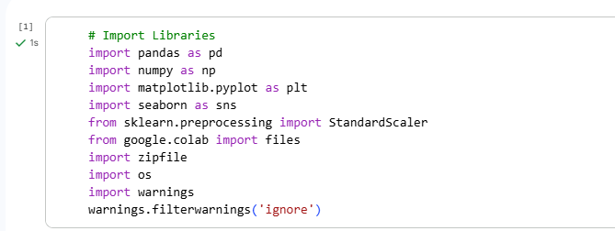

2. csv Uploading and Extracting the Dataset.
The data was supplied in the form of a ZIP file. It was uploaded in Google Colab and was extracted automatically. The CSV file within the ZIP was then recognized and read with the help of Pandas after extraction.
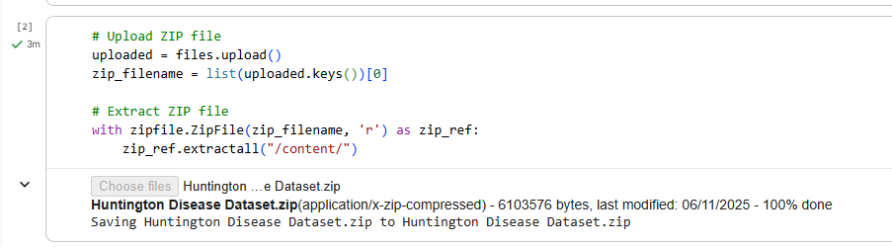

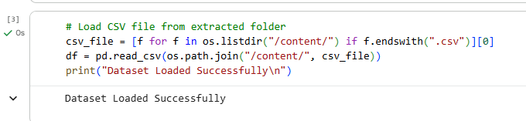

3. Initial Dataset Inspection
The initial review of the dataset was conducted in order to get a glimpse of its structure. This involved verifying the rows and the columns, data types, first and last few samples, missing, and duplicate rows. This action assists in determining the problem of data quality and the character of variables.
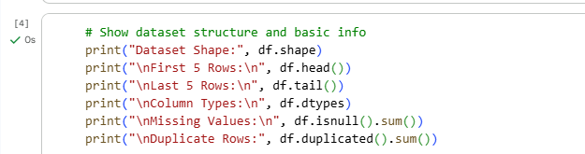

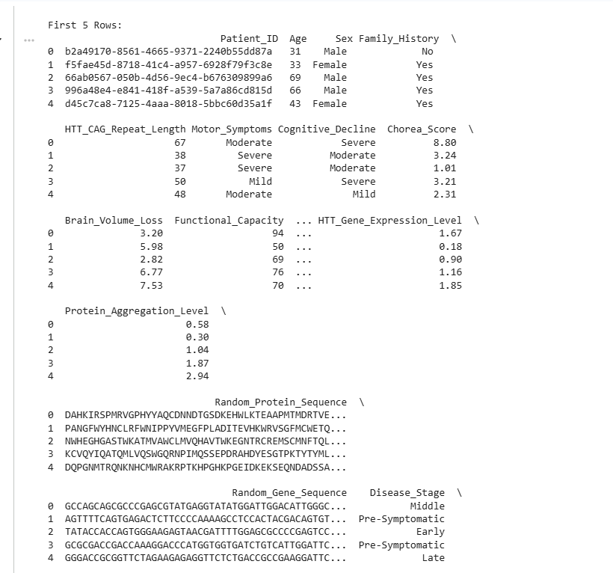

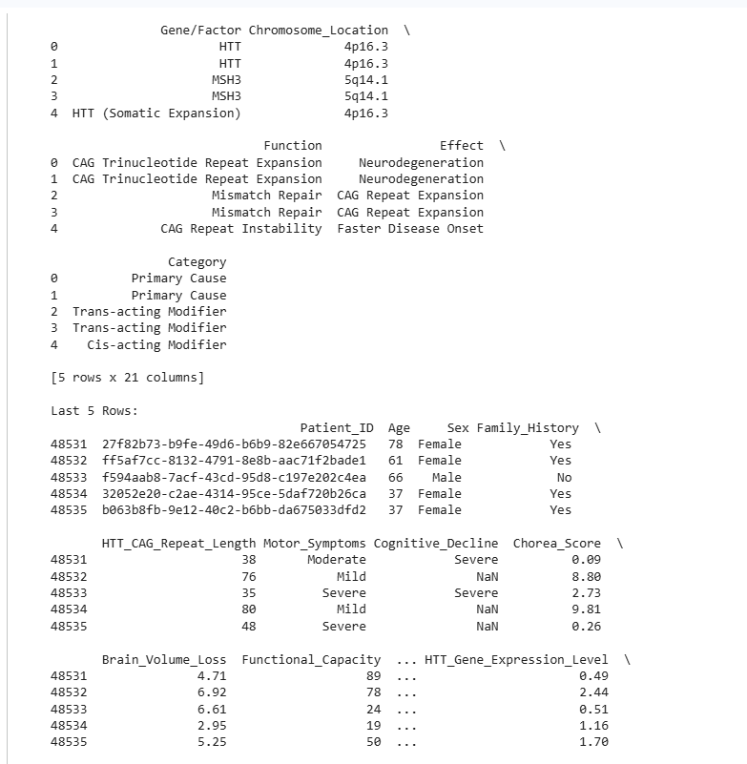

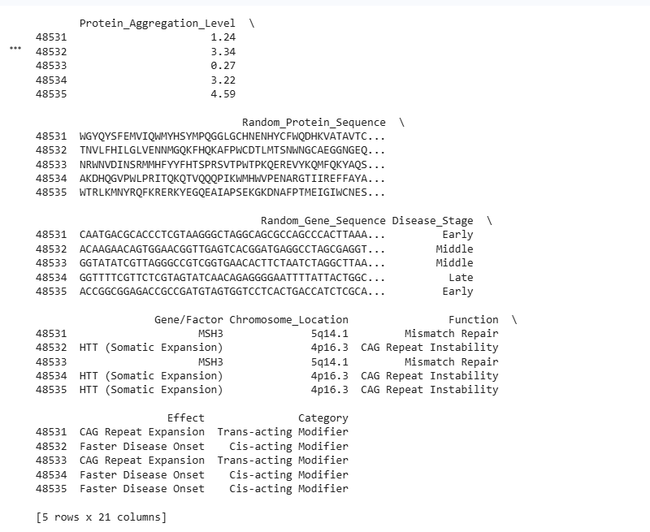

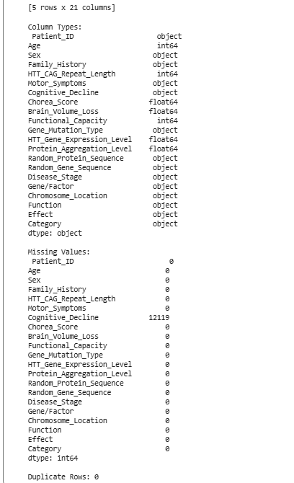

4. Removing Duplicate Records
There were duplicate entries that were eliminated to eliminate biased model training and wrong statistical analysis. Keeping distinct data is a guarantee of reliability and accuracy of the model.
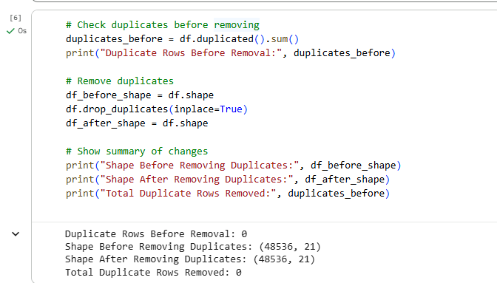

5. Determining Numeric and Categorical Columns.
The data were separated into numerical and nominal variables. This categorization is significant as the various preprocessing methods are incorporated to these two types of data.
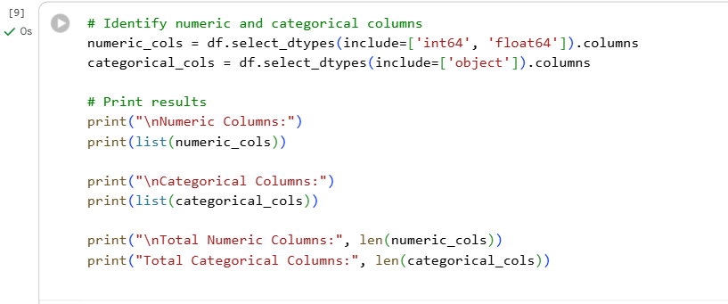

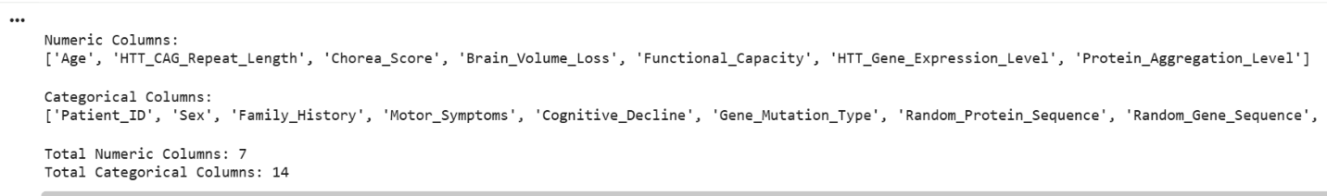

6. Handling Missing Values
The absence of values was dealt with differently based on the type of column:
Numeric columns: they are replaced by the median that reduces the effects of the extreme values. Categorical columns: The mode that preserves the most repeated category has been used in place of categorical columns.This makes sure that there are no gaps in the dataset.
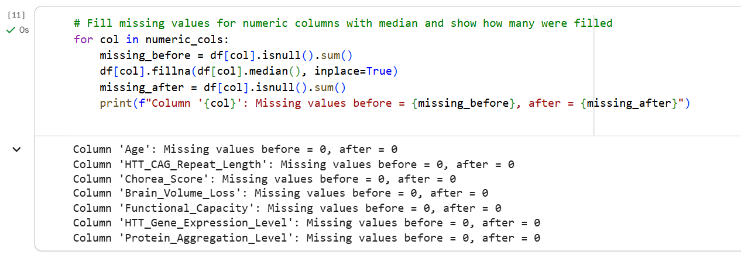

7. Outlier Treatment Using IQR
The Interquartile Range (IQR) technique was used to identify and process outliers. Any values that were below the lower limit or above the upper limit were substituted by boundary limits. This avoids the possibility of extreme values having a negative influence on model performance.

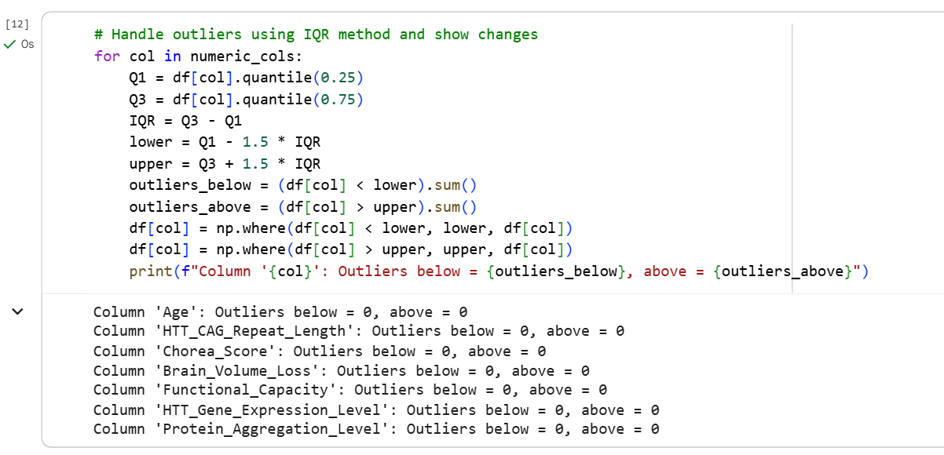

8. Feature Engineering
Age x CAG_repeats produced one new variable called Risk_Score. This characteristic is a composite risk measure of Huntington and can be used to enhance the efficiency of predictions.
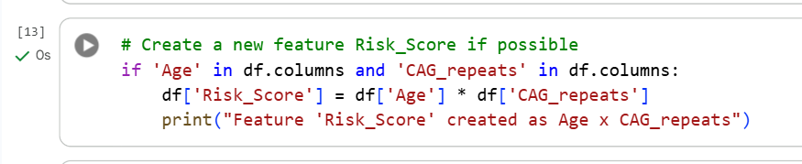

9. Feature Scaling
All the numeric characteristics underwent the StandardScaler, which changes the data so that the means are 0, and the standard deviation is 1. Scaling is used to make sure that each feature has equal input in model training.

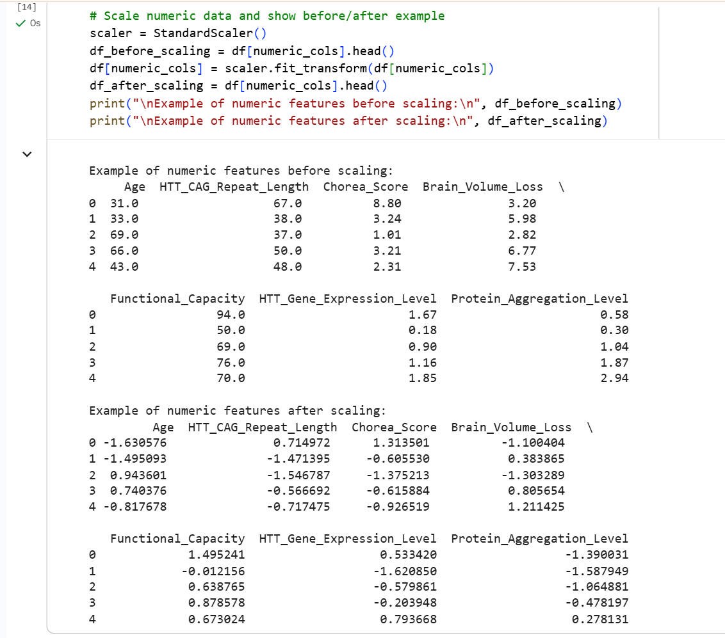

10. Target Variable Detection
The dependent variable was chosen automatically. In case there was a column called Status, it was taken as a target; otherwise, the final column of the dataset was selected.

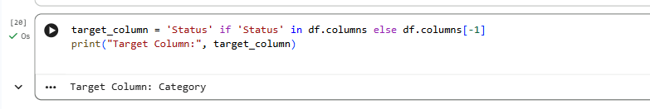

11. Target Class Distribution Visualization.
The distribution of the target variable was plotted in the form of a count plot. This is useful in finding class imbalance that is significant in deriving appropriate ML algorithms.
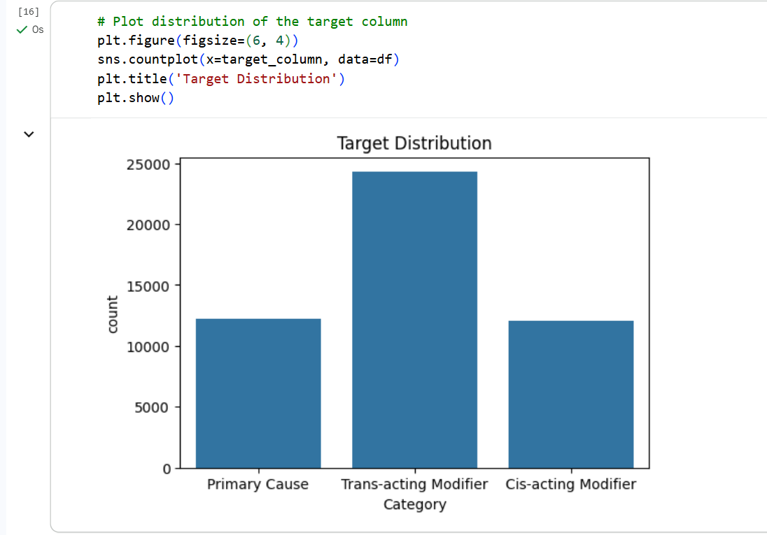

12. Histogram Visualization of Ordinal Features.
All the numerical attributes were produced into histograms to view their distribution, skewness and spread. This gives an idea of the behavior of features prior to model training.

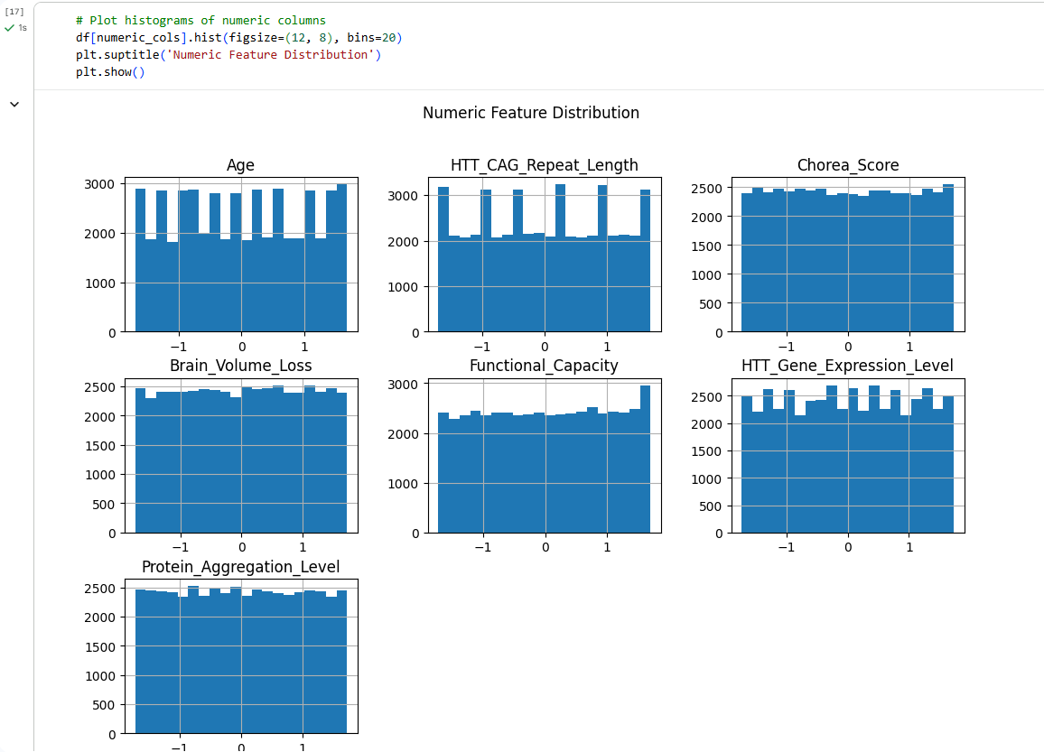

13. Correlation Heatmap
The heatmap to display the correlation between numeric features was created. High correlations mean that there is redundancy, and low correlations emphasize independent variables.
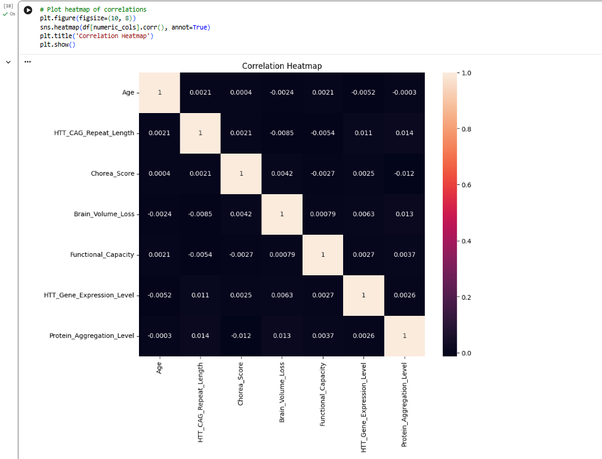

14. Final Cleaned Data Review
The cleaned data was presented to confirm that the preprocessing steps have been done successfully. This makes data modeling friendly.

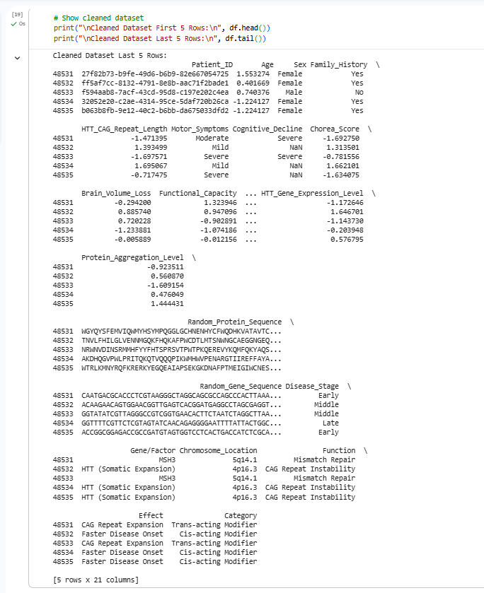

References

[1] | D. Pustinaa, S. Dasb, D. Rozellec, H. J. Johnson, R. I. Scahillg, Sarah J, N. Georgiou-Karistianish, C. Sampaioa and A. Wooda, "Bridging Huntington’s disease research with big data science:Harmonized neuroimaging datasets from multiple studies," 2024.
[2] | R. Jin, W. Deng, M. Chen and X. Li, "Debiased Noise Editing on Foundation Models for Fair Medical Image Classification," 2024.
[3] | Z. Li, Y. Liu, G. Ye, H. Chai, Z. Lu and J. Wu, "Integrating variational autoencoders for privacy preservation and performance retention in federated learning," 2024.
[4] | H. Derouiche, Z. Brahmi and H. Mazeni, "Agentic AI Frameworks: Architectures,Protocols, and Design Challenges," 2025.
[5] | Q. Chen, Q. Fu, H. Bai and Y. Hong, "LongFormer: Longitudinal Transformer for Alzheimer’s Disease Classification with Structural MRIs," 2024.
[6] | P. Dubey , P. Dubey and . P. N. Bokoro, "Federated Learning for Privacy-Enhanced Mental Health Prediction with Multimodal Data Integration," 2025.
[7] | N. Basnin, T. Mahmud , R. Ul Islam and K. Andersson, "An Evolutionary Federated Learning Approach to Diagnose Alzheimer’s Disease Under Uncertainty," 2025.
[8] | D. Dafna Schwartz, L. Lori Quinn, N. E. Fritz, L. M. Muratori, J. M. Hausdorff and R. Ran Gilad Bachrach, "Detecting Daily Living Gait Amid Huntington’s Disease Chorea using a Foundation Deep Learning Model," 2024.
[9] | A. Singh, "Agentic AI in Healthcare: Diagnosis and Treatment," 2025.
[10] | A. Chaddad, Y. Hu, Y. Wu, B. Wen and R. Kateb, "Generalizable and Explainable Deep Learning for Medical Image Computing: An Overview," 2025.
[11] | Y. Zhang, Y. Gao, H. Duan, H. Guo, T. Shah, R. Ranjan and B. Wei, "Federated Tuning with Similarity-guided Collaborative Aggregation for Heterogeneous Medical Image Segmentation," 2025.
[12] | P. Sahoo, A. Tripa, S. Saha and S. Mondal, "FedMRL: Data Heterogeneity Aware Federated Multi-agent Deep Reinforcement Learning for Medical Imaging," 2024.
[13] | J. Feng, Q. Zheng, C. Wu, Z. Zhao, Y. Zhang, Y. Wang and W. Xie, "M3Builder: A Multi-Agent System for Automated Machine Learning in Medical Imaging," 2025.
[14] | K. Meduri, G. Sandeep Nadella, A. Reddy Yadulla, V. Kumar Kasula, M. Harish Maturi, S. Brown, S. Satish and H. Gonaygunta, "Leveraging Federated Learning for Privacy-Preserving Analysis of Multi-Institutional Electronic Health Records in Rare Disease Research," 2025.
[15] | M. Usman, O. Varea, P. I Radeva, J. M Canals, J. Abante and D. Ortiz, "Explainable AI model reveals disease-related mechanisms in single-cell RNA-seq data," 2025.
[16] | A. Maria T˘aut¸an, B. Ionescu and E. Santarnecchi, "Artificial intelligence in neurodegenerative diseases: A review of available tools with a focus on machine learning techniques," 2021.
[17] | S. Dash, S. Padhy, P. Suman, S. Mal, L. Malviya, A. Suman and J. Kishore, "Privacy-Preserving Diabetes and Heart Disease Prediction via Federated Learning and WCO. International Journal of Computational Intelligence Systems," 2025.
[18] | J. Wang and F. Ma, "Federated learning for rare disease detection: a survey," 2023.
[19] | K. Sangeetha, S. Poorniammal, S. Suvitha and C. Nandhini, "Deep Learning Based Detection of Huntington’s Disease Using Convolutional Neural Networks," 2025.
[20] | L. M. Abu Zohair, H. Zantout, M. Vallejo, M. Azher Uddin and A. Mahmoud, "Artificial intelligence and machine learning for the diagnosis of Huntington disease: a narrative review," 2025.
[21] | J. Ouwerkerk, S. Feleus, K. F. van der Zwaan, S. T. Y. Li, M. Roos, W. M. C. Roon-Mom, K. J. Wolstencroft and E. Mina, "Machine learning in Huntington’s disease:exploring the Enroll-HD dataset for prognosis and driving capability prediction," 2023.
[22] | S. Aqel, J. Ahmad, I. Saleh, A. Fathima, A. A. Al Thani, W. M. Y. Mohamed and A. A. Shaito, "Advances in Huntington’s Disease Biomarkers: A 10-Year Bibliometric Analysis and a Comprehensive Review," 2025.
[23] | C. Masscheleina, M. Richerb and P. W. Ayersa, "Optimizing and benchmarking the computation of the permanent of general matrices," 2025.
[24] | P. K. Sharma, A. Aram, Y. Polaka and V. Pandian, "Huntington's Disease: A Report of an Interesting Case and Literature Review," 2024.

