HR ATTRITION ANALYSIS

- Total Employees
SELECT
COUNT(DISTINCT Employee_ID) AS Total_Employees
FROM hr_data;
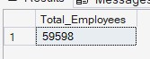
- Attrition Count
SELECT
SUM(CASE
WHEN Attrition = 'Left' THEN 1 ELSE 0
END) AS Attrition_Count
FROM hr_data;
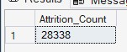
- Average Job Satisfaction
SELECT
AVG(Satisfaction_Level) AS Avg_Job_Satisfaction
FROM hr_data;
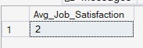
- Attrition Rate
SELECT
ROUND(
COUNT(CASE WHEN Attrition = 'Left' THEN 1 END) * 100.0
/ COUNT(*),
2) AS Attrition_Rate
FROM hr_data;

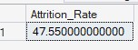
- Attrition By Job Role
SELECT
Job_Role,
COUNT(*) Employees,
SUM(CASE WHEN Attrition='Left' THEN 1 ELSE 0 END) AS Attrition_Count
FROM hr_data
GROUP BY Job_Role
ORDER BY Attrition_Count DESC;
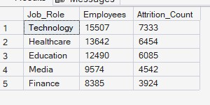
- Attrition By Income
SELECT
Income_Slab,
SUM(CASE WHEN Attrition = 'Left' THEN 1 ELSE 0 END) AS Attrition_Count
FROM hr_data
GROUP BY Income_Slab
ORDER BY Attrition_Count DESC;
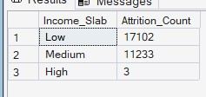
- Attrition By Years at Company
SELECT
Experience_Group,
SUM(CASE WHEN Attrition = 'Left' THEN 1 ELSE 0 END) AS Attrition_Count
FROM hr_data
GROUP BY Experience_Group
ORDER BY Attrition_Count DESC;
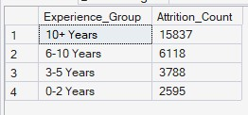
- Salary Ranking
SELECT
Employee_ID,
Monthly_Income,
RANK() OVER(ORDER BY Monthly_Income DESC) Income_Rank
FROM hr_data;
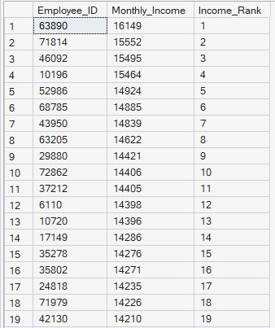
- Highly Paid Employees
SELECT
Employee_ID,
Monthly_Income
FROM hr_data
WHERE Monthly_Income > (
SELECT AVG(Monthly_Income) FROM hr_data);
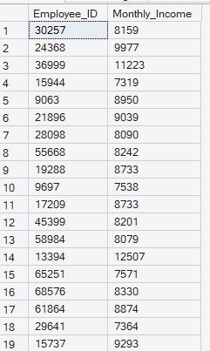
- Job Satisfaction Vs Attrition
SELECT
Job_Satisfaction,
SUM(CASE WHEN Attrition = 'Left' THEN 1 ELSE 0 END) AS Attrition_Count
FROM hr_data
GROUP BY Job_Satisfaction
ORDER BY Attrition_Count DESC;
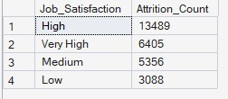
- Work-Life Balance Vs Attrition
SELECT
Work_Life_Balance,
SUM(CASE WHEN Attrition = 'Left' THEN 1 ELSE 0 END) AS Attrition_Count
FROM hr_data
GROUP BY Work_Life_Balance
ORDER BY Attrition_Count DESC;
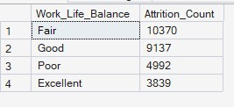
- Attrition By Performance Rating
SELECT
Performance_Rating,
SUM(CASE WHEN Attrition = 'Left' THEN 1 ELSE 0 END) AS Attrition_Count
FROM hr_data
GROUP BY Performance_Rating
ORDER BY Attrition_Count DESC;
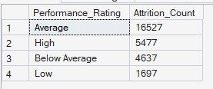
- Attrition By Promotions
SELECT
Number_of_Promotions,
SUM(CASE WHEN Attrition = 'Left' THEN 1 ELSE 0 END) AS Attrition_Count
FROM hr_data
GROUP BY Number_of_Promotions
ORDER BY Attrition_Count DESC;
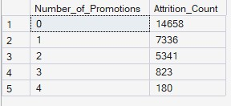
- Attrition Vs Employee Recognition
SELECT
Employee_Recognition,
SUM(CASE WHEN Attrition = 'Left' THEN 1 ELSE 0 END) AS Attrition_Count
FROM hr_data
GROUP BY Employee_Recognition
ORDER BY Attrition_Count DESC;
