Customer Sales & Retention Analysis (E-Commerce Dataset)

Business Requirements:
- Revenue Analysis
- Total revenue generated
- Monthly revenue trend
- City generating highest revenue
- Customer Performance
- Top 3 customers by spending
- Customer revenue contribution %
- Latest order per customer
- Retention Behaviour
- Customers with purchase gap > 30 days
- Repeat vs one-time customers

SQL Queries:
- Total revenue generated
SELECT
SUM(amount) AS total_revenue
FROM orders;
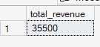
- Monthly revenue trend
SELECT
FORMAT(order_date,'yyyy-MM') AS year_month,
SUM(amount) AS revenue
FROM orders
GROUP BY FORMAT(order_date,'yyyy-MM')
ORDER BY year_month;
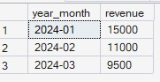

- City generating highest revenue
SELECT
TOP 1
c.city,
SUM(o.amount) AS highest_revenue
FROM customers AS c
INNER JOIN orders AS o
ON c.customer_id = o.customer_id
GROUP BY c.city
ORDER BY SUM(o.amount) DESC;
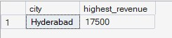
- Top 3 customers by spending
SELECT
TOP 3
customer_id,
SUM(amount) AS customer_spent
FROM orders
GROUP BY customer_id
ORDER BY customer_spent DESC;
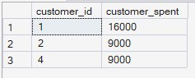
- Customer revenue contribution %
SELECT
order_id,
amount,
ROUND(amount * 100.0 / SUM(amount) OVER(),2) AS revenue_pct
FROM orders;
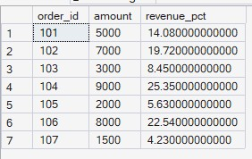
- Latest order per customer
SELECT
customer_id,
order_id,
order_date,
amount
FROM (
SELECT
customer_id,
order_id,
order_date,
amount,
ROW_NUMBER() OVER(
PARTITION BY customer_id
ORDER BY order_date DESC
) AS rn
FROM orders
) t
WHERE rn = 1
ORDER BY customer_id;
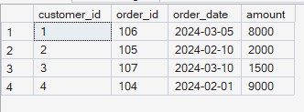
- Customers with purchase gap > 30 days
SELECT *
FROM
(SELECT
customer_id,
order_id,
amount,
DATEDIFF(
DAY,
LAG(order_date) OVER (PARTITION BY customer_id ORDER BY order_date),
order_date
) AS days_gap
FROM orders) AS t
WHERE days_gap > 30;
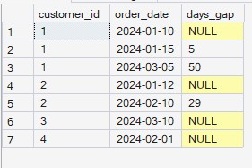
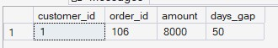
- Repeat vs one-time customers
SELECT
customer_id,
COUNT(order_id) AS total_orders,
CASE
WHEN COUNT(order_id) > 1 THEN 'Repeat Customer'
ELSE 'One-time Customer'
END AS customer_type
FROM orders
GROUP BY customer_id
ORDER BY total_orders DESC;
