# Assignment - 1

Setup a wired LAN using Layer 2 switch and then IP switch of minimum four computers. It includes preparation of cable, testing of cable using line tester, configuration machine using IP address, testing using *ping* and demonstrate using *ping* packets captured traces using Wireshark Packet Analyzer Tool.

7358 Umang Kumar

# Demonstration - 1

Connect Two Computers using Cross-Over Cable and capture the traces of ping command using Wireshark Protocol Analyser.

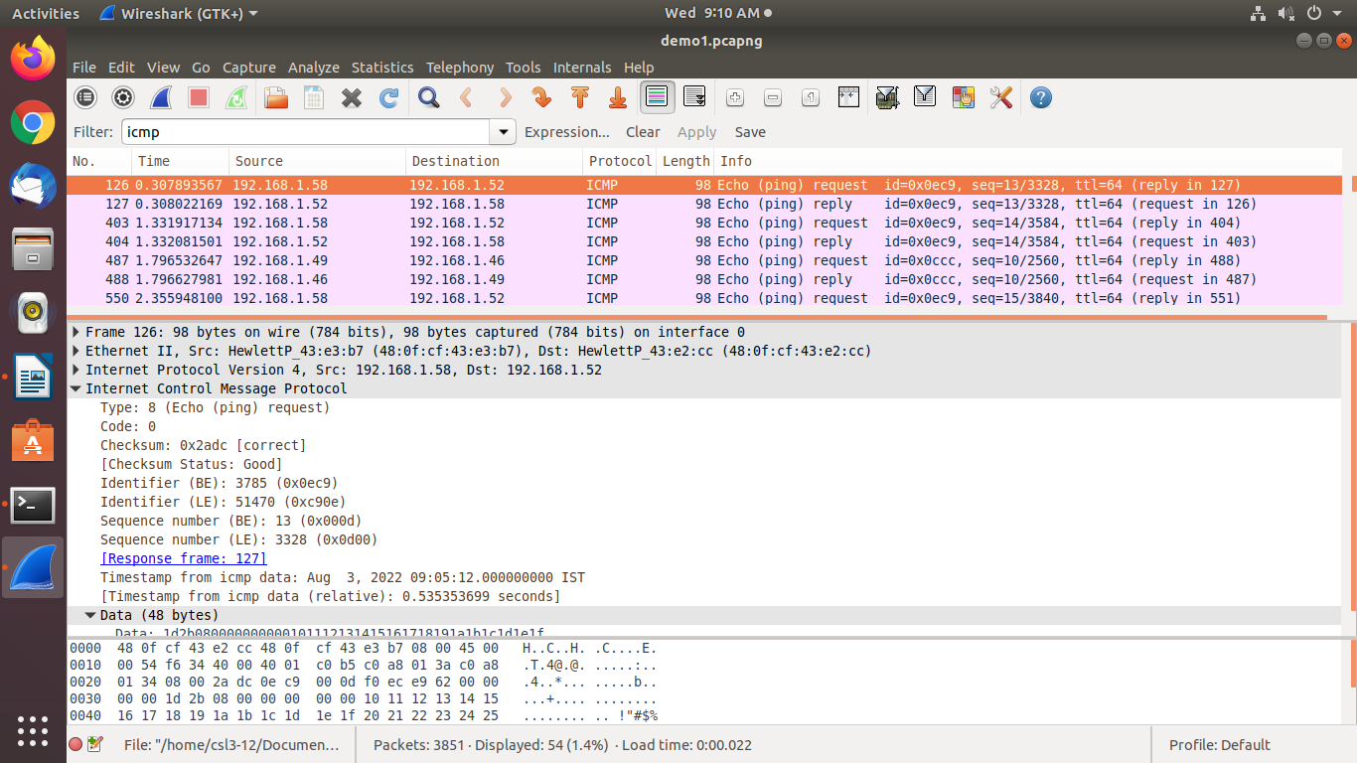  
Fig 1: Traces of ping using Wireshark

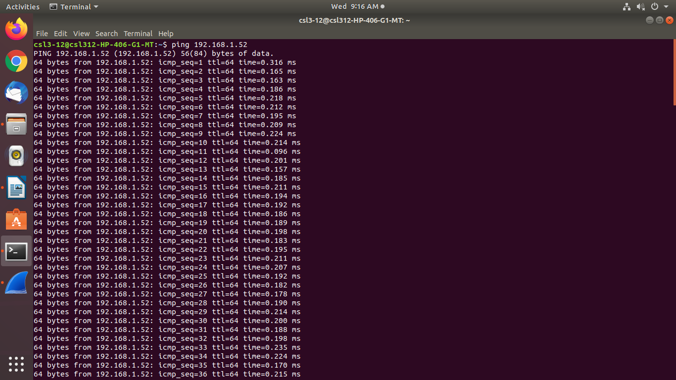  
Fig 2: ping command

# Demonstration – 2

Setting up LAN using Straight-Through Cable, test the connectivity’s using ping 192.168.1.X, and capture traces of ping using Wireshark Packet Analyser.

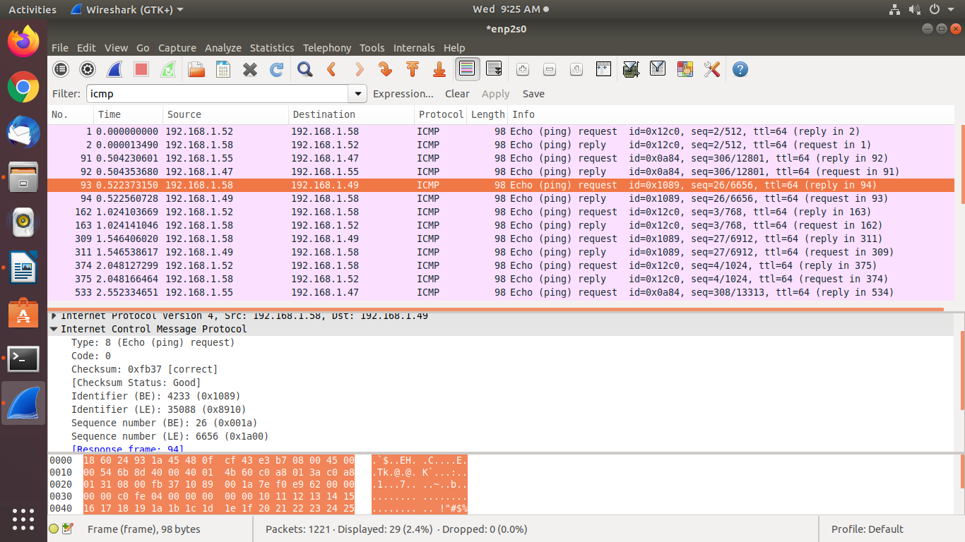  
Fig 3: Traces of ping using Wireshark, Demo_2

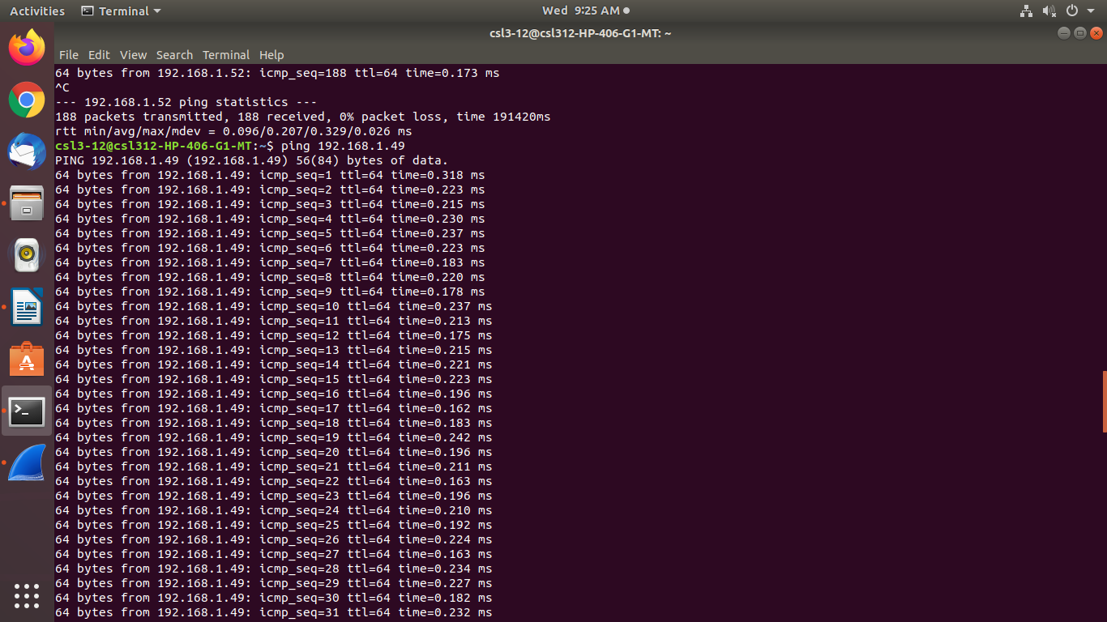

Fig 4: ping multiple IP's

# Demonstration – 3

Test the Web Server by accessing web pages stored on server from client and capture the traces of HTTP, TCP, IP and ethernet-2 using Wireshark.

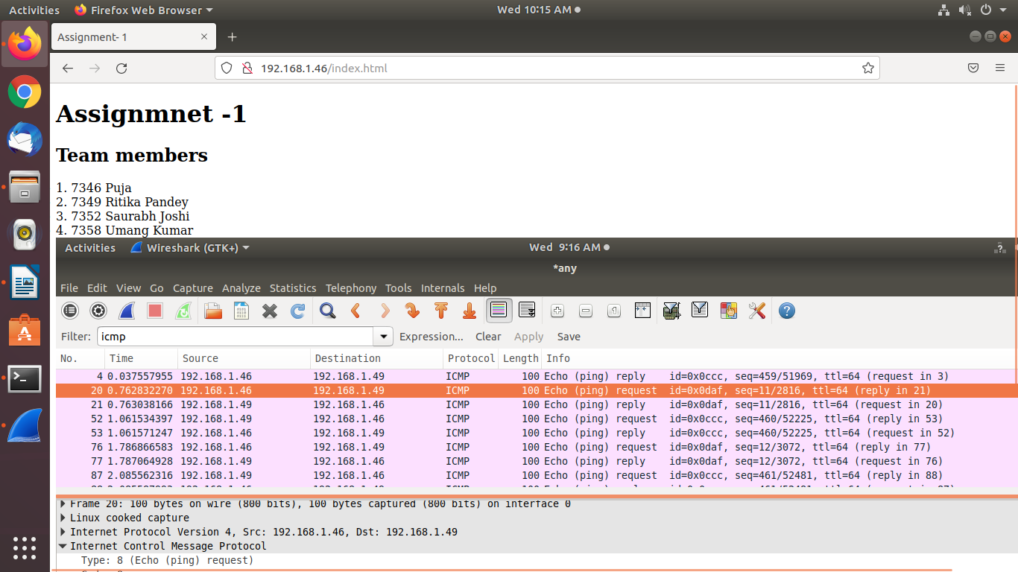  
Fig 5: Webpage by Team

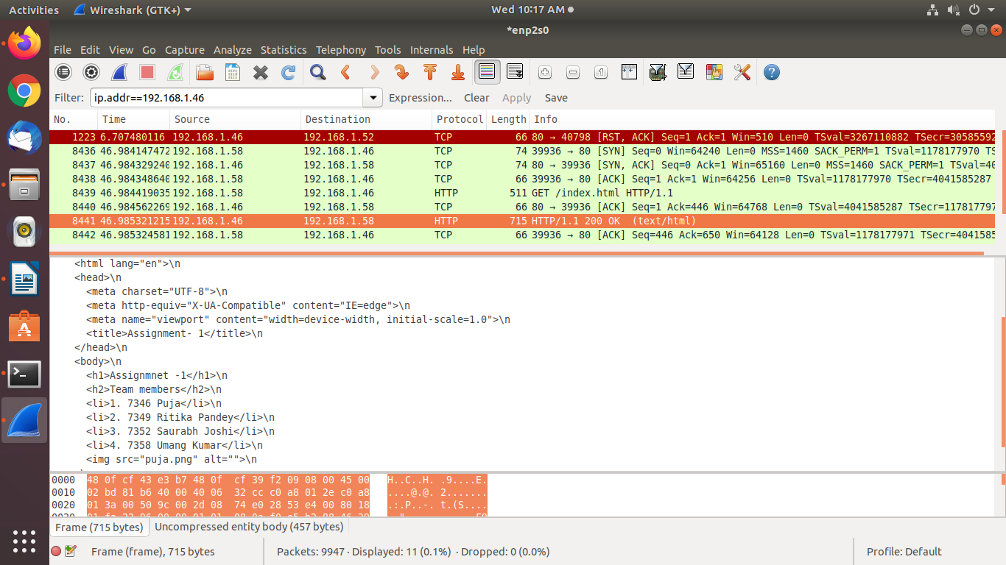  
Fig 6: Accessing webpage through Wireshark