**CNS ASSIGNMENT 11**

Study and Analyze the performance of DHCP, Email, HTTP, HTTPS and FTP Protocol using Packet tracer tool.

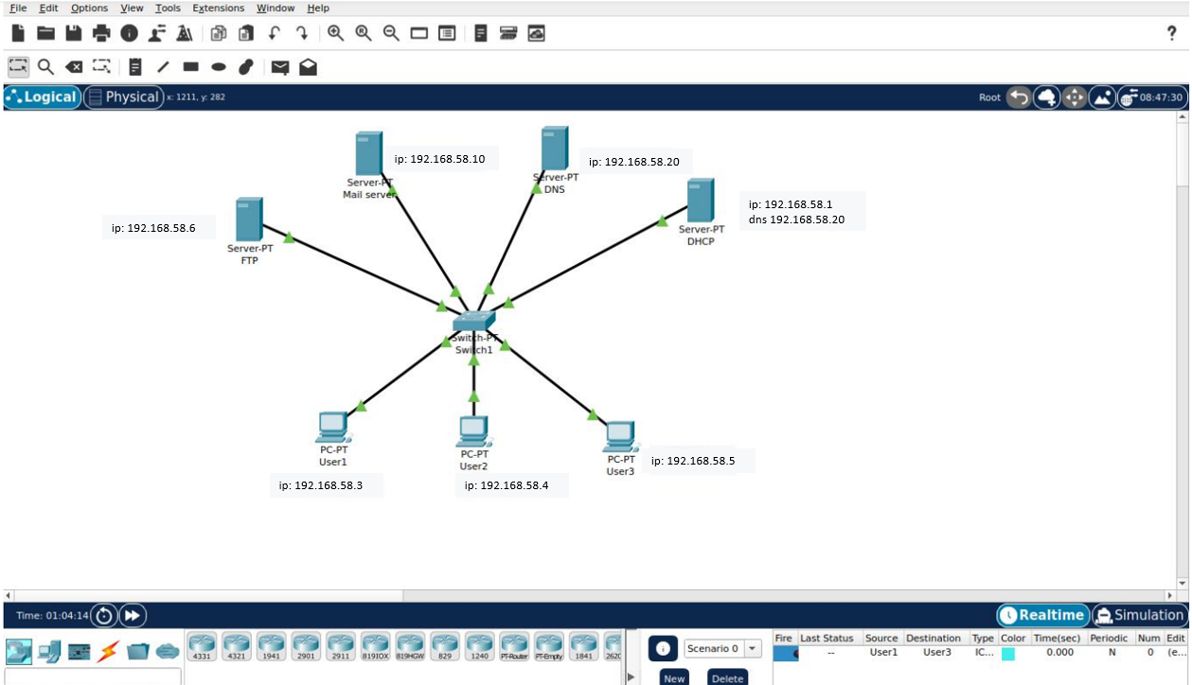

CONFIGURING DHCP SERVER:

First allot an Ip address to Dhcp server and Dns server as well. And after that a lot IP address to Other devices with help of DHCP server.

Configuring DNS Server:

Configuring Email Server:

First Give IP Address to the Email server with the help of DHCP Server.

After give a Domain name and register some users for the users.

Switch on the ports for the email service in Email server and configure users in the respective devices using this allotted usernames and passwords.

Compose mail in one device and send it to other user.

Receive the mail in the other user.

Configuring FTP Server:

First set up IP Address of the FTP Server using DHCP server.

Switch on the FTP service in the server and set up a User and give all

permissions for transfer of file.

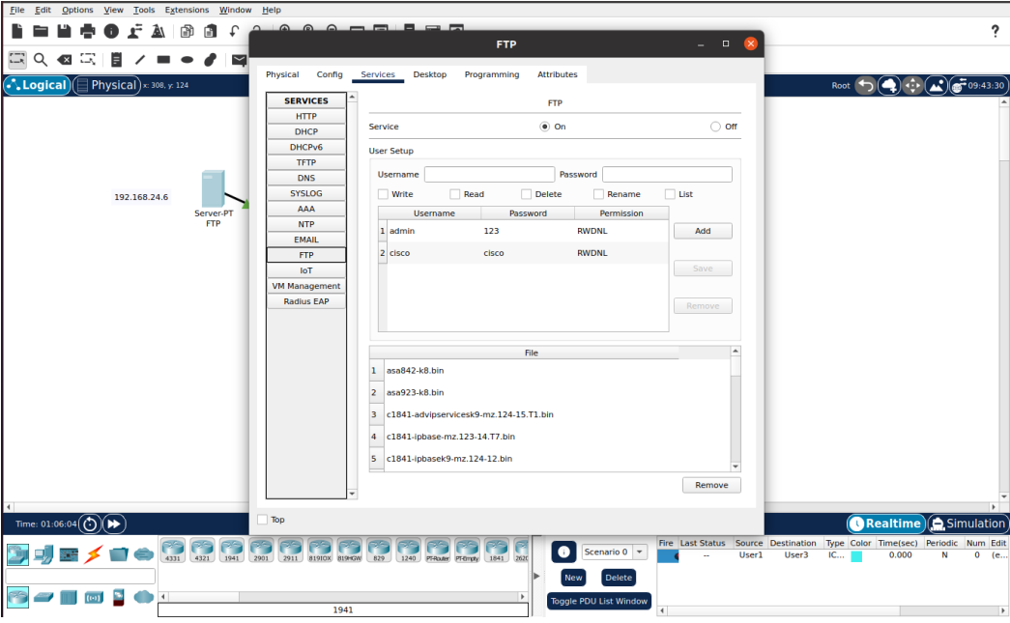

TEST CONNECTIVITY:

Create a file in one device

