**Practical Assignment – 2: Network Topologies**

7358 | Umang Kumar | 10 August 2022

**Demonstration 1: Star Topology**

In the star topology, all the computers connect with the help of a hub. This cable is called a central node, and all other nodes are connected using this central node. It is most popular on LAN networks as they are inexpensive and easy to install.

With Hub: With Switch:

Figure 1

**Advantages:**

• Easy to troubleshoot, set up, and modify.

• Only those nodes are affected, that has failed. Other nodes still work.

• Fast performance with few nodes and very low network traffic.

• In Star topology, addition, deletion, and moving of the devices are easy.

**Disadvantages:**

• If the hub or concentrator fails, attached nodes are disabled.

• Cost of installation of star topology is costly.

• Heavy network traffic can sometimes slow the bus considerably.

• Performance depends on the hub’s capacity.

• A damaged cable or lack of proper termination may bring the network down.

**Steps Implementing Star Topology using Cisco Packet Tracer:**

Step 1: Take a Hub/Switch and link it to four end devices.

Step 2: Provide the IP address to each device.

Step 3: Transfer message from one device to another and check the Table for Validation.

1. **With Hub**

Screenshots of Star Topology Simulation, using Hub. (Packet transfer from 192.168.58.1 to 192.168.58.3)

|  |  |
| --- | --- |
|   *Figure 2* | |
| Graphical user interface, application  Description automatically generated  Figure 3 | |
| Graphical user interface, application  Description automatically generated  Figure 4 | |
| Graphical user interface, application  Description automatically generated  Figure 5 | |
|  |  |

**Simulation Panel**

Screenshot of Simulation Panel, for the above implemented topology.

Figure 6

**IP Addresses**

IP configurations of the devices used for demonstration.

|  |  |
| --- | --- |
| Figure 7 | Graphical user interface, text, application, email  Description automatically generated  Figure 8 |

|  |  |
| --- | --- |
| Figure 9 | Figure 10 |

**Ping**

Screenshot of Star Topology Simulation, using ping. (Packet transfer from 192.168.58.1 to 192.168.58.4)

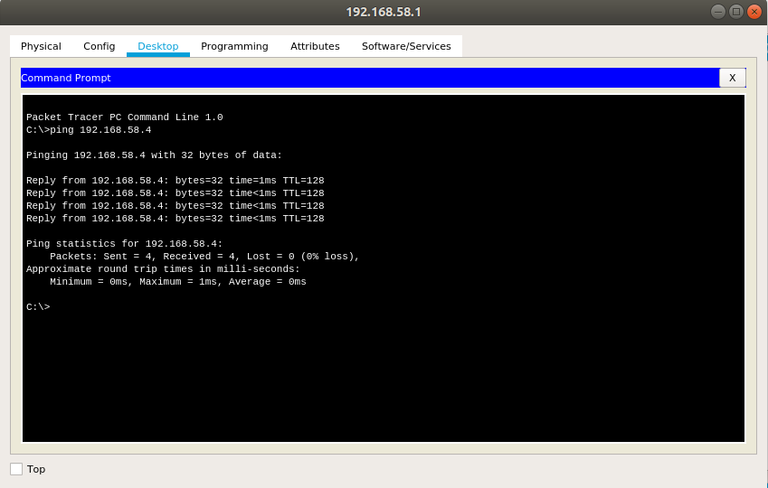

Figure 11

1. **With Switch**

Screenshots of Star Topology Simulation, using Switch. (Packet transfer from 192.168.58.5 to 192.168.58.8).

|  |
| --- |
| Figure 12 |
| Figure 13 |
| Figure 14 |
| Figure 15 |
| Figure 16 |
| Figure 17 |
| Figure 18 |
| Figure 19 |
| Figure 20 |

**Simulation Panel**

Screenshot of Simulation Panel, for the above implemented topology.

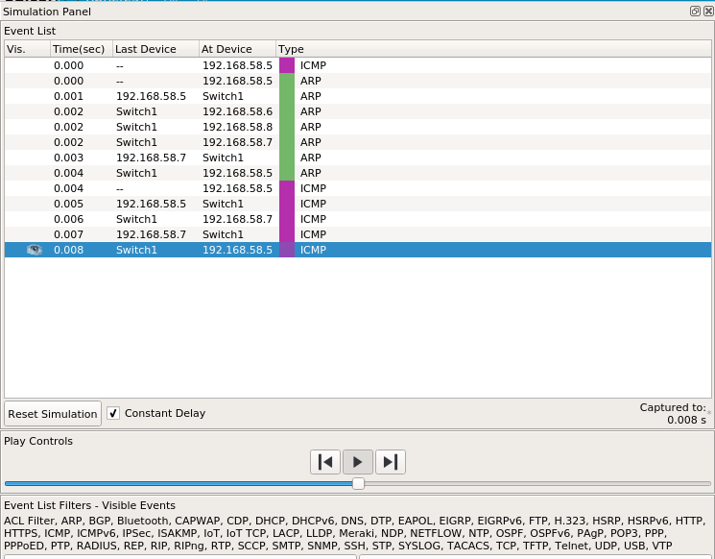

Figure 21

**IP Addresses**

IP configurations of the devices used for demonstration.

|  |  |
| --- | --- |
| Graphical user interface, text, application, email  Description automatically generated  Figure 22 | Graphical user interface, text, application, email  Description automatically generated  Figure 23 |

|  |  |
| --- | --- |
| Figure 24 | Figure 25 |

**Demonstration 2: Bus Topology**

Bus topology uses a single cable which connects all the included nodes. The main cable acts as a spine for the entire network. One of the computers in the network acts as the computer server. When it has two endpoints, it is known as a linear bus topology.

Figure 26

**Advantages:**

* Cost of the cable is very less as compared to other topology, so it is widely used to build small networks.
* Famous for LAN network because they are inexpensive and easy to install.
* It is widely used when a network installation is small, simple, or temporary.
* It is one of the passive topologies. So, computers on the bus only listen for data being sent, that are not responsible for moving the data from one computer to others.

**Disadvantages:**

* In case if the common cable fails, then the entire system will crash down.
* When network traffic is heavy, it develops collisions in the network.
* Whenever network traffic is heavy, or nodes are too many, the performance time of the network significantly decreases.
* Cables are always of a limited length.

**Steps Implementing Bus Topology using Cisco Packet Tracer:**

* Step 1: Take four switches and connect them to create the main cable.
* Step 2: Link every device with the main cable via switch.
* Step 3: Provide the IP address to each device.
* Step 4: Transfer message from one device to another and check the Table for Validation.

Screenshots of Bus Topology Simulation. (Packet transfer from 192.168.58.1 to 192.168.58.3)

|  |  |
| --- | --- |
| Figure 27 |  |
| Figure 28 |  |
| Figure 29 |  |
| Figure 30 |  |
| Figure 31 | |
| Figure 32 | |
| Figure 33 | |
| Diagram  Description automatically generated  Figure 34 | |

**Simulation Panel**

Screenshots of Simulation Panel, for the above implemented topology.

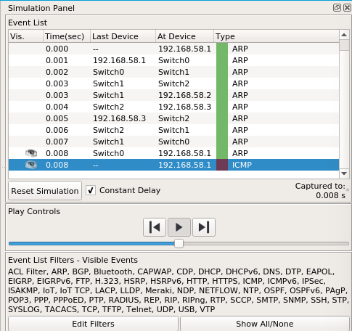

Figure 35

**IP Addresses**

IP configurations of the devices used for demonstration.

|  |  |
| --- | --- |
| Graphical user interface, text, application, email  Description automatically generated  Figure 36 | Figure 37 |

|  |  |
| --- | --- |
| Graphical user interface, text, application, email  Description automatically generated  Figure 38 | Graphical user interface, text, application, email  Description automatically generatedFigure 39 |

**Demonstration 3:**

Ring Topology In a ring network, every device has exactly two neighbouring devices for communication purpose. It is called a ring topology as its formation is like a ring. In this topology, every computer is connected to another computer. Here, the last node is combined with a first one. This topology uses token to pass the information from one computer to another. In this topology, all the messages travel through a ring in the same direction.

Figure 40

**Advantages:**

* Easy to install and reconfigure.
* Adding or deleting a device in-ring topology needs you to move only two connections.
* Offers equal access to all the computers of the networks.
* Faster error checking and acknowledgment.

**Disadvantages:**

* Unidirectional traffic.
* Break in a single ring can risk the breaking of the entire network.
* In the ring, topology signals are always circulating, which develops unwanted power consumption.
* It is very difficult to troubleshoot the ring network.
* Adding or removing the computers can disturb the network activity.

**Steps Implementing Ring Topology using Cisco Packet Tracer:**

* Step 1: Take four end devices and connect every end device to a different switch.
* Step 2: Link switches in a way such that every switch is connected to two other switches, forming a ring.
* Step 3: Provide the IP address to each device.
* Step 4: Transfer message from one device to another and check the Table for Validation.

Screenshots of Ring Topology Simulation. (Packet transfer from 192.168.58.1 to 192.168.58.3)

|  |  |
| --- | --- |
| Figure 41 | Figure 42 |

|  |  |
| --- | --- |
| Figure 43 | Figure 44 |
| Figure 45 | Figure 46 |
| Figure 47 | Figure 48 |

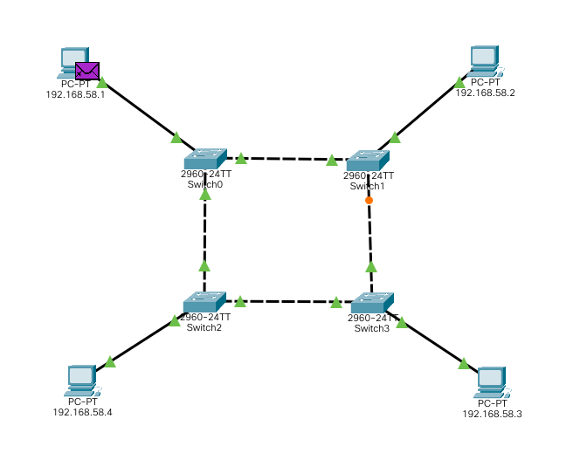

Figure 49

**Simulation Panel**

Screenshots of Simulation Panel, for the above implemented topology.

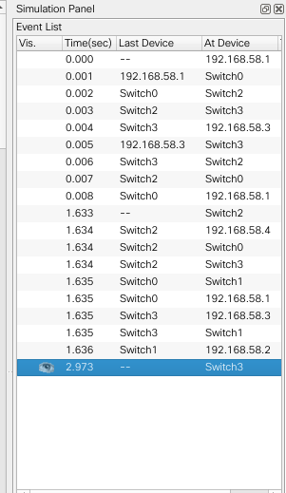

Figure 50

**IP Addresses**

IP configurations of the devices used for demonstration.

|  |  |
| --- | --- |
| Graphical user interface, text, application, email  Description automatically generated  Figure 51 | Graphical user interface, text, application, email  Description automatically generated  Figure 52 |

|  |  |
| --- | --- |
| Figure 53 | Figure 54 |

**Demonstration 4: Mesh Topology**

The mesh topology has a unique network design in which each computer on the network connects to every other. It is developing a P2P (point-to-point) connection between all the devices of the network. It offers a high level of redundancy, so even if one network cable fails, still data has an alternative path to reach its destination.

Figure 55

**Advantages:**

* The network can be expanded without disrupting current users.
* No traffic problem as nodes has dedicated links.
* A mesh topology is robust.
* It has multiple links, so if any single route is blocked, then other routes should be used for data communication.
* P2P links make the fault identification isolation process easy.
* Every system has its privacy and security.

**Disadvantages:**

* Installation is complex because every node is connected to every node.
* It is expensive due to the use of more cables. No proper utilization of systems.
* It requires a large space to run the cables.

**Steps Implementing Mesh Topology using Cisco Packet Tracer:**

* Step 1: Take four end devices and connect every end device to a different switch.
* Step 2: Link every switch with every other switch.
* Step 3: Provide the IP address to each device.
* Step 4: Transfer message from one device to another and check the Table for Validation.

Screenshots of Mesh Topology Simulation. (Packet transfer from 192.168.58.30 to 192.168.58.33)

|  |
| --- |
| Figure 56 |
| Figure 57 |
| Figure 58 |
| Figure 59 |
| Figure 60 |
| Figure 61 |

**Simulation Panel**

Screenshots of Simulation Panel, for the above implemented topology.

|  |  |
| --- | --- |
| Figure 62 | Figure 63 |

**IP Addresses**

IP configurations of the devices used for demonstration.

|  |  |
| --- | --- |
| Figure 64 | Figure 65 |
| Figure 66 | Figure 67 |