**Assignment: 07**

**Problem definition**: Use packet Tracer tool for configuration of 3 router network using one of the following protocol RIP/OSPF/BGP.

**Network Topology:**

1. Drag and drop PC from End Devices.

2. Drag and drop switch (2950-24) for each network and router (1841) for each network.

3. Connect the PC and switch using Copper straight through cable in fast ethernet ports of

both PC and switch.

4. Repeat Step 3 to connect switch to router.

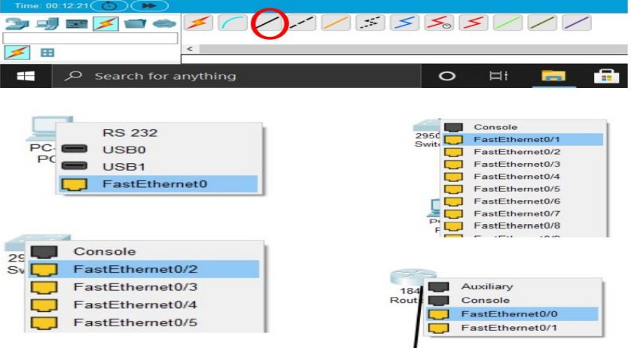

5. As by default not many ports are available on routers, we need to add some extra

serial ports to form the network.

6. To add the serial ports click on the router go to PHYSICAL ----> WIC-2T.

7. Turn off the router by toggling(click) the switch. (FOR ALL ROUTERS)

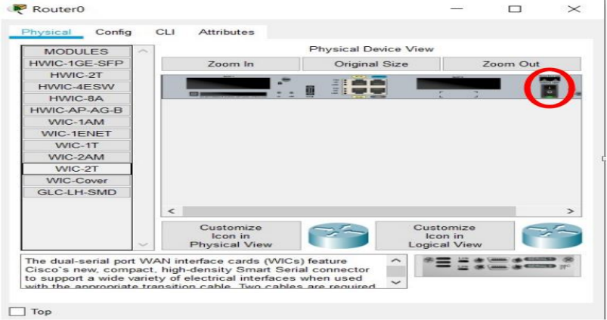

8. Now Drag and drop the ports image from bottom just to the left of switch

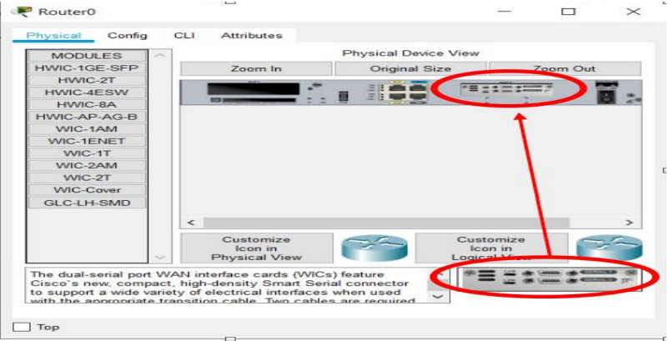

9. Now toggle(click) the switch to turn on the router.

10. Now to connect the routers select the **serial DTE cable** and connect the routers using

the serial ports.

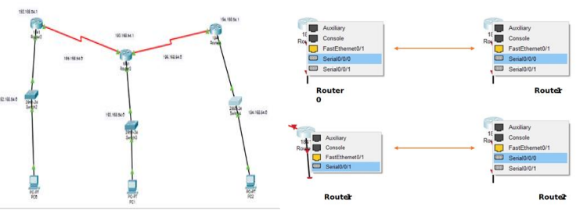

**Ip Address Configuration**

ADDING gateway in router

1. Click on the router.

2. Go to Config ->Fast ethernet 0/0.

3. Then add the gateway for each network in all the routers.

4. Then turn on the port.

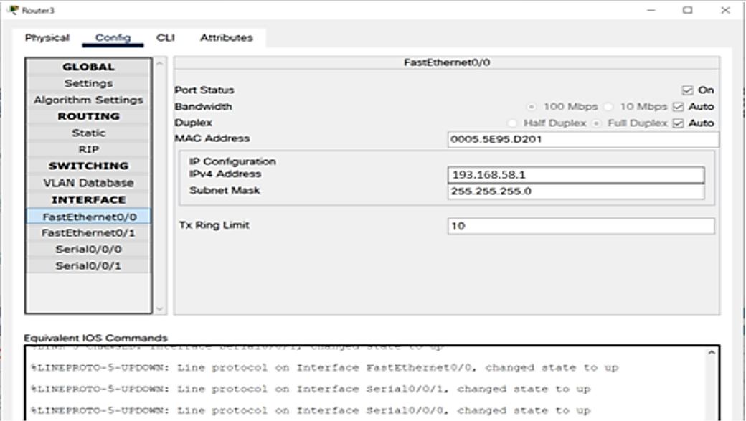

**CONNECTING ROUTERS (SERIAL CONFIG)**

After configuring set the port status on.

1. Assigning Ip’s addresses to the PC

2. Click on the PC.

3. Go to Desktop ->IP configuration.

4. Add the Ip address and the gateway.

**Configuring RIP**

1. Adding networks to communicate between (for each router)

2. Click on the router.

3. Go to Config -> RIP.

4. Add the network Id’s for each network (192.168.58.0, 193.168.58.0, 194.168.58.0,

195.168.58.0, 196.168.58.0).

5. Then click Add.

