**Group B Assignment 4 MongoDB Java Connectivity**

By Umang Kumar, Roll :- 7358

Establishing Connection

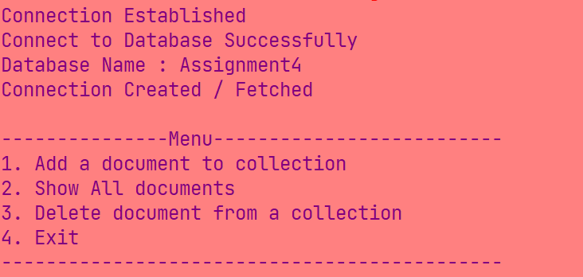

Adding document to a collection

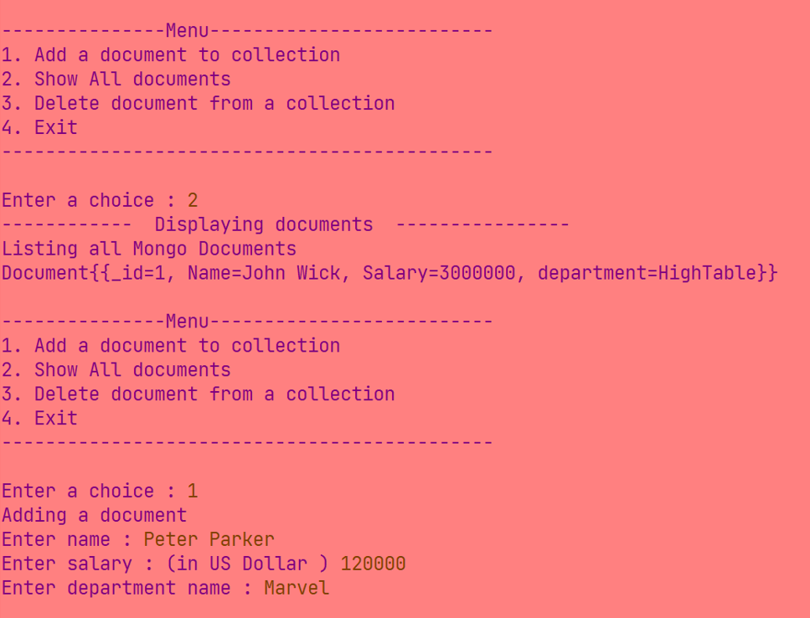

Displaying Documents in collection

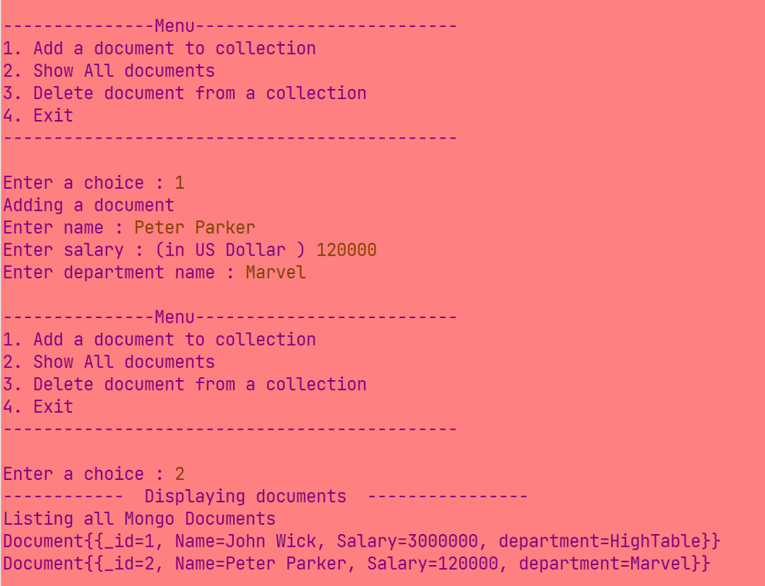

Adding and Displaying Documents

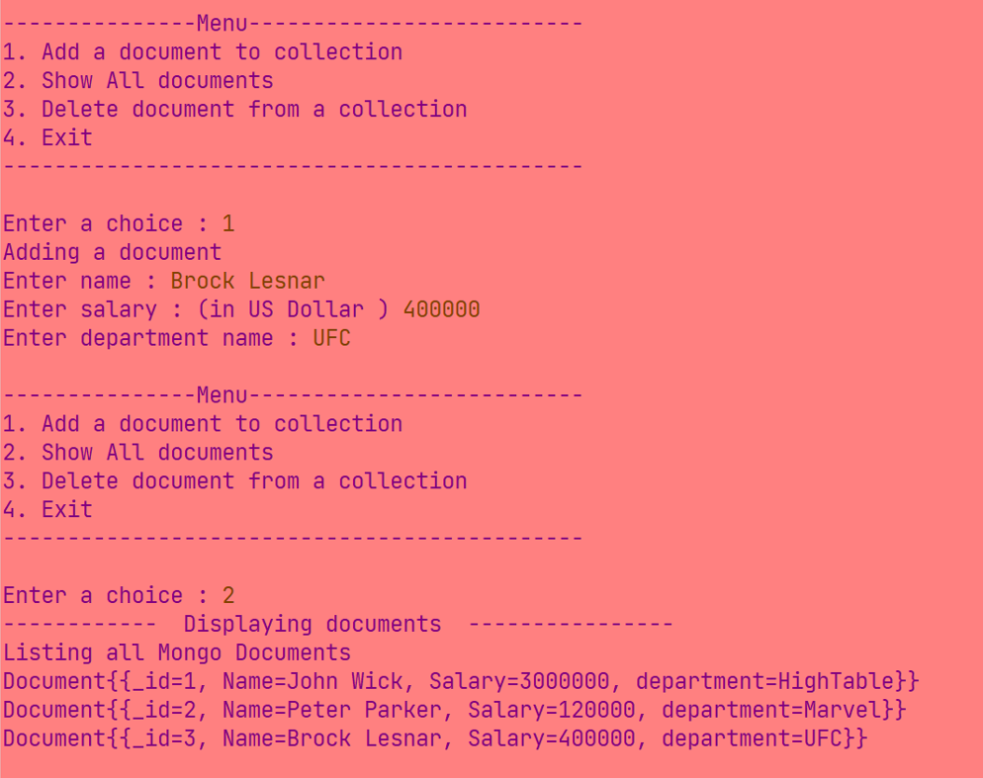

Deleting document from collection

