**1. What are the new tags added in HTML5?**

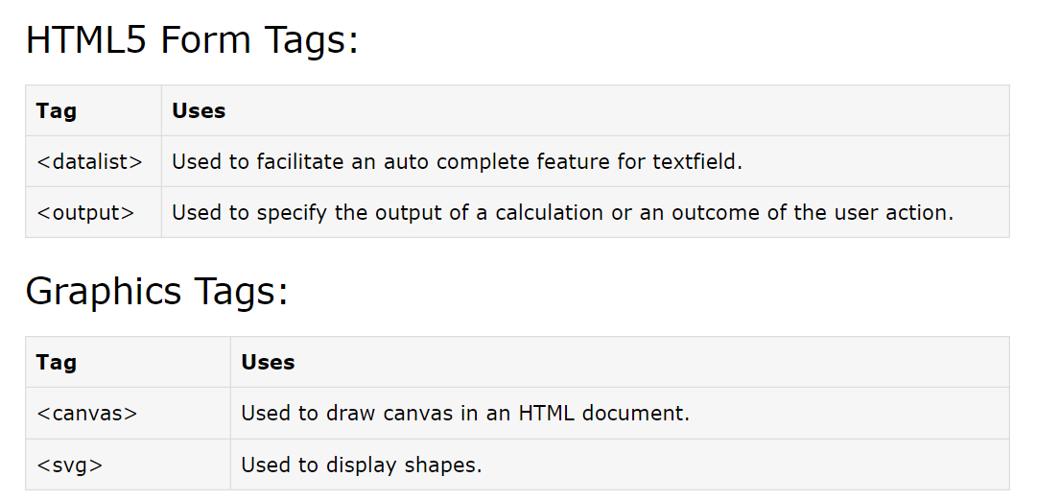

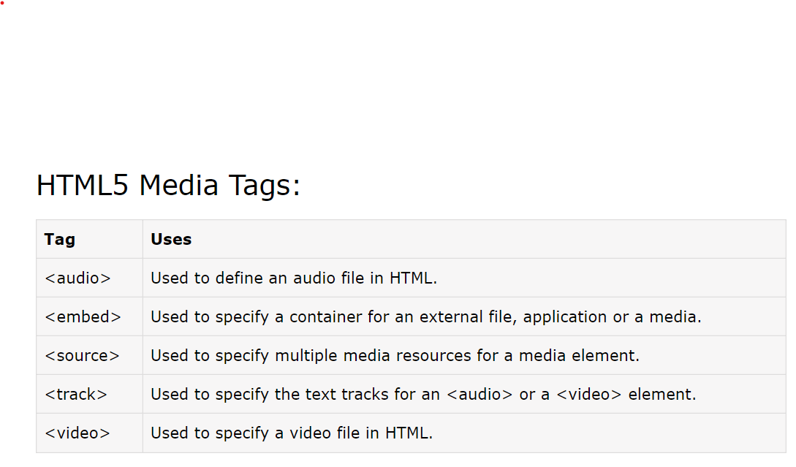

**2. How to embed audio and video in a webpage?**

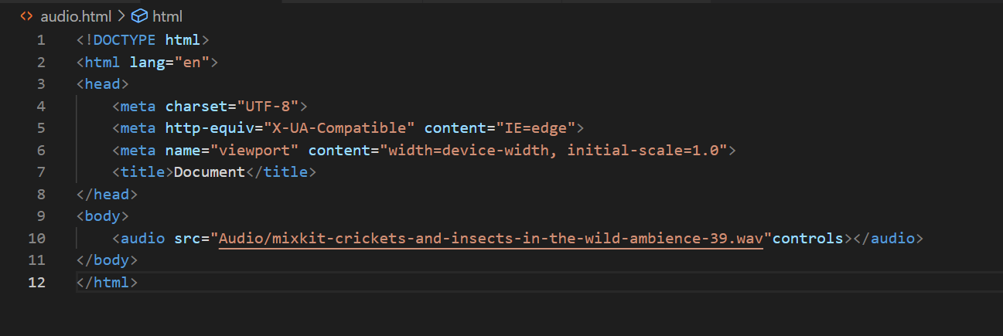

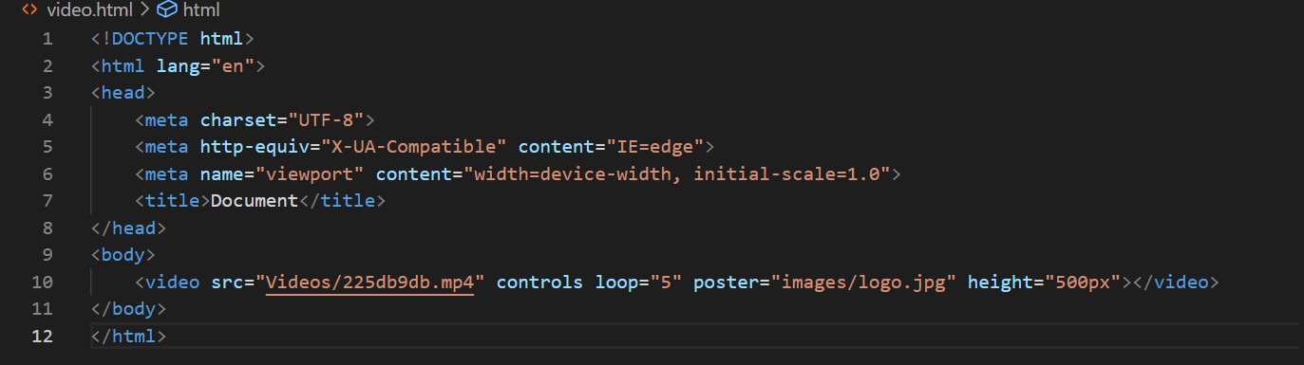

**3. Semantic element in HTML5?**

* <article>
* <aside>
* <details>
* <figcaption>
* <figure>
* <footer>
* <header>
* <main>
* <mark>
* <nav>
* <section>
* <summary>
* <time>

**4. Canvas and SVG tags**

