* **Project :- Resume Scanner**
* A resume scanner is an application that scans all the keywords on a resume to match the skills and qualifications needed for a particular job. Most businesses’ human resources departments today use software known as an Applicant Tracking System which is used to select the right candidates for a particular job.
* Such software scans a document to extract and match the keywords on a resume with the skills and qualifications needed to perform a particular job. This is nothing more than resume scanning and an application used to perform this task is known as a resume scanner.

**Code :-**

* Install and import docx2txt module.

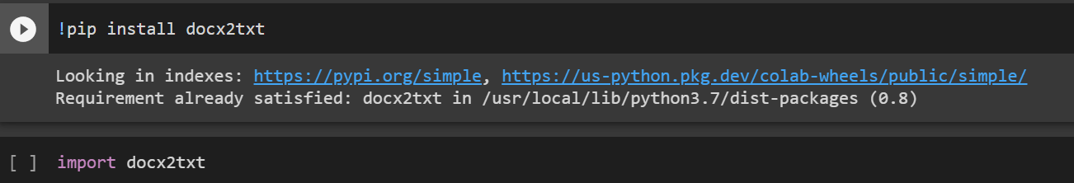

* Add Job description and Resume docx file.

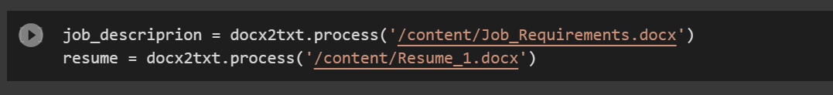

* Print Resume.

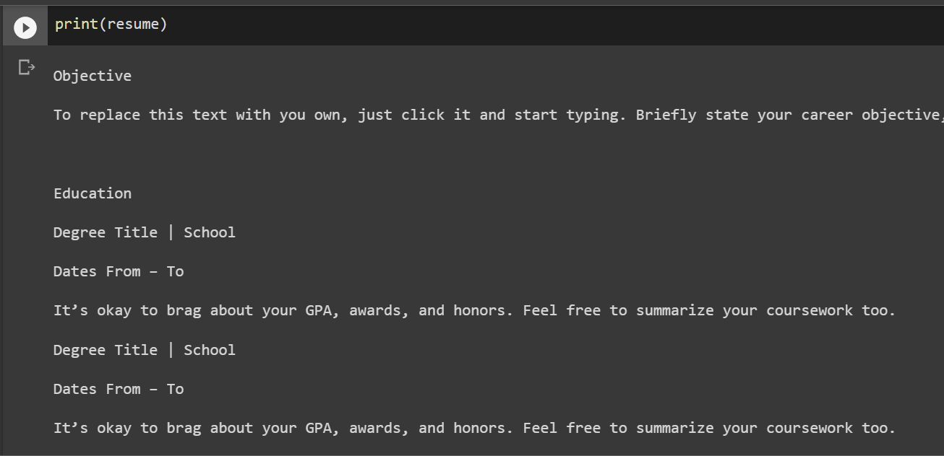

* Create List, function for convert txt to vector form.

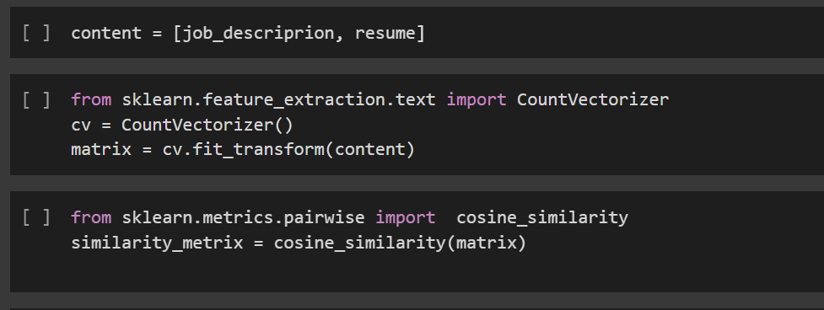

* Final Output of scanning resume.



