Initial phases with using the buttons

This is the initial process where we used buttons to switch between two windows and since it was not possible to switch between them. We ended up using ultrasonic which was even more convenient.

Ultrasonic attached (layout)

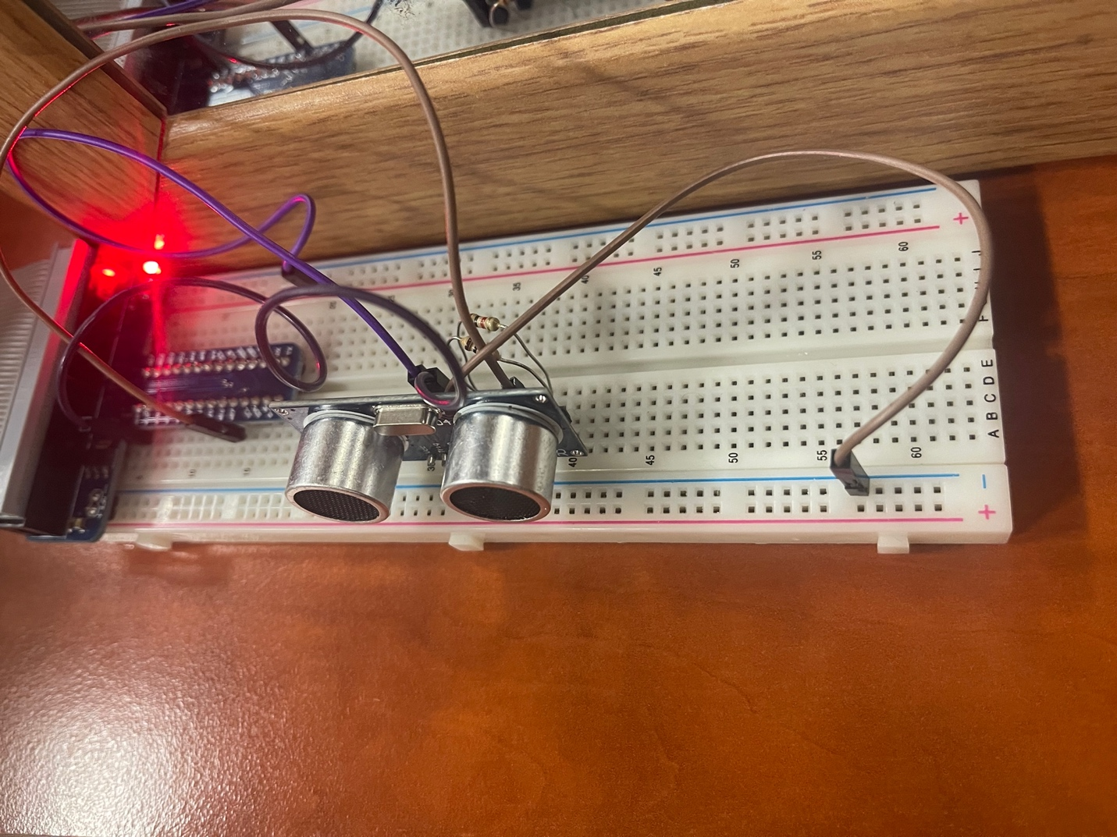

To use the API

Our repository contains some pictures which you will need to run the program. Other than that, everything should be perfectly fine. All the pictures are gif.

Final product

