Lab1-U24AI041
Exercise 1:
Que 1:
Create a table EMPLOYEE with following schema:
(Emp_no, E_name, E_address, E_ph_no, Dept_no, Dept_name,Job_id , Salary)
Query:
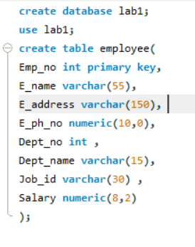
A: Add a new column; HIREDATE to the existing relation.
Query:
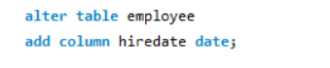
B: Change the datatype of JOB_ID from char to varchar2.
Query:
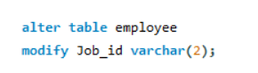
C: Change the name of column/field Emp_no to E_no.
Query:
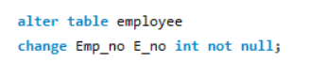
D: Modify the column width of the job field of emp table
Query:
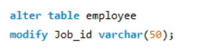
OUTPUT:
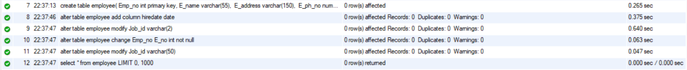
Table:
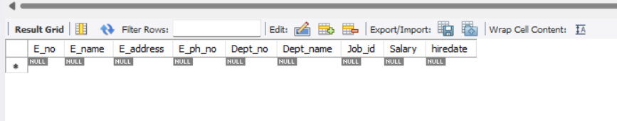
Exercise 2:
Que 1:
1. Create Table “employee”
create table (empid varchar(10) primary key, empname varchar2(20) not null,
gender varchar2(7) not null, age number(3) not null, dept varchar2(15) not null,
dob date not null, doj date not null);
Query:
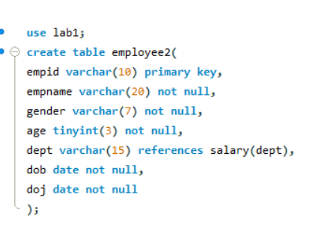
2. Create table “salary”
create table salary (empid varchar(10) references employee(empid), salary
number(10) not null, dept varchar(15) not null, branch varchar2(20) not null);
Query:
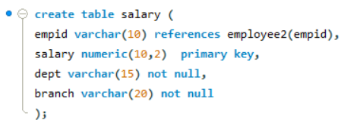
3. Create table “branchtable”
create table branchtable (branch varchar2(20) not null, city varchar2(20) not null);
Query:
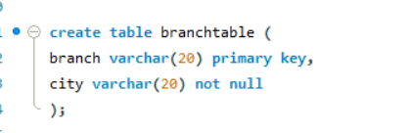
Task:
- Add a new column named designation in the employee table.
Query:
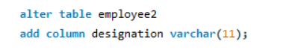

- To drop a column from table salary.
Query:
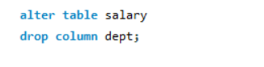

- Rename the table employee to emp.
Query:
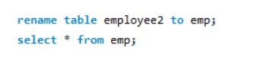
- Display the tables.
Query:

- Perform drop and truncate operations.
Query:
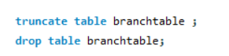
Output:
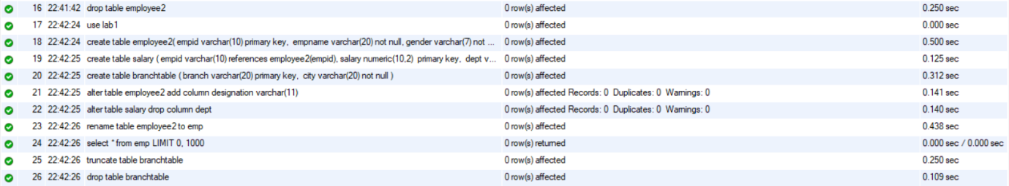
Table:
