Potato Disease Classification Using Machine Learning
A project proposal submitted to Department of Computer Science & IT, in partial fulfilment of the requirements for the degree of Bachelor of Science in Information Technology.

SUBMITTED BY

Umar Farooq
2022-GU-0580

SUBMITTED TO

Sir Muiz-ud-Din

SESSION 2022-2026



Department of Computer Science & IT Ghazi University, Dera Ghazi Khan 2026

1. Introduction
Agriculture plays a critical role in Pakistan’s economy, with potatoes being one of the key crops contributing to food security and farmer livelihoods. Potato plants are highly susceptible to diseases like Early Blight and Late Blight, which can drastically reduce yield if not detected early.
Traditional methods of disease identification rely on manual inspection by farmers or laboratory testing. These approaches are often time-consuming, costly, and error-prone, particularly in rural areas where agricultural expertise is limited.
Advancements in Artificial Intelligence (AI) and Machine Learning (ML) provide a solution. Specifically, Convolutional Neural Networks (CNNs) have proven effective in image classification and can be leveraged to accurately identify plant diseases through leaf images.
The proposed project aims to develop a web and mobile application powered by a CNN model that automatically classifies potato leaf diseases. This system will provide early detection, cost-effective analysis, and easy accessibility, reducing crop losses and supporting sustainable agriculture.

2. Problem Statement
Potato crops face significant threats from diseases, and current methods of identification present several challenges:
- Manual Dependency: Disease detection relies on farmers’ observation, leading to errors.
- Limited Expertise: Farmers in rural areas may lack access to agricultural specialists.
- Delayed Diagnosis: Late identification can lead to crop failure.
- High Costs: Laboratory-based testing is expensive and inaccessible for small-scale farmers.
- Inefficient Crop Management: Lack of timely intervention reduces productivity.
To address these challenges, there is a need for an automated, AI-based system capable of quickly and accurately identifying potato leaf diseases using image analysis.

3. Objectives
The primary goal of this project is to develop an intelligent system for potato disease classification. Specific objectives include:
- Study and analyse common potato leaf diseases (Early Blight, Late Blight, healthy leaves).
- Collect and preprocess a dataset of potato leaf images.
- Train a CNN model to classify diseases accurately.
- Develop a React-based web interface and React Native mobile app for image upload and disease prediction.
- Deploy the backend using FastAPI on Google Cloud for real-time access.
- Evaluate model performance in terms of accuracy, precision, and reliability.
- Provide an accessible, cost-effective, and user-friendly solution for farmers and agricultural professionals.

4. Project Scope
The project focuses on image-based potato disease detection and consists of:
- Automated disease classification: Detect Early Blight, Late Blight, and healthy leaves.
- Supervised learning using CNN: Train a model on labelled leaf images.
- Backend API integration: FastAPI for serving predictions.
- Web & Mobile Interface: React for web, React Native for mobile.
- Real-time results: Instant predictions displayed to the user.
Out of scope:
- IoT or sensor-based field data collection
- Automated pesticide recommendations
- Offline-only mobile solutions (initially)
Future scope:
- Addition of more crops (tomato, wheat, rice)
- Integration with treatment recommendation systems
- Offline-capable mobile apps

5. Methodology
5.1 Data Collection
- Gather images of potato leaves (healthy and diseased) from open datasets (e.g., PlantVillage) and local farms.
- Preprocess images: resizing, normalization, and augmentation (rotation, flipping) to improve model robustness.
5.2 Model Development
- Use CNN architecture (TensorFlow/Keras) for image classification.
- Split dataset into training, validation, and testing sets (80:10:10).
- Evaluate model using accuracy, precision, recall, and F1-score.
5.3 System Development
- Frontend: React for web application, React Native for mobile app.
- Backend: FastAPI serving CNN predictions as REST APIs.
- Database: MongoDB/PostgreSQL to store user queries and predictions.
5.4 Deployment
- Deploy backend and model on Google Cloud Platform (GCP).
- Ensure scalability, fast response times, and security.
5.5 Testing and Evaluation
- Test with real user images for accuracy and usability.
- Measure response times and user satisfaction.

6. System Architecture
Workflow:
- User uploads a leaf image via web or mobile app.
- Backend API (FastAPI) preprocesses the image.
- CNN model predicts disease category.
- Prediction results returned to frontend and displayed to the user.
Key Components:
- Frontend: React, React Native
- Backend API: FastAPI
- Machine Learning: CNN (TensorFlow/Keras)
- Database: MongoDB/PostgreSQL
- Cloud Deployment: Google Cloud
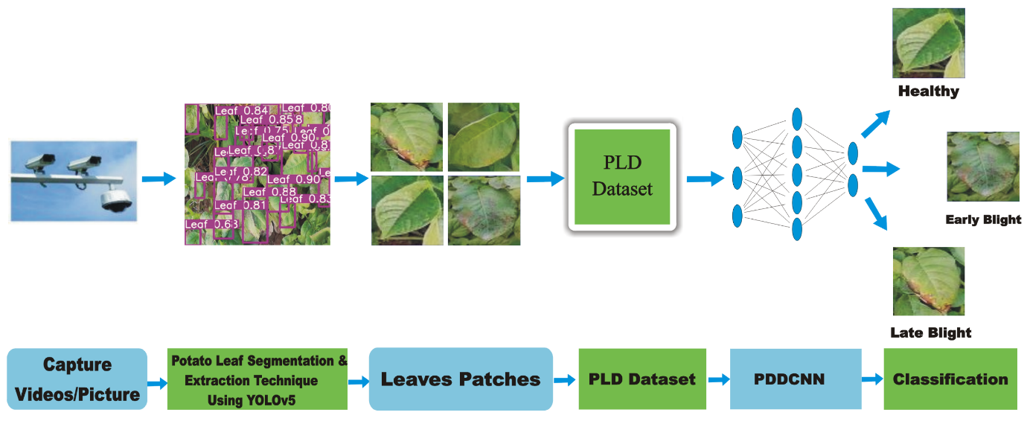

7. Technology Stack
Component | Technology
Frontend Web | React.js
Mobile App | React Native
Backend API | FastAPI
ML Framework | TensorFlow/Keras
Database | MongoDB/PostgreSQL
Deployment | Google Cloud
Version Control | Git/GitHub
Containerization | Docker

8. Expected Outcomes
- Accurate classification of potato diseases in real time.
- Web and mobile apps for easy farmer access.
- Reduction in crop loss through early detection.
- Scalable system for future crop disease inclusion.
- Demonstration of practical AI/ML application in agriculture.

9. Significance
- Agricultural Support: Helps farmers make timely decisions.
- Economic Impact: Reduces financial losses from diseased crops.
- Technological Advancement: Demonstrates AI application in real-world scenarios.
- Educational Use: Can be used for teaching and research in agricultural technology.

