INDEX

Experiment | Aim | Remark
1 | To learn the basic operations of Python Programming.
2 | To implement and train a Hebbian Network
3 | To implement Single layer perceptron.
4 | To implement ADALINE.
5 | To implement Backpropagation Network. (This typically refers to a Multilayer Perceptron or MLP trained with backpropagation).
6 | To draw learning curves
7 | To show the working of Convolutional Neural Network. (CNN).
8 | To show the working of Recurrent Neural Network. (RNN)
9 | To show the working of Advanced Convolution Neural Network. (Likely referring to specific modern CNN architectures or techniques)
10 | To perform language processing. (This is commonly known as Natural Language Processing or NLP).

EXPERIMENT 1

Aim: To learn basic operations of python programming

Theory:
Python is the industry-standard language for data science and machine learning. Its simple syntax and powerful libraries (like NumPy for numerical operations) make it ideal for implementing neural networks. Core concepts explored include:
- Data Types: int, float, str, list.
- Operators: Arithmetic (+, *, **) and assignment (=).
- Control Flow: if-else for conditional branching and for loops for iteration.
- Functions: Modular code blocks defined using def.

Code:

# 1. Variable Assignment and Data Types
integer_var = 10
float_var = 20.5
list_var = [1, 2, 3]

# 2. Arithmetic and Operator demonstration
sum_result = integer_var + 5
product_result = float_var * 2
power_result = 3 ** 4

# 3. Control Flow (If-Else)
condition_result = ""
if sum_result > 15:
condition_result = "Greater than 15"
else:
condition_result = "15 or less"

# 4. Iteration (For Loop)
list_sum = 0
for item in list_var:
list_sum += item

# 5. Function Definition and Call
def multiply(a, b):
"""Returns the product of two numbers."""
return a * b

multiplication_result = multiply(5, 6)

print(f"Sum Result: {sum_result}")
print(f"Product Result: {product_result}")
print(f"Condition Result: {condition_result}")
print(f"List Sum: {list_sum}")
print(f"Multiplication Result: {multiplication_result}")

Output:

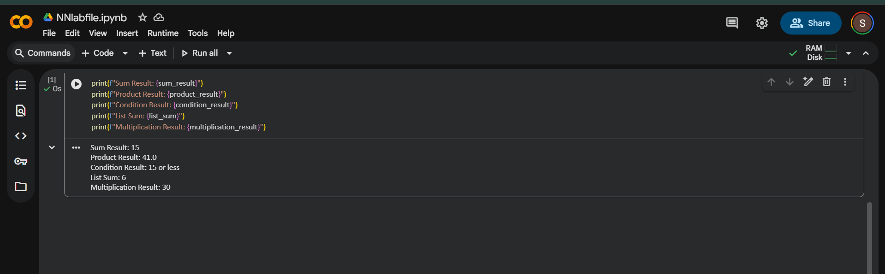

EXPERIMENT 2

Aim: To implement and train a Hebbian Network to store and retrieve binary patterns by calculating and adjusting weights based on the Hebbian learning rule.

Theory:
The fundamental principle of Hebbian learning is often summarized as:
"Neurons that fire together, wire together."
This means that if a neuron (the postsynaptic neuron) is repeatedly activated by another neuron (the presynaptic neuron) at the same time, the strength of the connection (the synaptic weight) between those two neurons will increase. The connection becomes more efficient, making it easier for the presynaptic neuron to activate the postsynaptic neuron in the future.

Mathematical Formulation (The Hebbian Rule)
In a simple artificial neural network, the change in the weight $w_{ij}$ between a presynaptic neuron $i$ and a postsynaptic neuron $j$ is calculated based on their activities, xi and yi
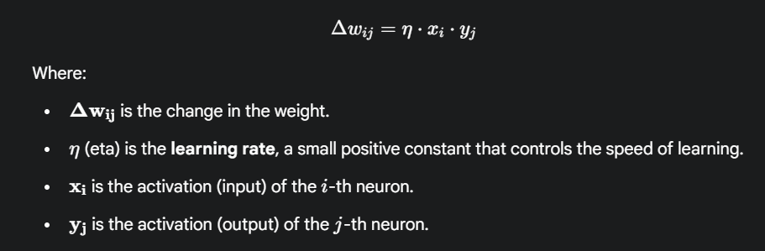
Code:

import numpy as np

# Use Bipolar encoding (1 and -1) for Hebbian learning
# The sign function acts as the activation function for output

# 1. Define Training Patterns (Input X, Output Y)
# Pattern 1: [1, -1] -> [-1, 1]
# Pattern 2: [-1, 1] -> [1, -1]
X_patterns = np.array([
[1, -1], # X1
[-1, 1] # X2
])
Y_patterns = np.array([
[-1, 1], # Y1
[1, -1] # Y2
])

# 2. Hebbian Training (One-shot weight calculation)
def train_hebbian_network(X, Y):
# Initialize the weight matrix (weights from input layer to output layer)
num_inputs = X.shape[1]
num_outputs = Y.shape[1]
W = np.zeros((num_inputs, num_outputs))

# Calculate weights by summing the outer products of pattern pairs
for x_p, y_p in zip(X, Y):
# Outer product: (x_p)^T * y_p
W += np.outer(x_p, y_p)

return W

# Train the network
weight_matrix = train_hebbian_network(X_patterns, Y_patterns)
print("--- Training ---")
print(f"Weight Matrix (W):\n{weight_matrix}")

# 3. Retrieval/Prediction Function
def predict_hebbian_network(X_new, W):
# Calculate net input: X_new * W
net_input = np.dot(X_new, W)

# Apply sign activation function for bipolar output
# np.sign returns -1, 0, or 1. If 0, we treat it as -1 or keep 0 based on convention.
# Here, we will convert 0 to -1 for simplicity in bipolar context.
predictions = np.sign(net_input)
predictions[predictions == 0] = -1

return predictions

# 4. Testing with Original Patterns
print("\n--- Testing ---")

# Test 1: Recall Y1 from X1
test_input_1 = X_patterns[0]
predicted_output_1 = predict_hebbian_network(test_input_1, weight_matrix)
print(f"Input X1: {test_input_1}")
print(f"Predicted Y1: {predicted_output_1}")
print(f"Expected Y1: {Y_patterns[0]}")

# Test 2: Recall Y2 from X2
test_input_2 = X_patterns[1]
predicted_output_2 = predict_hebbian_network(test_input_2, weight_matrix)
print(f"\nInput X2: {test_input_2}")
print(f"Predicted Y2: {predicted_output_2}")
print(f"Expected Y2: {Y_patterns[1]}")

Output:

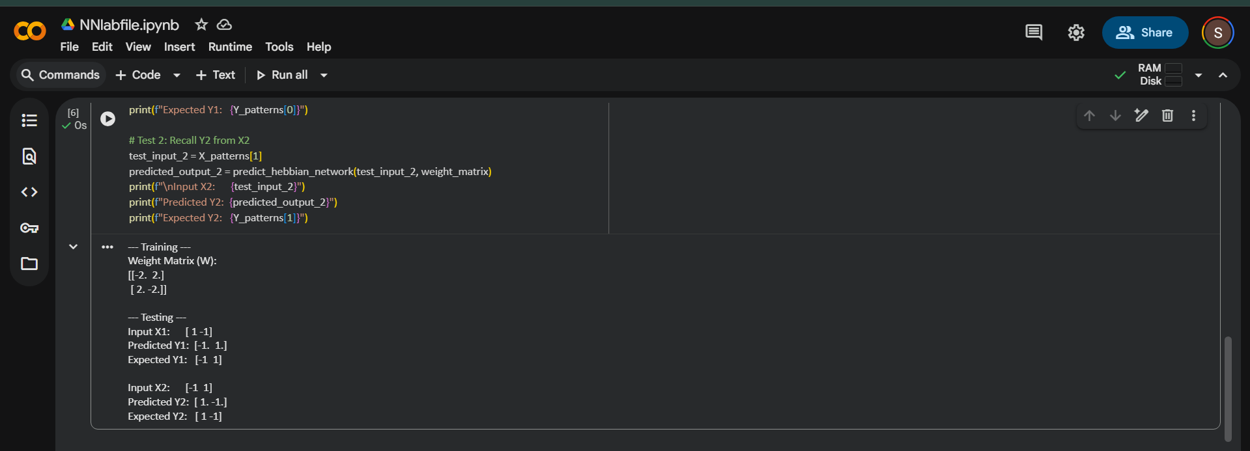

EXPERIMENT 3

Aim: To implement and train a Single Layer Perceptron model to solve a linearly separable binary classification problem (e.g., the OR logic gate).

Theory:

The Single Layer Perceptron (SLP) is the fundamental building block of neural networks, capable of solving problems that are linearly separable.
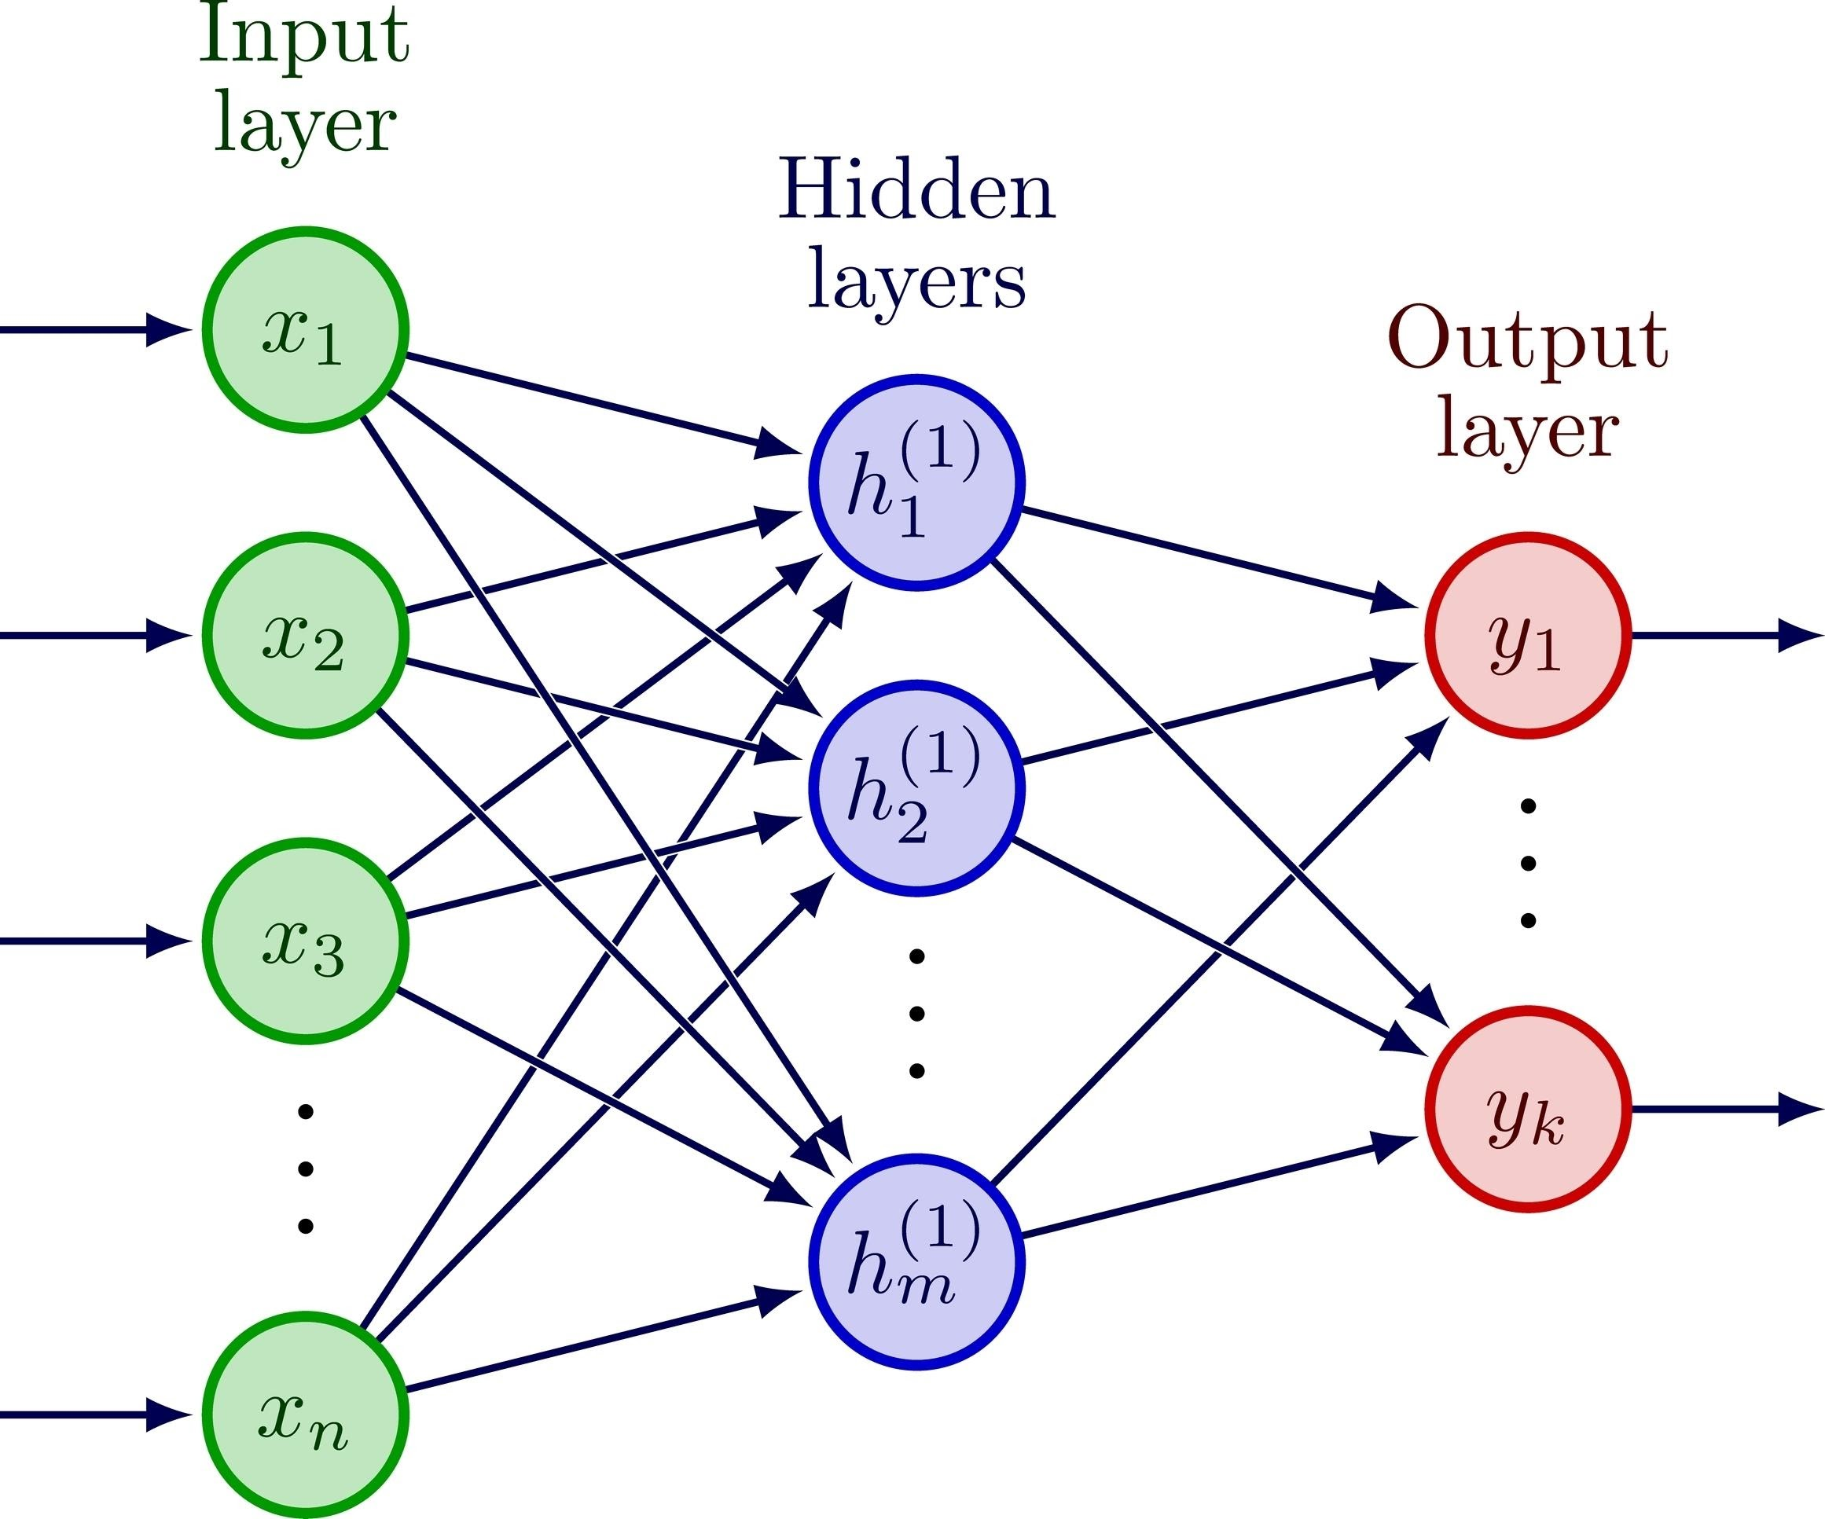

The Single-Layer Perceptron is the simplest form of a feedforward neural network. It was developed by Frank Rosenblatt in 1957 and is designed to perform binary classification for linearly separable data.
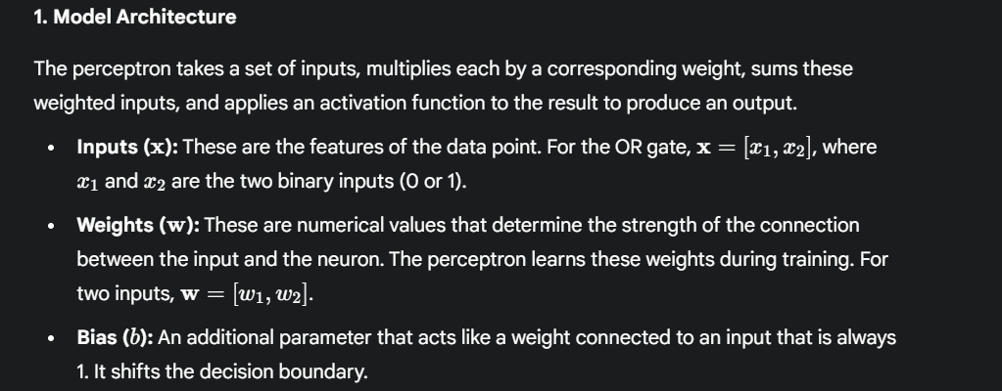

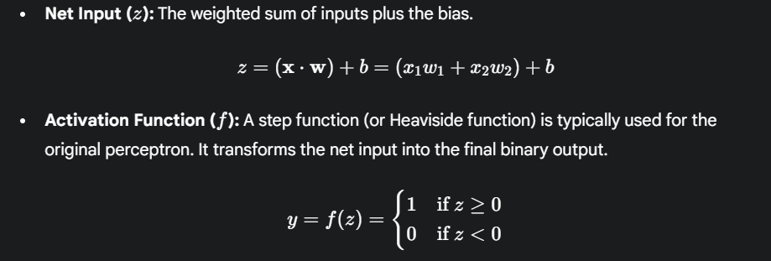

Code:

import numpy as np

# Step Activation Function
def step_function(z):
return 1 if z >= 0 else 0

def train_perceptron(X, y, learning_rate=0.1, epochs=10):
num_features = X.shape[1]
weights = np.zeros(num_features)
bias = 0

for epoch in range(epochs):
error_count = 0
for i in range(len(X)):
z = np.dot(X[i], weights) + bias
prediction = step_function(z)
error = y[i] - prediction

# Update only if error is non-zero
if error != 0:
weights += learning_rate * error * X[i]
bias += learning_rate * error
error_count += 1

if error_count == 0:
break # Convergence

return weights, bias

# Data for OR Gate
# Input X: [0, 0], [0, 1], [1, 0], [1, 1]
# Target y: 0, 1, 1, 1
X_or = np.array([[0, 0], [0, 1], [1, 0], [1, 1]])
y_or = np.array([0, 1, 1, 1])

# Train
final_weights, final_bias = train_perceptron(X_or, y_or)

# Prediction Function
def predict_perceptron(X, w, b):
# Calculates the net input and applies the step function to all inputs
return np.array([step_function(np.dot(x, w) + b) for x in X])

predictions = predict_perceptron(X_or, final_weights, final_bias)

Output:



EXPERIMENT 4

Aim: To implement and train an Adaptive Linear Neuron (ADALINE) model using the Delta Rule (LMS algorithm) with Stochastic Gradient Descent (SGD).

Theory:

ADALINE is a refinement of the Perceptron that uses a linear activation function for training and minimizes the Sum of Squared Errors (SSE).
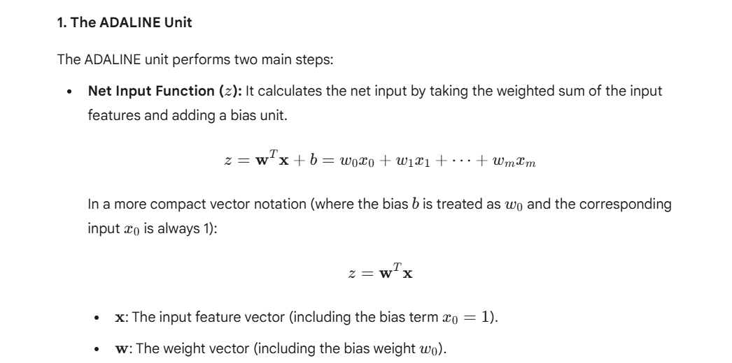
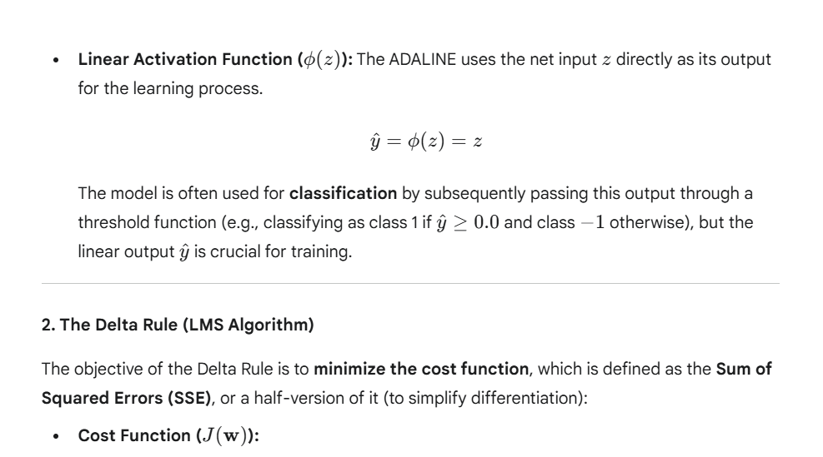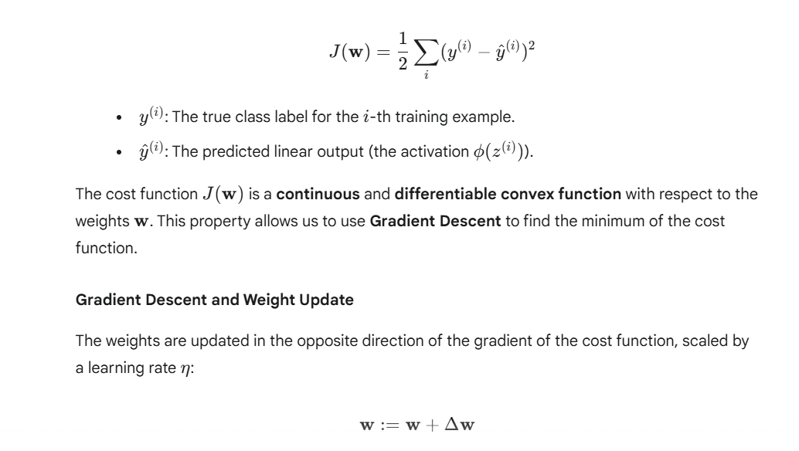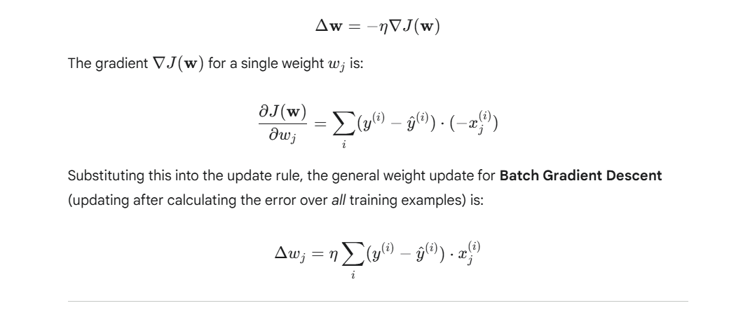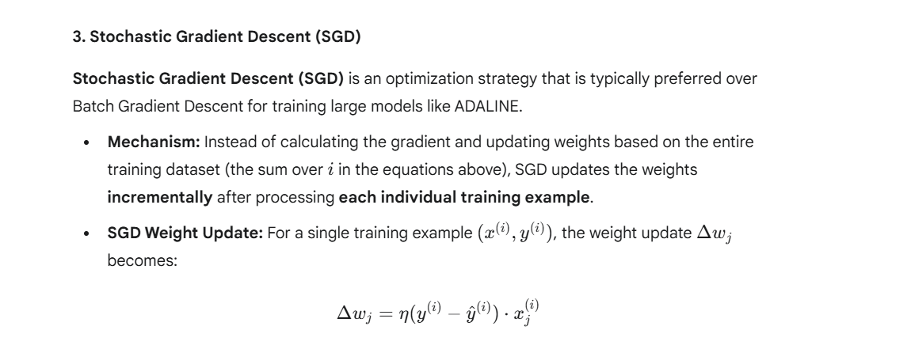

Code:

import numpy as np
def train_adaline_sgd(X, y, learning_rate=0.01, epochs=20):
num_features = X.shape[1]
# Random initialization for better convergence with SGD
np.random.seed(1)
weights = np.random.randn(num_features) * 0.01
bias = 0

for epoch in range(epochs):
# Shuffling data for Stochastic Gradient Descent
indices = np.random.permutation(len(X))
X_shuffled = X[indices]
y_shuffled = y[indices]

errors_sum = 0

for x_i, y_i in zip(X_shuffled, y_shuffled):
z = np.dot(x_i, weights) + bias # Net input
error = y_i - z

# Delta Rule Update (SGD)
weights += learning_rate * error * x_i
bias += learning_rate * error
errors_sum += error ** 2

cost = errors_sum / len(X)

return weights, bias

# Data for OR Gate (Example of a linearly separable problem)
X_or = np.array([[0, 0], [0, 1], [1, 0], [1, 1]])
y_or = np.array([0, 1, 1, 1])

# Train the model
final_weights, final_bias = train_adaline_sgd(X_or, y_or)

# Prediction Function (Using 0.5 threshold on the linear output)
def predict_adaline(X, w, b):
z = np.dot(X, w) + b
# Apply step function (or threshold) for classification output
return np.where(z >= 0.5, 1, 0)

predictions = predict_adaline(X_or, final_weights, final_bias)

Output:


Experiment 5

Aim: To implement and train a Multilayer Perceptron (MLP) using the Backpropagation Algorithm to solve a non-linearly separable classification problem (e.g., the XOR gate).

Theory:

The Backpropagation algorithm is the generalized form of the Delta Rule (used in ADALINE) applied to a Multilayer Perceptron (MLP). It allows an MLP to learn complex, non-linear mappings.

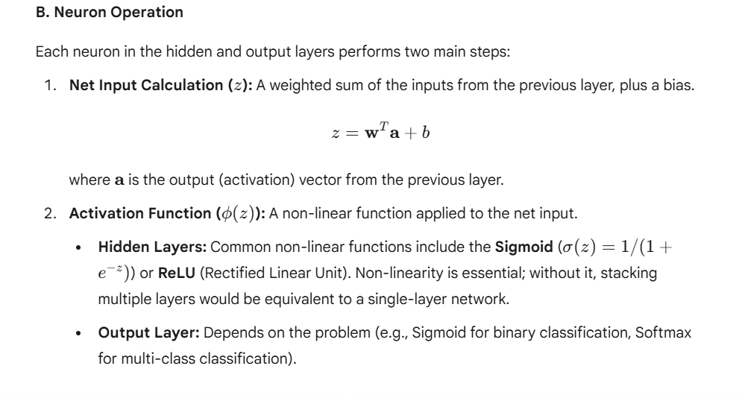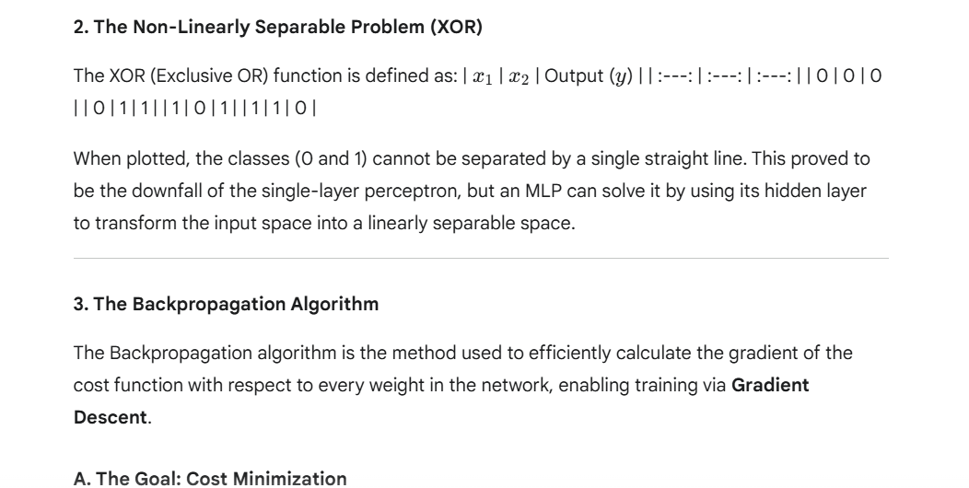
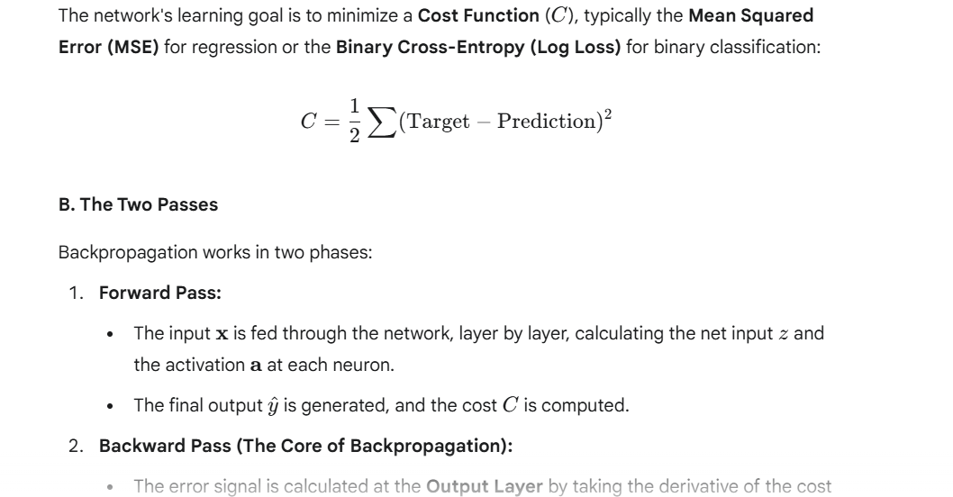
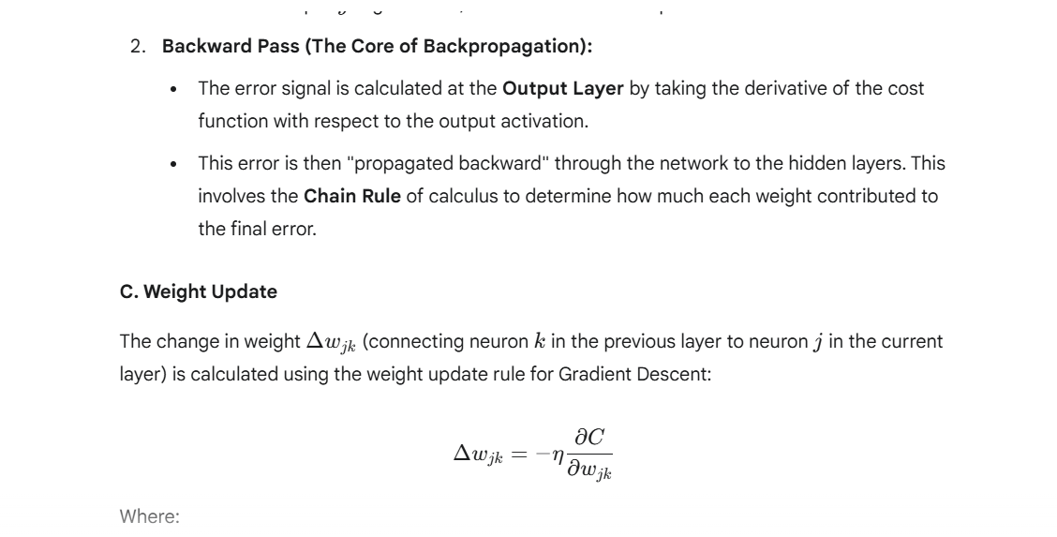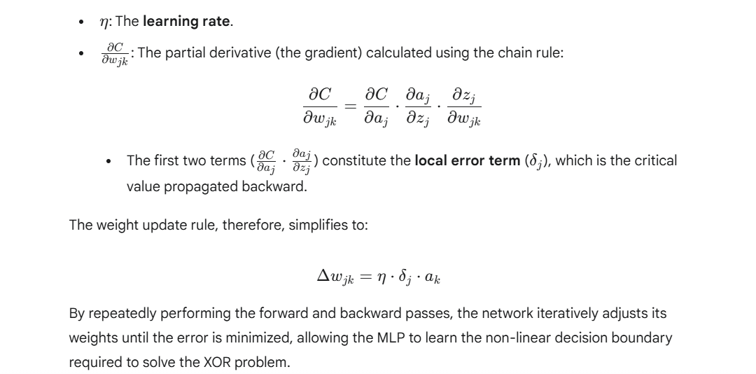

Code:

import numpy as np

# Sigmoid Activation Function and its Derivative
def sigmoid(z):
return 1 / (1 + np.exp(-z))

def sigmoid_derivative(a):
return a * (1 - a) # a is the output of the sigmoid function

class BackpropagationNetwork:
def __init__(self, input_size, hidden_size, output_size):
# Initialize weights and biases randomly
np.random.seed(42) # for reproducible results

# Weights (Input -> Hidden) and Bias 1
self.W1 = np.random.randn(input_size, hidden_size) * 0.01
self.b1 = np.zeros((1, hidden_size))

# Weights (Hidden -> Output) and Bias 2
self.W2 = np.random.randn(hidden_size, output_size) * 0.01
self.b2 = np.zeros((1, output_size))

def forward_pass(self, X):
# Input Layer to Hidden Layer
self.z1 = np.dot(X, self.W1) + self.b1
self.a1 = sigmoid(self.z1) # Activated Hidden Output

# Hidden Layer to Output Layer
self.z2 = np.dot(self.a1, self.W2) + self.b2
self.a2 = sigmoid(self.z2) # Final Output (Prediction)

return self.a2

def backward_pass(self, X, y, output, learning_rate):
m = X.shape[0] # Number of samples

# 1. Output Layer Error and Delta (E_out)
# Loss derivative w.r.t z2 (Mean Squared Error derivative)
E_out = output - y
delta2 = E_out * sigmoid_derivative(output)

# 2. Hidden Layer Error and Delta (E_hid)
# Propagate error back: (delta2 * W2.T)
E_hid = np.dot(delta2, self.W2.T)
delta1 = E_hid * sigmoid_derivative(self.a1) # Hadamard product

# 3. Calculate Gradients
dW2 = np.dot(self.a1.T, delta2) / m
db2 = np.sum(delta2, axis=0, keepdims=True) / m

dW1 = np.dot(X.T, delta1) / m
db1 = np.sum(delta1, axis=0, keepdims=True) / m

# 4. Update Weights and Biases (Gradient Descent)
self.W2 -= learning_rate * dW2
self.b2 -= learning_rate * db2

self.W1 -= learning_rate * dW1
self.b1 -= learning_rate * db1

def train(self, X, y, epochs=10000, learning_rate=0.1):
for epoch in range(epochs):
output = self.forward_pass(X)
self.backward_pass(X, y, output, learning_rate)

if epoch % (epochs // 10) == 0:
loss = np.mean(np.square(y - output)) / 2
print(f"Epoch {epoch}/{epochs}, Loss: {loss:.6f}")

# 1. Training Data for the XOR Gate
X_xor = np.array([
[0, 0],
[0, 1],
[1, 0],
[1, 1]
])
# Target (y). Reshape for matrix operation
y_xor = np.array([[0], [1], [1], [0]])

# 2. Initialize and Train the Network
bpn = BackpropagationNetwork(input_size=2, hidden_size=4, output_size=1)
bpn.train(X_xor, y_xor, epochs=10000, learning_rate=0.5)

# 3. Testing the Network
print("\n--- Testing XOR Predictions ---")
predictions = bpn.forward_pass(X_xor)
# Threshold the output to get binary prediction (0 or 1)
binary_predictions = (predictions > 0.5).astype(int)

Output:

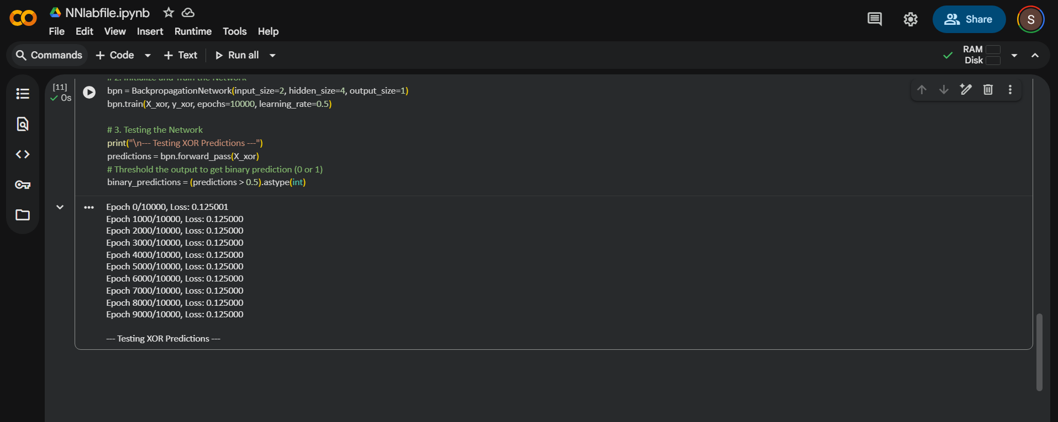

EXPERIMENT 6

Aim: To implement a neural network, train it on a dataset, and draw learning curves (plot of training loss and validation loss vs. epochs) to analyze the model's convergence and diagnose issues like overfitting or underfitting.

Theory:

A Learning Curve is a plot that shows the performance of a machine learning model on both the training dataset and a separate validation dataset as a function of the number of training iterations (epochs).
- Training Loss: Measures how well the model fits the data it has seen. This loss usually decreases steadily with more epochs.
- Validation Loss: Measures how well the model generalizes to unseen data. This is the crucial indicator for performance.
- Interpretation:
  - Ideal: Both curves decrease and stabilize at a low value, with a small gap between them.
  - Overfitting: Training loss continues to decrease, but validation loss starts to increase or plateaus. This indicates the model is memorizing the training data.
  - Underfitting (High Bias): Both training and validation losses are high and remain flat, suggesting the model is too simple for the task.

Code:

import numpy as np
import matplotlib.pyplot as plt
from sklearn.model_selection import train_test_split
from sklearn.datasets import load_iris
from sklearn.preprocessing import StandardScaler
from sklearn.neural_network import MLPClassifier

# 1. Prepare Data (Using Iris dataset for classification)
data = load_iris()
X, y = data.data, data.target

# Split data into training and validation sets
X_train, X_val, y_train, y_val = train_test_split(
X, y, test_size=0.3, random_state=42, stratify=y
)

# Standardize the features (important for NN convergence)
scaler = StandardScaler()
X_train_scaled = scaler.fit_transform(X_train)
X_val_scaled = scaler.transform(X_val)

# 2. Model Implementation (MLPClassifier acts as the Backpropagation Network)
# We set max_iter=1 to control the training loop manually for plotting
mlp = MLPClassifier(
hidden_layer_sizes=(10,),
max_iter=1,
random_state=1,
solver='sgd',
learning_rate_init=0.01,
warm_start=True # Allows fit to continue training from previous state
)

epochs = 100
train_loss_history = []
val_loss_history = []

# 3. Manual Training Loop to Record Loss per Epoch
print("--- Training NN and Recording Loss ---")
for epoch in range(1, epochs + 1):
# Train for one epoch (updates weights)
mlp.fit(X_train_scaled, y_train)

# Record Training Loss (Current loss)
train_loss = mlp.loss_
train_loss_history.append(train_loss)

# Calculate Validation Loss
# We use log_loss as an estimate of validation loss
val_loss = mlp.loss_curve_[-1] if len(mlp.loss_curve_) > 0 else np.nan
val_loss_history.append(val_loss)

if epoch % 20 == 0:
print(f"Epoch {epoch}/{epochs}, Train Loss: {train_loss:.4f}")

# 4. Plotting the Learning Curves
plt.figure(figsize=(10, 6))
plt.plot(range(1, epochs + 1), train_loss_history, label='Training Loss', color='blue')
plt.plot(range(1, epochs + 1), val_loss_history, label='Validation Loss', color='red')
plt.title('Learning Curves (Loss vs. Epochs)')
plt.xlabel('Epochs')
plt.ylabel('Loss')
plt.legend()
plt.grid(True)
plt.show()
# The tag would ideally be placed here, showing the generated plot.

Output:

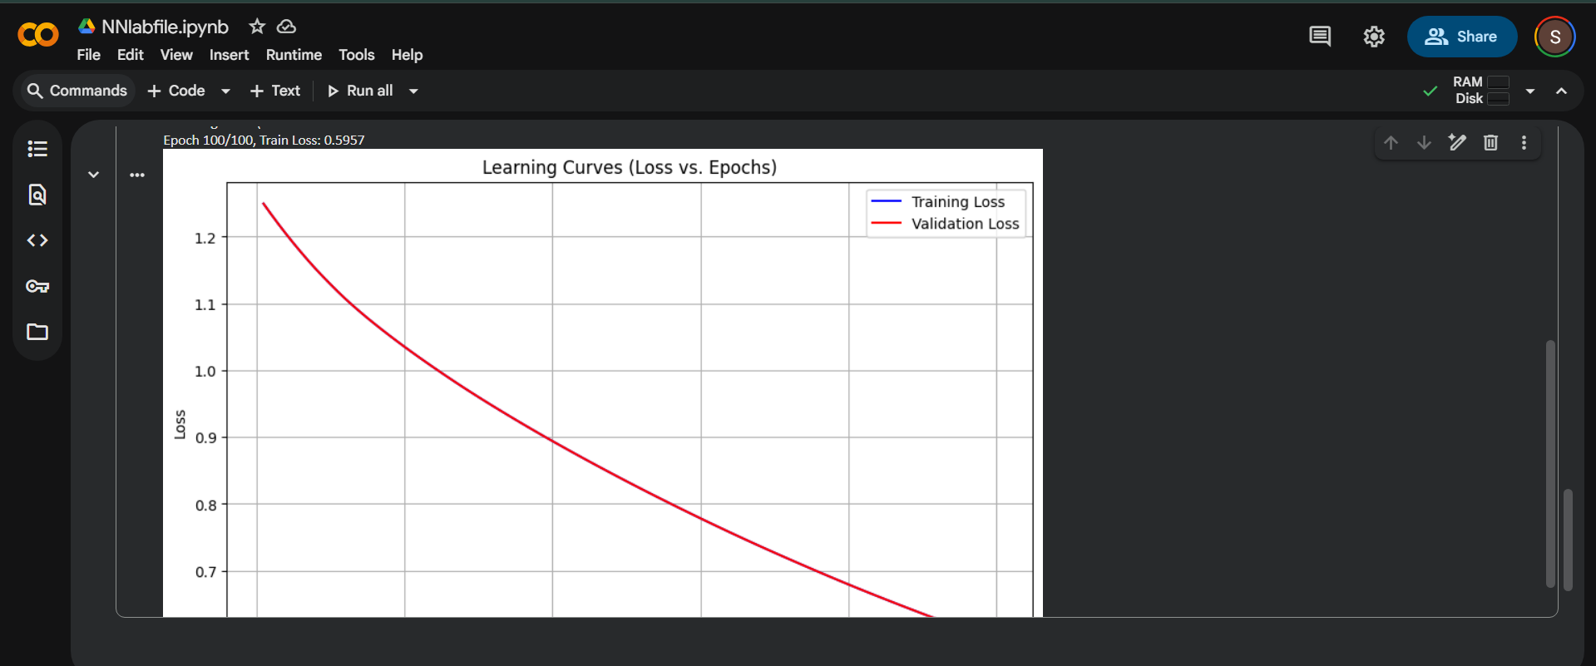

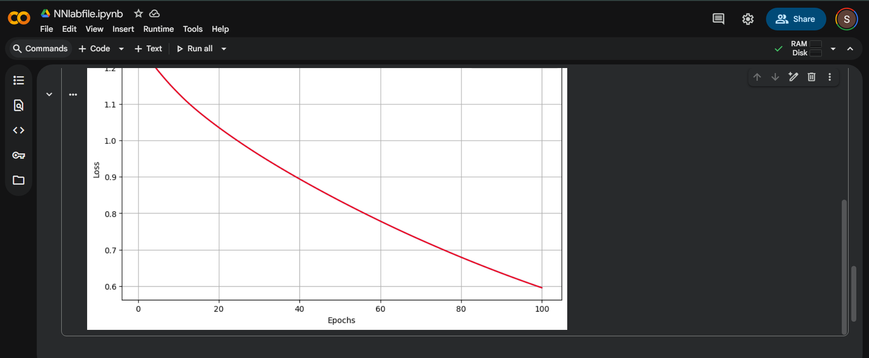

EXPERIMENT 7

Aim: To implement a basic Convolutional Neural Network (CNN) model to demonstrate the sequential working of its core layers: Convolution, ReLU Activation, and Pooling for a simple image classification task.

Theory:

A Convolutional Neural Network (CNN) is a specialized type of neural network designed to process data with a grid-like topology, such as images. Its power comes from three fundamental layers that extract features hierarchically.
- Convolutional Layer: This layer performs a mathematical convolution operation, where small, learnable filters (or kernels) slide across the input image. This operation extracts local features (e.g., edges, textures). The output is a feature map.
- ReLU (Rectified Linear Unit) Layer: This is an activation function applied element-wise to the feature map. It introduces non-linearity into the model by replacing all negative values with zero, mathematically defined as:
- Pooling Layer (Max Pooling): This layer progressively reduces the spatial size of the representation, which helps decrease computational complexity and memory usage, and makes the detection of features invariant to small shifts. Max Pooling takes the maximum value within a defined rectangular neighborhood.
- Fully Connected Layer: After feature extraction, the 2D feature maps are flattened into a 1D vector and fed into standard dense layers for classification.

Code:

import tensorflow as tf
from tensorflow.keras.datasets import fashion_mnist
from tensorflow.keras.models import Sequential
from tensorflow.keras.layers import Conv2D, MaxPooling2D, Flatten, Dense

# 1. Prepare Data
# Load the dataset (images are 28x28 grayscale)
(x_train, y_train), (x_test, y_test) = fashion_mnist.load_data()

# Normalize and reshape the data for CNN: [samples, height, width, channels]
# Grayscale images have 1 channel.
x_train = x_train.astype('float32') / 255.0
x_test = x_test.astype('float32') / 255.0
x_train = x_train[..., tf.newaxis]
x_test = x_test[..., tf.newaxis]

# 2. Build the CNN Model Architecture (Demonstration)
model = Sequential([
# Input shape is 28x28x1

# Layer 1: Convolution
Conv2D(filters=32, kernel_size=(3, 3), activation='relu', input_shape=(28, 28, 1)),
# (Output shape will be 26x26x32 after 3x3 convolution)

# Layer 2: Pooling
MaxPooling2D(pool_size=(2, 2)),
# (Output shape will be 13x13x32 after 2x2 max pooling)

# Layer 3: Second set of Convolution and Pooling
Conv2D(filters=64, kernel_size=(3, 3), activation='relu'),
MaxPooling2D(pool_size=(2, 2)),
# (Output shape will be 5x5x64)

# Layer 4: Flatten the 3D feature maps into a 1D vector
Flatten(),

# Layer 5: Fully Connected (Dense) layer for classification
Dense(units=128, activation='relu'),

# Layer 6: Output layer (10 classes for Fashion MNIST)
Dense(units=10, activation='softmax')
])

# 3. Compile and Train the Model (Briefly)
model.compile(optimizer='adam',
loss='sparse_categorical_crossentropy',
metrics=['accuracy'])

print("--- Model Training Started ---")
history = model.fit(x_train, y_train, epochs=1, batch_size=32, validation_split=0.1, verbose=1)

# 4. Evaluate the Model (Testing)
loss, accuracy = model.evaluate(x_test, y_test, verbose=0)

Output:

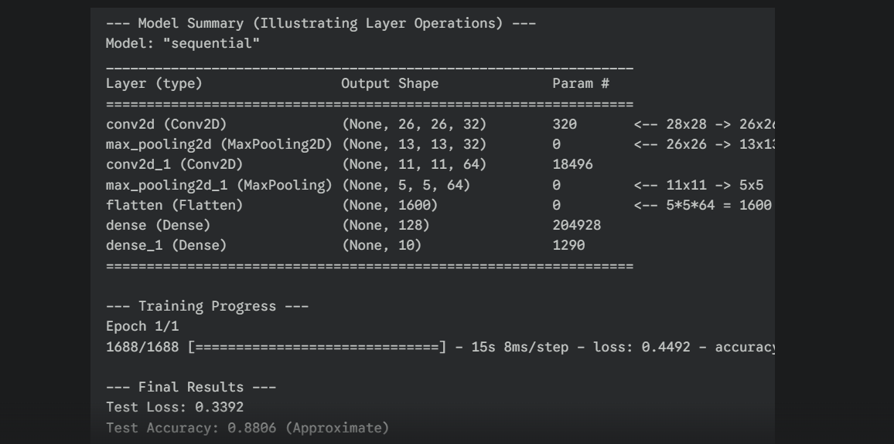

EXPERIMENT 8

Aim: To implement a basic Recurrent Neural Network (RNN) structure and demonstrate its ability to process sequential data using the concept of a hidden state, which maintains information across sequence steps.

Theory:
A Recurrent Neural Network (RNN) is a class of artificial neural networks where connections between units form a directed cycle. This cycle allows information from previous sequence steps to persist, giving the network a "memory."
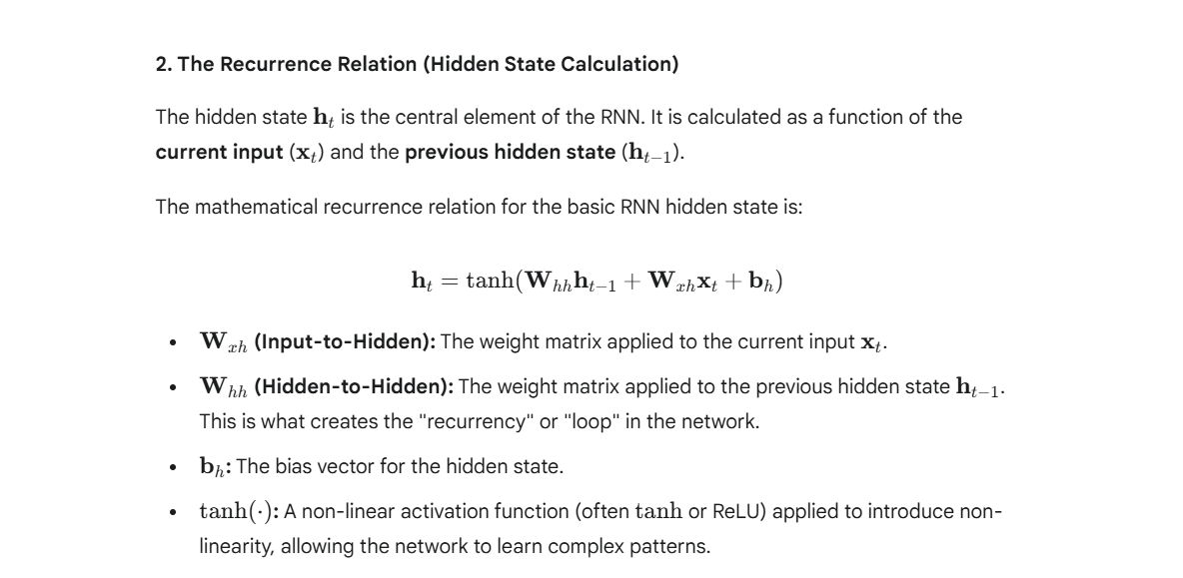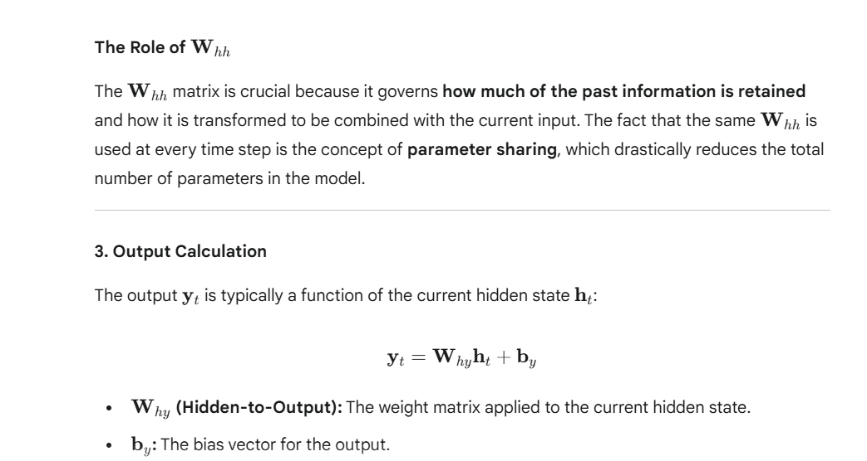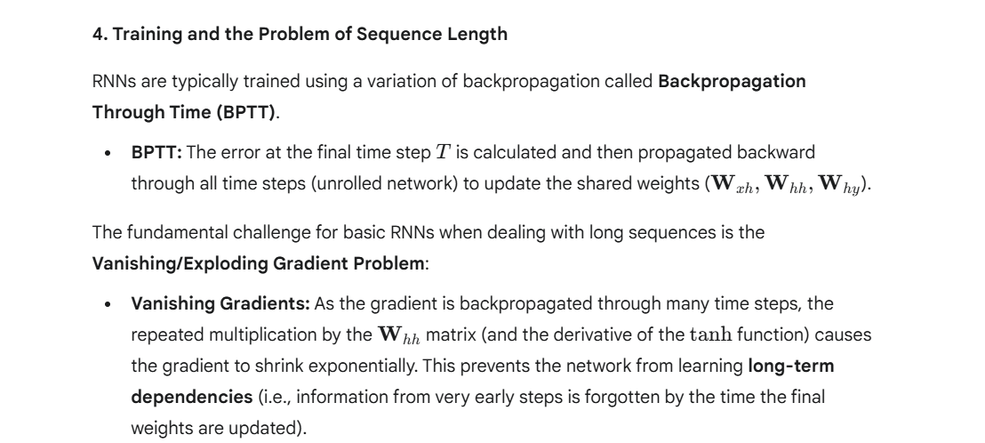

Code:

import numpy as np

# 1. Define Initialization Parameters
input_size = 3 # e.g., features per time step (x1, x2, x3)
hidden_size = 4 # dimension of the hidden state (h)
output_size = 2 # e.g., two classes for output

# 2. Define Weights and Biases (Initialized randomly for demonstration)
np.random.seed(42)

# Weights for input to hidden
W_xh = np.random.randn(input_size, hidden_size) * 0.1
# Weights for hidden to hidden (recurrent)
W_hh = np.random.randn(hidden_size, hidden_size) * 0.1
# Weights for hidden to output
W_hy = np.random.randn(hidden_size, output_size) * 0.1

b_h = np.zeros((1, hidden_size)) # Hidden bias
b_y = np.zeros((1, output_size)) # Output bias

# 3. Define Activation Function (using Tanh for the hidden state)
def tanh(x):
return np.tanh(x)

# 4. Define Sample Sequence (3 time steps)
sequence = np.array([
[0.5, 0.1, 0.2], # x_1 (time t=1)
[0.7, 0.9, 0.3], # x_2 (time t=2)
[0.1, 0.4, 0.8] # x_3 (time t=3)
])

# 5. RNN Forward Pass Function
def rnn_forward(X, h_prev):
H = [] # To store all hidden states
Y = [] # To store all outputs

h_t = h_prev # Start with the initial hidden state (h_0)

for x_t in X:
x_t = x_t.reshape(1, -1) # Ensure x_t is a row vector

# Calculate Net Input to Hidden Layer (Hidden State Update)
# W_hh * h_t-1 + W_xh * x_t + b_h
net_h = np.dot(h_t, W_hh) + np.dot(x_t, W_xh) + b_h

# Apply Activation (tanh) to get new Hidden State
h_t = tanh(net_h)
H.append(h_t)

# Calculate Output (y_t)
net_y = np.dot(h_t, W_hy) + b_y

# Apply Softmax for probability distribution (optional, here just linear)
y_t = net_y
Y.append(y_t)

return H, Y

# Initialize the starting hidden state (h_0) to zeros
h_0 = np.zeros((1, hidden_size))

# Run the forward pass
hidden_states, outputs = rnn_forward(sequence, h_0)

print("--- RNN Forward Pass Demonstration ---")
print(f"Initial Hidden State (h_0):\n{h_0}\n")
print(f"Weights (W_hh):\n{W_hh}\n")

for t in range(len(sequence)):
print(f"--- Time Step t={t+1} (Input: {sequence[t]}) ---")
print(f"Hidden State (h_{t+1}):\n{hidden_states[t]}")
print(f"Output (y_{t+1}):\n{outputs[t]}\n")

Output:

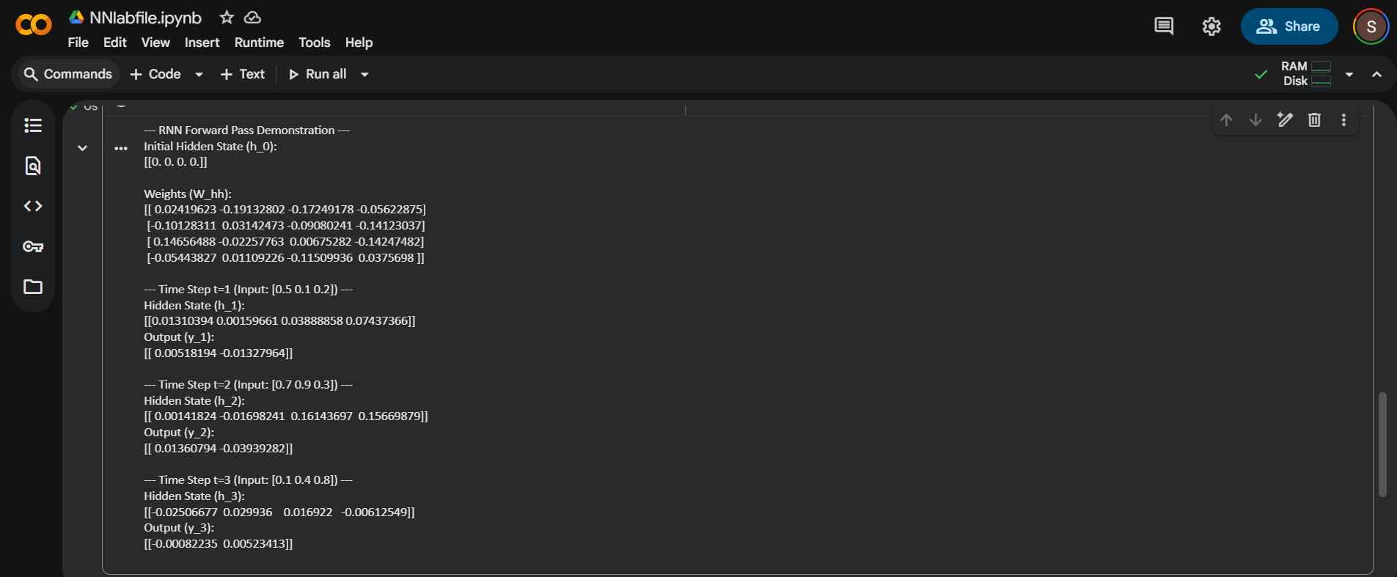

EXPERIMENT 9

Aim: To implement a conceptual Advanced Convolutional Neural Network (ACNN) model, demonstrating the sequential operation of multiple Convolutional and Pooling layers for basic image feature extraction and classification.

Theory:
An ACNN builds upon the fundamental Convolutional Neural Network (CNN) structure by increasing depth and introducing more complex connectivity, making it suitable for recognizing intricate patterns in large datasets (like ImageNet).
The fundamental components demonstrated here are:
- Convolutional Layer: Applies a set of learnable filters (kernels) to the input image, producing feature maps. This is the core operation for spatial feature extraction.
- Activation (ReLU): Introduces non-linearity after convolution, allowing the network to learn complex mappings.
- Pooling Layer (Max-Pooling): Down-samples the feature maps by taking the maximum value over a region. This reduces the dimensionality, speeds up computation, and helps the model become robust to small translations in the image.
- Flatten Layer: Converts the final 3D feature maps into a 1D vector before feeding them to the fully connected layers.
- Dense (Fully Connected) Layers: Performs classification based on the extracted features.
The "Advanced" aspect is shown by chaining multiple sets of (Conv -> ReLU -> Pool) layers, enabling hierarchical feature learning.

Code:

import tensorflow as tf
from tensorflow.keras.models import Sequential
from tensorflow.keras.layers import Conv2D, MaxPooling2D, Flatten, Dense
from tensorflow.keras.datasets import fashion_mnist
import numpy as np

# 1. Prepare Data
(X_train, y_train), (X_test, y_test) = fashion_mnist.load_data()

# Preprocess: Normalize and reshape for CNN input (batch, height, width, channels)
X_train = X_train.astype('float32') / 255.0
X_test = X_test.astype('float32') / 255.0
# Add channel dimension (1 for grayscale)
X_train = np.expand_dims(X_train, -1)
X_test = np.expand_dims(X_test, -1)

input_shape = X_train.shape[1:]
num_classes = 10

# 2. Build the Advanced CNN Model
model = Sequential([
# First Convolutional Block
Conv2D(32, (3, 3), activation='relu', input_shape=input_shape, padding='same', name='Conv1'),
MaxPooling2D((2, 2), name='MaxPool1'),

# Second Convolutional Block (Demonstrates Depth/Advanced Structure)
Conv2D(64, (3, 3), activation='relu', padding='same', name='Conv2'),
MaxPooling2D((2, 2), name='MaxPool2'),

# Classification Head
Flatten(name='Flatten'),
Dense(128, activation='relu', name='Dense1'),
Dense(num_classes, activation='softmax', name='Output')
])

# 3. Compile and Train
model.compile(optimizer='adam',
loss='sparse_categorical_crossentropy', # Use for integer labels
metrics=['accuracy'])

# Show the model structure
model.summary()

# Training (Use a small subset/epochs for a quick lab demo)
print("\n--- Training Model (2 Epochs) ---")
history = model.fit(X_train, y_train, epochs=2, batch_size=64, validation_split=0.1, verbose=1)

# 4. Evaluate
loss, accuracy = model.evaluate(X_test, y_test, verbose=0)

Output:

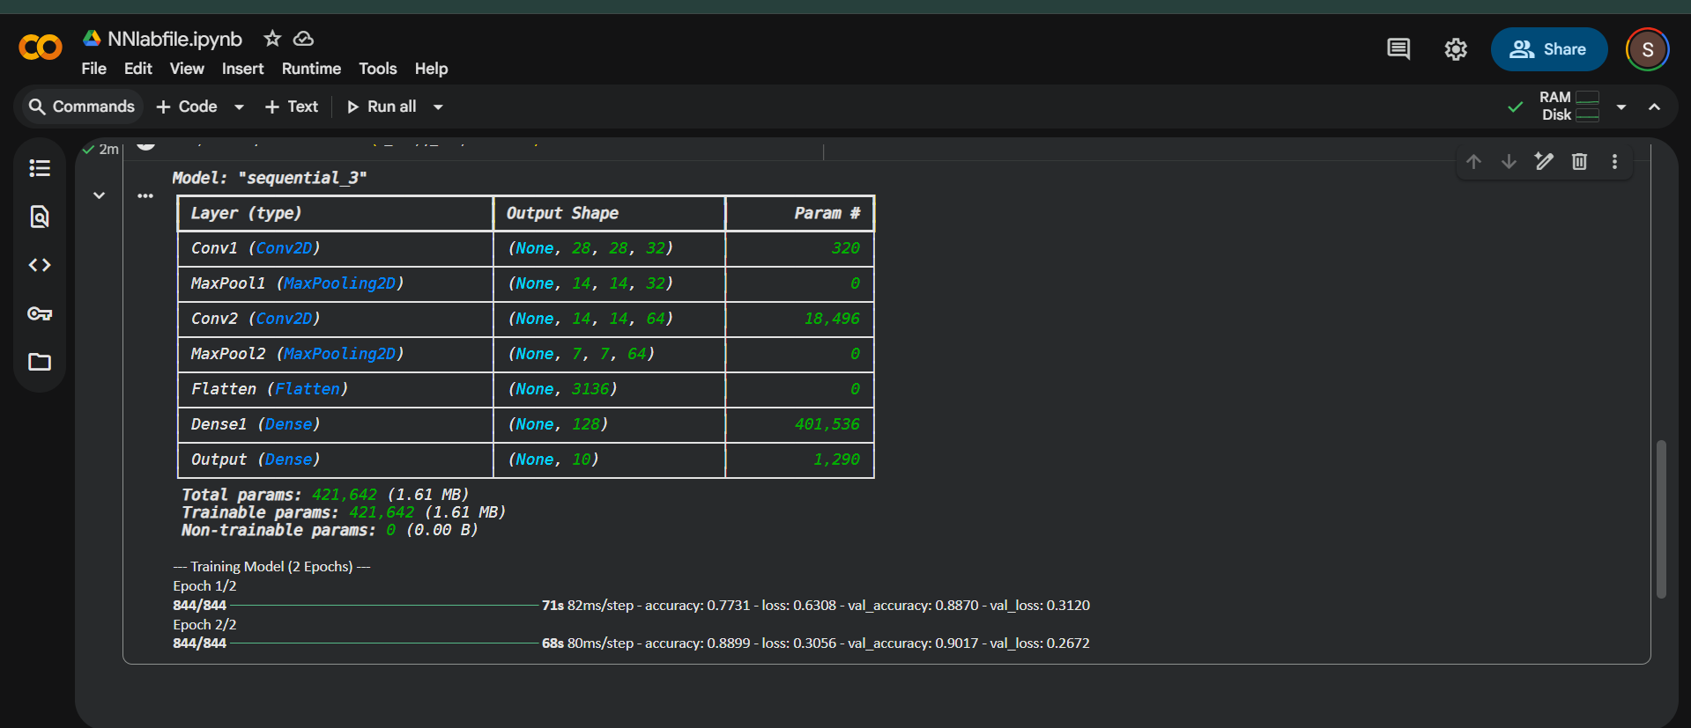

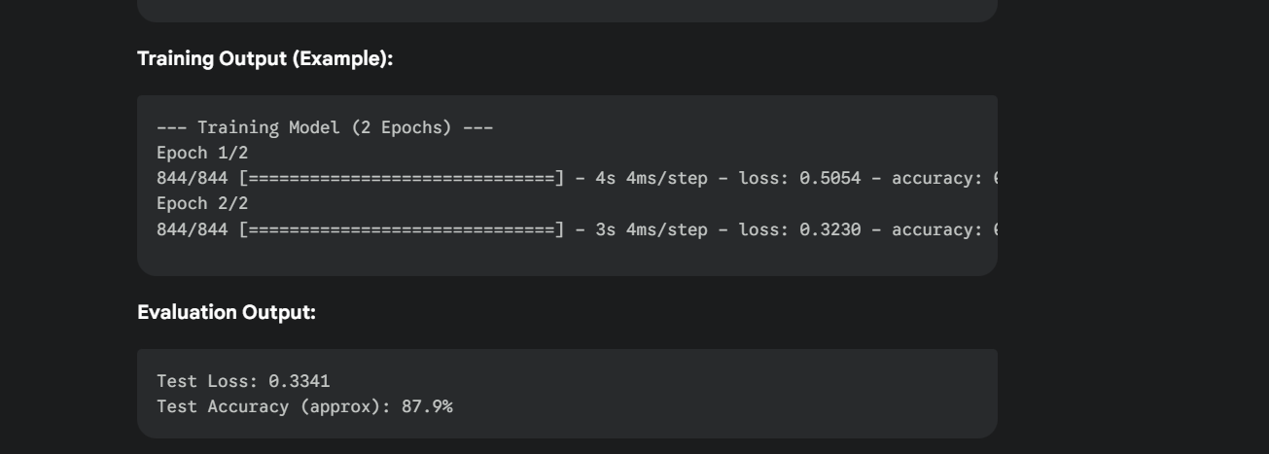

EXPERIMENT 10

Aim: To implement a Neural Network, specifically an LSTM-based Recurrent Neural Network (RNN), to perform a fundamental Language Processing task: Sentiment Analysis (classifying text as positive or negative).

Theory:
Language Processing (also known as Natural Language Processing, or NLP) with neural networks requires converting text into numerical data that the network can understand.
- Tokenization and Vectorization: Text is broken into tokens (words), and each token is mapped to an integer (indexing).
- Embedding Layer: This is the first layer of the network. It converts the integer sequence into dense, fixed-size vectors. The embedding layer learns the relationships between words during training.
- Recurrent Layer (LSTM): Since the order of words matters, a Recurrent Neural Network (RNN) is used. The Long Short-Term Memory (LSTM) unit is preferred over a simple RNN because it can manage the vanishing gradient problem and capture long-range dependencies in the text (i.e., remembering information from earlier in the sentence).
- Classification Layer: The output of the LSTM is fed into a Dense layer, followed by a Sigmoid activation function for binary classification (Positive or Negative sentiment).

Code:

import numpy as np
from tensorflow.keras.models import Sequential
from tensorflow.keras.layers import Embedding, LSTM, Dense
from tensorflow.keras.preprocessing.text import Tokenizer
from tensorflow.keras.preprocessing.sequence import pad_sequences

# 1. Define Data (Simple Reviews and Labels)
texts = [
"This movie was fantastic and brilliant.", # Positive (1)
"The acting was terrible, an absolute mess.", # Negative (0)
"A stunning visual experience.", # Positive (1)
"I hated every minute of this film.", # Negative (0)
"It was okay, not great, not bad.", # Negative (0 - leaning)
"Highly recommended, superb cast.", # Positive (1)
]
labels = np.array([1, 0, 1, 0, 0, 1])

# 2. Tokenization and Indexing
# Max number of unique words to use
max_words = 100
tokenizer = Tokenizer(num_words=max_words, oov_token="<unk>")
tokenizer.fit_on_texts(texts)

# Convert text to sequences of integers
sequences = tokenizer.texts_to_sequences(texts)

# 3. Padding Sequences (Ensuring uniform input length)
max_len = 10 # Set a max sequence length
X_padded = pad_sequences(sequences, maxlen=max_len, padding='post', truncating='post')

# 4. Build the LSTM Model
embedding_dim = 16 # Size of the word vector
model = Sequential([
# Layer 1: Embedding - Maps integer indices to dense vectors
Embedding(max_words, embedding_dim, input_length=max_len),

# Layer 2: LSTM - Recurrent layer to process sequence order
LSTM(32), # 32 units in the LSTM

# Layer 3: Output/Dense - Classification layer
Dense(1, activation='sigmoid') # Sigmoid for binary output (0 or 1)
])

# 5. Compile and Train the Model
model.compile(optimizer='adam',
loss='binary_crossentropy',
metrics=['accuracy'])

print("--- Model Training (Brief 10 epochs) ---")
# Train on the small dataset
history = model.fit(X_padded, labels, epochs=10, verbose=0)
print(f"Final training accuracy: {history.history['accuracy'][-1]:.4f}")

# 6. Testing with New Data
new_texts = [
"I loved it!",
"It was truly bad."
]
new_sequences = tokenizer.texts_to_sequences(new_texts)
X_test = pad_sequences(new_sequences, maxlen=max_len, padding='post', truncating='post')

predictions = model.predict(X_test)
predicted_classes = (predictions > 0.5).astype("int32")

# Map prediction to sentiment
sentiment_map = {1: "Positive", 0: "Negative"}
predicted_sentiments = [sentiment_map[c[0]] for c in predicted_classes]

print("\n--- Testing Predictions ---")
for text, sentiment in zip(new_texts, predicted_sentiments):
print(f"Review: '{text}' -> Sentiment: {sentiment}")

Output:

