

Data Technician

Name:
Course Date:
Table of contents
Day 1: Task 1 2
Day 1: Task 2 2
Day 2: Task 1 3
Day 2: Task 2 3
Day 3: Task 1 4
Day 3: Task 2 5
Day 4: Task 1 6
Day 4: Task 2 7
Course Notes 7
Additional Information 8

Day 1: Task 1

Please research the different versions of Tableau, compare and contrast them below and explain the limited functionality on ‘Tableau Public’.

Different Tableau versions | Tableau Versions List  Tableau provides a comprehensive list of versions released across different time cycles for all its products. Here are some of the notable versions:  - Tableau Desktop: The current/latest version is 2024.2, released on July 1, 2024. Previous versions include 2024.1, 2023.4, and so on.  - Tableau Desktop. The latest version released on July 1 2024.  - Tableau Prep Builder: The latest version is 2024.2, released on July 1, 2024. Previous versions include 2024.1, 2023.4, etc.  - Tableau Server: Similar to Tableau Desktop and Prep Builder, Tableau Server also has versions like 2024.2, 2024.1, 2023.4, etc.  - Tableau Cloud: Follows the same versioning pattern as other Tableau products.  - Data Privacy: All data is public and cannot be saved privately. Everything you create is visible to anyone on the internet.  - No Local Storage: You cannot save workbooks locally; they must be hosted publicly.  - Data Sources: Tableau Public only supports public datasets and does not allow access to databases or private data.  - Publishing Limits: There are restrictions on the number of workbooks you can publish and the storage space available.

Day 1: Task 2

Using the EMSI_JobChange_UK dataset, create your own dashboard, I want to see a bar chart showing percentage change and a UK based map showing the key city locations impacted.

Paste your print screen here | 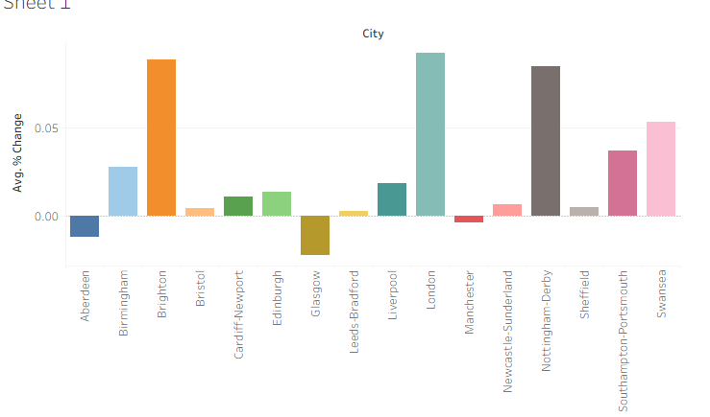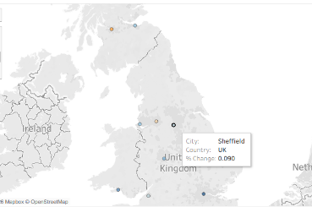

Day 2: Task 1

Using the Spotify data set, conduct an analysis to find trends and key information that could be used by an organisation for future projects.

There is no set scope for the analysis, simply to find trends and document them below:

Paste your print screens here | 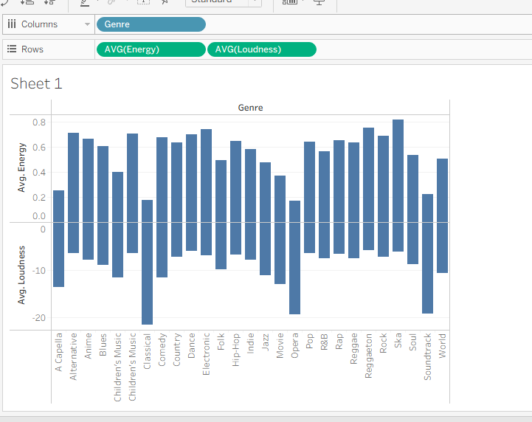  Energy and Loudness  Danceability  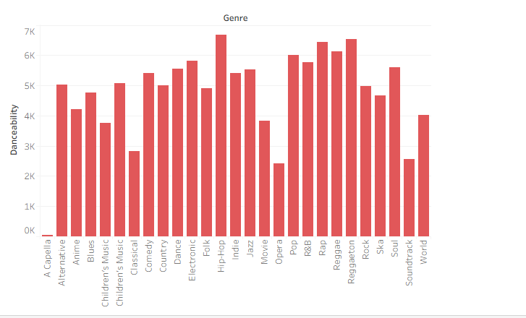  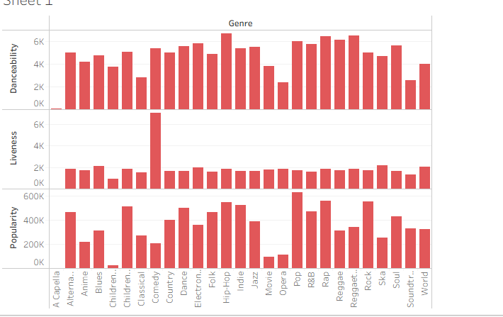

What did you find? | HipHop has the highest danceability yet one of the lowest liveness  The amount of volume used in music does not mean it has needed large amounts of energy to produce. I.E Classical music has a low energy rate, whilst its loudness being recorded as the highest out of all genres.  Pop is the most popular genre of music yet its liveness is low. Classical music has the highest liveness out of all the genres.

Day 2: Task 2

Using the Health, conduct an analysis to find trends and key information that could be used by an organisation for future support.

There is no set scope for the analysis, simply to find trends and document them below.

- Data can be lifesaving and is being used more within the NHS, reflect on how this data could support decision making for the NHS.

Paste your print screens here | - Life expec  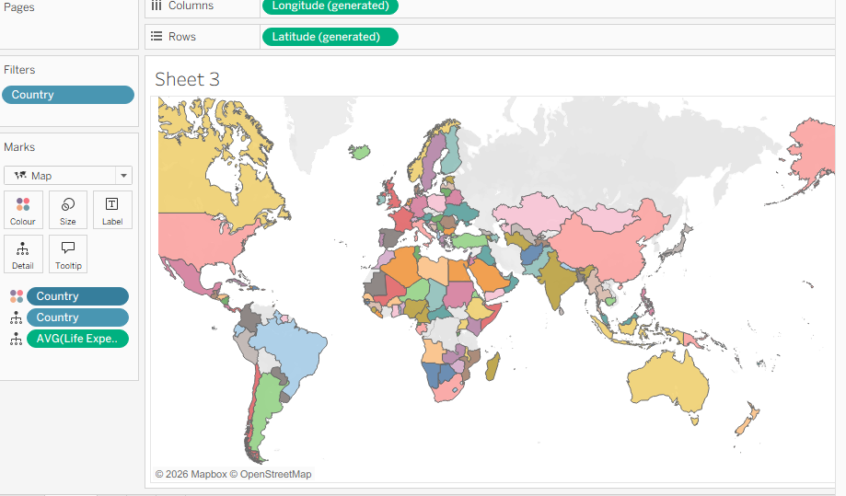  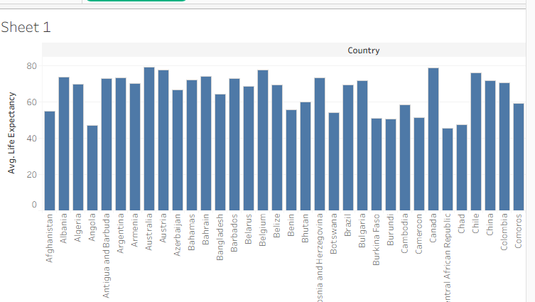  - Cancer over the years  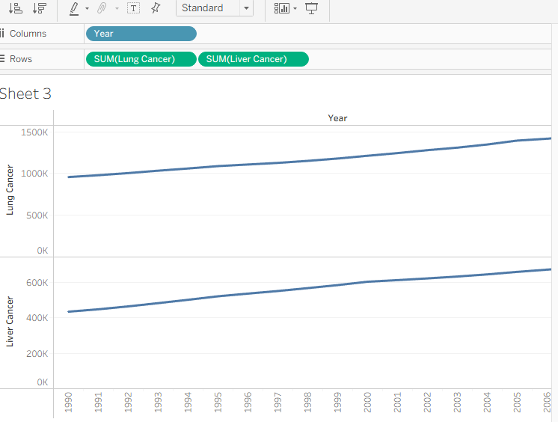  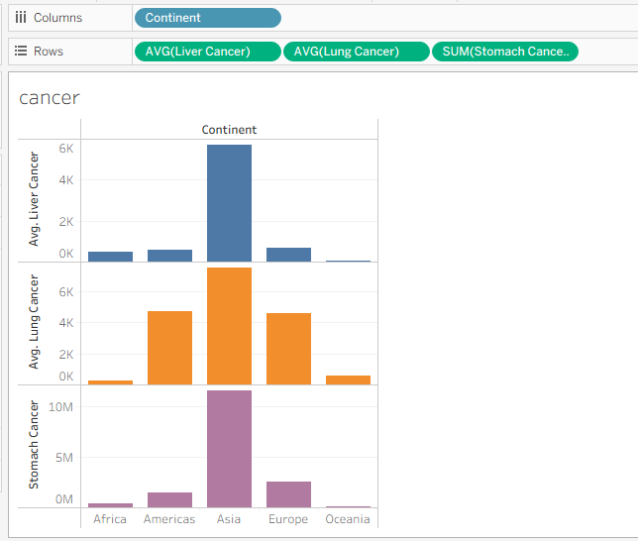  - Blood pressure , cholesterol and no of records  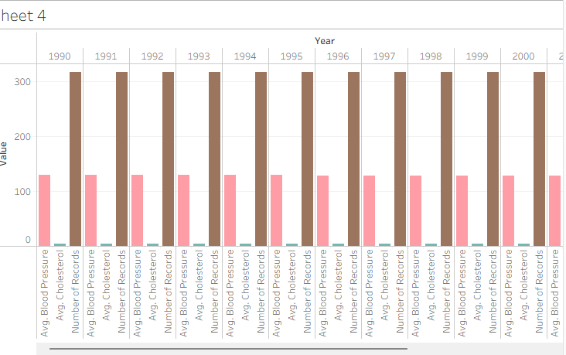  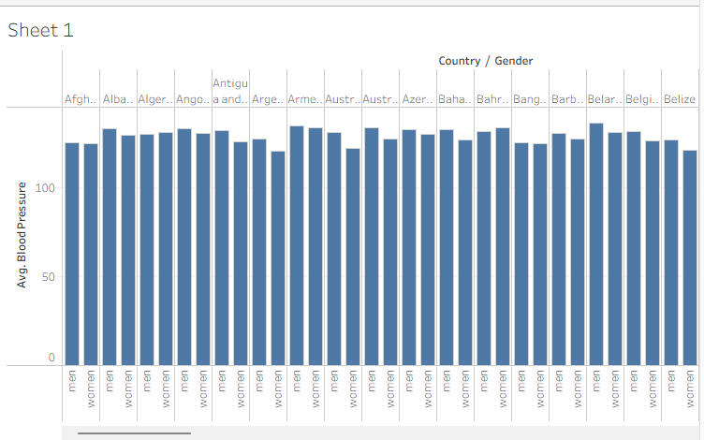  - Male and Female Blood pressures in each country.
What did you find and any reflections on how the NHS could use this? | Males Have a higher blood pressure than females in almost all if not all of the different countries  From the Cancer data we can notice that from the early years i.e 1990 to the later years 2000s cancer has been increasing. I.e China has the biggest record of cancer due to their massive population.  Life expectancy levels have been shown throughout all countries.  The NHS could use this Data to comprehend what countries, gender and ages have the highest cases of cancer for example.  The data can be used to acknowledge which part of the world has the highest blood level and why.  NHS could use this to record the amount of deaths by cancer in a certain area and what gender has been effected the most.

Day 3: Task 1

Please complete Lab 1 ‘Get Data in Power Bi Desktop’. Once complete, paste a print screen below and in the collaboration board.

“Teaching is the best way to learn, so please listen out for support requests from the class and we’ll work through the challenges together”

Paste your completed lab here | 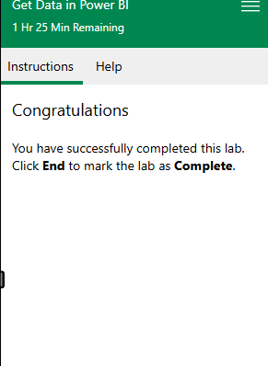

Day 3: Task 2

Please complete Lab 2 ‘Load Transformed Data in Power BI Desktop’. Once complete, paste a print screen below and in the collaboration board.

“Teaching is the best way to learn, so please listen out for support requests from the class and we’ll work through the challenges together”

Paste your completed lab here | 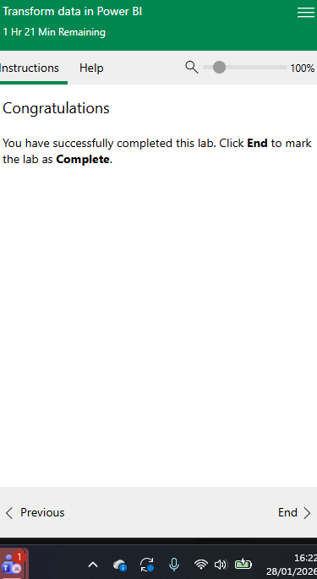

Day 4: Task 1

Please complete Lab 8 ‘Design a Report in Power BI Desktop’. Once complete, paste a print screen below and in the collaboration board.

“Teaching is the best way to learn, so please listen out for support requests from the class and we’ll work through the challenges together”

Paste your completed lab here | 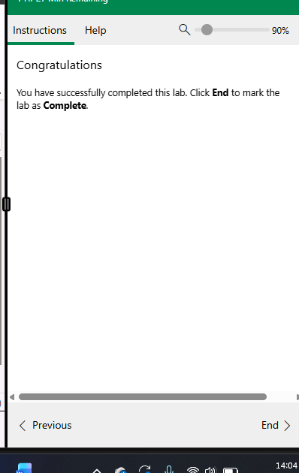

Day 4: Task 2

Please complete Lab 12 ‘Create a Power BI Dashboard’. Once complete, paste a print screen below and in the collaboration board.

“Teaching is the best way to learn, so please listen out for support requests from the class and we’ll work through the challenges together”

Paste your completed lab here | 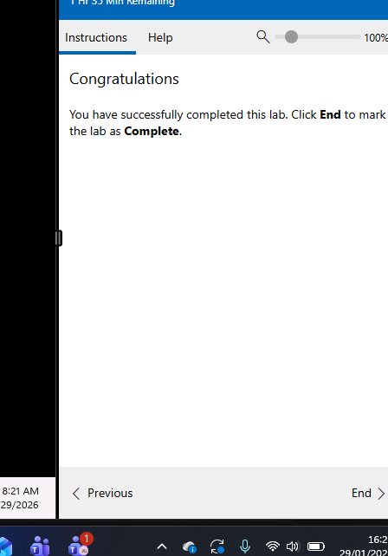

Course Notes

It is recommended to take notes from the course, use the space below to do so, or use the revision guide shared with the class.

We have included a range of additional links to further resources and information that you may find useful, these can be found within your revision guide.

END OF WORKBOOK

Please check through your work thoroughly before submitting and update the table of contents if required.

Please send your completed work booklet to your trainer.

Information

