Data Technician

Name:
Course Date:
Table of contents
Day 2: Task 1 3
Day 3: Task 1 3
Exercise 1: Loading and Exploring the Data 4
Exercise 2: Indexing and Slicing 4
Exercise 3: Data Manipulation 4
Exercise 4: Aggregation and Grouping 5
Exercise 5: Advanced Operations 5
Exercise 6: Exporting Data 6
Exercise 7: If finished early try visualising the results 6
Day 4: Task 1 7
Day 4: Task 2 8
Course Notes 8
Additional Information 9

Day 2: Task 1

It is a common software development interview question to create the below with a certain programming language. Create the below using Python syntax, test it and past the completed syntax and output below.

FizzBuzz:

Go through the integers from 1 to 100.
If a number is divisible by 3, print "fizz."
If a number is divisible by 5, print "buzz."
If a number is both divisible by 3 and by 5, print "fizzbuzz."
Otherwise, print just the number.

Paste your completed work to the right | for i in range(1, 101):  if i % 3 == 0 and i % 5 == 0:  print("fizzbuzz")  elif i % 3 == 0:  print("fizz")  elif i % 5 == 0:  print("buzz")  else:  print(i)

Day 3: Task 1

Using the ‘student.csv’complete the below exercises as a group and paste your input and output. Although this is a group activity, everyone should have the below answered so it supports your portfolio:

Exercise 1: Loading and Exploring the Data
- Question: "Write the code to read a CSV file into a Pandas DataFrame."
- Question: "Write the code to display the first 5 rows of the DataFrame."
- Question: "Write the code to get the information about the DataFrame."
- Question: "Write the code to get summary statistics for the DataFrame."

- df= pd.read_csv(‘filename.csv’) df = pd.read_csv('student.csv')
- Df.head() id name class mark gender
0 1 John Deo Four 75 female
1 2 Max Ruin Three 85 male
2 3 Arnold Three 55 male
3 4 Krish Star Four 60 female
4 5 John Mike Four 60 female

- Input Df.info() output <class 'pandas.core.frame.DataFrame'>
RangeIndex: 35 entries, 0 to 34
Data columns (total 5 columns):
# Column Non-Null Count Dtype
--- ------ -------------- -----
0 id 35 non-null int64
1 name 34 non-null object
2 class 34 non-null object
3 mark 35 non-null int64
4 gender 33 non-null object
dtypes: int64(2), object(3)

- Input Df.describe() output id mark
count 35.000000 35.000000
mean 18.000000 74.657143
std 10.246951 16.401117
min 1.000000 18.000000
25% 9.500000 62.500000
50% 18.000000 79.000000
75% 26.500000 88.000000
max 35.000000 96.000000

Exercise 2: Indexing and Slicing
- Question: "Write the code to select the 'name' column."
- Question: "Write the code to select the 'name' and 'mark' columns."
- Question: "Write the code to select the first 3 rows."
- Question: "Write the code to select all rows where the 'class' is 'Four'."

- Input Df[‘name’] output 0 John Deo
1 Max Ruin
2 Arnold
3 Krish Star
4 John Mike
...
34 Rows Noump
Name: name, dtype: object

- Input Df[[‘name’, ‘mark’]output name mark
0 John Deo 75
1 Max Ruin 85
2 Arnold 55
3 Krish Star 60
4 John Mike 60
...
34 Rows Noump 88

- Input Df[: 3] or df.head(3) output id name class mark gender
0 1 John Deo Four 75 female
1 2 Max Ruin Three 85 male
2 3 Arnold Three 55 male

- Input Df[df[‘class’] == “Four”] output id name class mark gender
0 1 John Deo Four 75 female
3 4 Krish Star Four 60 female
4 5 John Mike Four 60 female
5 6 Alex John Four 55 male
9 10 Big John Four 55 female
15 16 Gimmy Four 88 male
20 21 Babby John Four 69 female
30 31 Marry Toeey Four 88 male

Exercise 3: Data Manipulation
- Question: "Write the code to add a new column 'passed' that indicates whether the student passed (mark >= 60)."
- Question: "Write the code to rename the 'mark' column to 'score'."
- Question: "Write the code to drop the 'passed' column."

- Input Df[‘passed’] = df[‘mark’] >= 60 output id name class mark gender passed
0 1 John Deo Four 75 female True
1 2 Max Ruin Three 85 male True
2 3 Arnold Three 55 male False
3 4 Krish Star Four 60 female True
4 5 John Mike Four 60 female True

- Input Df.rename(columns=('mark’:’score’), inplace = True) output id name class score gender passed
0 1 John Deo Four 75 female True
1 2 Max Ruin Three 85 male True
2 3 Arnold Three 55 male False
3 4 Krish Star Four 60 female True
4 5 John Mike Four 60 female True

- Input Df.drop(columns=[’passed’], inplace = True) output id name class score gender
0 1 John Deo Four 75 female
1 2 Max Ruin Three 85 male
2 3 Arnold Three 55 male
3 4 Krish Star Four 60 female
4 5 John Mike Four 60 female

Exercise 4: Aggregation and Grouping
- Question: "Write the code to group the DataFrame by the 'class' column and calculate the mean 'mark' for each group."
- Question: "Write the code to count the number of students in each class."
- Question: "Write the code to calculate the average mark for each gender."

- Df.groupby(‘class’)[‘score’].mean()

1 import pandas as pd
# Read dataset
df = pd.read_csv('/mnt/data/student.csv')
# Group by class and calculate mean mark
mean_marks = df.groupby('class')['mark'].mean()
print(mean_marks)

- Df[‘class’].value_counts()

2 # Count number of students in each class
class_counts = df['class'].value_counts()
print(class_counts)

- Df.groupby(‘gender’)[‘score’].mean()

3 # Group by gender and calculate average mark
gender_average = df.groupby('gender')['mark'].mean()
print(gender_average)

Exercise 5: Advanced Operations
- Question: "Write the code to create a pivot table with 'class' as rows, 'gender' as columns, and 'mark' as values."
- Question: "Write the code to create a new column 'grade' where marks >= 85 are 'A', 70-84 are 'B', 60-69 are 'C', and below 60 are 'D'."
- Question: "Write the code to sort the DataFrame by 'mark' in descending order."

- Df.pivot_table(index=’class’, columns=’gender’, values=’score’, aggfunc=’mean’)
1.
# Read the dataset
df = pd.read_csv('/mnt/data/student.csv')
# Create pivot table
pivot_table = pd.pivot_table(df,
values='mark',
index='class',
columns='gender')
print(pivot_table)

- Df[‘grade’]=pd.cut(df[‘score’], bins=[0, 59, 69, 84, 100], labels=['D’, ‘C’, ‘B’, ‘A’])

def assign_grade(mark):
if mark >= 85:
return 'A'
elif mark >= 70:
return 'B'
elif mark >= 60:
return 'C'
else:
return 'D'
df['grade'] = df['mark'].apply(assign_grade)
print(df.head())

- Df.sort_values(by=['score’], ascending = False)

df_sorted = df.sort_values(by='mark', ascending=False)
print(df_sorted)

Exercise 6: Exporting Data
- Question: "Write the code to save the DataFrame with the new 'grade' column to a new CSV file."

From google.colab import files
Files.download(‘new_filename.csv’)

# Read the dataset
df = pd.read_csv('/mnt/data/student.csv')
# Create grade column
def assign_grade(mark):
if mark >= 85:
return 'A'
elif mark >= 70:
return 'B'
elif mark >= 60:
return 'C'
else:
return 'D'
df['grade'] = df['mark'].apply(assign_grade)
# Save to a new CSV file
df.to_csv('/mnt/data/student_with_grades.csv', index=False)
print("File saved successfully as 'student_with_grades.csv'")

Exercise 7: If finished early try visualising the results

Df.groupby(‘class’)[‘score’].mean().plot(kind=’bar’)

Day 4: Task 1

Using the ‘GDP (nominal) per Capita.csv’complete the below exercises and paste your input and output. Work individually, but we will work and support each other in the room.

- Read and save the ‘GDP (nominal) per Capita’ data to a data frame called “df” in Jupyter notebook
- Print the first 10 rows
- Print the last 5 rows
- Print ‘Country/Territory’ and ‘UN_Region’ columns

1
import pandas as pd
df = pd.read_csv('/mnt/data/GDP (nominal) per Capita.csv')
print("DataFrame successfully loaded as 'df'")
Output:
DataFrame successfully loaded as 'df'

2
Input (Code):
print(df.head(10))
Output:
Unnamed: 0 Country/Territory UN_Region IMF_Estimate IMF_Year
0 1 Monaco Europe 0 0
1 2 Liechtenstein Europe 0 0
2 3 Luxembourg Europe 132372 2023
3 4 Ireland Europe 114581 2023
4 5 Bermuda Americas 0 0
5 6 Norway Europe 101103 2023
6 7 Switzerland Europe 98767 2023
7 8 Singapore Asia 91100 2023
8 9 Isle of Man Europe 0 0
9 10 Cayman Islands Americas 0 0
...

3
Input (Code):
print(df.tail(5))
Output:
Unnamed: 0 Country/Territory UN_Region IMF_Estimate IMF_Year
218 219 Malawi Africa 496 2023
219 220 South Sudan Africa 467 2023
220 221 Sierra Leone Africa 415 2023
221 222 Afghanistan Asia 611 2020
222 223 Burundi Africa 249 2023.

4
Input (Code):
print(df[['Country/Territory', 'UN_Region']])
Output:
Country/Territory UN_Region
0 Monaco Europe
1 Liechtenstein Europe
2 Luxembourg Europe
3 Ireland Europe
4 Bermuda Americas
...
218 Malawi Africa
219 South Sudan Africa
220 Sierra Leone Africa
221 Afghanistan Asia
222 Burundi Africa
[223 rows x 2 columns]

Day 4: Task 2

Back with ‘GDP (nominal) per Capita’. As a group, import and work your way through the Day_4_Python_Activity.ipynb notebook which can be found here. There are questions to answer, but also opportunities to have fun with the data – paste your input and output below.

Once complete, and again as a group, work with some more data and have some fun –there is no set agenda for this section, other than to embed the skills developed this week. Paste your input and output below and upon return we’ll discuss progress made.

Additional data found here.

umar ulhaq day 4 task 2.ipynb - Colab

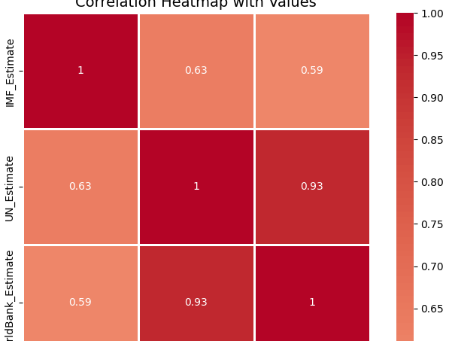

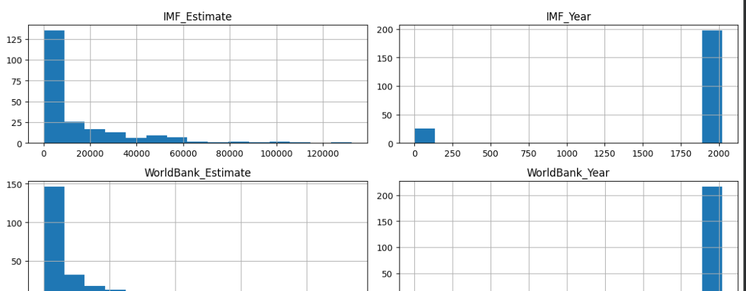

Course Notes

It is recommended to take notes from the course, use the space below to do so, or use the revision guide shared with the class:

Additional Information

We have included a range of additional links to further resources and information that you may find useful, these can be found within your revision guide.

END OF WORKBOOK

Please check through your work thoroughly before submitting and update the table of contents if required.

Please send your completed work booklet to your trainer.

