Trait dispersion drives a continuous loss of collective order in a heterogeneous Vicsek model: a finite-size scaling analysis
Umar Aziz
[Affiliation — to be completed]
[Corresponding author email — to be completed] · ORCID 0009-0009-6266-4340

Abstract
Collective motion in animal groups is classically studied under the assumption that individuals are interchangeable. Real groups are not homogeneous: individuals differ consistently in how strongly they respond to social cues, and this individual heterogeneity is increasingly recognised as a driver of group-level outcomes. Here we ask a deliberately narrow question using an agent-based model: if the population mean of a social-responsiveness trait is held fixed, does increasing the dispersion of that trait across individuals change collective order, and how does this interact with movement noise? We use a heterogeneous Vicsek-type model in which each self-propelled agent carries an individual social weight w drawn from a Beta distribution with fixed mean (0.7) and systematically varied standard deviation σ (0 to 0.45), at three movement-noise levels (η = 0.3, 0.5, 0.7). Increasing trait dispersion produces a smooth, continuous decline of the polar order parameter φ rather than a sharp threshold. The dispersion tolerated before order begins to erode (φ = 0.90) falls monotonically as noise rises, from σ* ≈ 0.36 at η = 0.3 to σ* ≈ 0.28 at η = 0.7, and the effect is traceable to a growing minority of weakly responsive individuals as the trait distribution develops heavy tails. To test whether this decline reflects a genuine collective phenomenon rather than a single-size artifact, we performed a finite-size-scaling analysis across five system sizes (N = 100, 200, 400, 800, 1600) at fixed density. The between-replicate susceptibility grows as a clean power of system size (χ_{max} ∝ N^{0.91}), showing that the order fluctuations are collective rather than independent across individuals, and the Binder cumulants for different sizes remain near the ordered-phase value at low dispersion and converge in the high-dispersion region. The associated order–disorder transition lies near the upper edge of the accessible dispersion range, close to the variance ceiling of the mean-0.7 trait distribution, where the distribution is necessarily bimodal; we therefore characterise the approach to an order–disorder transition rather than extracting a sharply located critical point with universal exponents. The framework is offered as a transparent, fully reproducible scaffold for later work integrating empirical movement data.
Keywords: collective motion; Vicsek model; individual heterogeneity; behavioural variation; flocking; order–disorder; finite-size scaling; agent-based model

1. Introduction
Coordinated collective motion — flocks of birds, schools of fish, herds of grazing mammals, and marching insect bands — emerges from local interactions among individuals without centralised control [1–6]. A long tradition of self-propelled-particle models, beginning with Reynolds' boids [2] and the minimal model of Vicsek and colleagues [1], has established that simple alignment rules combined with noise are sufficient to generate an order–disorder transition: above a critical noise the group moves coherently, and below it motion is incoherent [1,15–18]. Empirical studies of starlings [8], pigeons [10], baboons [11], locusts [9], fish [22], and sheep [12,13] have since grounded these abstractions in measured interaction rules.
Classical models treat individuals as interchangeable. Yet a large body of behavioural-ecology research shows that group-living animals differ consistently and repeatably in traits such as boldness, sociability, and responsiveness to neighbours [19–21]. Such individual heterogeneity is not noise to be averaged away: it can determine leadership, spatial position, and group-level performance [4,5,21], and Jolles, King and Killen [19] argue it is a key intermediary mechanism linking individual phenotype to collective outcome. A natural and underexplored question follows: holding the average behaviour of a group constant, does the spread of behaviour among its members matter for collective order?
Disentangling the mean of a trait from its dispersion is essential, because the two are easily confounded. If one simply lowers average social responsiveness, order will of course decline. The more informative manipulation fixes the mean and varies only the variance. Here I implement exactly this manipulation in a heterogeneous Vicsek-type model, assigning each agent an individual social weight drawn from a Beta distribution whose mean is held at 0.7 while its standard deviation σ is swept from 0 (homogeneous) to 0.45 (maximally dispersed). Because environmental and sensory noise also modulate alignment [1,15], I repeat the sweep at three noise levels and examine the interaction.
My aims are deliberately conservative. I characterise (i) the functional form of the order response to dispersion, (ii) how movement noise shifts the dispersion a group tolerates, (iii) the accompanying fluctuation and temporal-autocorrelation signatures, and (iv) the distributional mechanism underlying the effect. I then ask, through a finite-size-scaling (FSS) analysis across five system sizes at fixed density, whether the order loss is a genuine collective phenomenon whose fluctuations scale with system size, or merely a single-size artifact. As I show, the fluctuations are demonstrably collective, but the transition itself sits at the upper structural edge of the trait model, so I make no claim of a precisely localised thermodynamic critical point or of universal critical exponents. The model is abstract and simulation-only, and is presented as a reproducible scaffold rather than a fitted description of any particular species.

2. Materials and Methods

2.1 Model
The model is a heterogeneous variant of the standard Vicsek self-propelled-particle model [1]. N point agents move at constant speed v = 0.03 in a two-dimensional square domain of side L with periodic boundary conditions. Each agent i has a position and a heading θ_{i}. At every discrete time step, agent i identifies its neighbours within a metric interaction radius r = 1.0 and computes the average heading of those neighbours. The agent then updates its heading toward this local average, with the strength of the update set by its individual social weight w_{i} ∈ [0,1]: an agent with w_{i} = 1 aligns fully to its neighbourhood, while an agent with w_{i} = 0 ignores neighbours and follows only its own previous heading. A uniform random perturbation of amplitude η (the movement-noise parameter) is added to every heading update, and positions are advanced by one step along the new heading. The single-size sweeps use the canonical N = 200, L = 20; the finite-size-scaling sweep varies N at fixed density (Section 2.7). The exact update equations are implemented in src/heterogeneous_model_v2.jl in the accompanying repository.

2.2 Order parameter and observables
Collective order is quantified by the polar order parameter φ, the normalised magnitude of the mean heading vector across all agents. φ = 1 indicates perfect directional consensus and φ ≈ 0 indicates incoherent motion. For each run φ was averaged over the stationary portion of the trajectory (Section 2.5). Four further observables were recorded per condition: the between-replicate susceptibility χ = N · Var(φ), estimated across independent seeds; the Binder fourth-order cumulant U = 1 − ⟨φ⁴⟩ / (3⟨φ²⟩²), which tends to 2/3 in the ordered phase and to 0 in the disordered phase and is the standard finite-size crossing diagnostic [24]; the lag-1 temporal autocorrelation of the φ time series, a measure of relaxation speed; and the fractions of the population in the weakly responsive (w < 0.2) and strongly responsive (w > 0.8) tails of the trait distribution.

2.3 Trait distribution
Each agent's social weight w_{i} was drawn independently from a Beta distribution reparameterised by its mean μ and standard deviation σ. The mean was fixed at μ = 0.7 throughout, so that the average social responsiveness of the population was identical across all conditions; only the dispersion σ was varied. This decoupling is the central experimental manipulation. For a Beta distribution with mean 0.7 the standard deviation is mathematically bounded above by √(0.7 × 0.3) ≈ 0.458; the top of the swept range (σ = 0.45) therefore approaches this ceiling, at which the distribution necessarily becomes U-shaped (bimodal). This constraint is central to the interpretation of the finite-size-scaling results and is examined directly below.

2.4 Single-size parameter sweep
The dispersion σ was swept from 0.000 to 0.450 in steps of 0.025 (19 values), crossed with three movement-noise levels η ∈ {0.3, 0.5, 0.7}, giving 57 conditions. Each condition was simulated with 20 independent random seeds, for a total of 1,140 runs at the canonical size N = 200. Each run comprised 60,000 time steps. All simulations were implemented in Julia using the Agents.jl framework; the pinned environment is provided in Project.toml and Manifest.toml.

2.5 Equilibration and relaxation diagnostics
Because order parameters in alignment models relax slowly near the transition, the measurement window was validated explicitly. The first 30,000 of 60,000 steps were discarded as transient. Two diagnostics support this choice. First, a comparison of short (500-step) against long runs shows that short runs overstate φ by up to approximately 0.13 in the transition region (e.g. a bias of 0.134 at σ = 0.35), confirming that brief simulations would have produced spuriously sharp, high-order results. Second, a relaxation analysis comparing the third and fourth quarters of each long run shows a late-run drift of ≤ 0.01 at every dispersion level (maximum 0.010 at σ = 0.33), indicating that the retained measurements are stationary. The same relaxation analysis found no evidence of bistability or hysteresis. Diagnostic outputs are provided in results/diagnostics/.

2.6 Statistics
Condition means were computed across seeds. Ninety-five percent confidence intervals on φ were obtained by nonparametric bootstrap resampling of the per-seed values (3,000 resamples). The dispersion threshold σ* was defined as the value of σ at which the mean order curve crosses φ = 0.90, obtained by linear interpolation between adjacent grid points. No null-hypothesis significance tests were performed; this is a parameter-sweep study and effect sizes are read directly from the curves. Analysis scripts (Python: numpy, pandas, matplotlib, scipy) are provided in src/.

2.7 Finite-size-scaling sweep
To distinguish a genuine collective transition from a single-size artifact, the dispersion sweep was repeated at five system sizes, N ∈ {100, 200, 400, 800, 1600}, holding the number density ρ = N/L² constant at 0.5 (the canonical N = 200, L = 20 value), so that the domain side scales as L = √(N/ρ). Holding density fixed is the correct FSS protocol: each agent sees the same expected number of neighbours regardless of system size, so only the system size — not the local interaction structure — changes. The dispersion was swept over the same 19 values (0.000–0.450, step 0.025) at the single noise level η = 0.5, giving 95 conditions, each run with 16 independent seeds (1,520 runs total). Each run comprised 80,000 steps with the first 40,000 discarded as transient. For each run the time-series moments ⟨φ⟩, ⟨φ²⟩ and ⟨φ⁴⟩ were accumulated over the stationary window, yielding the order parameter, the susceptibility χ = N(⟨φ²⟩ − ⟨φ⟩²), and the Binder cumulant U. The growth of the susceptibility maximum with N and the relative positions of the Binder curves are the core FSS deliverables. The sweep and analysis are implemented in src/fss_sweep_v2.jl and src/analyze_fss.py.

3. Results

3.1 Order declines smoothly and continuously with trait dispersion
At zero dispersion the flock is strongly ordered at all three noise levels, with φ = 0.990, 0.974 and 0.947 at η = 0.3, 0.5 and 0.7 respectively (Fig. 1a). As σ increases, φ declines smoothly and monotonically, reaching 0.603, 0.573 and 0.540 at the maximum dispersion σ = 0.45. The decline is gradual rather than abrupt: order is essentially flat for σ ≲ 0.2, rolls off through an intermediate region, and continues to fall without any discontinuity across the full swept range. Bootstrap confidence intervals are narrow throughout (Fig. 1a, shaded bands). Within the parameter range explored, φ does not fall below approximately 0.54; the study therefore characterises the onset and progressive erosion of order, not its complete breakdown.

3.2 Movement noise reduces the dispersion a group can tolerate
The dispersion tolerated before order begins to erode, quantified by the φ = 0.90 crossing σ*, decreases monotonically with movement noise (Fig. 1b; Table 2): σ* ≈ 0.36 at η = 0.3, ≈ 0.32 at η = 0.5, and ≈ 0.28 at η = 0.7. In other words, the more environmental or sensory noise individuals are subject to, the less behavioural diversity the group can absorb before cohesion is measurably degraded. This noise–dispersion interaction is the central single-size quantitative result, and the φ = 0.90 threshold is reported in preference to fluctuation-based measures because it is clean and strictly monotonic.

3.3 Fluctuations grow as order is lost
Between-replicate susceptibility χ = N · Var(φ) is negligible at low dispersion and grows as σ increases, becoming largest in the σ ≈ 0.40–0.45 region where order is eroding most steeply (Fig. 1c). At the single canonical size the precise location of the maximum is not cleanly reproducible across noise levels; the susceptibility is interpreted here only as evidence that run-to-run variability is greatest in the transition region. Its scaling with system size is treated quantitatively in Section 3.6.

3.4 Temporal autocorrelation rises as the group approaches disorder
The lag-1 temporal autocorrelation of the φ time series increases as dispersion rises, from approximately 0.97 at low σ toward values approaching 0.99–1.00 at high σ (Fig. 1d). A higher autocorrelation indicates that fluctuations in order decay more slowly, i.e. the system relaxes more sluggishly as it approaches the loss of order. This slowing of relaxation is reminiscent of the early-warning signatures described for approaching transitions in other systems [23] and is consistent with the collective character of the fluctuations established by the finite-size-scaling analysis below.

3.5 Mechanism: heavy tails in the trait distribution
The order loss is traceable to the changing shape of the trait distribution. Holding the mean fixed while raising σ necessarily develops heavy tails: the fraction of weakly responsive individuals (w < 0.2) grows from 0 to approximately 0.30, and the fraction of strongly responsive individuals (w > 0.8) grows from 0 to approximately 0.68, as σ increases to 0.45 (Fig. 1e). Figure 1f shows the underlying Beta densities: at σ = 0.1 the distribution is unimodal around the mean, whereas at σ = 0.45 it is U-shaped, splitting the population into near-non-responders and near-full-aligners. A growing cohort of weakly responsive agents that barely track their neighbours provides a transparent mechanism for the erosion of order. The accompanying spatial snapshots (Fig. 2) visualise this progression: headings are near-uniform at σ = 0, partially fragmented at intermediate σ, and broadly disordered at σ = 0.45, with the spontaneous density structure characteristic of Vicsek-type dynamics visible throughout.
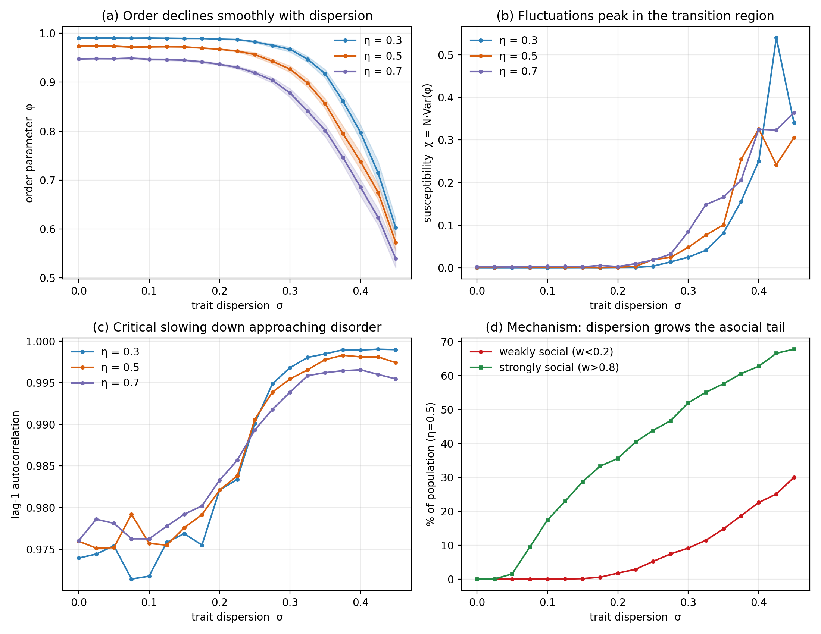
Figure 1. Trait dispersion drives a continuous loss of collective order (single size, N = 200). (a) The polar order parameter φ versus trait dispersion σ at three movement-noise levels η; shaded bands are bootstrap 95% confidence intervals and the dotted line marks φ = 0.90. (b) The tolerated dispersion σ* (the φ = 0.90 crossing) decreases monotonically with noise. (c) Between-replicate susceptibility χ = N·Var(φ) grows and is largest in the σ ≈ 0.40–0.45 region. (d) Lag-1 temporal autocorrelation of φ rises as dispersion increases, indicating slower relaxation. (e) Composition of the imposed trait distribution: the weakly responsive (w < 0.2) and strongly responsive (w > 0.8) tail fractions grow with σ (shown at η = 0.5; noise-independent by construction). (f) Beta trait densities for three dispersions, showing the transition from a unimodal distribution at low σ to a U-shaped distribution at σ = 0.45.
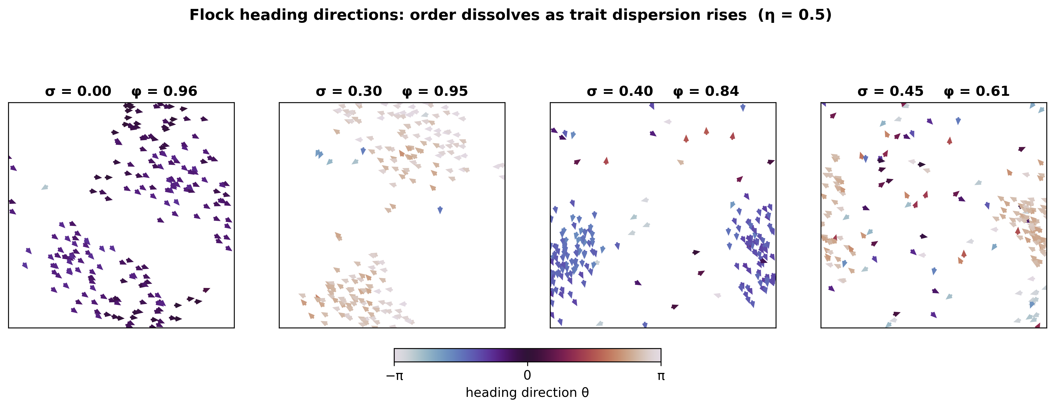
Figure 2. Representative flock heading fields at η = 0.5 for increasing trait dispersion (single seed). Each arrow is one agent, coloured by heading direction θ on a cyclic colour scale; the per-panel order parameter φ is annotated. Headings are near-uniform at σ = 0.00 (φ = 0.96), remain largely aligned at σ = 0.30 (φ = 0.95), fragment at σ = 0.40 (φ = 0.84), and become broadly disordered at σ = 0.45 (φ = 0.61). Spatial density structure reflects the spontaneous clustering characteristic of Vicsek-type alignment dynamics.

3.6 Finite-size scaling: the loss of order is a collective phenomenon
Repeating the dispersion sweep across five system sizes at fixed density resolves whether the order loss is collective or a single-size artifact (Fig. 3). Three features stand out. First, the order curves retain their smooth, continuous form at every N; larger systems are slightly more ordered in the low-dispersion plateau and roll off marginally more steeply, but no discontinuity emerges (Fig. 3a). Second, and most importantly, the between-replicate susceptibility grows strongly and systematically with system size: the susceptibility maximum χ_{max} rises from 2.82 at N = 100 to 4.16, 7.81, 15.86 and 33.81 at N = 200, 400, 800 and 1600 (Fig. 3b; Table 3). On log–log axes this growth is a clean straight line, χ_{max} ∝ N^{0.91} (Fig. 3d). Because χ = N · Var(φ), an exponent close to unity means that Var(φ) is almost independent of system size — the order-parameter fluctuations do not self-average away as the group grows. This is the defining signature of collective, system-spanning fluctuations rather than independent per-agent noise, and it is the principal result of the scaling analysis: the erosion of order is a genuine cooperative effect, not an artifact of measuring a single small system.
The third feature qualifies how far that interpretation can be pushed. For every size N ≥ 200 the susceptibility peak sits at the largest swept dispersion, σ = 0.45 (Table 3): the susceptibility is still rising where the data run out, so its maximum is not captured within the accessible range. This is not an arbitrary cutoff. As noted in Section 2.3, a Beta distribution with mean 0.7 has a hard maximum standard deviation of √(0.7 × 0.3) ≈ 0.458, so σ = 0.45 is essentially the structural ceiling of the trait model, at which the distribution is forced into the bimodal U-shape of Fig. 1f. The order–disorder transition therefore lies at or beyond this upper edge, where increasing variance and splitting the population into non-responders and full-responders are not separable. Consistent with this, the Binder cumulants for all five sizes remain near the ordered-phase value of 2/3 across the low-dispersion plateau and separate only at high dispersion, converging and tangling in the σ ≈ 0.43–0.45 region (Fig. 3c; Table 4) — behaviour consistent with an approaching crossing near the upper edge, but not resolving a single sharp crossing point within the accessible range.
Two consequences follow, and I state them plainly. The size scaling of the susceptibility is robust and removes the single most important limitation of the original single-size study: the order loss is collective. But because the transition sits at the structural variance ceiling, the susceptibility peak is not bracketed, and I therefore do not interpret the empirical exponent of 0.91 as a measured critical exponent γ/ν, nor do I claim a precisely localised critical point. The honest reading is that the model exhibits the approach to a collective order–disorder transition whose critical point lies at the edge of — or just beyond — the dispersion range that the mean-0.7 trait distribution can structurally support.
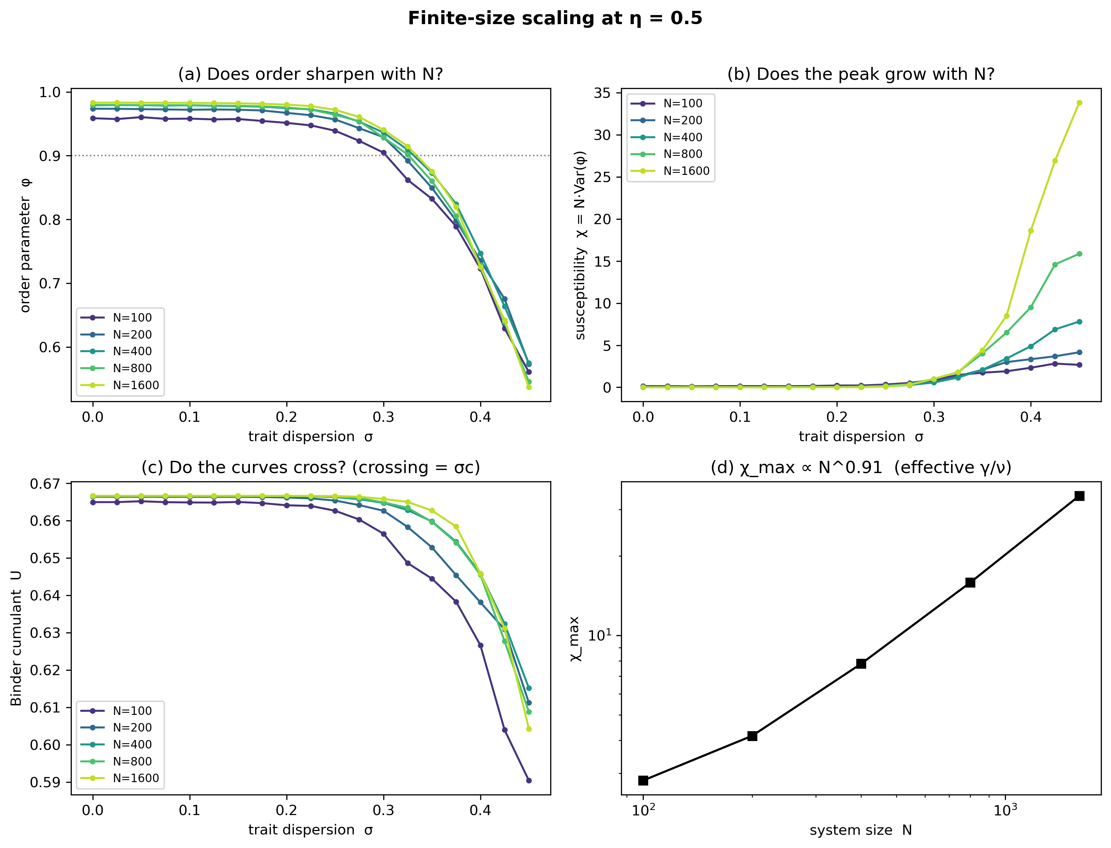
Figure 3. Finite-size scaling at η = 0.5 across five system sizes (N = 100–1600) at fixed density ρ = 0.5. (a) Order parameter φ versus dispersion σ; curves retain their smooth form at every N, with larger systems slightly more ordered on the plateau. (b) Between-replicate susceptibility χ = N·Var(φ); the peak grows strongly with N and, for N ≥ 200, sits at the largest swept dispersion (σ = 0.45), i.e. the susceptibility is still rising at the edge of the accessible range. (c) Binder cumulant U; curves remain near the ordered-phase value 2/3 at low σ and converge in the σ ≈ 0.43–0.45 region. (d) Log–log scaling of χ_max with N: a clean power law, χ_max ∝ N^0.91, indicating that order-parameter fluctuations are collective (Var(φ) nearly N-independent). The empirical exponent is not interpreted as a critical γ/ν because the susceptibility peak is not captured within the accessible dispersion range (see text).

4. Discussion
Holding the mean social responsiveness of a simulated group constant while increasing the dispersion of that trait produces a smooth, continuous, and noise-dependent erosion of collective order. The effect is not a sharp threshold but a gradual roll-off, and the dispersion a group tolerates before order degrades shrinks as movement noise grows. These findings extend the minimal Vicsek picture [1,18] by showing that the second moment of a behavioural trait — not only its mean and not only the external noise — is a determinant of collective order, consistent with the broader argument that individual heterogeneity is a mechanistically important variable in collective behaviour [19,21].
The finite-size-scaling analysis is what lifts this from a single-size observation to a statement about collective dynamics. The susceptibility maximum grows as a clean power of system size (χ_{max} ∝ N^{0.91}), so the variance of the order parameter is nearly size-independent and the fluctuations do not self-average. Independent per-agent noise would instead give a size-independent χ and a Var(φ) falling as 1/N; the observed scaling is qualitatively different and identifies the order loss as a cooperative, system-spanning phenomenon. This directly answers the question the single-size study could only pose, and it is the result that most strengthens the contribution.
The mechanism is transparent and is made explicit rather than left implicit. Fixing the mean of a bounded trait while inflating its variance necessarily moves probability mass into the tails (Fig. 1e,f). The growing cohort of weakly responsive agents — individuals that barely align to their neighbours — is sufficient to account for the loss of order. This same structural fact bounds the interpretation of the transition. Because the trait is bounded on [0,1] with a fixed mean of 0.7, its variance cannot exceed ≈ 0.21 (σ ≈ 0.458), and the order–disorder transition revealed by the scaling analysis sits at this very edge. At that edge, increasing variance and forcing the population into a bimodal split of non-responders and full-responders are one and the same manipulation. The transition is therefore real and collective, but it is structurally pinned to the boundary of what the mean-0.7 trait model can express, which is why I decline to extract a critical point or universal exponents from it.
One further interpretive caution is warranted. The rising temporal autocorrelation of φ (Fig. 1d) resembles the critical-slowing-down signature used as an early-warning indicator in ecological and physical systems [23]. Read alongside the size scaling of the susceptibility, it is consistent with the approach to a collective transition; but it does not by itself establish a diverging correlation time, and should be read as slower relaxation accompanying the collective loss of order.

4.1 Relation to animal movement and to sheep specifically
This model is abstract. It is a generic alignment model and contains no ingredient specific to any species: there is no attraction or repulsion zone, no explicit field of view, and no behavioural-state switching of the kind shown to govern real sheep herds, where intermittent collective dynamics arise from alternating slow dispersion and rapid, allelomimetic regrouping [12,13]. The connection to livestock is therefore one of motivation rather than of fitted correspondence. Framed honestly, the contribution is a controlled demonstration that behavioural dispersion erodes alignment through a collective mechanism in a minimal model; whether the same quantitative relationship holds in animals with cohesion forces and discrete behavioural states is an empirical question that this work cannot answer and does not claim to.

4.2 Limitations
The principal limitations are: (i) the order–disorder transition lies at the upper structural edge of the trait model (the variance ceiling of the mean-0.7 Beta distribution), so the susceptibility peak is not bracketed and a precise critical point and universal exponents cannot be extracted; (ii) the finite-size-scaling sweep was carried out at a single noise level (η = 0.5), so the size dependence of the noise–dispersion interaction is not mapped; (iii) an abstract, alignment-only model with no cohesion, attraction, or empirically calibrated interaction rules; (iv) a bounded trait distribution whose variance and shape are coupled at high dispersion; and (v) no empirical validation, since no movement data were used. Each is a clear target for future work.

4.3 Future directions
The most informative next step follows directly from the main limitation. Because the transition is pinned to the variance ceiling of the mean-0.7 trait distribution, moving it into the interior of the accessible range would allow the susceptibility peak to be captured and a critical point localised. Two manipulations achieve this: lowering the trait mean (e.g. to 0.5, which raises the attainable variance and is expected to bring the transition well inside the swept range), or sweeping the movement noise η at fixed dispersion, since noise has no upper structural bound. Either would convert the present “approach to a transition” into a bracketed transition with a measurable crossing. Beyond this, incorporating cohesion and behavioural-state switching would bring the model closer to documented sheep dynamics [12], and confronting the same trait-dispersion manipulation with empirical movement data — for example GPS trajectories of grazing flocks, by inferring per-individual responsiveness and testing whether real among-individual dispersion predicts measured cohesion — would close the loop between the model and real groups. The present framework is designed as a transparent, fully reproducible scaffold for exactly such extensions.

5. Conclusions
In a heterogeneous Vicsek model with fixed mean social responsiveness, increasing the dispersion of responsiveness across individuals causes a continuous loss of collective order, and the dispersion a group tolerates falls as movement noise rises. A finite-size-scaling analysis across five system sizes shows that the order-parameter fluctuations are collective — the susceptibility maximum grows as χ_{max} ∝ N^{0.91} — establishing the order loss as a genuine cooperative phenomenon rather than a single-size artifact. The transition itself lies at the upper structural edge of the trait model, where the mean-0.7 distribution becomes bimodal, so the result is reported as the approach to a collective order–disorder transition rather than as a precisely localised critical point. The effect is driven by the growth of a weakly responsive minority as the trait distribution develops heavy tails. The results are presented with their mechanism and limitations made explicit, and are intended as a reproducible foundation for future work linking behavioural variation to collective movement in real animal groups.

Tables
Table 1. Model and simulation parameters.
Parameter | Single-size sweep | Finite-size-scaling sweep
Number of agents, N | 200 | 100, 200, 400, 800, 1600
Domain side, L (periodic) | 20 | √(N/ρ), ρ = 0.5 fixed
Speed, v | 0.03 | 0.03
Interaction radius, r | 1.0 | 1.0
Trait distribution | Beta, mean 0.7 | Beta, mean 0.7
Trait dispersion, σ | 0.000–0.450, step 0.025 (19) | 0.000–0.450, step 0.025 (19)
Movement noise, η | 0.3, 0.5, 0.7 | 0.5
Steps per run | 60,000 (first 30,000 discarded) | 80,000 (first 40,000 discarded)
Seeds per condition | 20 | 16
Total runs | 1,140 | 1,520
Table 2. Tolerated trait dispersion σ* (the φ = 0.90 crossing) at each movement-noise level, with order at the dispersion extremes (single size, N = 200).
Noise η | φ at σ = 0 | φ at σ = 0.45 | σ* (φ = 0.90)
0.3 | 0.990 | 0.603 | 0.358
0.5 | 0.974 | 0.573 | 0.323
0.7 | 0.947 | 0.540 | 0.279
Table 3. Finite-size scaling of the susceptibility at η = 0.5. The maximum χ grows as a clean power of N (χ_max ∝ N^0.91). For N ≥ 200 the maximum sits at the largest swept dispersion, indicating the peak is not captured within the accessible range.
System size N | χ_max | σ at χ_max
100 | 2.82 | 0.425
200 | 4.16 | 0.450 (edge)
400 | 7.81 | 0.450 (edge)
800 | 15.86 | 0.450 (edge)
1600 | 33.81 | 0.450 (edge)
Table 4. Binder cumulant U(N, σ) in the high-dispersion region at η = 0.5. Curves remain near the ordered-phase value 2/3 at lower σ and converge in the σ ≈ 0.43–0.45 region.
σ | N=100 | N=200 | N=400 | N=800 | N=1600
0.350 | 0.6445 | 0.6528 | 0.6598 | 0.6597 | 0.6627
0.375 | 0.6383 | 0.6454 | 0.6544 | 0.6541 | 0.6584
0.400 | 0.6267 | 0.6381 | 0.6458 | 0.6455 | 0.6459
0.425 | 0.6039 | 0.6309 | 0.6324 | 0.6277 | 0.6312
0.450 | 0.5904 | 0.6113 | 0.6152 | 0.6088 | 0.6043

Supplementary Material
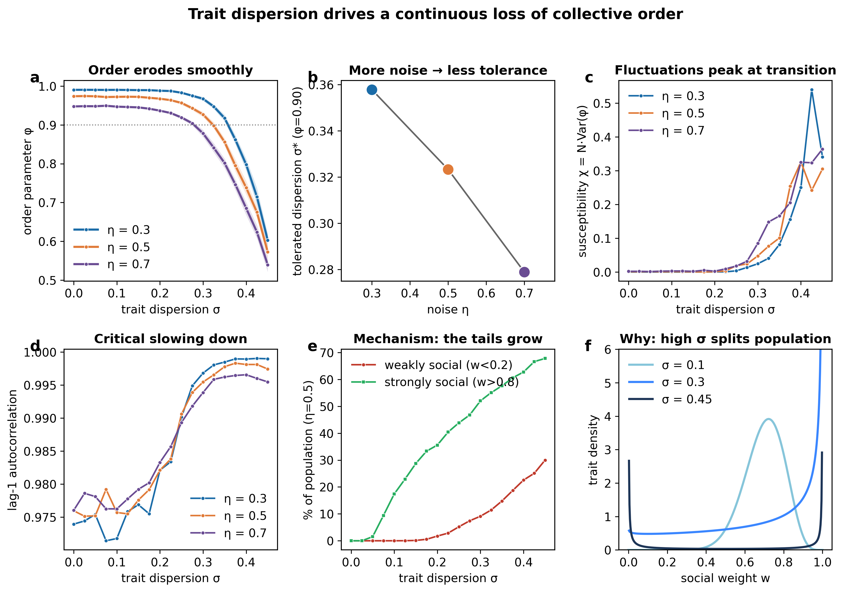
Figure S1. Four-panel summary of the single-size (N = 200) dataset, provided for completeness: (a) order curves with bootstrap confidence bands, (b) susceptibility, (c) lag-1 autocorrelation, and (d) the growth of the weakly and strongly responsive tail fractions at η = 0.5. The isolated high susceptibility value near σ = 0.42 at η = 0.3 reflects a single high-variance seed and should not be over-interpreted.

Data and Code Availability
All model code, simulation outputs, diagnostic data, and figure-generation scripts are openly available at https://github.com/Umar2213/sheep-collective-abm. The repository includes the Julia model and sweep scripts (single-size and finite-size-scaling), the equilibration and relaxation diagnostics, the canonical condition-mean and per-replicate datasets for both the single-size and finite-size-scaling sweeps (results/production/ and results/fss/), and the Python analysis and plotting scripts, together with a pinned computational environment (Project.toml, Manifest.toml, requirements.txt). A tagged release archived on Zenodo provides a permanent DOI [DOI to be inserted on acceptance].

Declarations
Funding: [to be completed]
Competing interests: The author declares no competing interests.
Acknowledgements: [to be completed]

References
- Vicsek T, Czirók A, Ben-Jacob E, Cohen I, Shochet O. Novel type of phase transition in a system of self-driven particles. Phys Rev Lett. 1995;75(6):1226–1229.
- Reynolds CW. Flocks, herds and schools: a distributed behavioral model. Comput Graph (ACM SIGGRAPH). 1987;21(4):25–34.
- Aoki I. A simulation study on the schooling mechanism in fish. Bull Jpn Soc Sci Fish. 1982;48(8):1081–1088.
- Couzin ID, Krause J, James R, Ruxton GD, Franks NR. Collective memory and spatial sorting in animal groups. J Theor Biol. 2002;218(1):1–11.
- Couzin ID, Krause J, Franks NR, Levin SA. Effective leadership and decision-making in animal groups on the move. Nature. 2005;433(7025):513–516.
- Sumpter DJT. The principles of collective animal behaviour. Philos Trans R Soc B. 2006;361(1465):5–22.
- Toner J, Tu Y. Long-range order in a two-dimensional dynamical XY model: how birds fly together. Phys Rev Lett. 1995;75(23):4326–4329.
- Ballerini M, Cabibbo N, Candelier R, et al. Interaction ruling animal collective behavior depends on topological rather than metric distance: evidence from a field study. Proc Natl Acad Sci USA. 2008;105(4):1232–1237.
- Buhl J, Sumpter DJT, Couzin ID, et al. From disorder to order in marching locusts. Science. 2006;312(5778):1402–1406.
- Nagy M, Ákos Z, Biro D, Vicsek T. Hierarchical group dynamics in pigeon flocks. Nature. 2010;464(7290):890–893.
- Strandburg-Peshkin A, Farine DR, Couzin ID, Crofoot MC. Shared decision-making drives collective movement in wild baboons. Science. 2015;348(6241):1358–1361.
- Ginelli F, Peruani F, Pillot MH, Chaté H, Theraulaz G, Bon R. Intermittent collective dynamics emerge from conflicting imperatives in sheep herds. Proc Natl Acad Sci USA. 2015;112(41):12729–12734.
- Gautrais J, Ginelli F, Fournier R, et al. Deciphering interactions in moving animal groups. PLoS Comput Biol. 2012;8(9):e1002678.
- Toulet S, Gautrais J, Bon R, Peruani F. Imitation combined with a characteristic stimulus duration results in robust collective decision-making. PLoS ONE. 2015;10(10):e0140188.
- Grégoire G, Chaté H. Onset of collective and cohesive motion. Phys Rev Lett. 2004;92(2):025702.
- Chaté H, Ginelli F, Grégoire G, Raynaud F. Collective motion of self-propelled particles interacting without cohesion. Phys Rev E. 2008;77(4):046113.
- Cavagna A, Cimarelli A, Giardina I, et al. Scale-free correlations in starling flocks. Proc Natl Acad Sci USA. 2010;107(26):11865–11870.
- Vicsek T, Zafeiris A. Collective motion. Phys Rep. 2012;517(3–4):71–140.
- Jolles JW, King AJ, Killen SS. The role of individual heterogeneity in collective animal behaviour. Trends Ecol Evol. 2020;35(3):278–291.
- Sih A, Bell A, Johnson JC. Behavioral syndromes: an ecological and evolutionary overview. Trends Ecol Evol. 2004;19(7):372–378.
- Jolles JW, Boogert NJ, Sridhar VH, Couzin ID, Manica A. Consistent individual differences drive collective behavior and group functioning of schooling fish. Curr Biol. 2017;27(18):2862–2868.
- Herbert-Read JE, Perna A, Mann RP, Schaerf TM, Sumpter DJT, Ward AJW. Inferring the rules of interaction of shoaling fish. Proc Natl Acad Sci USA. 2011;108(46):18726–18731.
- Scheffer M, Bascompte J, Brock WA, et al. Early-warning signals for critical transitions. Nature. 2009;461(7260):53–59.
- Binder K. Finite size scaling analysis of Ising model block distribution functions. Z Phys B Condens Matter. 1981;43(2):119–140.
- Baglietto G, Albano EV. Finite-size scaling analysis and dynamic study of the critical behavior of a model for the collective displacement of self-driven individuals. Phys Rev E. 2008;78(2):021125.
- Ioannou CC, Laskowski KL. A multi-scale review of the dynamics of collective behaviour: from rapid responses to ontogeny and evolution. Philos Trans R Soc B. 2023;378(1874):20220059.

