ASSIFNMENT #3
Group Number: 20
Roll Number: 24280025, 24280003
Topic created: 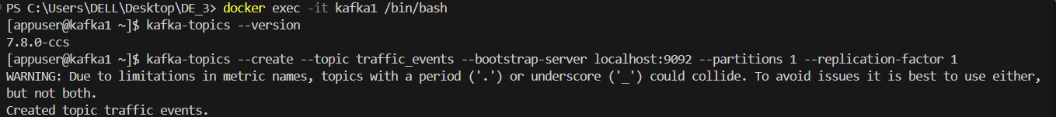

A stream of events on the command line: 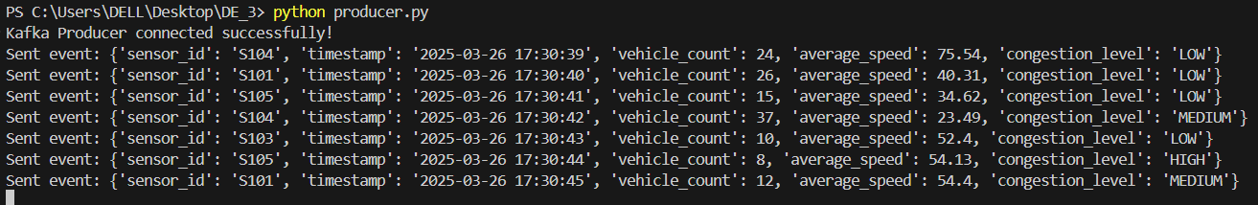

An error was appearing while running the streaming.py which wasn’t resolving.
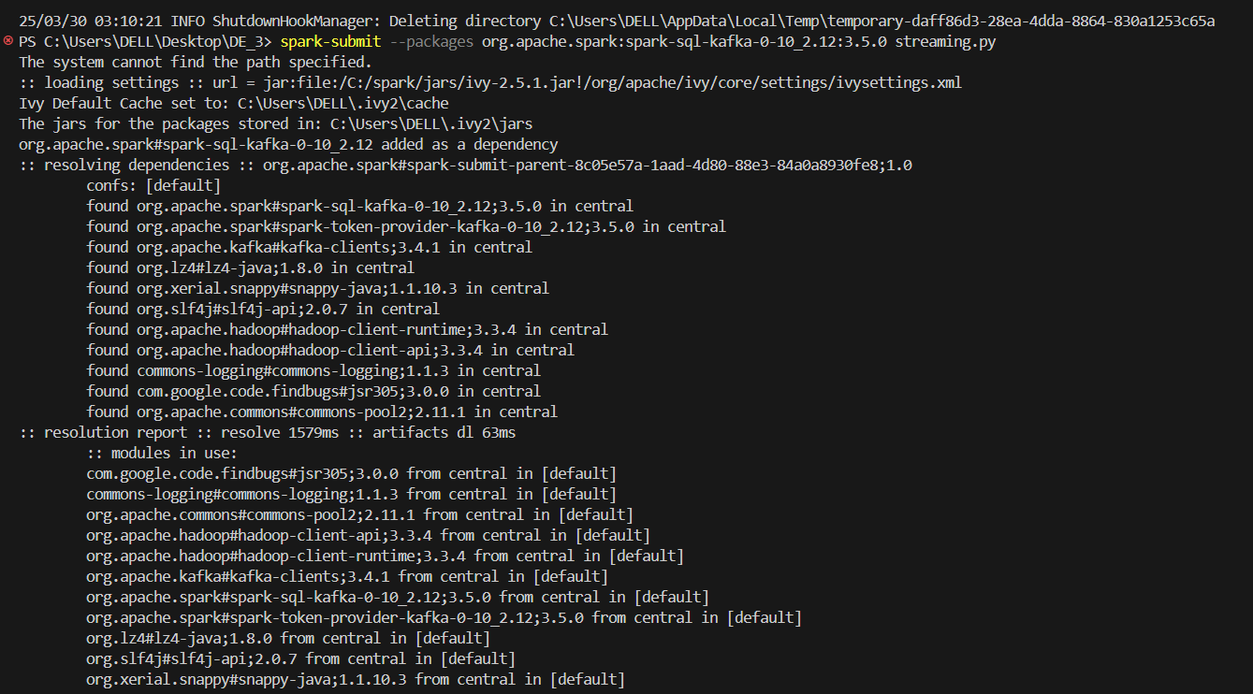
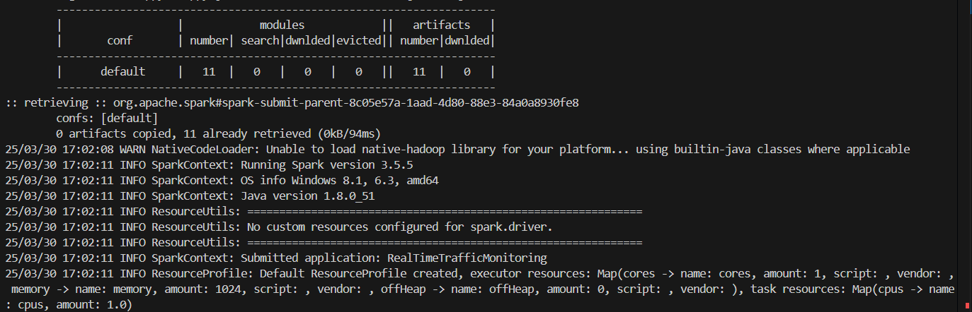
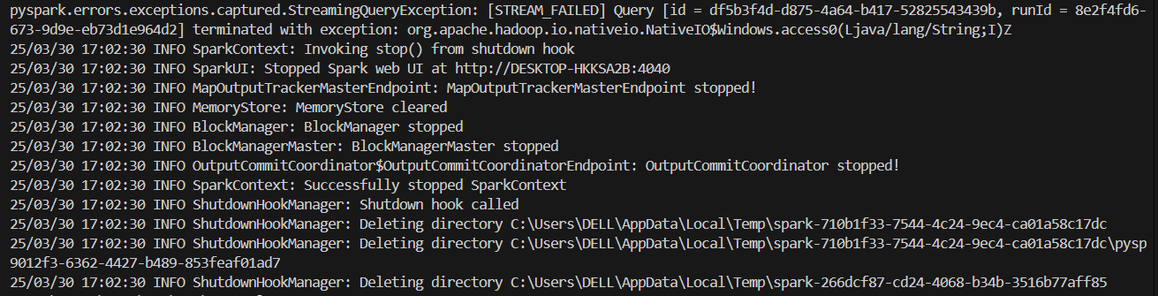
In order to avoid this error, we had to shift to ubuntu to run our code again. It resolved the error and the file was working absolutely fine. All the checks were added to the file and one by one every query was checked.
Stream of events: 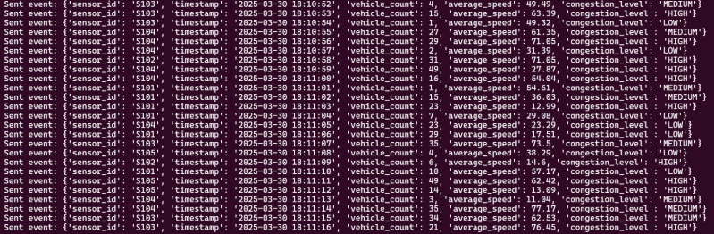

Query outputs:
QUERY1: 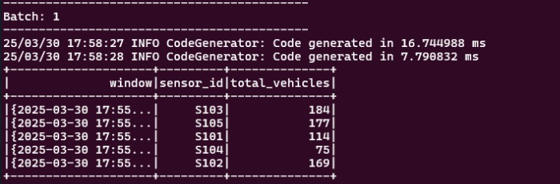
QUERY2: 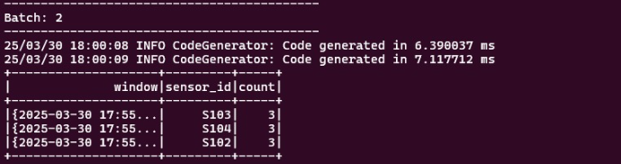

QUERY3: 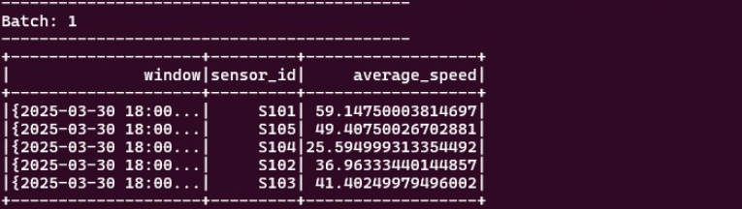

QUERY4: 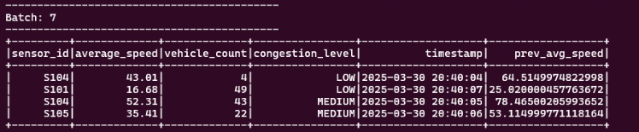
QUERY5: 