**ASSIGNMENT # 1**

**Subject: Computer Networking**



**Submitted by: Umar Abdullah**

**Submitted to: Sir Bakhtawar Ur Rehman**

**Program: B.S (Computer Science)**

**Registration #: 2121-323013**

**Date of Submission: 31st Jan 2025**

**DEPARTMENT OF COMPUTER SCIENCE**

**PRESTON UNIVERSITY KOHAT**

|  |  |  |
| --- | --- | --- |
| S#  1.  2.  3.  4.  5.  6.  7.  8.  9.  10.  11. | TITLE  What is unicast?  Unicast protocols  Advantages of unicast communication  Disadvantages of unicast communication  Real world example  What is multicast?  Three multicast protocols  Real world example  Packet tracer task  Network topology  Task description | PAGE#  3  4  5  6  7 |

**Q1: Unicast Protocols?**

**ANS:**

**Definition of Unicast Communication:**

Unicast communication is a one-to-one form of communication where data is sent from a single sender to a single receiver. In networking, it involves routing data packets from the source address to the destination address.

**Three Unicast Protocols:**

1. **Transmission Control Protocol (TCP):**
   * **Description:** TCP is a connection-oriented protocol that ensures reliable transmission of data between devices. It provides error-checking, flow control, and guarantees the delivery of packets in the correct order.
   * **Use Case:** Web browsing, email.
2. **User Datagram Protocol (UDP):**
   * **Description:** UDP is a connectionless protocol that provides faster, but less reliable data transmission compared to TCP. It doesn't guarantee packet delivery or order, making it suitable for applications that can tolerate some loss.
   * **Use Case:** Online gaming, video conferencing.
3. **Internet Protocol (IP):**
   * **Description:** IP is responsible for addressing and routing packets of data so that they can travel across networks and arrive at the correct destination.
   * **Use Case:** General internet traffic.

**Advantages of Unicast Communication:**

* **Efficiency:** Direct communication reduces unnecessary network load.
* **Reliability (TCP):** Protocols like TCP ensure data is transmitted accurately and in order.
* **Simplicity:** Straightforward communication between two devices.

**Disadvantages of Unicast Communication:**

* **Scalability:** Not efficient for scenarios involving multiple receivers, leading to potential network congestion.
* **Resource Intensive:** Each unicast session consumes network resources.

**Real-World Examples of Unicast Protocol Usage:**

* **Web Browsing:** When you access a website, your browser uses HTTP over TCP to communicate with the server.
* **Email:** Sending and receiving emails involves unicast communication using SMTP, IMAP, or POP3 over TCP.

**Q2: Multicast Protocols?**

**ANS:**

**Definition of Multicast Communication:**

Multicast communication involves data transmission from one sender to multiple receivers, but only those who have explicitly requested it. Unlike unicast, it avoids sending duplicate copies of the same data to multiple receivers.

**Three Multicast Protocols:**

1. **Internet Group Management Protocol (IGMP):**
   * **Description:** IGMP is used by IPv4 networks to establish multicast group memberships. It helps routers understand which devices want to receive specific multicast traffic.
   * **Use Case:** IPTV services.
2. **Protocol Independent Multicast (PIM):**
   * **Description:** PIM is used to manage multicast traffic efficiently in large networks. PIM-SM (Sparse Mode) and PIM-DM (Dense Mode) are two types.
   * **Use Case:** Video conferencing, online broadcasting.
3. **Real-Time Transport Protocol (RTP):**
   * **Description:** RTP is used for delivering audio and video over IP networks. It's often used in conjunction with UDP to provide end-to-end network transport functions suitable for applications transmitting real-time data.
   * **Use Case:** Streaming media.

**How Multicast Routing Works and Its Benefits:**

* **Operation:** Multicast routing relies on multicast group addresses, where routers use protocols like IGMP and PIM to manage and route the data to multiple recipients without redundancy.
* **Benefits:**
  + **Efficiency:** Reduces network bandwidth consumption by sending a single stream of data to multiple recipients.
  + **Scalability:** Suitable for applications involving large numbers of receivers.
  + **Cost-Effective:** Minimizes the overall load on the network infrastructure.

**Real-World Examples of Multicast Protocol Usage:**

* **Video Streaming:** Platforms like IPTV use multicast to efficiently deliver video content to subscribers.
* **Financial Networks:** Real-time stock ticker services often use multicast to disseminate data to multiple users.

**Q3: Packet Tracer Task:**

**Students will configure Routing Information Protocol (RIP) or Open Shortest Path First (OSPF) routing in Packet Tracer, including loopback addresses, to understand how routers manage multiple networks.**

**ANS:**

**NETWORK TOPOLOGY:**

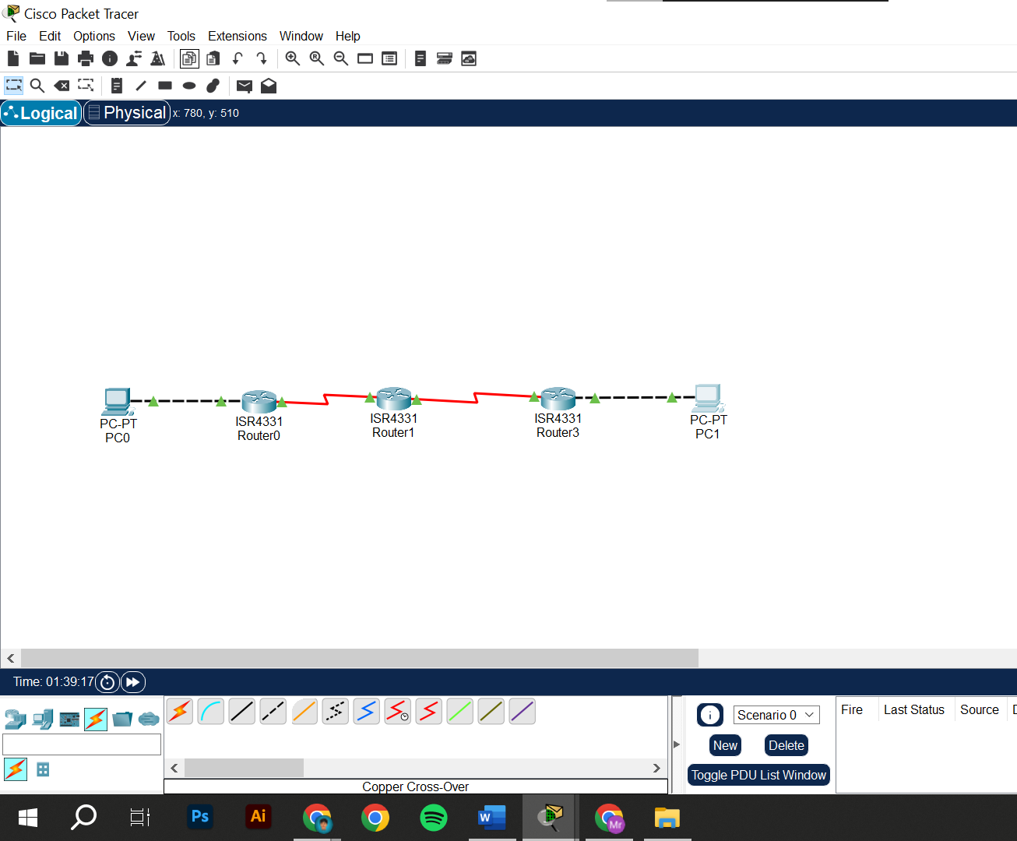

**ROUTING TABLE AND PING RESULT:**

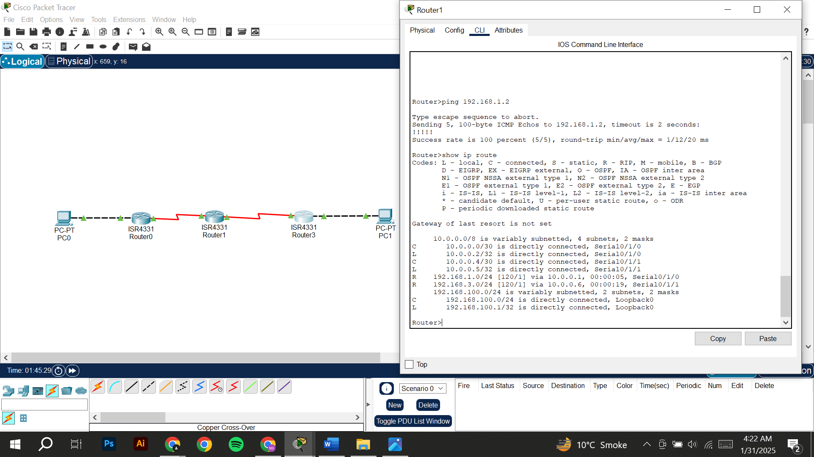

**TASK DESCRIPTION:**

In this task, we are setting up a network in Cisco Packet Tracer that consists of three routers connected via serial links, along with two PCs connected to different routers through Ethernet. The goal is to establish connectivity between all devices by configuring IP addresses, setting up Routing Information Protocol (RIP v2) for dynamic routing, and verifying network communication.

**The configuration process includes:**

1. **Network Design:** Creating a topology with routers, PCs, and proper connections.
2. **Assigning IP Addresses:** Configuring appropriate IP addresses for Ethernet and Serial interfaces.
3. **Configuring RIP v2:** Enabling the RIP routing protocol on all routers to dynamically share route information.
4. **Testing and Verification:** Using commands like show IP route, ping, and RIP to check network connectivity and troubleshoot issues.