Comsat University Islamabad
(Vehari Campus)

Project Title:Amazon Polly (Text-To-speech Converter)

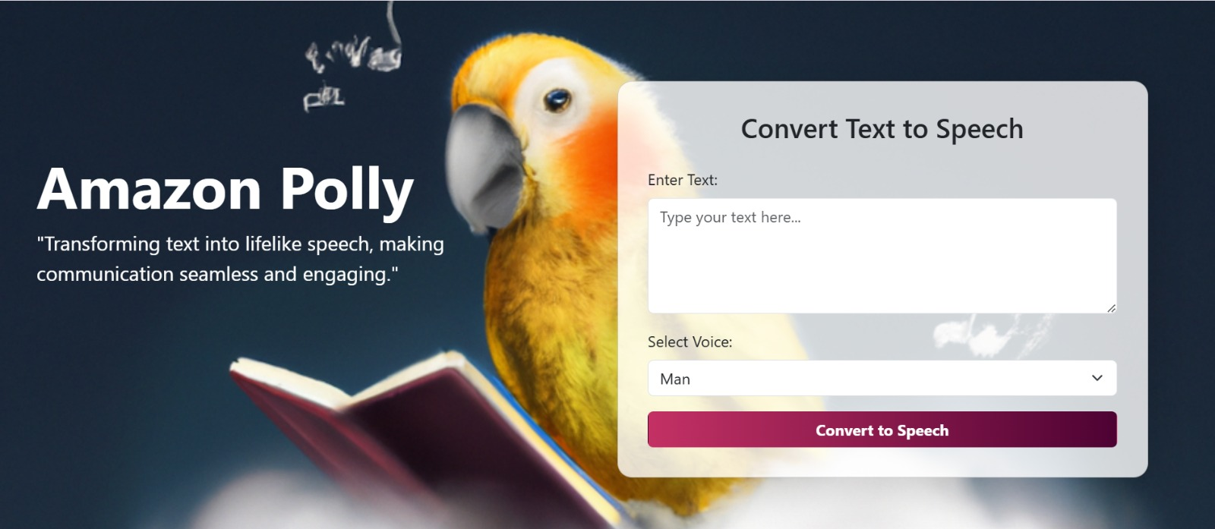

Submitted by:
Esha Fatima FA22-BCS-138
Manahil Tariq FA22-BCS-086
Submitted to:
Dr.Rehan Ashraf

Abstract
The rise of accessible and natural-sounding text-to-speech (TTS) systems has enabled significant advancements in human-computer interaction. This project, titled "Dynamic Text-to-Speech Conversion System," leverages ‘Microsoft Edge TTS’, and the ‘Flask framework’ to convert user-inputted text into lifelike audio in real time.
The system supports multiple voice styles and allows users to select different pitch and speed adjustments, providing a highly customizable audio experience. The project aims to create an interactive and user-friendly web-based application that demonstrates practical implementation of modern NLP-based tools.
This report provides an overview of the project's design, development, and implementation, including key code components, testing, and future improvements. Through this work, we aim to bridge the gap between static text content and its dynamic auditory representation.

Table of Contents
Abstract 2
1. Introduction 4
2. Objectives 4
3. Scope of the Project 5
3.1. Key Features 5
3.2. Technologies Used 5
3.3. Limitations 6
3.4. Applications 6
4. System Architecture 6
4.1. Overview 6
4.2. Components of the System 7
4.2.1. Frontend Layer 7
4.2.2. Backend Layer 7
4.2.3. External Services/API Integration 7
4.3. Flow of Execution 8
4.4. Advantages of the Design 8
5. Methodology 8
5.1. Importing Libraries 8
5.2. User Input 9
5.3. Backend Processing 11
5.4. Generating Speech with Edge TTS API 12
5.5. Saving and Returning Audio File 13
5.6. Frontend-Audio Playback 14
5.7 Error Handling 14
5. Challenges 16
6. Future Enhancements 16
7. Results 17
8. Conclusion 17
9. References 17

1. Introduction
In today’s fast-paced world, technology has significantly evolved, with one of the most remarkable advancements being Natural Language Processing (NLP). NLP enables computers to understand, interpret, and generate human language, making it a cornerstone in the development of intelligent systems that can communicate effectively with humans. One of the most exciting applications of NLP is the Text-to-Speech (TTS) technology, which converts written text into spoken words. TTS plays a critical role in enhancing accessibility for individuals with visual impairments, creating interactive voice assistants, and providing real-time information in various domains, such as customer service, e-learning, and navigation systems.
The main objective of this project is to create a web-based Text-to-Speech converter using Microsoft Edge TTS technology. This project explores the implementation of Edge TTS to provide a dynamic and customizable text-to-speech experience. Users can input any text, select the preferred voice type, and receive an audio output with lifelike speech. The project also offers flexibility in speech styles, such as different voices, pitch, and speed adjustments, making it adaptable to various use cases.
Initially, this project was based on a GitHub repository, but it has been customized and enhanced to meet specific requirements, focusing solely on the integration of Microsoft Edge TTS. By leveraging this tool, the project demonstrates how TTS can be used in practical applications like voice assistants, accessibility tools, and language learning.
This report outlines the design, implementation, and testing of the Text-to-Speech converter, with detailed discussions on the system architecture, the integration of TTS APIs, and the steps taken to ensure the smooth operation of the application. By the end of this report, readers will have a comprehensive understanding of how TTS systems work and how they can be effectively integrated into web applications for real-world use.

2. Objectives
The main objectives of the project are:
- Develop a user-friendly web-based text-to-speech converter.
- Integrate Microsoft Edge TTS for flexible and high-quality speech generation.
- Provide a seamless user experience with easy text input and voice selection.
- Generate audio files in MP3 format for download.
- Support both male and female voice options.
- Allow users to adjust the speech speed for better customization.

3. Scope of the Project

This project focuses on the development of a dynamic Text-to-Speech (TTS) conversion system using Microsoft Edge TTS API. The project aims to create a web-based application that can convert any user-provided text into natural-sounding speech, offering users the ability to choose different voices, adjust speech parameters like pitch and speed, and receive the output as an audio file.

3.1. Key Features

- Text-to-Speech Conversion: The primary functionality of the system is to convert input text into lifelike speech. It uses the Microsoft Edge TTS API to generate speech with high-quality, neural-based voices.
- Voice Selection: Users can select from different voice options, such as male and female voices, for speech output.
- Customization of Speech Output: Users can adjust the speed of the speech output to match their preferences, offering flexibility in how fast or slow the text is read.
- Audio Output: Once the text is converted, the generated speech is provided as an audio file that users can play or download.
- Web Interface: The system is designed with a simple, user-friendly web interface where users can enter text, choose the desired voice, and interact with the application.

3.2. Technologies Used

- Microsoft Edge TTS API: Microsoft Edge TTS is a cloud-based service that converts text into speech using deep learning models. It offers neural-based voices and is integrated into the project to provide high-quality speech synthesis. The service supports multiple voices and customizable parameters such as speed.
- Flask Framework: Flask is used as the backend framework for handling user requests, integrating the Edge TTS API, and generating the audio files.
- HTML/CSS/JavaScript: The frontend of the application is developed using HTML for the structure, CSS for styling, and JavaScript for handling user interactions and asynchronous requests.

3.3. Limitations

- Internet Connectivity: Since the system relies on the Microsoft Edge TTS API, a stable internet connection is required to access the service and generate the speech output.
- Voice Availability: The project uses only two voice options from the Microsoft Edge TTS API. While Edge TTS offers multiple voices, users can currently select from a predefined set of two voices.
- Real-Time Processing: Although the system provides real-time audio conversion, larger text inputs may experience slight delays due to processing time on the backend.

3.4. Applications

- Accessibility Tools: This project can be used in accessibility tools to assist visually impaired individuals by converting written text into spoken words.
- E-Learning Platforms: The system can be applied in e-learning platforms where text-based content can be converted into audio for a more engaging learning experience.
- Voice Assistants: It can be integrated into voice assistants to enhance user interaction with natural-sounding voice responses.
- Audiobook Generation: The system can be adapted to generate audiobooks by converting text-based books or articles into speech.
- Navigation Systems: The system can be used in navigation apps to provide real-time audio instructions for better accessibility and convenience.
- Customer Support Systems: The system can be implemented in customer service platforms to convert text-based responses into speech for better user interaction.

4. System Architecture

4.1. Overview

The system architecture is designed to enable seamless text-to-speech conversion. It is divided into distinct components to ensure flexibility, scalability, and maintainability. The system processes user input from the frontend, integrates with backend logic, and utilizes external services for text-to-speech conversion.

4.2. Components of the System

4.2.1. Frontend Layer
The frontend is the user-facing interface of the system.
- Key Features:
- A web page where users can input text and select voice preferences.
- Styled with HTML, CSS, and JavaScript to provide an interactive experience.
- Provides a submit button to send input to the backend.

- Purpose:
- Captures user input and voice preferences.
- Displays the generated audio file for playback or download.

4.2.2. Backend Layer
The backend is responsible for processing user input and managing the application's logic.
- Key Features:
- Developed using the Flask framework.
- Handles routing, user requests, and responses.
- Validates input and integrates with external APIs.
- Purpose:
- Validates the user’s input to ensure it meets requirements (e.g., no empty text).
- Calls the text-to-speech API and processes its response.
- Saves the generated audio files in a static directory for playback or download.

4.2.3. External Services/API Integration
The system uses Microsoft Edge TTS as the core text-to-speech service.

- Key Features:
- Converts text into natural-sounding speech.
- Offers support for multiple voices and languages.
- Efficiently generates audio files with a lifelike voice quality.

- Purpose:
- It generates the speech from text, making the system reliable and flexible.

4.3. Flow of Execution

- User Interaction:
The user inputs text and selects a voice from the web interface.
- Backend Processing:
The backend validates the input and generates a unique filename for the audio file.
- Text-to-Speech Conversion:
The backend communicates with the Edge TTS API to convert the text into speech.
- Response to the User:
The generated audio file is sent back to the frontend for playback or download.

4.4. Advantages of the Design

- Scalability:
The modular design allows for future integration of additional APIs or features, such as support for more languages or advanced voice customization.
- User-Friendly:
The clear separation between frontend, backend, and external services ensures a smooth user experience.
- Maintainability:
The structured design makes it easy to debug, update, or enhance the system over time.

5. Methodology

The Text-to-Speech (TTS) conversion system is a sophisticated application designed to convert user-provided text into spoken words using the Microsoft Edge TTS API. The methodology outlines the process from user input to speech output, detailing the steps involved in generating and delivering the speech in real-time.

5.1. Importing Libraries

- Purpose:
The purpose of this step is to load the necessary Python libraries required to implement the core functionalities of the Text-to-Speech Converter application. Each library serves

a specific purpose, such as handling web requests, managing audio files, or integrating Edge TTS APIs.
- Actions:
- The Flask library is imported to create and manage the web application, handling user requests and rendering templates.
- os is used to manage and create file directories dynamically.
- uuid generates unique names for audio files to prevent duplication.
- asyncio is used to handle asynchronous operations, ensuring non-blocking communication with the Edge TTS API.
- The edge_tts library is imported to communicate with Microsoft’s Edge TTS system and convert text to speech.
- Code:

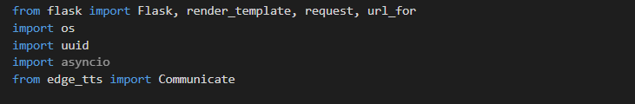

- Detailed Explanation of Code:
- Flask: This is the backbone of the application, enabling the connection between the frontend (HTML) and backend (Python logic).
- os: Creates the directories where audio files are saved during runtime. Ensures that the files are properly organized within the static/audio folder.
- uuid: Assigns unique names to audio files so that multiple users can interact with the system without overwriting files.
- asyncio: Ensures smooth and efficient communication with the Edge TTS API by allowing the application to handle multiple requests simultaneously.
- edge_tts.Communicate: This is the main library that interacts with Microsoft’s TTS service, enabling the conversion of text into natural-sounding audio.

5.2. User Input

The process begins with the user entering the desired text into a text field on the web interface. The user also selects the preferred voice (e.g., male or female). This step captures the user's input and preferences for the text-to-speech conversion. The inputted text and selected voice are sent to the backend for processing.

- Text Area for Input

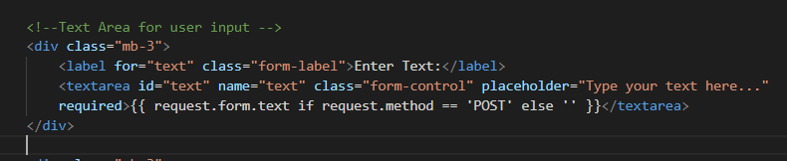

- Purpose:
- The purpose of this section is to allow the user to enter the text that they want to convert into speech.
- It provides a multi-line input field where the user can type their content.
- Actions:
- The <textarea> HTML element is used to create a multi-line input box.
- The required attribute ensures the form cannot be submitted without entering text.
- The {{ request.form.text }} is used to retain the text input after form submission so the user can see what they typed.

- Select Dropdown for Voice Selection

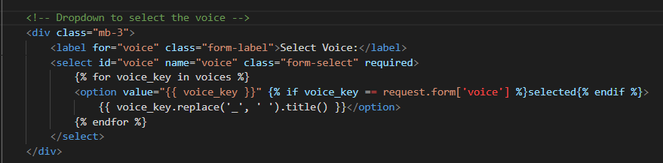

- Purpose:
- The dropdown list allows the user to select the voice for the speech synthesis process.
- It presents a set of predefined options (male, female, etc.) for the user to choose from.
- Actions:
- The <select> element creates a dropdown list of available voices.
- The {% for voice_key in voices %} is a Jinja loop that iterates through all the available voices.
- The selected attribute ensures that the selected voice stays chosen after form submission.

- Submit Button for Conversion

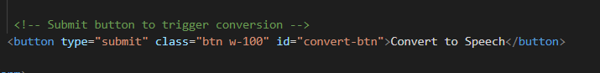

- Purpose:
- The button triggers the form submission, which sends the user input to the backend for processing.
- Actions:
- The <button> element creates a submit button that triggers the backend process when clicked.
- The w-100 class ensures the button occupies the full width of the container.

5.3. Backend Processing

Once the user submits the text and voice selection, the Flask application receives the data and processes it. The Flask route handles the request, retrieves the inputted text and voice selection, and sends them to the Microsoft Edge TTS API for text-to-speech conversion.

- Data Handling and Validation

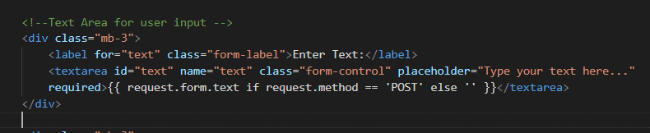

- Purpose:
- This section handles and validates the user input before passing it to the TTS API.
- It checks if the user has entered text and if the selected voice is valid.
- Actions:
- The if not text: condition checks if the user has entered text. If not, it returns an error.
- The if voice_selection not in VOICES: ensures the selected voice is valid by checking it against the available voices.

- Unique Filename Generation

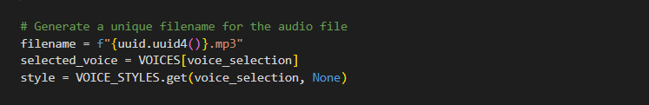

- Purpose
- The purpose of this step is to ensure that every audio file generated by the system has a unique name. This prevents overwriting issues when multiple users interact with the application or generate audio simultaneously.
- Actions
- Generate Unique Identifier:
The uuid.uuid4() function creates a unique identifier for each audio file. This ensures that even if multiple users generate files at the same time, their files are stored without conflicts.
- Select Voice for Speech Conversion:
The VOICES dictionary maps user selections to specific voice IDs provided by Edge TTS. This step retrieves the appropriate voice ID based on the user’s input.
- Retrieve Style (if applicable):
The VOICE_STYLES dictionary provides additional styles like pitch or rate adjustments for the selected voice. If no specific style is defined, this step defaults to None.

5.4. Generating Speech with Edge TTS API

The heart of the application is the generate_speech() function, which interacts with the Microsoft Edge TTS API. The function sends the inputted text and voice selection to Edge TTS and receives the audio file in MP3 format. This function uses asynchronous processing to ensure the application remains responsive while the audio file is being generated.

- Speech Generation Process

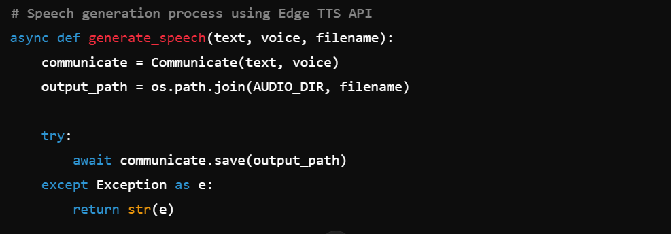
- Purpose:
- This function handles the interaction with the Edge TTS API and generates the speech from the provided text.
- It saves the generated speech as an MP3 file.
- Actions:
- The Communicate class from the Edge TTS library is used to convert the text into speech.
- The await communicate.save(output_path) saves the generated audio to the specified file path.

5.5. Saving and Returning Audio File

Once the speech is successfully generated, the audio file is saved on the server, and its path is generated. The server then sends the audio file’s URL to the frontend so that the user can listen to or download it.

- Save Audio File

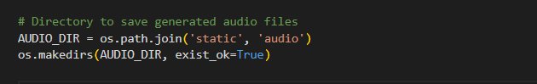

- Purpose:
- To save the generated audio file in a specified directory on the server.
- Actions:
- The file is saved to the static/audio directory to ensure it can be accessed via a URL.

- Return Audio File URL

- Purpose:
- To generate the URL for the generated audio file, which is used in the frontend to play the audio.
- Actions:
- The url_for('static', filename=f"audio/{filename}") generates the URL for the saved audio file.
- The render_template function is used to send this URL back to the frontend for playback.

5.6. Frontend-Audio Playback

The frontend page then displays the generated audio along with a Download button. The audio element allows users to play the generated speech.

- Displaying Audio Player

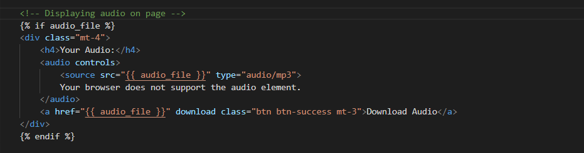

- Purpose:
- The audio player is displayed for the user to listen to the generated speech.
- Actions:
- The audio element plays the generated speech.
- <a href="{{ audio_file }}" download> link allows user to download the audio file.

5.7 Error Handling

The system ensures that any errors during the text-to-speech conversion are properly handled and communicated to the user.

- Error Validation

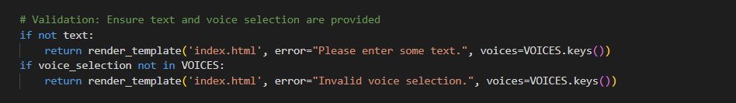
Explanation:
  - Purpose:
- To validate the user's input and ensure that the necessary fields (text and voice selection) are provided before proceeding with the speech generation process.
  - Actions:
- Check Empty Text Field:
    - If the text field is empty, the system will render the main page (index.html) with an error message: "Please enter some text."
    - This guides the user to input the required text.
- Validate Voice Selection:
    - Checks if the voice selected by the user exists in the predefined VOICES dictionary.
    - If the selected voice is invalid, it displays the error message: "Invalid voice selection."
    - The user is then redirected to the main page to correct their selection.

- Handling Speech Generation Errors

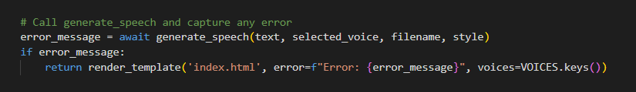

Explanation:
- Purpose:
- To detect and respond to any errors that may occur during the text-to-speech conversion process, such as issues with saving the file or invalid input for the TTS engine.
- Actions:
- Capture Errors:
- Calls the generate_speech function and stores any error messages returned during the process.
- Common errors could include file I/O failures or invalid SSML structures.
- Display Error to the User:
- If an error occurs, the user is redirected to the main page (index.html) with a specific error message.
- The message helps the user understand the issue and try again.

5. Challenges

During the development of the Text-to-Speech Conversion System, the following challenges were encountered:

- API Integration Issues:
Initially, there were difficulties in correctly implementing and testing the Microsoft Edge TTS API.
Solution: Extensive debugging and understanding the API documentation resolved the issues.
- User Input Validation:
Ensuring that users only input valid text and select appropriate voice options required robust validation mechanisms.
- Real-Time Processing:
Generating audio files quickly while handling multiple user requests posed a challenge.
Solution: Optimized backend processing and efficient use of asynchronous functions improved performance.

6. Future Enhancements

To make the system more advanced and user-friendly, the following future enhancements are planned:

- Mobile Application:
Developing a mobile-friendly version for greater accessibility.
- Multi-Language Support:
Adding more languages and regional accents to cater to a broader audience.
- Real-Time Playback:
Enabling instant playback of generated speech without requiring a file download.
- Enhanced Voice Customization:
Allowing users to adjust pitch, speed, and tone for more personalized outputs.
- Integration with Accessibility Tools:
Incorporating the system into accessibility software for individuals with visual or speech impairments.

7. Results

The Text-to-Speech Conversion System achieved the following results:

- Efficient Text-to-Speech Conversion:
The system successfully converts user input text into lifelike audio files.
- User-Friendly Interface:
The web-based frontend makes it easy for users to interact with the system.
- High-Quality Output:
The use of Microsoft Edge TTS ensures clear, natural-sounding speech output.
- Error Handling:
The application gracefully handles invalid inputs and system errors, providing meaningful feedback to users.

8. Conclusion
The Text-to-Speech Conversion System demonstrates how modern NLP tools like Microsoft Edge TTS can be utilized to convert textual data into realistic speech. By combining a user-friendly web interface with robust backend processing, the system offers a seamless experience. Future enhancements will further expand the system's capabilities, making it even more versatile and beneficial for diverse applications.

9. References
- Microsoft Edge TTS API Documentation: Microsoft Edge TTS
- Flask Framework Documentation: Flask
- Bootstrap Documentation: Bootstrap 5

