## Q: Requirement 1

### Task1:

Main colour: Blue colour is chosen as a main colour with the HSL value of (207, 100%, 50%)

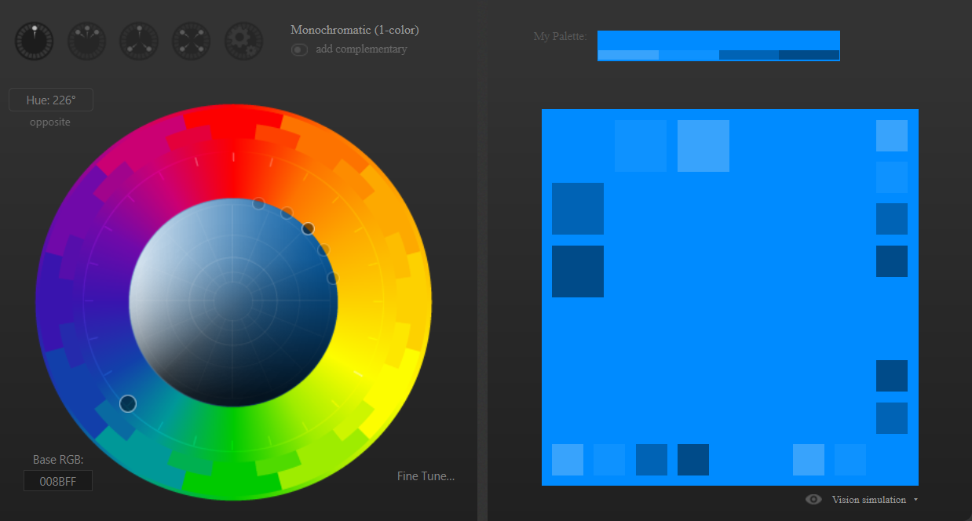

Complementary colour: The complementary colour chosen to blue is orange with HSL value (39, 100%, 50%)

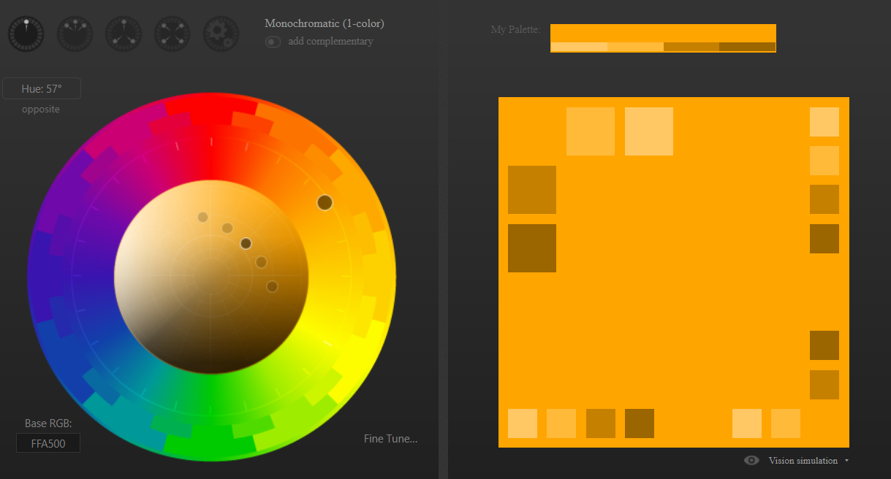

Variants from the main colour:

a. (207, 80%, 70%)

b. (207, 60%, 60%)

c. (207, 40%, 50%)

<https://coolors.co/palette/00ffff-00f5ff-00eaff-00deff-00ccff-00baff-00acff-009cff-008bff-0980ff>

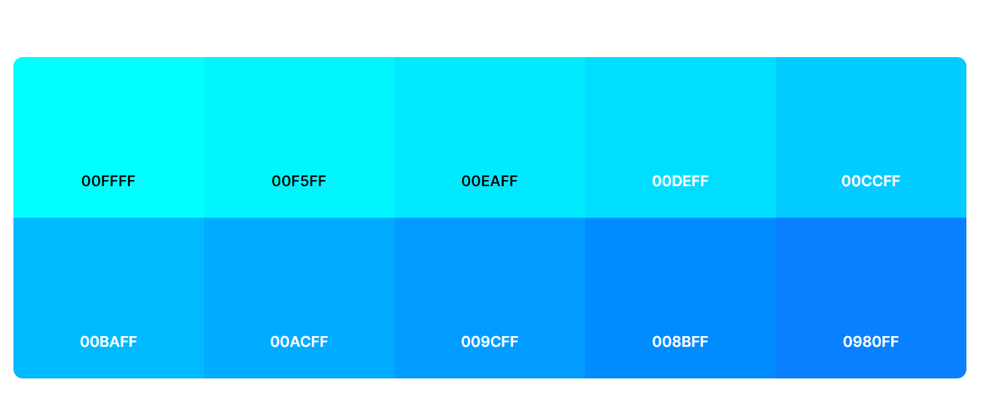

Variants from the complementary colour:

a. (39, 80%, 70%)

b. (39, 60%, 60%)

<https://coolors.co/palette/fff200-ffe600-ffd900-ffcc00-ffbf00-ffb300-ffa600-ff9900-ff8c00-ff8000>

Background colour: Light gray is chosen as a background colour with HSL value of (0, 0%, 90%)

### Task2:

**Why did they choose the corresponding main colour?**

Justify the choice of the main colour:

The personality of the brand, the target market, and the message that the company wants to express are some of the variables that influence the choice of a major colour.

Blue was chosen as a main color due to its connotations with stability, trust, cleanliness, innovation, learning, and authority and also because it is frequently used in the finance and banking, healthcare, technology, education, and government sectors.

**Which background colour did you choose and why?**

Light grey is chosen as the background colour, since it provides a neutral and peaceful backdrop against which the primary and complimentary colours may shine out,. Moreover, it produces a sense of stability and balance, both of which are crucial in design. Light grey is a safe option that is unlikely to conflict with the other colours in the palette since it is a flexible colour that can easily be matched with a range of other colours.

### Task3:

Here is an example of how the CSS file (general.css) could look like, including all the defined colours with HSL values and CSS properties (--Name):

:root {

  --main-color: hsl(207, 100%, 50%);

  --main-color-variant1: hsl(207, 80%, 70%);

  --main-color-variant2: hsl(207, 60%, 60%);

  --main-color-variant3: hsl(207, 40%, 50%);

  --complementary-color: hsl(39, 100%, 50%);

  --complementary-color-variant1: hsl(39, 80%, 70%);

  --complementary-color-variant2: hsl(39, 60%, 60%);

  --background-color: hsl(0, 0%, 90%);

}

In this CSS code, the :root selector is configured to hold the names of all the defined colours' CSS custom attributes. The colours may then be applied to other website components by using these attributes across the HTML and CSS files.

## Q: Requirement 2

The two set the following requirements:

* A font should be chosen for the title and one for the rest of the text.
* Select a generic font as backup
* Define the spacing for your website (line-height and letter-spacing)
* Select a font colour.

### Task1:

We choose the "Open Sans" typeface for the title. It is a contemporary, plain sans-serif typeface that may be utilised for both headers and body text in a technological brand, as in our instance.

We utilise the "Roboto" typeface for the remaining text. It is a sans-serif typeface that is also straightforward, clear, and easy to read, making it a terrific option for body text.

Use "Arial" as a standard font. It is generally accessible across the majority of platforms and devices, making it a solid backup choice

#### Here's the typography.css file:

@import url("https://fonts.googleapis.com/css2?family=Open+Sans:wght@400;600&display=swap");

@import url("https://fonts.googleapis.com/css2?family=Roboto:wght@400;700&display=swap");

:root {

  --title-font: "Open Sans", sans-serif;

  --text-font: "Roboto", sans-serif;

  --generic-font: Arial, sans-serif;

}

h1,

h2,

h3 {

  font-family: var(--title-font);

  font-weight: 600;

}

body {

  font-family: var(--text-font);

  font-weight: 400;

}

p,

span,

a,

button {

  font-family: var(--text-font);

}

input,

textarea {

  font-family: var(--generic-font);

}

#### And here's the layout.css file:

@import url("general.css");

@import url("typography.css");

body {

  margin: 0;

  padding: 0;

  font-family: "Open Sans", sans-serif;

  font-size: 16px;

  line-height: 1.5;

  color: var(--font-color);

}

header {

  background-color: var(--main-color);

  padding: 20px;

}

header h1 {

  margin: 0;

  font-size: 36px;

  text-align: center;

  color: var(--background-color);

}

main {

  padding: 20px;

}

footer {

  background-color: var(--complementary-color);

  color: var(--background-color);

  padding: 20px;

  text-align: center;

}

### Task2:

Line-height and letter-spacing for the text are defined in the typography.css file.

@import url("https://fonts.googleapis.com/css2?family=Open+Sans:wght@400;600&display=swap");

@import url("https://fonts.googleapis.com/css2?family=Roboto:wght@400;700&display=swap");

:root {

  --title-font: "Open Sans", sans-serif;

  --text-font: "Roboto", sans-serif;

  --generic-font: Arial, sans-serif;

}

h1,

h2,

h3 {

  font-family: var(--title-font);

  font-weight: 600;

  line-height: 1.2;

  letter-spacing: 0.05em;

}

body {

  font-family: var(--text-font);

  font-weight: 400;

  line-height: 1.5;

  letter-spacing: 0.1em;

}

p,

span,

a,

button {

  font-family: var(--text-font);

  line-height: 1.5;

  letter-spacing: 0.1em;

}

input,

textarea {

  font-family: var(--generic-font);

}

### Task3:

Black and white are both chosen as a font colour because they are both classic and versatile colors. White is connected with simplicity, purity, and clarity in a technological brand, whereas black is associated with sophistication, power, and elegance. Together, they produce a classic and high-contrast combination that works well in a variety of settings, from graphic design to current fashion.

#### Background colour:

16.82:1 with black

#### Main Colour:

6.19:1 with black

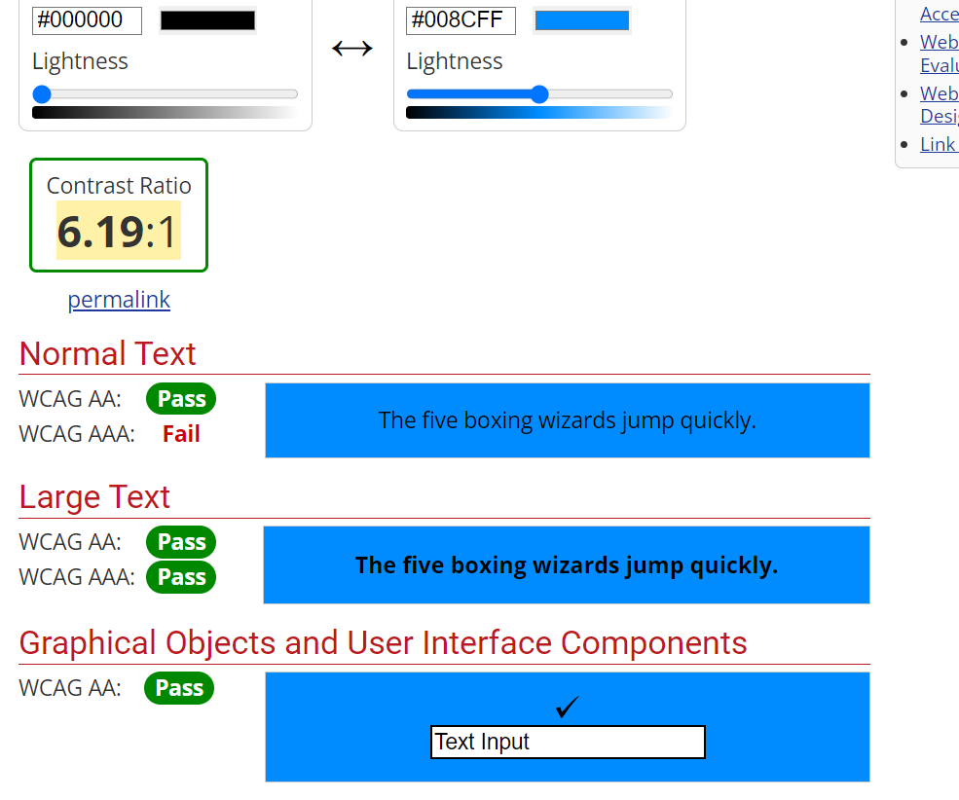

3.38:1 with white

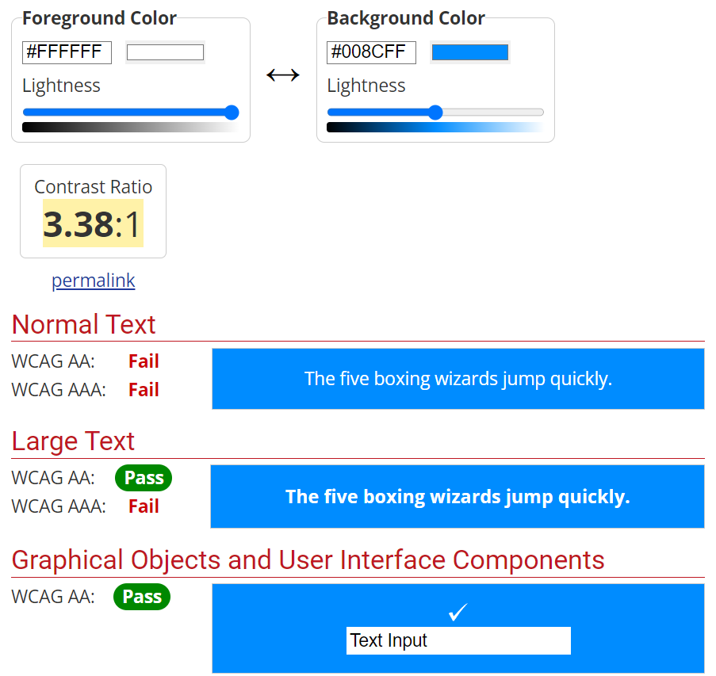

#### Complementary colour:

10.7:1 with Black

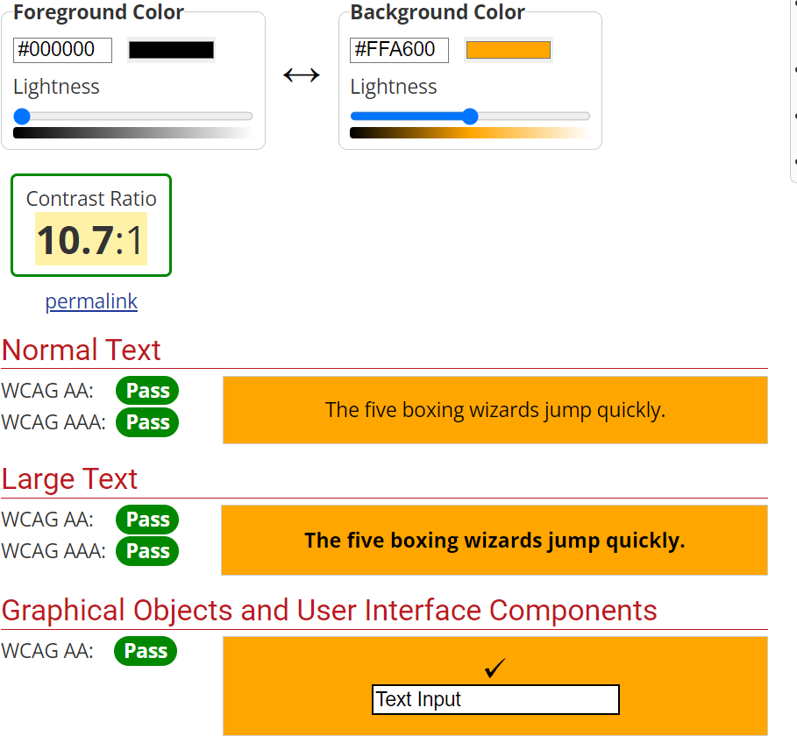

1.96:1 with white

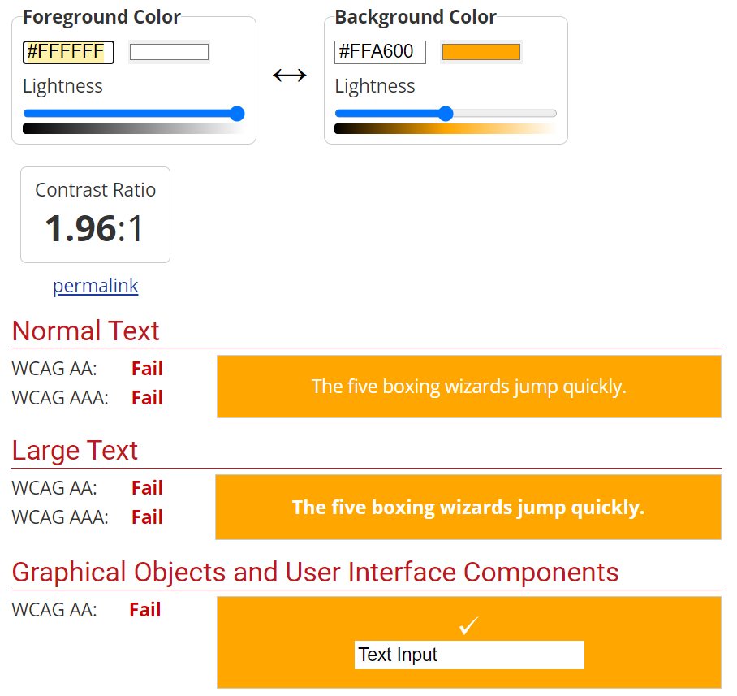

## Q Requirement 5

### Tick the one that applies.

var variable1 = 8;

var variable2 = 7;

var variable3 = 0;

var variable4 = "0";

var variable5 = "";

var variable6 = true;

|  |  |  |  |
| --- | --- | --- | --- |
| **No** | **Instruction** | **IF** | **Else** |
| **1** | if (variable1 > variable2){...} else {...} | **✓** |  |
| **2** | if (variable1 != variable2){...} else {...} | **✓** |  |
| **3** | if (variable1){...} else {...} | **✓** |  |
| **4** | if (variable1 === "8") {...} else {...} |  | **✓** |
| **5** | if (variable1 == "8") {...} else {...} | **✓** |  |
| **6** | if (!variable3){...} else | **✓** |  |
| **7** | if (variable3 || variable5){...} else |  | **✓** |
| **8** | if (variable1 && variable6){...} else {...} | **✓** |  |
| **9** | if ((variable3 == variable4) && (variable3 === variable4)) {...}  else {...} |  | **✓** |
| **10** | if ((variable1 < variable2) && (variable3 == variable4) ||       (variable1 > variable2) && (variable3 ==variable4)) {...}  else {...} | **✓** |  |