EMERGENCY ROOM TRIAGE MACHINE
Project Report

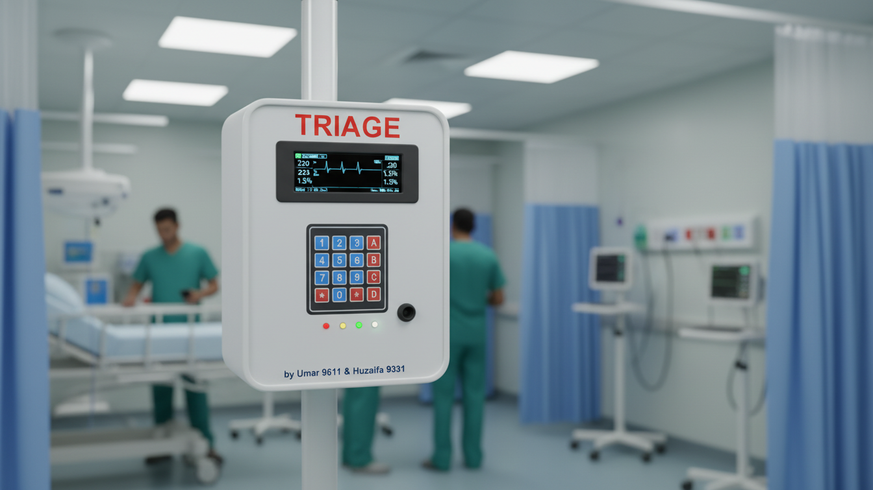

Triage, The Ultimate Patient Priority System
Prototype
By
Umar Khan (Reg. No: 9611)
Huzaifa Masood (Reg. No: 9331)

Introduction
Emergency Rooms (ERs) frequently experience overcrowding where doctors must manage multiple patients with varying levels of medical urgency. Without a structured prioritization system, treatment delays occur, increasing the risk of severe injury or loss of life. The Emergency Room Triage Machine addresses this issue by applying Data Structures and Algorithms to organize patients based on urgency.
Problem Statement
Manual patient handling lacks an effective priority mechanism. Critical patients may wait behind less severe cases, doctors experience mental overload, and treatment scheduling becomes inefficient. A structured system is required to automatically prioritize patients based on medical condition.
Objectives
• To implement a triage-based patient prioritization system
• To apply core Data Structures and Algorithms in a real-world scenario
• To reduce confusion and decision-making time for doctors
• To demonstrate efficiency improvements using DSA concepts
Triage Classification
Patients are categorized into phases:
Phase 0 – Death (No response possible)
Phase 1 – Critical (Immediate attention)
Phase 2 – Urgent (Treatment within minutes)
Phase 3 – Minor (Can safely wait)
System Overview
The Triage Machine allows staff to enter patient data, assign priority levels, store arrivals, and automatically sort patients based on urgency. Arrival order and treatment priority are handled separately to ensure efficiency.
Data Structures
Singly Linked List
A singly linked list is used to store patients in arrival order. It supports dynamic insertion and accurately models real-world patient flow.
Binary Search Tree (BST)
A Binary Search Tree is used to sort patients based on priority. BST insertion maintains ordered structure, allowing efficient retrieval of high-priority patients.
Tree Traversal
In-order traversal of the BST outputs patients in sorted priority order, ensuring critical patients are processed first.
Algorithm
Step 1: Initialize an empty linked list for patient arrivals.
Step 2: Insert each arriving patient as a node at the end of the linked list.
Step 3: Create an empty Binary Search Tree.
Step 4: Insert linked list nodes into the BST using priority as key.
Step 5: Perform in-order traversal to display sorted patients.
Step 6: Delete BST after display while retaining arrival list.
Hardware Components Used
• Arduino Nano
• I2C 20x4 LCD
• Keypad
• Breadboard
• Jumper Wires
• LEDs and Buzzer
Conclusion
This project demonstrates how Data Structures and Algorithms can directly impact life-saving systems. By using linked lists and binary search trees, the Triage Machine ensures efficient prioritization of emergency patients.
Future Enhancements
• Integration of medical sensors
• Automated priority detection
• Patient data storage and analytics
• Wireless monitoring systems

