

|  |
| --- |
| Axure Prototype  Module 3  Assignment 2 |
|  |
| December 21  PGSE-0922A-017  Authored by: Umar Bin Kasan |



# UX Prototype

## Landing Page

Interactable buttons:

.XYZ : Home Page

SIGN IN : Goes to Sign in page

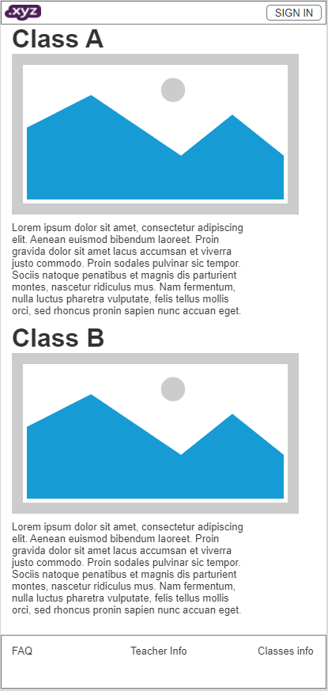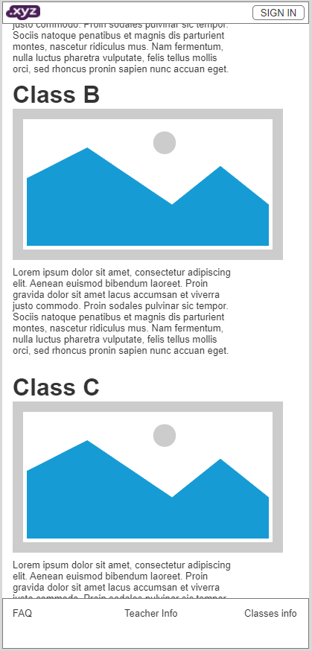

## Sign In Page

Interactable buttons:

.XYZ : Home Page

SIGN IN : Goes to Sign in page

Submit: Will go to corresponding page if you are a Student | Teacher | Admin

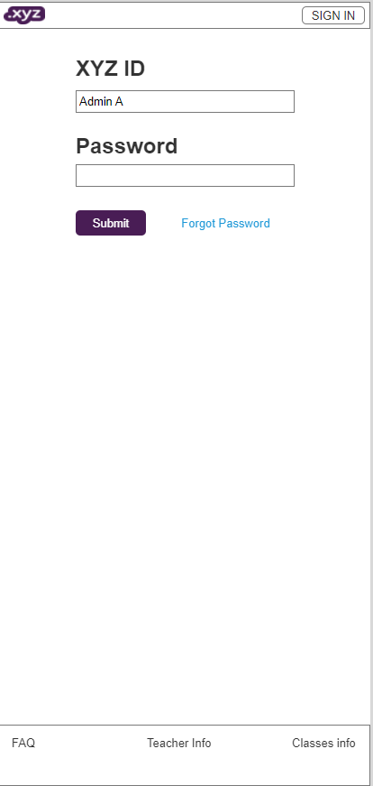Forget Password: Will Auto scroll down to forgot password section

## Admin Page

Interactable buttons:

.XYZ : Home Page

Log Out : Goes to Log Out page

Pages:

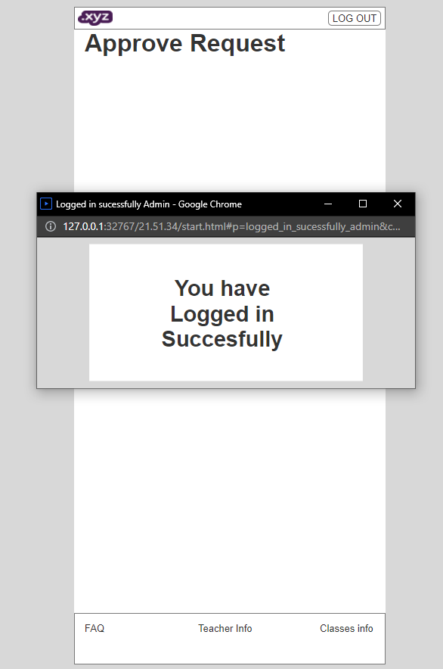Submit: Will go to corresponding page if you are an Admin

Pop Up Page: Confirming the Admin is Logged in

## Student Page

Interactable buttons:

.XYZ : Home Page

Log Out : Goes to Log Out page

Pages:

Submit: Will go to corresponding page if you are a Student

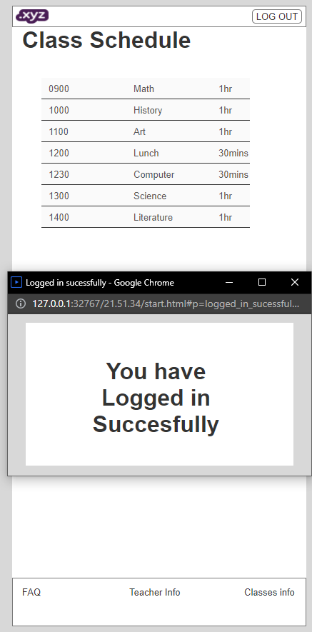Pop Up Page: Confirming the Student is Logged in

## Teacher Page

Interactable buttons:

.XYZ : Home Page

Log Out : Goes to Log Out page

Pages:

Submit: Will go to corresponding page if you are a Teacher

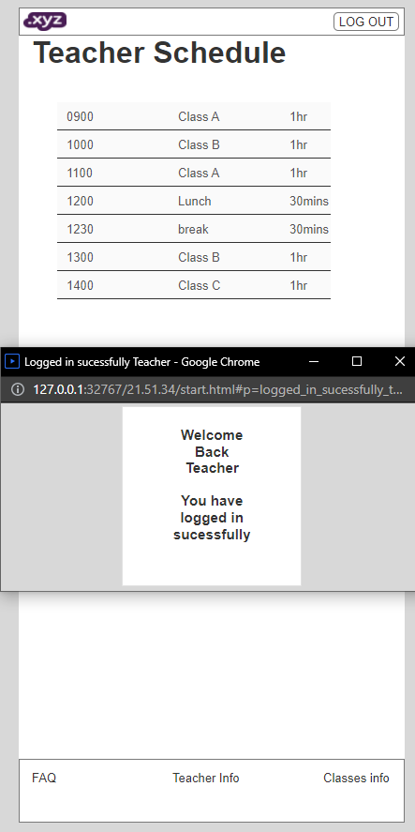Pop Up Page: Confirming the Teacher is Logged in

## Forget Password Page

Interactable buttons:

.XYZ : Home Page

Sign In : Goes to Sign In page

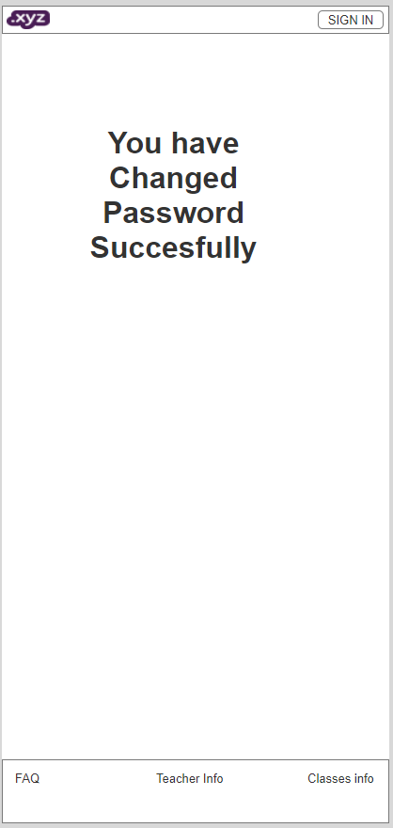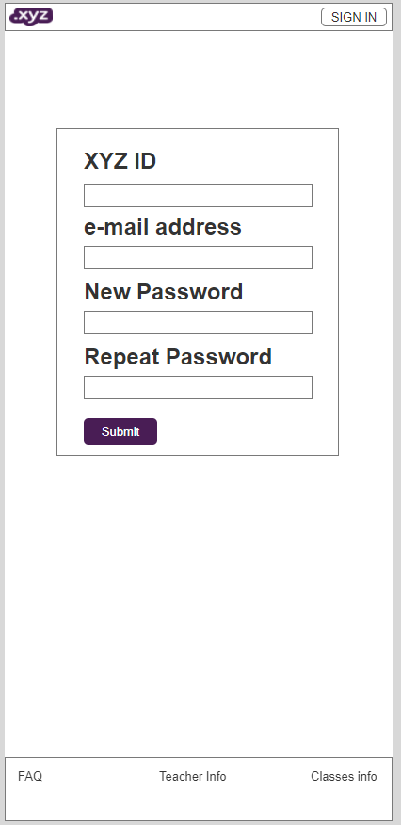Submit: Will go to Successful password reset page