# Project Report

|  |  |
| --- | --- |
| **Product Name** | Advanced Certificate in Web Development |
| **Qualification Name (ITSF)** | NICF-Advanced Certificate in Infocomm Technology (Software & Applications) |
| **Product Name** | NICF-UI Frameworks |
| **Module Name (ITSF)** | NICF-UI Frameworks |

|  |  |  |  |
| --- | --- | --- | --- |
| **Student name** | | **Assessor name** | |
| Umar Bin Kasan | |  | |
| **Date issued** | **Completion date** | | **Submitted on** |
|  |  | |  |
|  | | | |
| **Project title** | **Development of prototype for an ecommerce solution** | | |

|  |
| --- |
| **Learner Declaration** |
| I certify that the work submitted for this assignment is my own and research sources are fully acknowledged.  Student signature: Date: 12/01/2023 |

Contents

Project Report 1

Project Background 3

Project Objective 3

Tools & platform 3

1. Axure RP tool 3

2. Word 3

3. Microsoft Excel 3

4. Google Chrome 3

Business Process & Solution Architecture 3

Wireframe : 4

Task 1 (A1, K1) 7

Task Statement: 7

Task 2 (A2, K2) 8

Task Statement: 8

Scenario 1 8

Task 3 (A3) 9

Task Statement: 9

Task 4 (A4) 10

Task Statement 10

Task 5 (K3, K4) 11

Task Statement 11

Task 6 (A5) 12

Task Statement: 12

Task 7 (A6) 13

Task 8 (A7) 14

Task 9 (K5, K6, A8) 15

Appendix A: Detail UX Testing Report 16

Appendix B: References 16

# Project Background

Boutiqa is a boutique florist shop that specialised in premium and creative designs. Focusing on a variety of colour combinations and the right Art style to suit the various events/ occasions the client may have.

The goal of Boutiqa app is to streamline the online order process to encourage existing a new prospective client to view the new designs developed by Boutiqa.

## Project Objective

1. Create a register page in the portal
2. User able to update profile after logging in
3. Promote their products

## Tools & platform

## Axure RP tool

## Word

## Microsoft Excel

## Google Chrome

## Business Process & Solution Architecture

1. Landing page & search page
2. Registration
3. Log in
4. Forget password
5. Update Profile

## Wireframe :

Landing Page

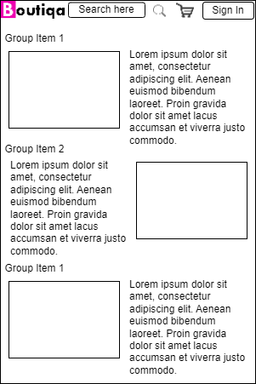

Register Page

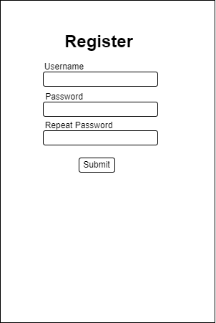

Log in Page

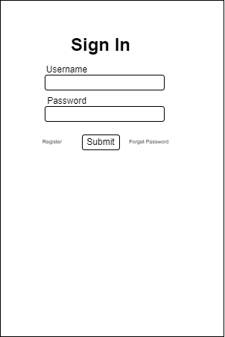

Forget Password Page

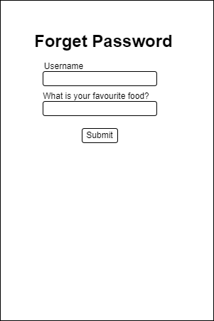

Update profile Page

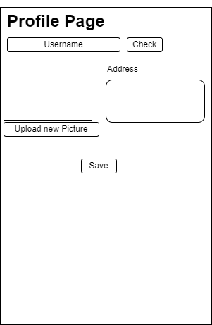

Flow Chart for the solution Architecture

# Task 1 (A1, K1)

## Task Statement:

1. Briefly explain techniques and methods for gathering and analysing user feedback.

The questionnaire consists of 3 parts; Pre-Test, trial Test & Post test.  
The Pre-test checks on the user demography  
The trial test observes the user time to use the website without the questioner interfering the test. Expectations and goals are explained prior the trial test.  
Tester are given the following information:  
Email: user1  
Password:123  
Goal:  
Login -> Key in email and password -> profile page -> edit username ->go main page->

Pre-Test Questions Sample & Answer

|  |  |  |
| --- | --- | --- |
| No | Questions | Answers |
| 1 | What is your occupation | Architect |
| 2 | How comfortable are you ordering through online? (1 – lowest to 5 – highest) | 5 |
| 3 | What is your expected duration of us from start to finish   1. <30 sec 2. 30sec< time> 1 min 3. 1 min < time > 2 mins 4. >2 mins | 3 |
| 4 | What is your expected budget when visiting a florist?  1)<$15  2) $15< budget >$20  3) $20< budget >$25  4 >$25 | 2 |

Trial run

|  |  |  |
| --- | --- | --- |
| No | Time taken | 2 min 24sec |

Post Test Questions Sample & Answer

|  |  |  |
| --- | --- | --- |
| No | Questions | Answers |
| 1 | How was your overall experience?  (1 – lowest to 5 – highest) | 3 |
| 2 | What did you like most? | The flower collection is pretty nice |
| 3 | Was there anything unsatisfactory? | Finding the profile page took time |
| 4 | How would you recommend to a friend?  (1 – lowest to 5 – highest) | 3 |

1. Find at least 2 websites which are like ecommerce website and visit and use them and record your experiences.

Solution:

2 websites:- 1.

# Task 2 (A2, K2)

## Task Statement:

1. Discuss, study and analyze the user experience based on the observations done in Task 1.
2. Study the experience for 2 to 3 scenarios

Solution: (Pls describe it with screen captures)

## Scenario 1

Linkdln :-

Xing :-

# Task 3 (A3)

## Task Statement:

1. Identify the performance levels and gaps between user experience in the study & desired user experience.
2. Document it as part of Project Report

Solution:

Amazon

|  |  |  |  |
| --- | --- | --- | --- |
| Scenario | Expected Completion Time | Actual completion Time | Performance Gap (Actual- Expected) |
| Registration | 30 s | 35 | 35-30=5 |
| Log in | 15 | 10 | -5 |

Shopee

|  |  |  |  |
| --- | --- | --- | --- |
| Scenario | Expected Completion Time | Actual completion Time | Performance Gap (Actual- Expected) |
| Registration | 30 s | 35 | 35-30=5 |
| Log in | 15 | 10 | -5 |

# Task 4 (A4)

## Task Statement

1. Develop & document 3 metrics to measure the user experience.
2. TSR
3. TOT
4. UER
5. NPS
6. CSAT

Solution

# Task 5 (K3, K4)

## Task Statement

1. Create the steps in User Interaction process for various scenario.

The questionnaire consists of 3 parts; Pre-Test, trial Test & Post test.  
The Pre-test checks on the user demography  
The trial test observes the user time to use the website without the questioner interfering the test. Expectations and goals are explained prior the trial test.  
Tester are given the following information:  
Email: user1  
Password:123  
Goal:  
Login -> Key in email and password -> profile page -> edit username ->go main page->

Pre-Test Questions Sample & Answer

|  |  |  |
| --- | --- | --- |
| No | Questions | Answers |
| 1 | What is your occupation | Architect |
| 2 | How comfortable are you ordering through online? (1 – lowest to 5 – highest) | 5 |
| 3 | What is your expected duration of us from start to finish   1. <30 sec 2. 30sec< time> 1 min 3. 1 min < time > 2 mins 4. >2 mins | 3 |
| 4 | What is your expected budget when visiting a florist?  1)<$15  2) $15< budget >$20  3) $20< budget >$25  4 >$25 | 2 |

Trial run

|  |  |  |
| --- | --- | --- |
| No | Time taken | 2 min 24sec |

Post Test Questions Sample & Answer

|  |  |  |
| --- | --- | --- |
| No | Questions | Answers |
| 1 | How was your overall experience?  (1 – lowest to 5 – highest) | 3 |
| 2 | What did you like most? | The flower collection is pretty nice |
| 3 | Was there anything unsatisfactory? | Finding the profile page took time |
| 4 | How would you recommend to a friend?  (1 – lowest to 5 – highest) | 3 |

1. Create a flow chart for user interaction.

Scenario Name- Registration

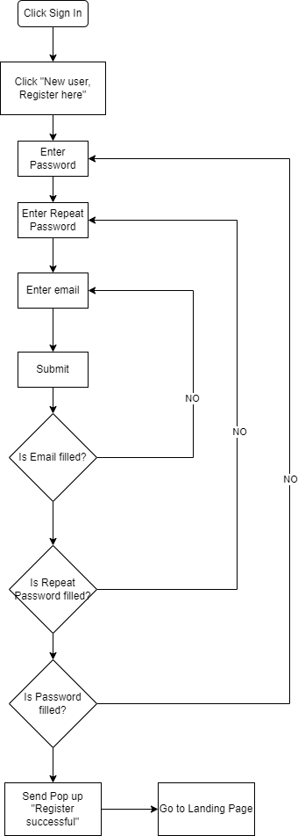

Scenario Name- Log in

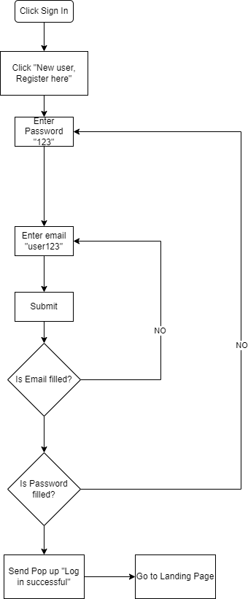

Scenario Name- Forget Password

Scenario Name- Check out

# Task 6 (A5)

## Task Statement:

1. In the Websites study’s get the general user response from one other user.

Solution

GrabMart

|  |  |  |  |  |
| --- | --- | --- | --- | --- |
| Scenarios | TOT | TSR | UER | Feedback |
| Registration | 110 s | 1-SUCCESS | 0 |  |
| Log in |  | 1-SUCCESS |  |  |
| Search |  | 1-SUCCESS |  |  |

You may come up with few general questions regarding the overall experience and can record it here

# Task 7 (A6)

Task Statement

1. Create a Prototype for the proposed system, with at least 5 screens
2. Get the user response and classify them to various types.
3. Screen capture the prototype and include it as part of Project Presentation

Solution

Start from home page-

1. Prototype name-
2. Screen capture of it
3. Specification table: - Note No/Name/Interactions/ Note description

# Task 8 (A7)

Task Statement

1. Demonstrate and let the users give feedback on prototype and document them
2. Make suggestions to improve the user experience and implement them in the prototype

Solution

# Task 9 (K5, K6, A8)

Task Statement

1. Create 3 Usability tests and execute the usability tests with a user
2. Get the users use the modified prototype
3. Gather feedback and measure its technical viability and effectiveness

Solution:

# Appendix A: Detail UX Testing Report

# Appendix B: References