GroceryGo — Technical Documentation

1. Architecture
GroceryGo is built as a multi-screen mobile application using the Expo / React Native framework. The app follows a layered architecture separated into Presentation, Business Logic, and Data layers.
┌─────────────────────────────────────────────────────---┐
│ PRESENTATION LAYER │
│ app/(tabs)/ ← Tab screens (Home, Explore, Cart…) │
│ app/(auth)/ ← Login, Signup, Forgot Password │
│ app/product/[id] ← Dynamic product detail screen │
│ app/category/[id] ← Dynamic category screen │
│ components/ ← Reusable UI (CustomTabBar, etc.) │
└──────────────────────────┬───────────────────────---──┘
│
┌──────────────────────────▼───────────────────────────┐
│ BUSINESS LOGIC LAYER │
│ context/CartContext.tsx ← Global cart state │
│ context/FavoritesContext.tsx← Global favourites state │
│ app/(tabs)/index.tsx ← Guided Tour, dashboard logic │
│ app/(tabs)/scanner.tsx ← Barcode scanning logic │
└──────────────────────────┬───────────────────────────┘
│
┌──────────────────────────▼───────────────────────────┐
│ DATA LAYER │
│ services/api.ts ← Centralised REST API calls │
│ AsyncStorage ← Local persistence (cart, tour flag) │
│ Algolia ← Full-text product search index │
│ Open Food Facts ← External barcode database (fallback) │
└─────────────────────────────────────────────────────--─┘
File & Folder Structure

Path | Purpose
app/(tabs)/ | All main tab screens
app/(auth)/ | Authentication screens
app/product/[id].tsx | Dynamic product details
app/category/[id].tsx | Products by category
app/brand/[id].tsx | Products by brand
components/ | Shared UI components
context/ | React Context providers
services/api.ts | Centralised API service
hooks/ | Custom React hooks
assets/ | Images, fonts, icons

2. Key Components

Component | File | Responsibility
Home Dashboard | app/(tabs)/index.tsx | Categories, Brands, Recommended products, Guided Tour
Explore | app/(tabs)/explore.tsx | Browse all categories and brands in grid layouts
Cart | app/(tabs)/cart.tsx | View items, update quantities, checkout
Scanner | app/(tabs)/scanner.tsx | Barcode scanning via camera, product lookup
Search | app/(tabs)/search.tsx | Real-time search powered by Algolia
Account | app/(tabs)/account.tsx | Profile, addresses, order history, settings
CustomTabBar | components/CustomTabBar.tsx | Custom floating bottom navigation bar
BasketLoader | components/BasketLoader.tsx | Animated loading indicator (fruits falling into basket)
CartContext | context/CartContext.tsx | Global cart state + AsyncStorage persistenc

3. Technical Choices
Technology | Role | Why chosen
React Native + Expo | Mobile cross-platform framework | Single codebase for iOS and Android; fast development with Expo Go
Expo Router | File-based navigation | Mirrors Next.js conventions; automatic deep linking
TypeScript | Static typing | Reduces runtime bugs; better IDE intellisense
React Context API | Global state management | Lightweight; no extra dependencies vs Redux
AsyncStorage | Local persistence | Native key-value store for cart and tour state
Algolia | Full-text search | Sub-100ms search results; hosted search-as-a-service
Open Food Facts API | External barcode database | Free global food product database for barcode fallback
expo-camera | Camera & barcode scanning | Native camera access with built-in barcode decoder
@expo/vector-icons (Ionicons, MaterialCommunityIcons) | Icon library | Consistent, offline-first icon rendering
react-native-svg | SVG rendering | Powers the custom BasketLoader animation
react-native-root-toast | Toast notifications | Lightweight global notifications for cart feedback
react-native-safe-area-context | Safe area insets | Handles notches/home bars on all devices

4. Data Flows
4.1 — User Login Flow
User → enters email + password
→ LoginScreen calls authApi.login()
→ Backend returns JWT token
→ Token stored in AsyncStorage
→ Expo Router redirects to /(tabs)/
4.2 — Product Search Flow
User → types in SearchScreen
→ Algolia SDK sends query to Algolia cloud index
→ Algolia returns list of matching products (hits)
→ FlatList renders result cards
→ User taps a result → navigates to /product/[id]
→ ProductDetails fetches full data from REST API backend
4.3 — Add to Cart Flow
User → taps "Add to Cart" (from Search, Product Details or Scanner)
→ CartContext.addToCart(product) called
→ State updated in memory (React state)
→ Full cart array serialised to AsyncStorage
→ Cart tab badge count updates reactively

4.4 — Barcode Scanner Flow
User → opens Scanner tab
→ expo-camera requests camera permission
→ CameraView streams live preview
→ Barcode detected → handleBarCodeScanned fires
→ productsApi.getByBarcode() queries our backend
→ If found: show product modal with "Add to Cart" option
→ If not found: query Open Food Facts API (fallback)
→ If still not found: show "Product Not Found" modal
4.5 — Checkout / Order Flow
User → reviews cart → taps Checkout
→ CheckoutScreen collects delivery address
→ ordersApi.create() sends order to backend
→ Backend creates order record in database
→ App navigates to OrderConfirmation screen
→ Order appears in OrderHistory (history tab)

5. UML Diagrams
5.1 — Class Diagram
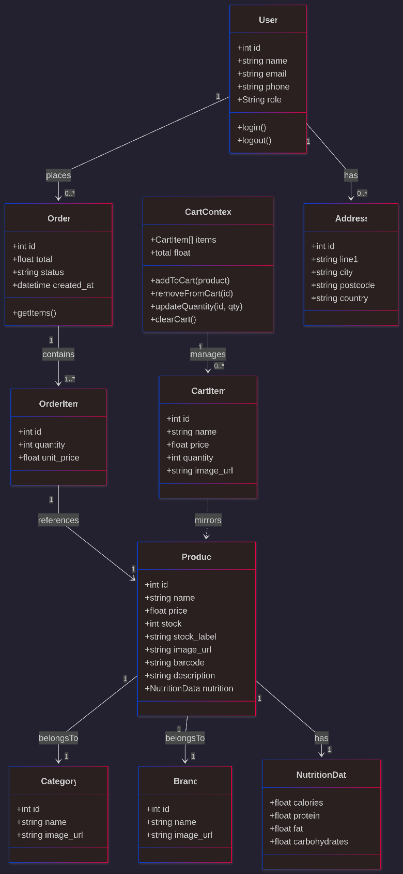

5.2 — Activity Diagram: Checkout Workflow
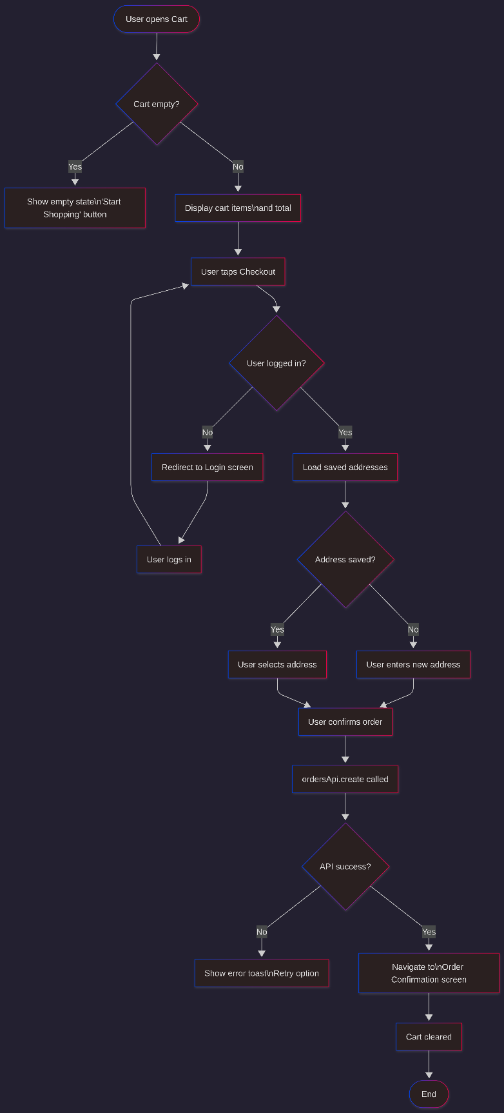

5.3 — Activity Diagram: Barcode Scanner Workflow
