**AROR UNIVERSITY OF ART ARCHITECTURE DESIGN AND HERITAGE SUKKUR**

Name: Muhammad Umar

Roll no: ARI-F23-0062

Section: B

Instructor: Sir Abdul Ghafoor

**Task01**

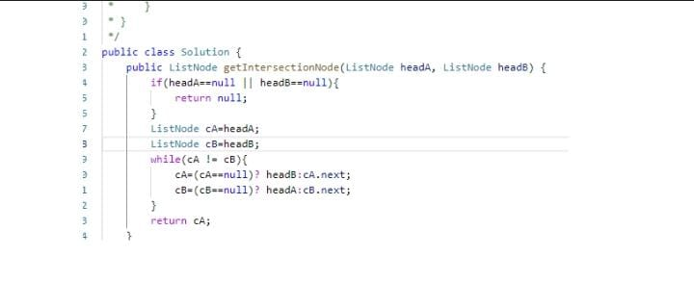

**Task02**

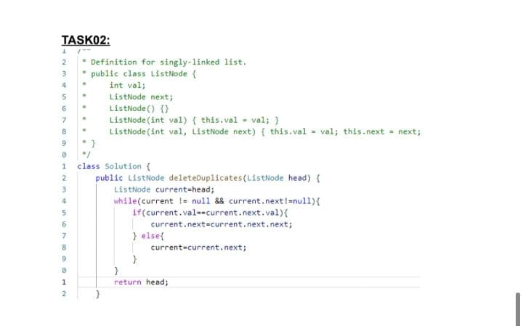

**Task03**

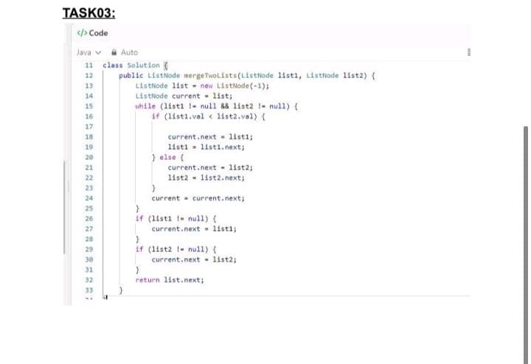

**Task04**

