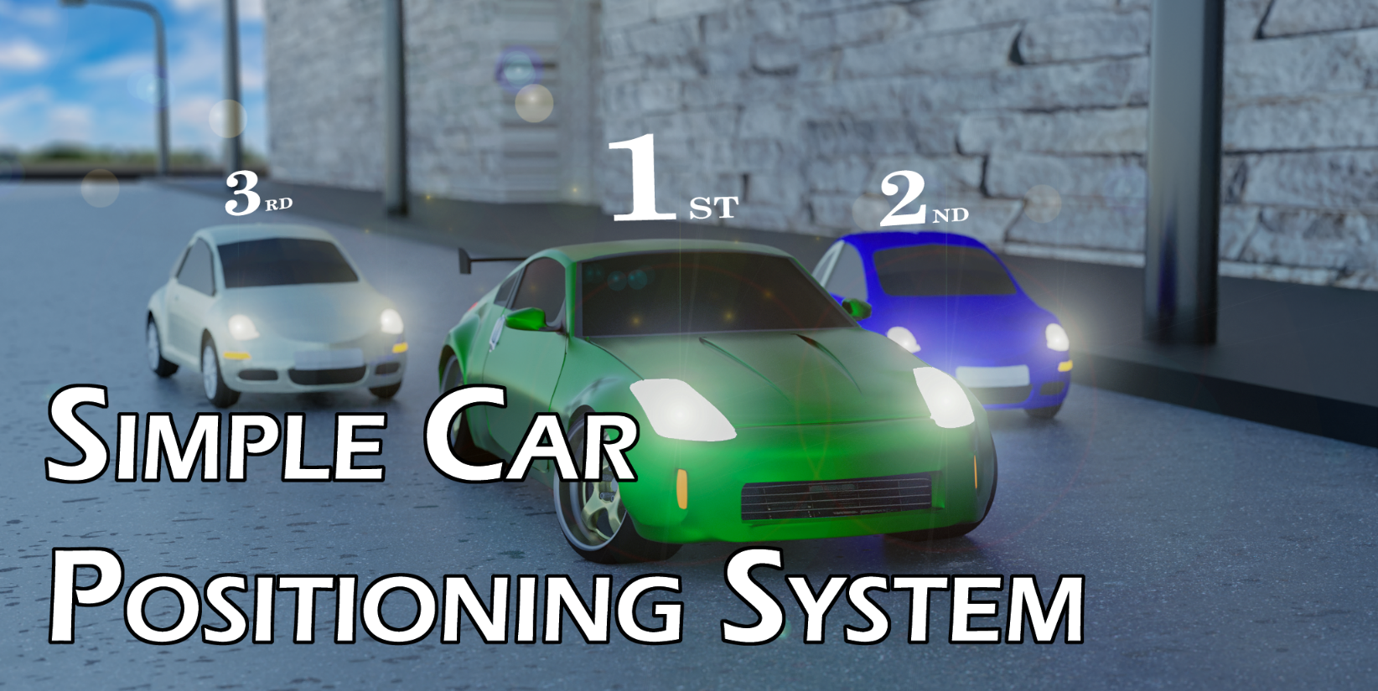

Thank you for installing the Simple Car Positioning System. Make sure you read the documentation in order to understand how to use this powerful asset.