Predicting Hourly Bike Rental Demand
A Multiple Linear Regression Analysis

Prepared by | Mohammad Umar Shaikh Mohd Abdul Sattar
Dataset | Seoul Bike Sharing Demand
Method | Multiple Linear Regression
Software | Python
Date | September 2026

Submitted report with figure insertion placeholders

Executive Summary
This project developed a multiple linear regression model to explain and predict hourly bicycle rental demand in Seoul. The analysis used 8,760 hourly observations containing rental counts, weather measurements, time information, season, holiday status, and system functioning status. The data were ordered chronologically and divided into 7,008 training observations and 1,752 testing observations.
The model achieved a training R-squared of 0.5535 and a test R-squared of 0.5511. Thus, approximately 55.1% of the variation in unseen hourly rental demand was explained by the selected predictors. The close training and test values indicate stable generalization rather than obvious overfitting. Test MAE was 309.67 rentals and test RMSE was 410.92 rentals.
The overall regression was statistically significant, F = 433.11, p < 0.001. Hour, functioning-day status, rainfall, winter season, solar radiation, humidity, and Sunday were among the strongest statistically significant variables. The Durbin-Watson statistic was 0.4923, indicating substantial positive residual autocorrelation. Therefore, the model is useful as an interpretable baseline, but statistical inference should be viewed cautiously because hourly observations are time ordered and the independence assumption is not fully satisfied.

1. Introduction
Bike-sharing operators need to anticipate demand so that bicycles can be available at the locations and times when customers need them. Underestimating demand can produce shortages, while overestimating demand can lead to inefficient allocation. This report evaluates whether hourly demand can be explained using weather, time, seasonal, holiday, and operational variables.
The research question was: To what extent can the available predictors explain hourly rented bike count in Seoul? The dependent variable was rented_bike_count, and multiple linear regression was selected because it provides both predictions and interpretable coefficients with p-values.

2. Dataset and Data Preparation
The Seoul Bike Sharing Demand dataset was obtained from the UCI Machine Learning Repository. It contains 8,760 hourly records and includes bike rental counts, date and hour, weather measurements, season, holiday status, and functioning-day status. UCI reports no missing values in this dataset.
Variable group | Examples | Role
Target | Rented bike count | Continuous response
Time | Hour, day of week | Predictors
Weather | Temperature, humidity, wind, visibility, solar radiation, rainfall, snowfall | Predictors
Calendar | Season, holiday | Categorical predictors
Operations | Functioning day | Categorical predictor

2.1 Preprocessing
- Column names were standardized to snake_case.
- The date field was converted to a datetime value and used to create day-of-week information.
- Categorical predictors were one-hot encoded, with one omitted reference category per variable.
- The redundant is_weekend variable was excluded because it is exactly determined by Saturday and Sunday indicators.
- Observations were sorted by date and hour before an 80:20 chronological split.
- The training set was used to estimate coefficients and p-values; the later test set was reserved for predictive evaluation.

3. Exploratory Data Analysis
The following figures should be inserted from the figures folder generated by the notebook. In Word, click Insert > Pictures > This Device, select the indicated file, choose In Line with Text, and replace the placeholder. Keep each caption directly below its figure.
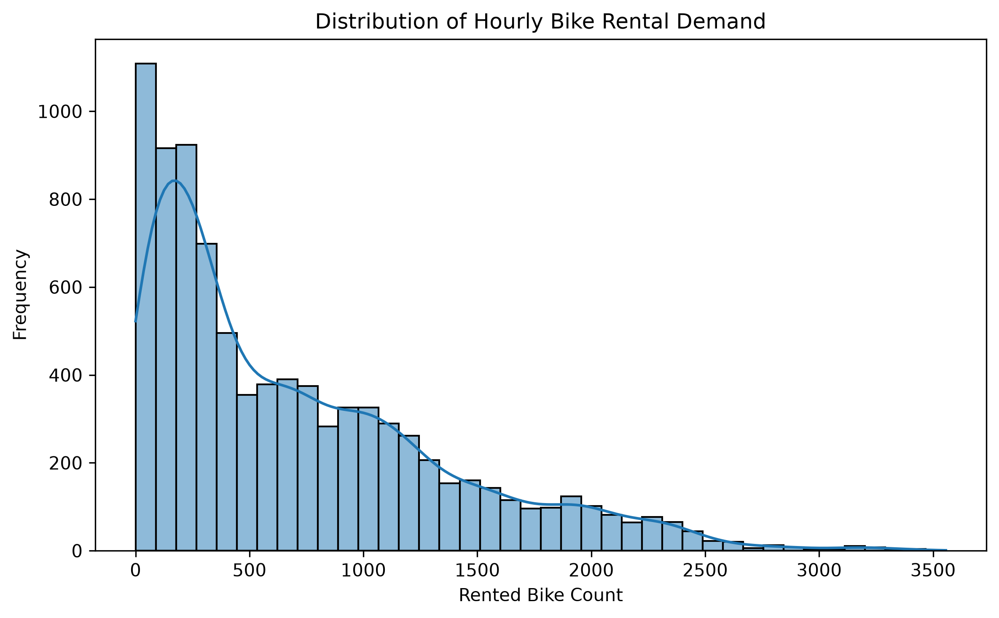
Figure 1. Distribution of Hourly Bike Rental Demand.
The target distribution should be reviewed for skewness and the frequency of low-demand and zero-demand periods. A right-skewed response indicates that very high rental counts occur less frequently than lower or moderate counts.
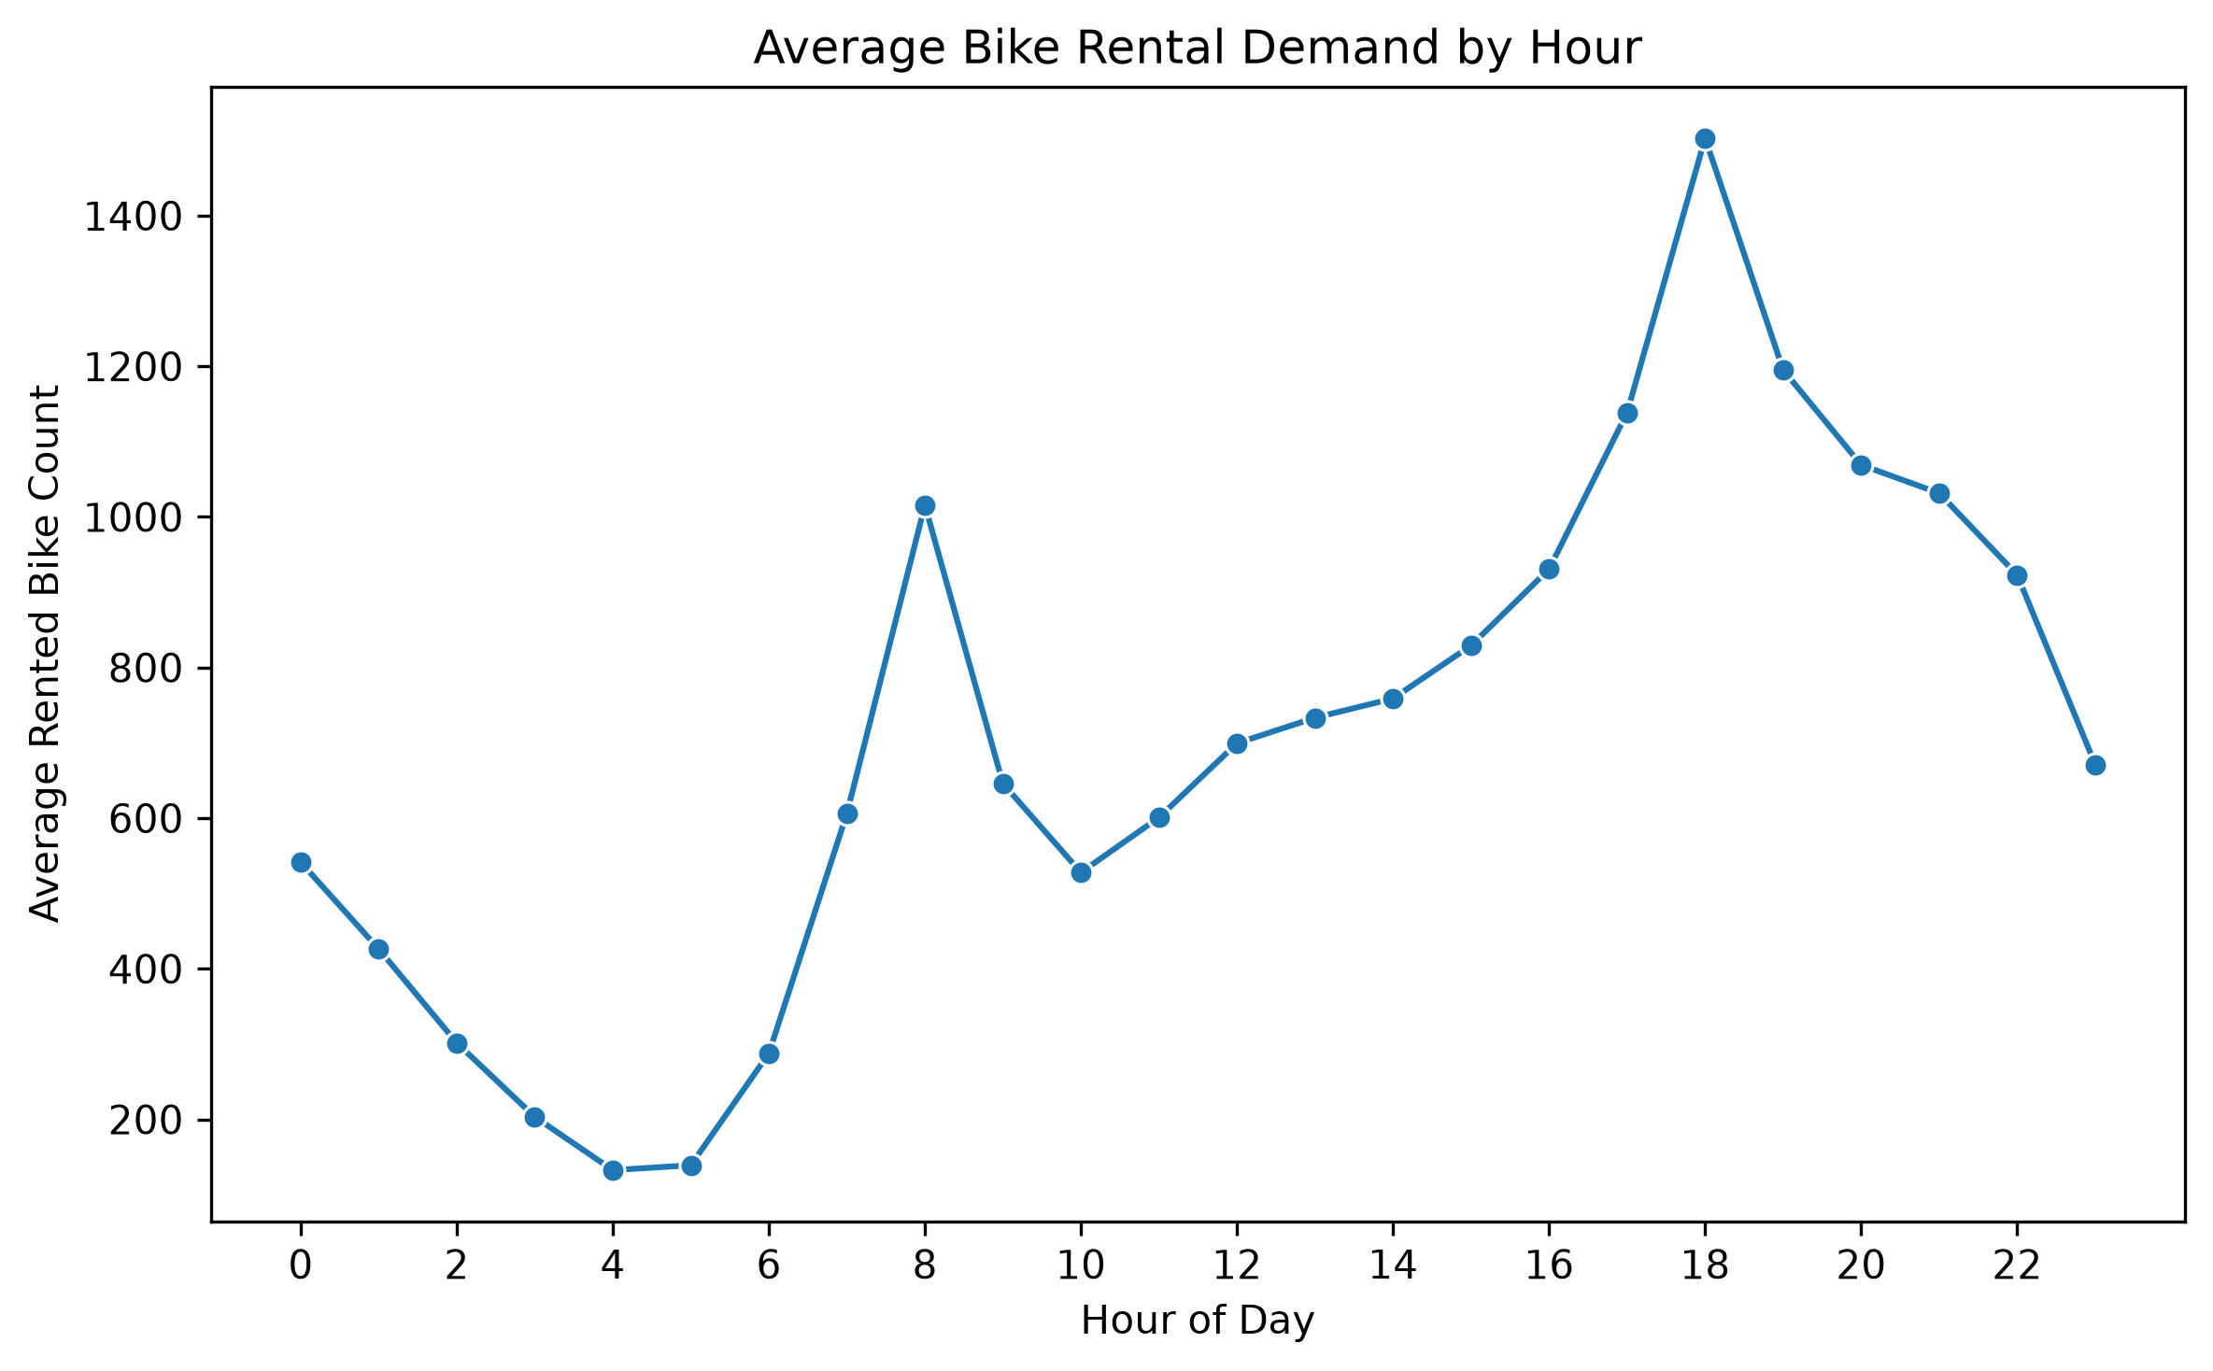
Figure 2. Average Bike Rental Demand by Hour.
Hourly averages reveal whether demand follows a daily pattern. Strong peaks support the inclusion of hour, although a single linear hour coefficient cannot completely represent a curved or multi-peak daily relationship.
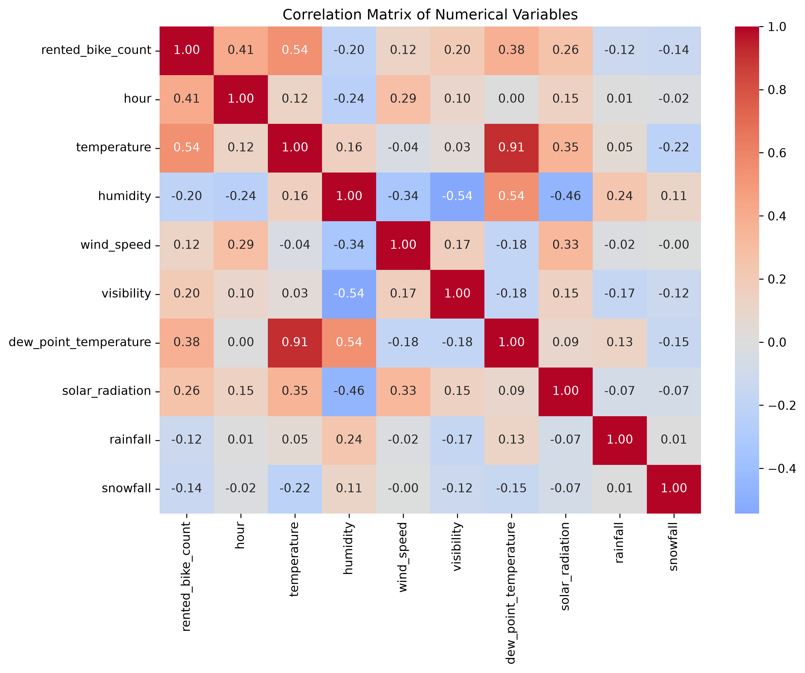
Figure 3. Correlation Matrix of Numerical Variables.
The heatmap supports preliminary assessment of relationships among numerical variables. Correlation is descriptive and should not be treated as proof of causation or as a replacement for multivariable regression.
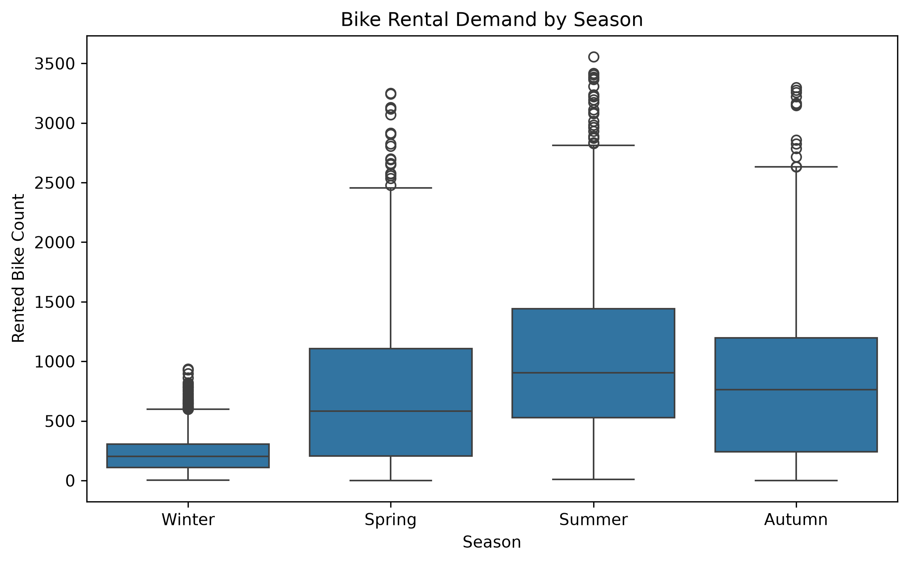
Figure 4. Bike Rental Demand by Season.
Seasonal boxplots allow demand levels and variability to be compared across seasons. The regression results later quantify these differences relative to the omitted reference season.

4. Regression Methodology
A multiple linear regression model was fitted in the general form:
Rented Bike Count = beta0 + beta1X1 + beta2X2 + ... + betapXp + error
For a numerical predictor, a coefficient represents the expected change in rented bike count associated with a one-unit increase in that predictor, holding the other predictors constant. For a dummy variable, the coefficient represents the expected difference from its omitted reference category. Statistical significance was assessed using p < 0.05. Because predictors use different units, raw coefficient magnitudes should not be used as the sole measure of importance.
Model fit was evaluated using R-squared, adjusted R-squared, MAE, and RMSE. R-squared measures the proportion of variation explained by the model. MAE gives the average absolute prediction error, while RMSE gives greater weight to large errors.

5. Model Results
Measure | Value | Interpretation
Training observations | 7,008 | Used to fit the model
Testing observations | 1,752 | Later observations used for evaluation
Training R-squared | 0.5535 | 55.35% of training variation explained
Testing R-squared | 0.5511 | 55.11% of unseen variation explained
Adjusted R-squared | 0.5522 | Accounts for the number of predictors
Test MAE | 309.67 | Average absolute error in bike rentals
Test RMSE | 410.92 | Larger errors receive more weight
F-statistic | 433.1127 | Overall model test
F-test p-value | < 0.001 | Model is statistically significant overall
Durbin-Watson | 0.4923 | Strong positive residual autocorrelation

5.1 Model Fit Interpretation
The test R-squared of 0.5511 indicates that approximately 55.1% of the variation in hourly bike rentals in the chronological test period was explained by the predictors. The remaining 44.9% reflects omitted factors, nonlinear relationships, temporal dependence, unpredictable variation, or measurement limitations. This is a moderate level of explanatory power for an interpretable linear baseline.
Training and test R-squared differ by only 0.0024, indicating that the model maintained similar performance on later observations. This reduces concern about conventional overfitting, although it does not prove that the linear specification is optimal.
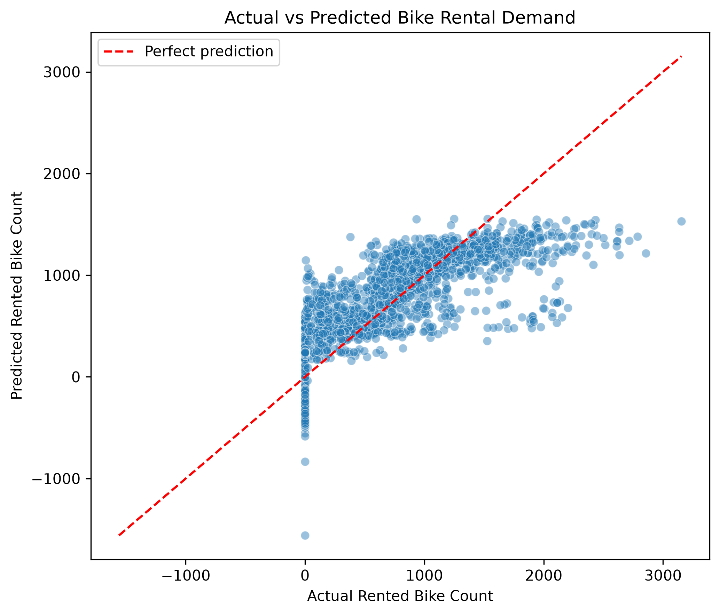
Figure 5. Actual vs Predicted Bike Rental Demand.
The actual-versus-predicted plot should be used to identify systematic underprediction or overprediction, particularly at high demand levels.

5.2 Statistically Significant Variables
Table 3 presents the most decision-relevant significant coefficients. Values are conditional associations, not causal effects. The omitted reference categories for dummy variables depend on the encoding order used in the notebook.
Variable | Coefficient | p-value | 95% CI | Interpretation
functioning day Yes | 912.11 | <0.001 | [808.70, 1015.51] | Operational hours had substantially higher expected demand than non-functioning hours.
hour | 27.88 | <0.001 | [26.25, 29.50] | Each one-hour increase was associated with about 27.9 additional rentals under the linear specification.
rainfall | -58.81 | <0.001 | [-67.93, -49.70] | Each additional mm of rainfall was associated with about 58.8 fewer rentals.
season Winter | -400.19 | <0.001 | [-474.48, -325.91] | Winter demand was lower than the reference season.
solar radiation | -83.56 | <0.001 | [-99.84, -67.29] | The conditional coefficient was negative after controlling for the other variables.
humidity | -9.69 | <0.001 | [-11.85, -7.53] | Each percentage-point increase was associated with about 9.7 fewer rentals.
day of week Sunday | -163.73 | <0.001 | [-201.92, -125.54] | Sunday demand was lower than the reference weekday.
temperature | 19.53 | <0.001 | [11.82, 27.24] | Each 1 C increase was associated with about 19.5 additional rentals.
holiday No Holiday | 114.64 | <0.001 | [64.30, 164.99] | Non-holidays had higher expected demand than holidays.
wind speed | 22.52 | <0.001 | [11.42, 33.61] | The conditional coefficient was positive.
snowfall | 52.45 | <0.001 | [25.28, 79.61] | The conditional coefficient was positive; interpret cautiously due to weather covariance and sparse snow events.

5.3 Non-significant Variables
At the 5% level, Wednesday, dew-point temperature, visibility, and the intercept were not statistically significant. Their confidence intervals included zero. This does not prove that they have no relationship with demand; it indicates that their unique linear contribution was not distinguishable from zero after controlling for the other predictors.

6. Diagnostics and Limitations
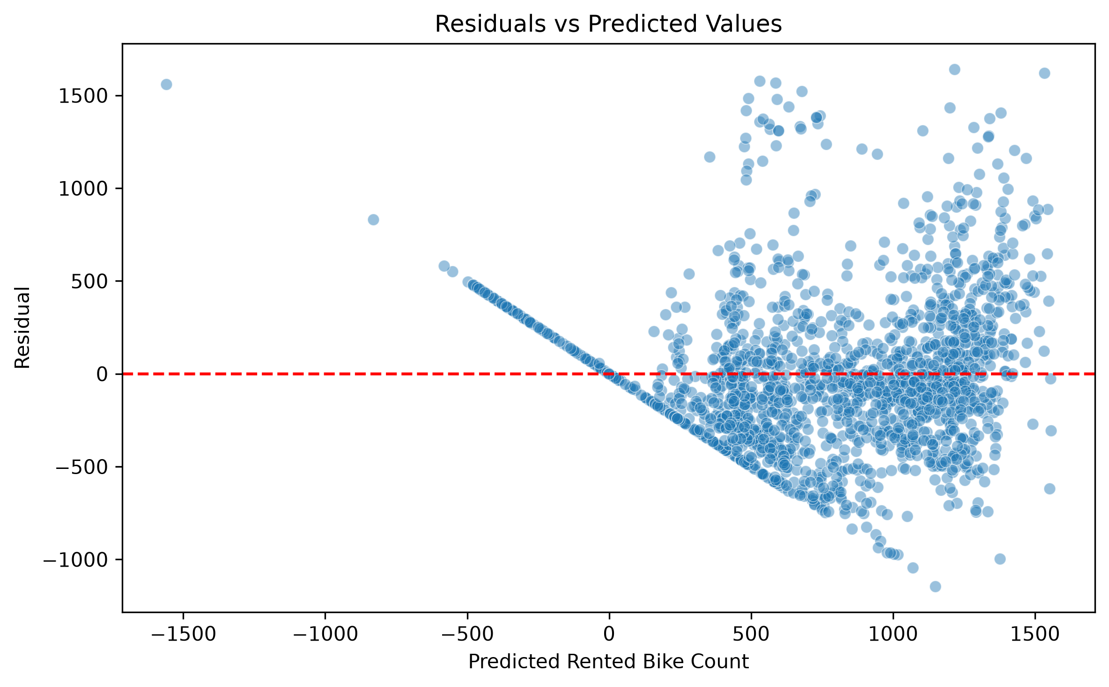
Figure 6. Residuals vs Predicted Values.
The Durbin-Watson statistic of 0.4923 is far below 2, indicating substantial positive autocorrelation in the residuals. This is unsurprising for hourly demand data because adjacent periods tend to be related. Autocorrelation violates the ordinary least squares independence assumption and can make standard errors and p-values too optimistic. Consequently, the reported p-values should be interpreted as baseline inferential results rather than definitive time-series inference.
- The relationship between hour and demand is unlikely to be strictly linear; commuting peaks may require categorical, polynomial, or cyclical hour features.
- Temperature, humidity, dew point, and solar radiation may be correlated, which can affect individual coefficients and their signs.
- The functioning-day indicator separates operational closures from normal demand and therefore has a very large coefficient.
- Important factors such as station-level availability, local events, transit disruptions, and customer behavior are not included.
- The chronological split is stronger than a random split for future-facing evaluation, but a single split does not replace rolling time-series validation.
- The findings describe associations and prediction, not causal effects.

7. Conclusion
A multiple linear regression model was successfully developed to predict hourly bike rental demand. The model explained 55.35% of training variation and 55.11% of test variation, with MAE of 309.67 and RMSE of 410.92 on later observations. The nearly identical training and test R-squared values indicate stable out-of-sample performance.
Functioning-day status, hour, rainfall, winter season, solar radiation, humidity, Sunday, temperature, holiday status, wind speed, and snowfall were statistically significant at the 5% level. Operational status had the largest raw coefficient, while rainfall, humidity, and winter were associated with lower demand. Temperature and later hours were associated with higher demand under the fitted linear specification.
Overall, the model provides a useful interpretable baseline, but it captures only a moderate proportion of demand variation and shows substantial residual autocorrelation. Future work should consider nonlinear hour effects, lagged demand, rolling validation, and time-series or ensemble models while retaining linear regression as the explanatory benchmark.

References
UCI Machine Learning Repository. (2020). Seoul Bike Sharing Demand [Data set]. https://archive.ics.uci.edu/dataset/560/seoul+bike+sharing+demand
Python Software Foundation. Python.
pandas development team. pandas.
scikit-learn developers. scikit-learn.
Seabold, S., & Perktold, J. statsmodels.

Appendix A. Figure Replacement Checklist
- Place the six PNG files inside the local figures folder next to the Word report.
- In Word, click the placeholder, delete the one-cell placeholder table, then select Insert > Pictures > This Device.
- Choose the matching PNG file and set Wrap Text to In Line with Text.
- Center the image and keep the existing caption directly underneath it.
- Use a width of approximately 14-15 cm unless the figure becomes difficult to read.
- After all insertions, update page numbers and inspect every page for split captions or oversized figures.

Appendix B. Files to Keep with the Submission
- seoul_bike_regression_report.docx
- seoul_bike_regression.ipynb
- coefficient_results.csv
- figures/demand_distribution.png
- figures/hourly_demand.png
- figures/correlation_heatmap.png
- figures/seasonal_demand.png
- figures/actual_vs_predicted.png
- figures/residual_plot.png

