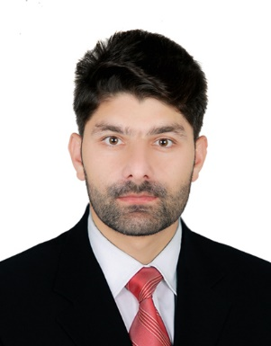

**Contact**

**Address:**

Village Torwarsak District Buner Kpk (Pakistan)

**Phone:**

(+92)3409465299

**Email:**

[kwaqas0777@gmail.com](mailto:kwaqas0777@gmail.com)

**Languages**

English – Educational

Urdu – Fluent

Pashto – Fluent

**Hobbies**

* Travelling
* Cricket
* Badminton
* Volleyball

**Objectives**

To secure a challenging position in a reputable organization to expand my learnings, knowledge, and skills.

**Skill Highlights**

|  |  |
| --- | --- |
| * Project management * Strong decision maker * Complex problem solver | * Team Leadership * Innovative * Time management |

**Experience**

Eight(8) months of experience in android.

**Education**

* **Bachelor’s of Computer Science (2020)**

**University:** Abdul Wali Khan University Mardan, Buner Campus(**CGPA:3.8)**

* **Intermediate – FSC Pre-Engineering (2015)**

**College:** Usmania Public School and CollegeTorwarsak, Buner**(789/1100)**

* **Matriculation –Science (2013)**

**Institute:** Usmania Public School and College Torwarsak, Buner **(864/1050)**

**Technical Skills**

**Programming Languages:** Android Application Development with Java and XML(API’s) JSON Parsing, Java, HTML5, OOP, CSS, SQL, MySQL, Java OOP.

**Final Year Project in Android**

**Final year project Title “Vehicle Parental Control Application”: A Low-cost Smartphone Solution to Track Teen Drivers While Driving.**

Waqas