GitHub Repository:
https://github.com/Umarismail-student/CalculatorApp-Testing-Project

Test Report – Calculator Application
1. Introduction
This test report summarizes the testing activities performed for the Calculator Application. The purpose of the testing was to verify that the calculator works correctly, handles invalid user input, and meets the requirements described in the user stories.
2. GitHub Repository
The GitHub repository includes multiple commits, branches, pull requests, and merged pull requests. This shows that Git was used during the project workflow.
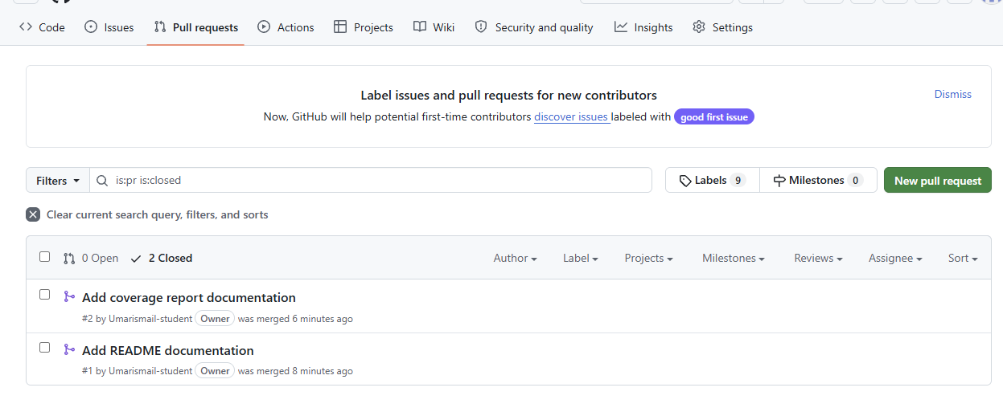
Figure 1. GitHub pull request history showing two merged pull requests.
GitHub Repository:
https://github.com/Umarismail-student/CalculatorApp-Testing-Project
The repository includes source code, test files, Git commits, feature branches, pull requests, and merged pull requests.
3. Test Environment
The application was developed and tested using:
- C#
- .NET
- xUnit
- Coverlet
- ReportGenerator
- Visual Studio
4. Testing Methods
Both manual and automated testing were used.
Manual testing was used to test the application from the user’s perspective. Manual testing can be time-consuming, but it is useful for checking the full user flow and finding usability problems.
Automated testing was used to test the calculator logic, input validation, and history functionality. Automated tests are faster to repeat and help ensure that changes do not break existing functionality.
5. Black-box Testing
Black-box testing means testing the application without looking at the internal source code. The tester focuses on inputs and expected outputs.
Example:
Input: 5 + 3
Expected output: 8
This type of testing checks if the application behaves correctly from the user’s perspective.
6. Invalid User Input Testing
The application was tested with incorrect input to make sure it handles user mistakes correctly.
Examples of invalid input:
- Empty input
- Letters instead of numbers
- Division by zero
- Invalid menu choices
- Unsupported operations
These tests are important because real users may enter incorrect values.
7. Test Results

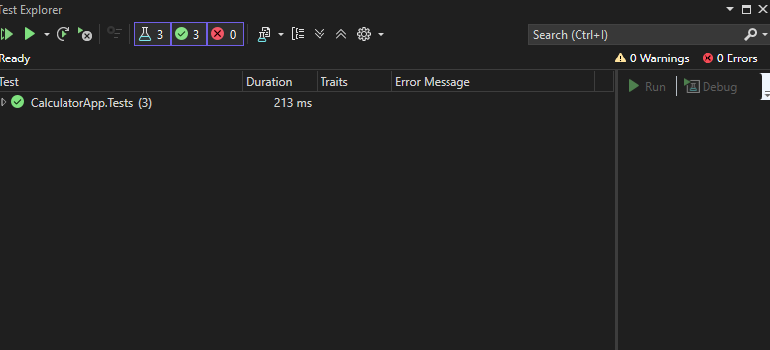
Figure 3. Code coverage by class showing tested and untested parts of the application.

The automated tests were executed using xUnit.
The tests covered:
- Addition
- Subtraction
- Multiplication
- Division
- Input validation
- Calculation history
Most core calculator functions passed successfully.
Screenshots of the test execution results are included below.
[Insert screenshot of test results here]
8. Code Coverage
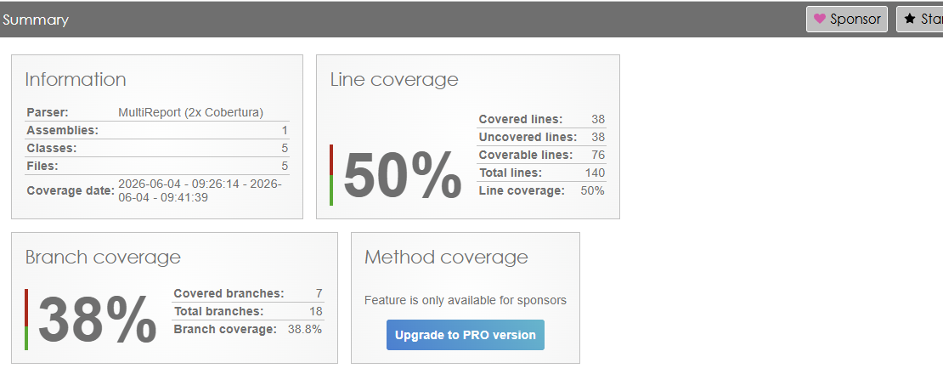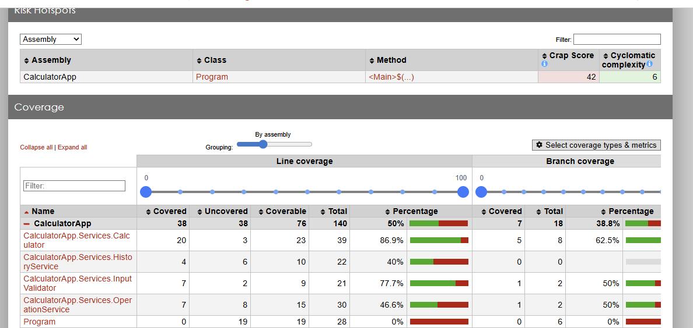
Figure 2. Code coverage summary generated with ReportGenerator. The result shows 50% line coverage and 38.8% branch coverage.
Code coverage was generated using Coverlet and ReportGenerator.
The coverage report showed:
- Line coverage: 50%
- Branch coverage: 38.8%
- Covered lines: 38
- Uncovered lines: 38
- Coverable lines: 76
- Total lines: 140
The result shows that important parts of the application were tested. However, some parts of the program, especially parts of the main program flow and some branches, were not fully covered. The coverage could be improved by adding more tests for edge cases and invalid input scenarios.
[Insert screenshot of coverage report here]
9. Lessons Learned
During this project, we learned how to plan, design, and execute tests for a small software application.
We learned the difference between manual testing, automated testing, and black-box testing. Manual testing is useful for checking the application from a user perspective, but it can take more time. Automated testing is more efficient for repeating tests and checking that the application still works after changes.
We also learned how code coverage can help identify which parts of the code are tested and which parts need more tests.
10. Conclusion
The Calculator Application was tested using both manual and automated testing. The main calculator functions worked as expected, and the project includes test cases, test plan, test strategy, GitHub repository, commits, pull requests, merged pull requests, and coverage results.
Future improvements could include increasing code coverage, adding more tests for invalid input, and testing more edge cases.

