Comparative Study of Bioinformatics Databases (NCBI, UniProt & PDB)
Submitted To: CodeAlpha Internship Program
Submitted By: Umar Sajad
B.Tech Electronics & Communication Engineering
Institute of Technology, Zakura Campus
University of Kashmir

Introduction
Bioinformatics is an interdisciplinary field that combines biology, computer science, mathematics, and information technology to analyze biological data. It helps researchers understand DNA sequences, protein structures, gene functions, and evolutionary relationships using computational methods. NCBI, UniProt and PDB are among the most widely used databases for biological research.

NCBI
The National Center for Biotechnology Information (NCBI) provides free access to nucleotide sequences, genomes, genes, PubMed literature and tools such as BLAST. Advantages include comprehensive data, regular updates and integration with many research resources. A limitation is that beginners may find the interface overwhelming.

NCBI Homepage
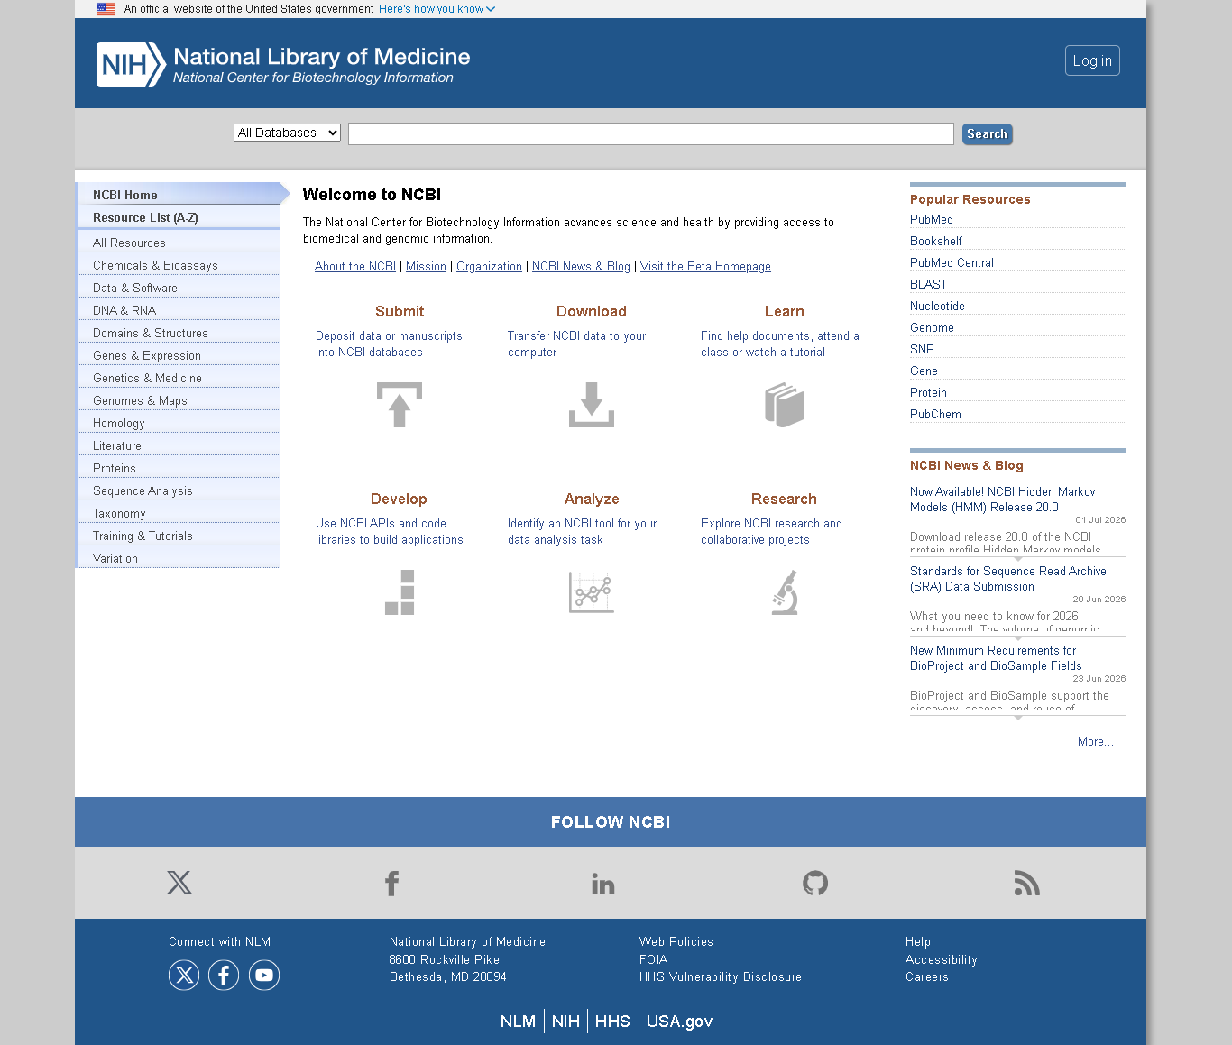
Figure 1: NCBI Homepage

UniProt
UniProt is a comprehensive protein database containing protein sequences, functional annotations, domains and disease associations. It offers high-quality curated data but focuses mainly on proteins.

UniProt Homepage
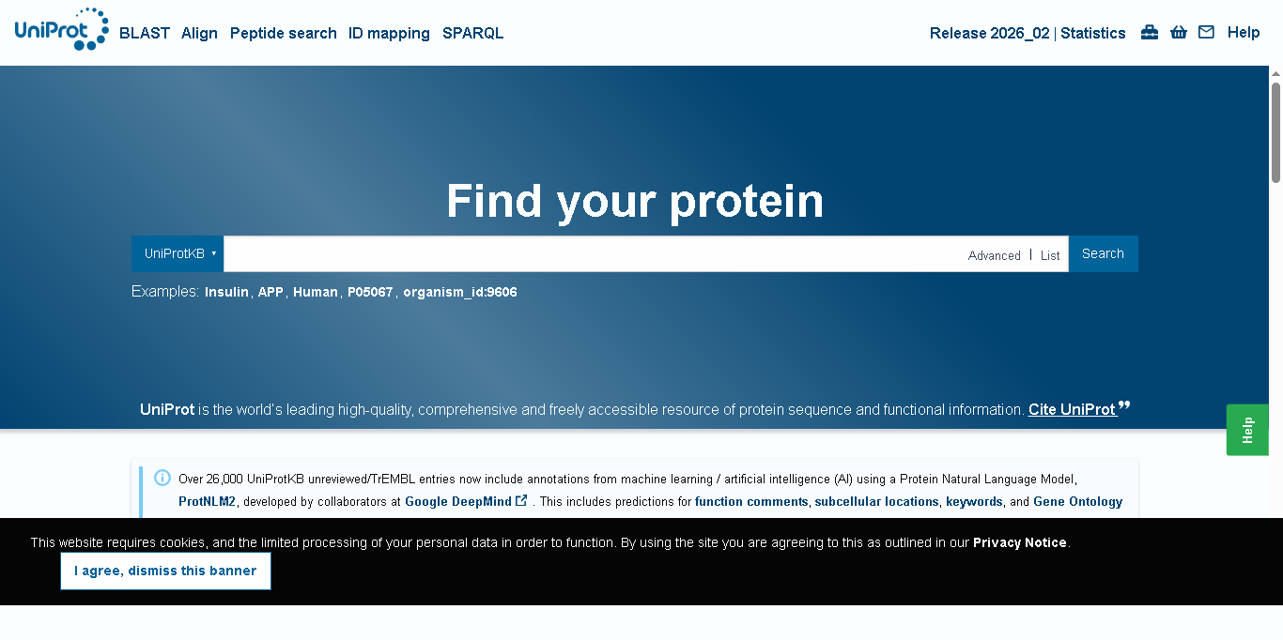
Figure 2: UniProt Homepage

Protein Data Bank (PDB)
The Protein Data Bank stores three-dimensional structures of proteins, nucleic acids and other biomolecules. It is widely used for structural biology, visualization and drug discovery.

RCSB PDB Homepage
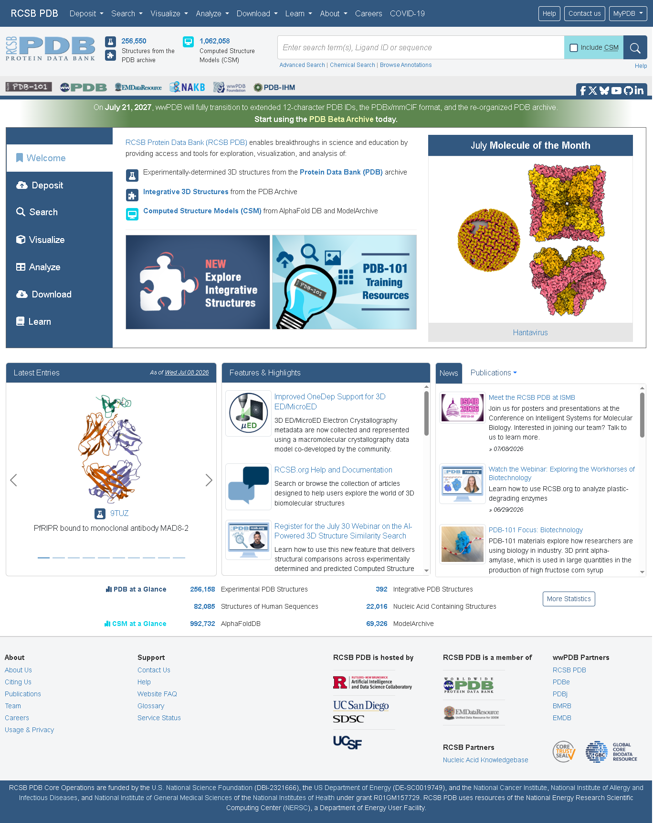
Figure 3: RCSB PDB Homepage

Comparison
NCBI focuses on DNA/RNA and genomes, UniProt focuses on proteins and annotations, while PDB specializes in 3D molecular structures. All three are free resources and complement one another in bioinformatics workflows.

Applications
These databases are used in drug discovery, genomics, biotechnology, disease research, vaccine development, molecular biology and evolutionary studies.

Conclusion
NCBI, UniProt and PDB are essential bioinformatics resources. Together they provide sequence information, protein knowledge and structural data that support modern biological and medical research.

References
1. National Center for Biotechnology Information (NCBI)
2. UniProt
3. RCSB Protein Data Bank (PDB)
4. National Institutes of Health (NIH)
5. David W. Mount, Bioinformatics: Sequence and Genome Analysis

