Protein Structure Prediction Report
Protein: Amyloid-beta precursor protein (APP)
UniProt ID: P05067-2
Organism: Homo sapiens

Objective
Predict and visualize the 3D structure using AlphaFold DB.

Methodology
Selected APP from UniProt, opened AlphaFold DB, visualized the model, and captured screenshots.

Protein Information
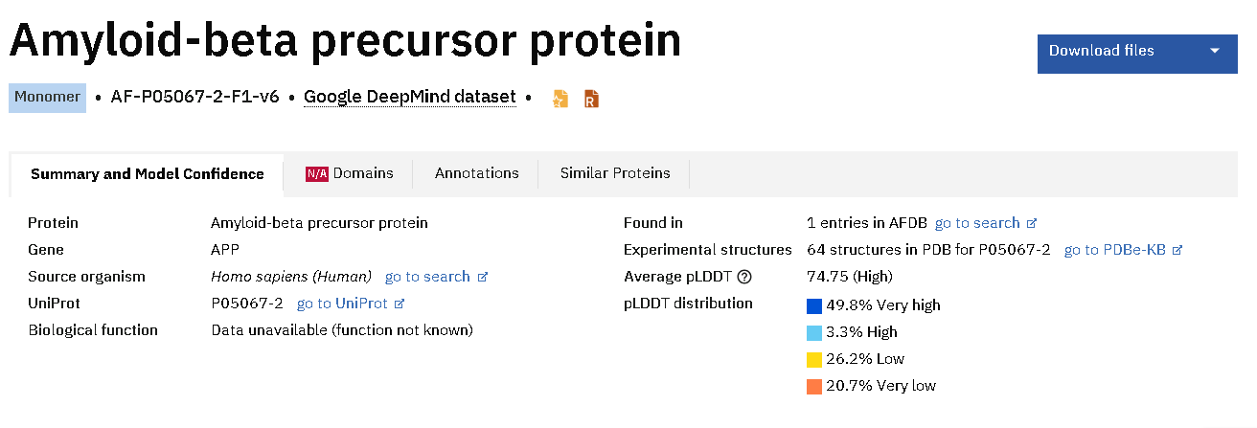
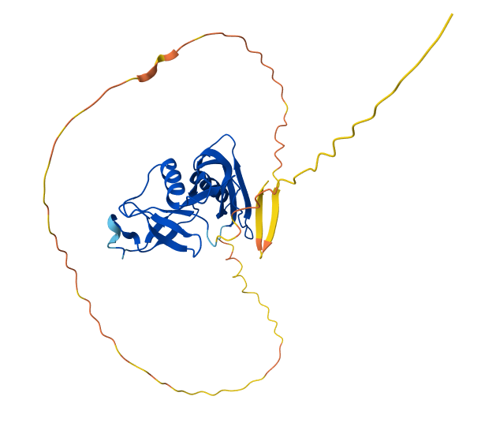
Figure 1: 3D structure view 1.
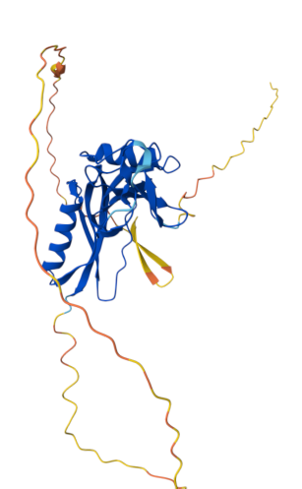
Figure 2: 3D structure view 2.
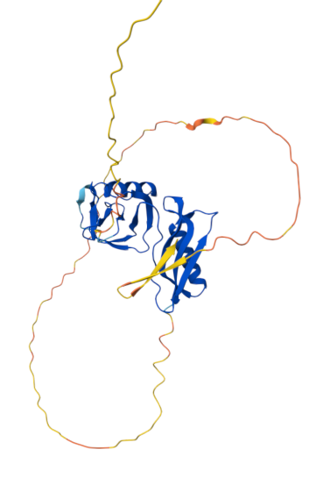
Figure 3: 3D structure view 3.
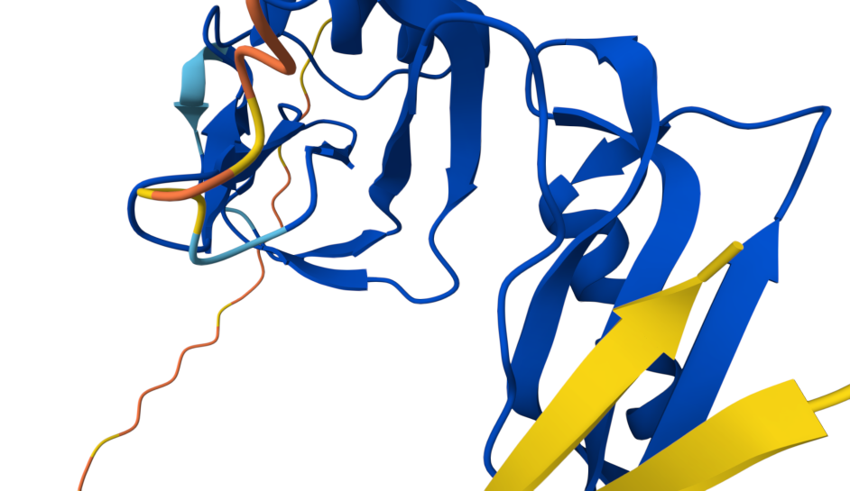
Figure 4: 3D structure view 4.

Structural Features
The protein contains alpha-helices, beta-sheets and loop regions. High-confidence regions form the folded core while flexible termini show lower confidence.

Conclusion
AlphaFold successfully predicted the 3D structure of APP, enabling visualization and structural analysis.

References
AlphaFold Protein Structure Database
UniProt

