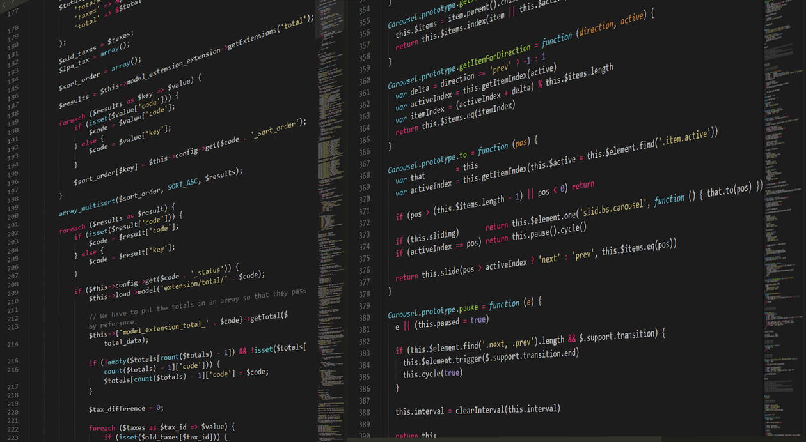 **Artificial Intelligence.**

**SELF DRIVING CAR – REPORT**

* **Abdul Haseeb**
* **Ahmad Abdullah**
* **Arshman Shahbaz**
* **Asad Ullah Rafi**
* **Ozair Attiq**

**Self driving car system**

In this upcoming era the world advancing towards automation. The most affected area would be the technology and automobiles industry. So we decided to make a project which would give us a better understanding about this rising industry.

Our Project will cover all major aspects of a self driving car which we analysed in our main inspiration TESLA.

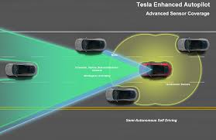 The problem we were facing was how to avoid obstacles infront of us and how to calculate cost for each lane ? For this purpose we took 5 sensors:

1. Front middle
2. Front Left
3. Front Right
4. Back Right
5. Back Left

We take values from these sensors and forward them to our **Think Tank** where It decides that which is the best solution to the problem and with the least cost.

For calculating the costs we used Uninformed Cost Search. It calculates the cost of moving from a lane to another, and the lane with least cost and no obstacle is out final state in which the car has to be everytime.

This automation is a major need of the time to provide most comfortable journey to the drivers on the highway and we are honored to be a part of this technology.