Lab Task 4

* Create Two Tables Named Faculty & Course
* Add Attributes to faculty as (Faculty_ID, Faculty_Name, Faculty_Course, Faculty_Salary)
* Add Attributes to Course as (Course_ID, Course_Name, Faculty_Id)
* Add Primary Keys to Both Tables
* Make Proper Foreign Key Relation between both tables
* Execute the SQL statement with (Natural Join) for following condition   
  (Get Name of the Faculty who is teaching the course Named as ‘Database Systems’

(Submit your word file with the images containing the output of the SQL statement and an image of the graph showing the relation between both databases)

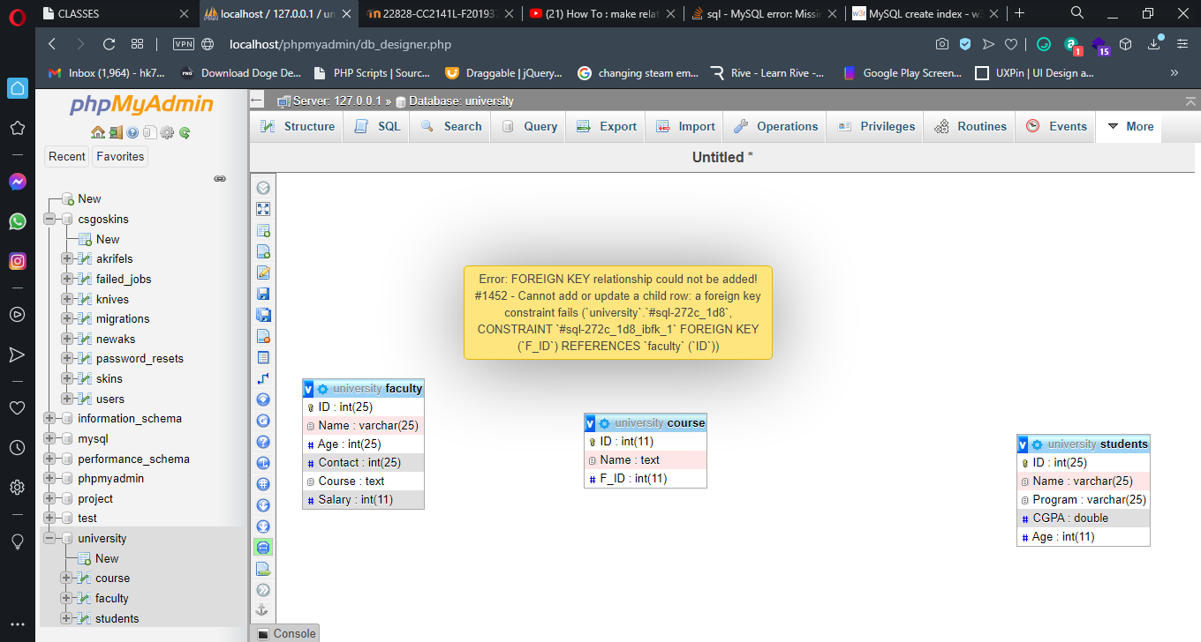

Sir im trying this since yesterday im getting this error constantly please clear this concept in next class thank u sir   
Regards ABDUL HASEEB

F2019376038