**Linux Commands**

## *ls:-*

**Parameters:-**

-a, -all, /

**Description:-**

Without arguments, lists the files and directories names in the current directory.

$ ls / : Lists the contents of the directory given as an argument.

$ ls –a /home/student : Includes so-called “hidden” files and directories whose names begin with a dot (.).

$ ls [options] [files_or_directories]: Lists the contents of the current directory or a specified directory.

$ ls –all: Lists files and directories with detailed information like permissions, size, owner, etc.

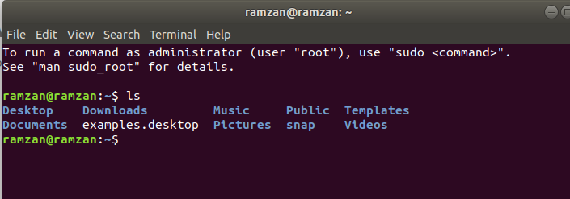**Screenshot:-**

## *date:-*

**Parameters:-**

N.A.

**Description:-**

Prints the system date and time.

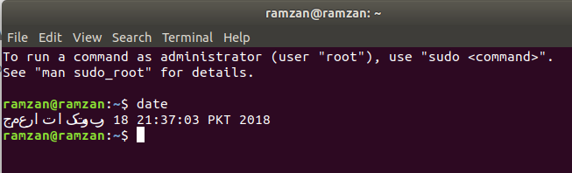**Screenshot:-**

## *cal:-*

**Parameters:-**

N.A.

**Description:-**

Prints the ASCII calendar of the current month.

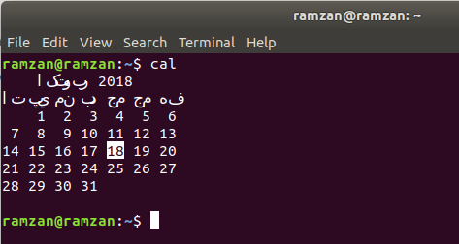**Screenshot:-**

## *pwd:-*

**Parameters:-**

N.A.

**Description:-**

Displays the absolute path to the current working directory.

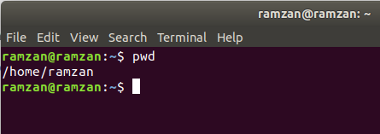**Screenshot:-**

## *cd:-*

**Parameters:-**

.., ~, -

**Description:-**

$ cd: Changes directories.

$ cd /home/uet/cs: To an absolute path.

$ project /docs: To a relative path.

$ cd .. : To a directory one level up.

$ cd ~ : T a directory one level up.

$ cd - : To your previous working directory.

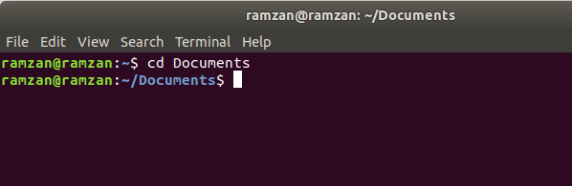**Screenshot:-**

## *mkdir:-*

**Parameters:-**

N.A.

Description:-

Directories can be created on a Linux operating system using the following command:- mkdir directoryname

This command will create a subdirectory in your present working directory, which is usually your "Home Directory".

For example, mkdir mydirectory

**Screenshot:-**

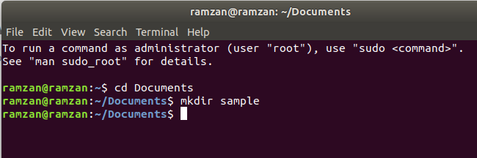

## *rm:-*

**Parameters:-**

N.A.

Description:-

To remove a file, use the command - rm filename

Example

Rm assignment.odt

will delete the directory mydirectory

**Screenshot:-**

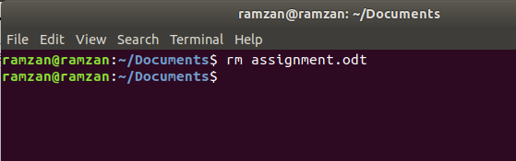

## *mv:-*

**Parameters:-**

N.A.

**Description:-**

The 'mv' (move) command can also be used for renaming directories. Use the below-given format:

mv directoryname newdirectoryname

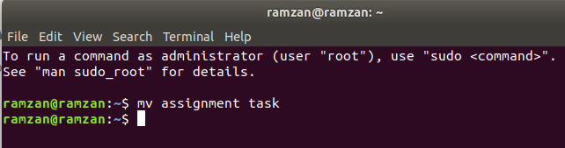**Screenshot:-**

## *man:-*

**Parameters:-**

N.A.

**Description:-**

Man stands for manual which is a reference book of a Linux operating system. It is similar to HELP file found in popular software.

To get help on any command that you do not understand, you can type man

The terminal would open the manual page for that command.

For an example, if we type man man and hit enter; terminal would give us information on man command

$ man man

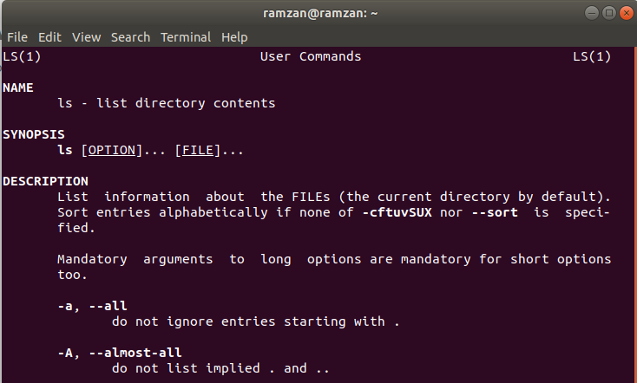**Screenshot:-**

## *history:-*

**Parameters:-**

N.A.

**Description:-**

History command shows all the commands that you have used in the past for the current terminal session. This can help you refer to the old commands you have entered and re-used them in your operations again.

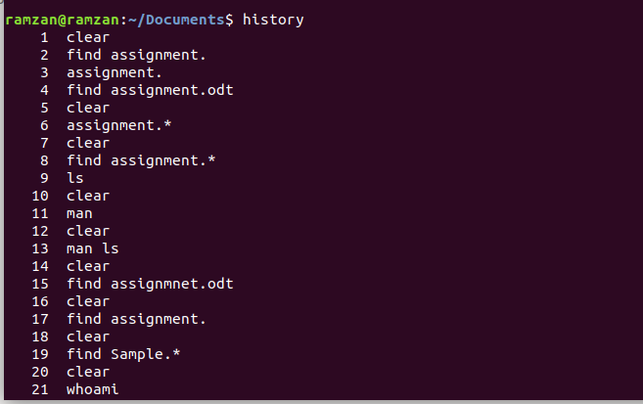**Screenshot:-**

## *clear:-*

**Parameters:-**

N.A.

**Description:-**

This command clears all the clutter on the terminal and gives you a clean window to work on, just like when you launch the terminal.

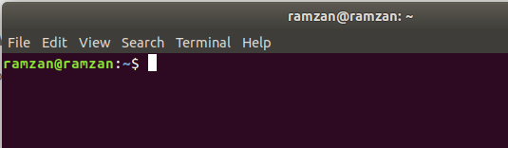**Screenshot:-**

1. ***df:-***

**Parameters:-**

N.A.

**Description:-**

Display free disk space.

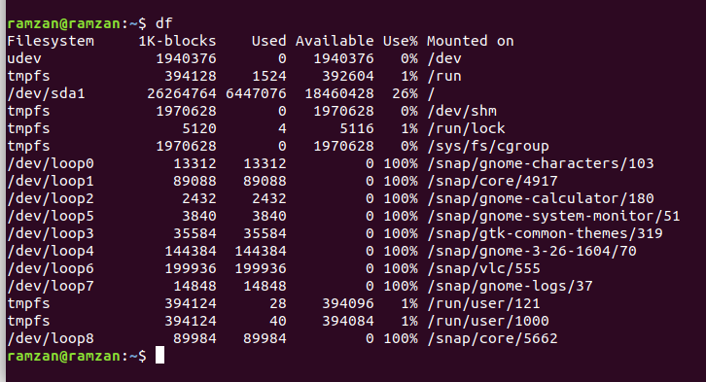**Screenshot:-**

## *echo:-*

**Parameters:-**

N.A.

**Description:-**

Display message on screen.

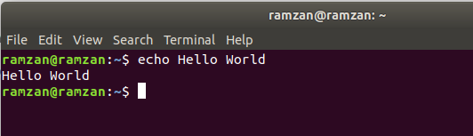**Screenshot:-**

## *free:-*

**Parameters:-**

-h, -m, -g

**Description:-**

Display memory usage.

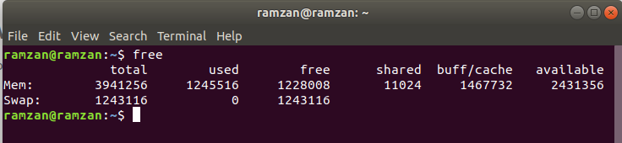**Screenshot:-**

1. ***logname:-*** ***Parameters:-***

N.A.

**Description:-**

Display memory usage.

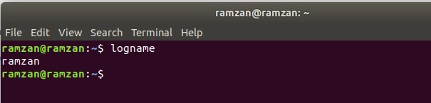**Screenshot:-**

## *whoami:-*

**Parameters:-**

N.A.

**Description:-**

Print the current user id and name.

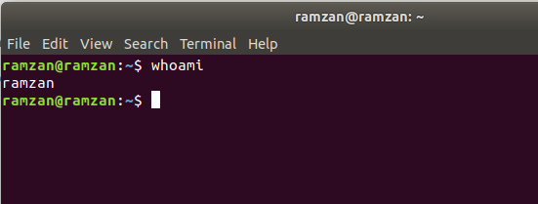**Screenshot:-**

## *uname:-*

**Parameters:-**

-a, -r

**Description:-**

Print system information

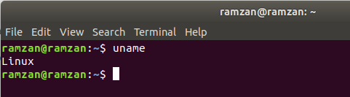**Screenshot:-**

## *factor:-*

**Parameters:-**

N.A.

**Description:-**

Display prime factors of specified integer numbers.

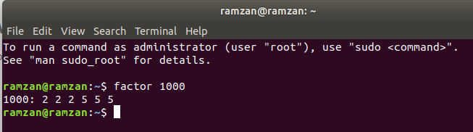**Screenshot:-**

## *top:-*

**Parameters:-**

N.A.

**Description:-**

Shows top consumers of memory and CPU.

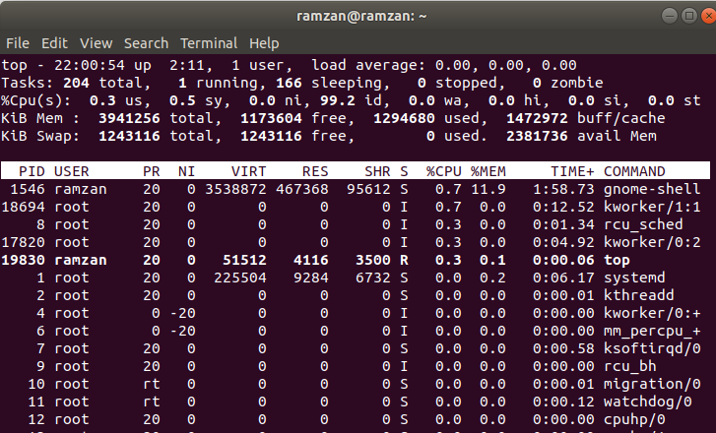**Screenshot:-**

1. ***ps:-***

**Parameters:-**

-ef

**Description:-**

Shows processes running by user.

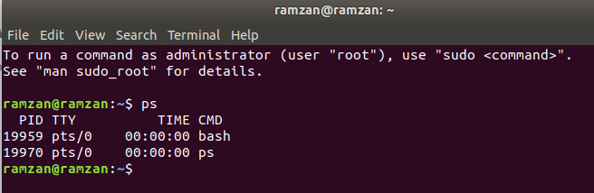**Screenshot:-**

**Lab Tasks:**

1. **Provide details about the following commands?**
   * apt-get
   * yum
   * wget
   * gzip tar
   * rar