Contents

1. Home 2

2. About Us 3

Leadership Team 4

Vision & Mission 5

Why Alviez 6

3. Services 7

Premium Support for Individual Traders 8

Portfolio management 12

Private Equity & Fund Management 13

Investment Solutions 14

4. Trainings 15

Price Action Training for Beginner to Intermediate Level Traders 16

ACTS Starter Pack training for Beginners 21

5. ACT Academy 23

Level 1 – Foundation 25

Level 2 – Intermediate 27

Level 3 – Trader 29

Level 4 – Master Trader 31

Level 5 – Expert Trader 33

One Year Mentorship 35

6. Careers 36

7. Contact Us 37

# Home

WELCOME TO ALVIEZ CAPITAL

We care for our clients' business as our own. We share their ambitions and align our incentives with their objectives—so they know we're in this together

We are renowned, not only for the quality of trainings, but also for extensive range of services that we offer. Our expert trader’s trading experience is broad and varied. We have been involved with wide range of companies, different industry sectors and high networth individuals in managing their investment portfolios. We offer services in following areas:

* Premium Support for Individual Traders
* Portfolio management
* Private Equity & Fund Management
* Investment Solution

We offer range of high-end training in following areas:

* ACT Academy
  + Level 1 – Foundation
  + Level 2 – Intermediate
  + Level 3 – Trader
  + Level 4 – Master Trader
  + Level 5 – Expert Trader
  + One Year Mentorship Program
* ACT Trainings
  + Price Action Training for Beginner to Intermediate Level Traders

Our services are designed to assist enterprises & individuals to manage their investment portfolio.

Please feel free to contact us at [info@alviez.com](mailto:info@alviez.co.uk) to discuss your needs.

**Landing Page – No addition required. Will explain It on skype**

# About Us

Alviez Capital is brainchild of Basit Alvi and Abdul Haq Alvi. We are renowned, not only for the quality of training, but also for extensive range of services that we offer. Our expert trader’s trading experience is broad and varied. We have been involved with wide range of companies, different industry sectors and high networth individuals in managing their investment portfolios. We offer services in following areas:

* Premium Support for Individual Traders
* Portfolio management
* Private Equity & Fund Management
* Investment Solution

We offer range of high-end training in following areas:

* ACT Academy
  + Level 1 – Foundation
  + Level 2 – Intermediate
  + Level 3 – Trader
  + Level 4 – Master Trader
  + Level 5 – Expert Trader
  + One Year Mentorship Program
* ACT Trainings
  + Price Action Training for Beginner to Intermediate Level Traders

Our services are designed to assist enterprises & individuals to manage their investment portfolio.

Please feel free to contact us at [info@alviez.com](mailto:info@alviez.co.uk) to discuss your needs.

## Leadership Team

**Abdul Haque Alvi Co-Founder & Managing Director**

Abdul Haq Alvi is co-founder Managing Director at Alviez Capital. Abdul's primary responsibility is to develop long term sustainable and profitable infrastructure for portfolio and investment management of high networth enterprises and individuals.

Before joining Alviez, Abdul was Financial Systems and Business Processes expert covering the Textile, Education, Health and Financial sectors. He was Management Faculty at Greenwich School of Management. He began his career at QS Quacquarelli Symonds Ltd, where he worked in variety of finance roles including financial systems, business processes management and corporate development.

Abdul has MSc in International Banking Finance from Glasgow University, UK, MSc Investment Analysis from Sterling University, UK, Post Grad in Trading Investment & Behavioural Finance from IFS London, UK & BSC (Hons) in Finance Investment and Risk from IFS, London, UK. He is Certified Accountant, Chartered Banker, Certified SAP Consultant, and Certified Tableau & Alteryx Consultant.

**Basit Alvi Founder & Chairman**

Basit Alvi is Founder & Chairman of Alviez Capital. Basit is seasoned entrepreneur and has experience in senior leadership roles in different industry sectors.

Basit Specialises in international portfolio management with core speciality in crypto currencies & real state acquisition development and expansion. Basit is expert in building businesses from scratch and converting them into profitable units through organic and strategic growth.

Basit has also led range of business transformation, Business Process Management, CapEx & OpEx optimisation Programmes and business programmes in the past.

Basit has delivered number of trainings and presentations in international forums on Business Transformation, Managed Services, and Business Process Management.

Basit has an MSc in Personal & Mobile Communication Systems from Kings’ College London UK, Post Graduate Certification in Information Systems Management from University of Bournemouth, UK and BSc in Electrical & Electronics Engineering from University of Engineering & Technology Peshawar, Pakistan. Basit has certifications in Leadership. ITIL V3, Lean Six Sigma, PRINCE 2, MSP and P3O.

## Vision & Mission

**Our Vision**

To be the most trusted and respected professional portfolio & investment management firm recognized by our clients for delivering excellence.

**Our Mission**

*CLIENTS*

*We strive to meet and exceed our client’s expectations to foster long term partnerships.*

*EMPLOYEES*

*Our employee are our most valued assets. We value our staff and create an enjoyable work environment which allows personal fulfilment that leads to a loyal and productive work force.*

***THE COMPANY***

We keep on delivering our value portfolio and investment management and training services in best possible way

## Why Alviez

We care for our clients' investments as our own. We share their ambitions and align our incentives with their objectives—so they know we're in this together

We have best team of expert traders who have experience of different industry sectors and have helped our clients to maximise their profits.

Alviez as your long-term strategic partner assist you to maximize profits and react effectively to the market trends/opportunities.

We’re a dynamic group of investment professionals, focused on exploring best ways to grow our client’s investment portfolios. We make sure our clients succeed in their long-term goals by helping them to adopt tried & tested strategies and methodologies into actions and generating maximum profits.

We have state of the art high end trainings for business graduates, proprietary traders and individuals.

# Services

We, at Alviez offer range of services and state of the art solutions to our valued clients to meet their objectives in following areas:

* Premium Support for Individual Traders
* Portfolio management
* Private Equity & Fund Management
* Bespoke Investing Solutions on Demand

Our services are designed in such a way to assist our customer to maximise their profits from available opportunities in the markets

## Premium Support for Individual Traders

**We have robust, tried & tested methodologies to ensure maximum profit from available opportunities at every step of trade**

We offer three types of premium support services which are as follow:

Premium Support

Premium Plus

Premium Platinum



**Button to Register**

**Premium Support:**

Premium support is subscription based closed group service for serious trader. We provide following service in premium support:

Daily Market briefs

Live updates during trading session

Calls for Up to 30 scrips in a month

Analysis on any KSE 100 scrip on demand

Market entry and exit strategy brief

**Premium Support Charges:**

Monthly Subscription – PkR 1,000 per month (to be paid 5 days before start/renewal date every month)

6 Month membership Subscription - PkR 5,500 (to be paid 5 days before start/renewal date every month)

1 Year membership subscription – PkR 10,500 (to be paid 5 days before start/renewal date every month)

One to one session on demand but there will be additional charges for dedicated sessions.

**Button to Register**

**Premium Plus:**

Premium plus support is subscription based closed group service for serious trader. We provide following service in premium plus support:

Daily Market briefs

Live updates during trading session

Calls for Up to 40 scrips in a month

Analysis on any KSE 100 scrip on demand

Market entry and exit strategy brief

Daily brief on gold

Daily brief on crude oil

Daily brief on major currency pairs

**Premium Plus Support Charges:**

Monthly Subscription – PkR 1,500 per month (to be paid 5 days before start/renewal date every month)

6 Month membership Subscription - PkR 8,500 (to be paid 5 days before start/renewal date every month)

1 Year membership subscription – PkR 16,500 (to be paid 5 days before start/renewal date every month)

One to one session on demand but there will be additional charges for dedicated sessions.

**Button to Register**

**Premium Platinum:**

Premium platinum support is subscription based closed group service for serious trader. We provide following service in premium platinum support:

Daily Market briefs

Live updates during trading session

Calls for Up to 50 scrips in a month

Analysis on any KSE 100 scrip on demand

Market entry and exit strategy brief

Daily brief on gold

Daily brief on crude oil

Daily brief on major currency pairs

Daily brief on NASDAQ

Daily brief on DOW JONES

Daily brief on S&P 500

Analysis on any international scrip on demand

**Premium Platinum Support Charges:**

Monthly Subscription – PkR 2,000 per month (to be paid 5 days before start/renewal date every month)

6 Month membership Subscription - PkR 11,000 (to be paid 5 days before start/renewal date every month)

1 Year membership subscription – PkR 21,000 (to be paid 5 days before start/renewal date every month)

One to one session on demand but there will be additional charges for dedicated sessions.

**Button to Register**

**We ensure that premium support is aligned to individual’s long-term financial objective**

30 mins zoom session is conducted once individual sign up for premium support service. Our Business development manager would explain the details of premium support service and answer queries.

Please feel free to contact us at [info@alviez.com](mailto:info@alviez.com) for further information.

## Portfolio management

At Alviez Capital, we develop, and construct portfolios based on our client’s long/short term strategic objectives, risk appetite, personal and tax circumstances. Our portfolio managers offer both discretionary and advisory investment services.

With our discretionary offering, we invest on behalf of our clients. We draw on proven market expertise to help our clients achieve their financial goals. Our advisory services give our clients a two-way relationship with a dedicated banker who liaises with our investment experts. This investment service enables you to be in control but not alone.

Please feel free to contact us at [info@alviez](mailto:info@alwees.co.uk).com for further information.

## Private Equity & Fund Management

We work with our clients as strategic partner to ensure highly profitable private equity and fund management.

Our private equity and fund management managers are expert to tailor, holistic solutions to tackle the complex world of fund administration and structuring, operational efficiency, governance and global regulation.

Our solutions can be customised and designed to meet your specific needs, so you can accelerate the possible across all private capital assets classes, including; private equity, real estate and infrastructure

Please feel free to contact us at [info@alviez](mailto:info@alwees.co.uk).com for further information.

## Investment Solutions

Investment solutions is the investment management function of Alviez Capital. Our sole focus is to care for, preserve and grow our clients’ wealth over the long term.

AT Alviez Capital, we cover a broad spectrum, including:

* Equities
* Investment funds
* Alternative investment
* Crypto currencies

Please feel free to contact us at [info@alviez](mailto:info@alwees.co.uk).com for further information.

# Trainings

We offer state of the art high end trainings for business graduates, enterprises, proprietary traders and individuals in following areas:

* ACT Academy
  + Level 1 – Foundation
  + Level 2 – Intermediate
  + Level 3 – Trader
  + Level 4 – Master Trader
  + Level 5 – Expert Trader
  + One Year Mentorship Program
* ACT Trainings
  + Price Action Training for Beginner to Intermediate Level Traders
  + ACT Starter Pack Training for Beginners

We deliver training both as part of on-going programs and standalone. We customise all our trainings as per need and requirement of our clients. We tailor trainings in a way that these enable delegates to implement the best practises in real life trading and maximise profits

Please feel free to contact us at [info@alviez.com](mailto:info@alviez.co.uk) for further information.

## Price Action Training for Beginner to Intermediate Level Traders

Price action training is customised training designed keeping in view that markets are forward looking and price action follows market’s sentiments compared to all other indicators which lag behind and rely on historical data

Price action training is 8 days intensive course based on real life scenarios

Price action training equips attendees to start trading with price action at completion of course with tried and tested methodologies

Course fee = PKR 30,000

Free Price action training for those who register for 1 year premium platinum support service

Training Structure is as follow:

Day 1 - Price Action Training for Beginner to Intermediate Level Traders

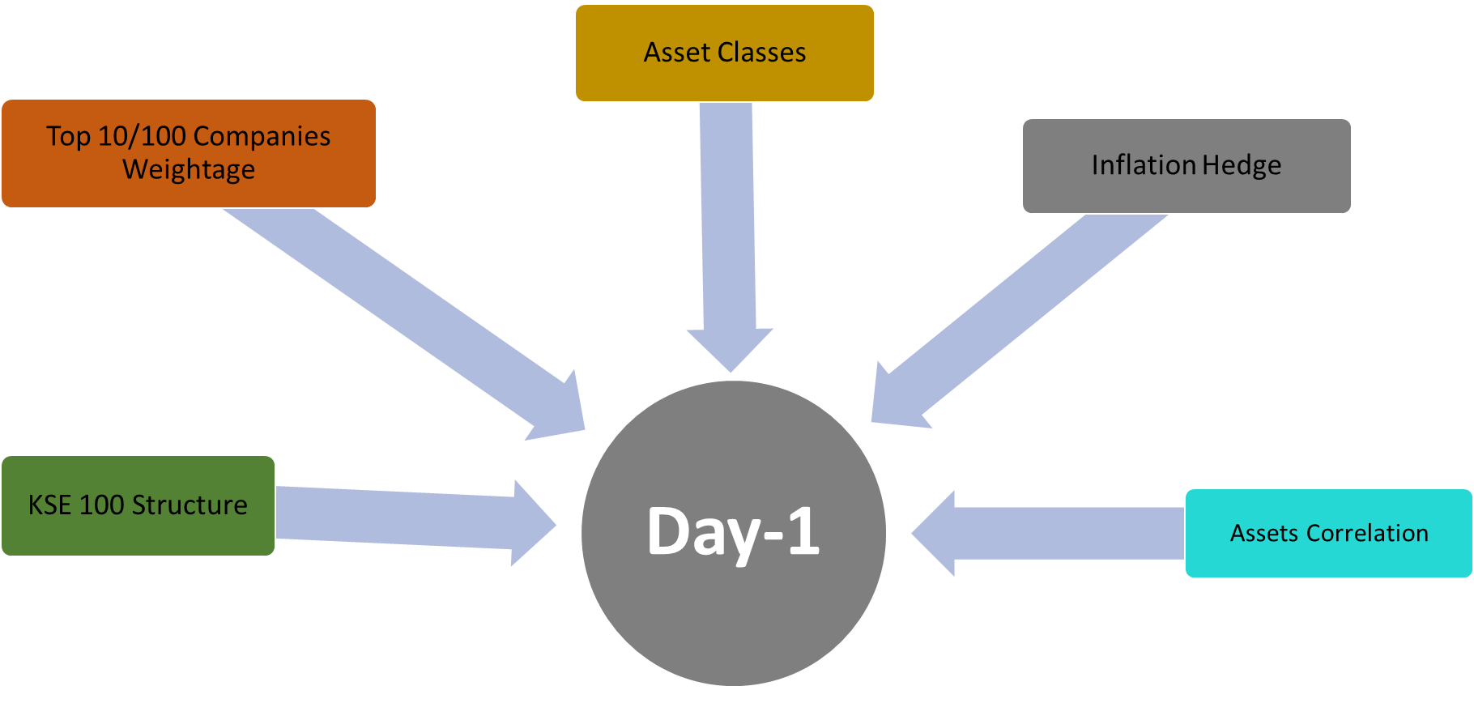

Day 2 - Price Action Training for Beginner to Intermediate Level Traders 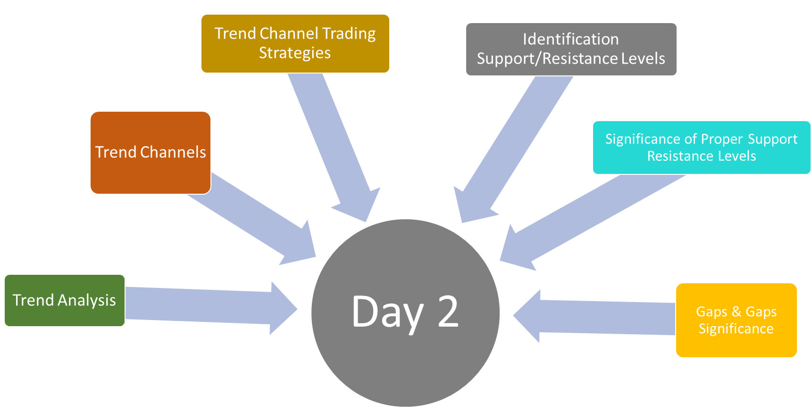

Day 3 - Price Action Training for Beginner to Intermediate Level Traders

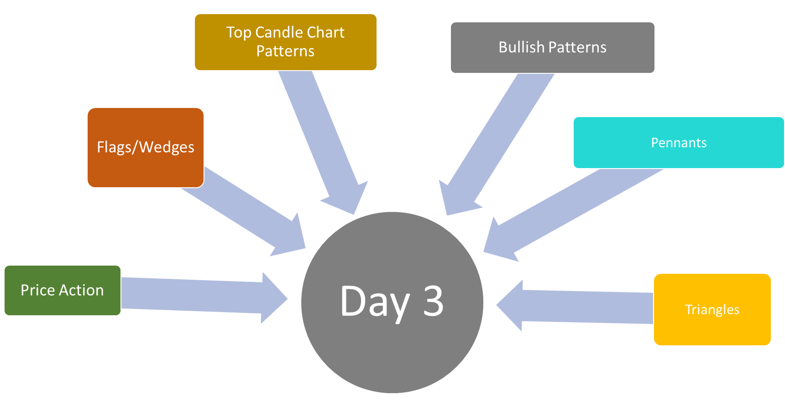

Day 4 - Price Action Training for Beginner to Intermediate Level Traders

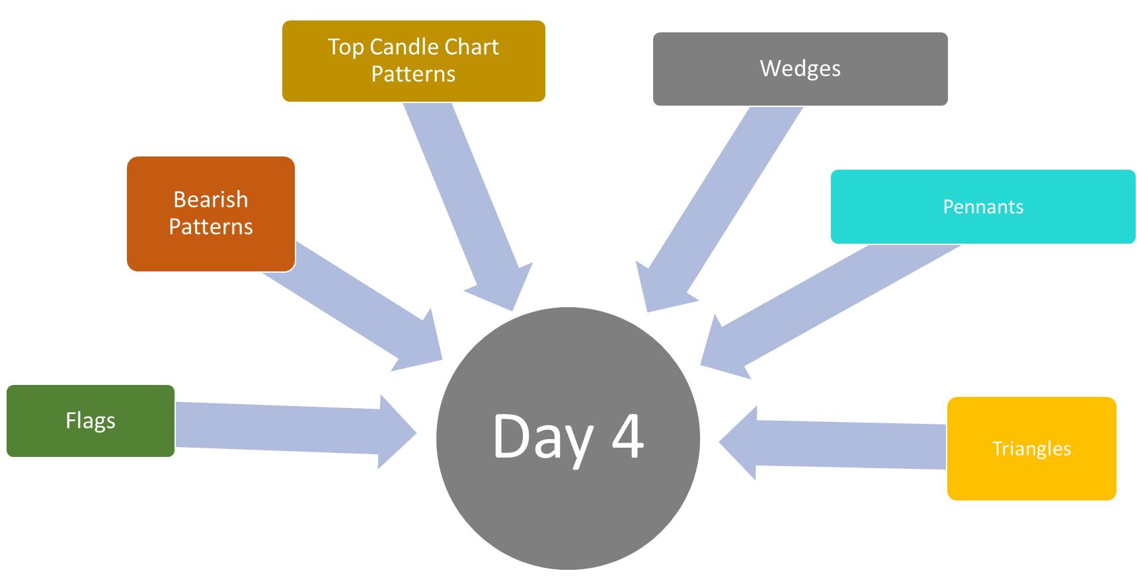

Day 5 - Price Action Training for Beginner to Intermediate Level Traders

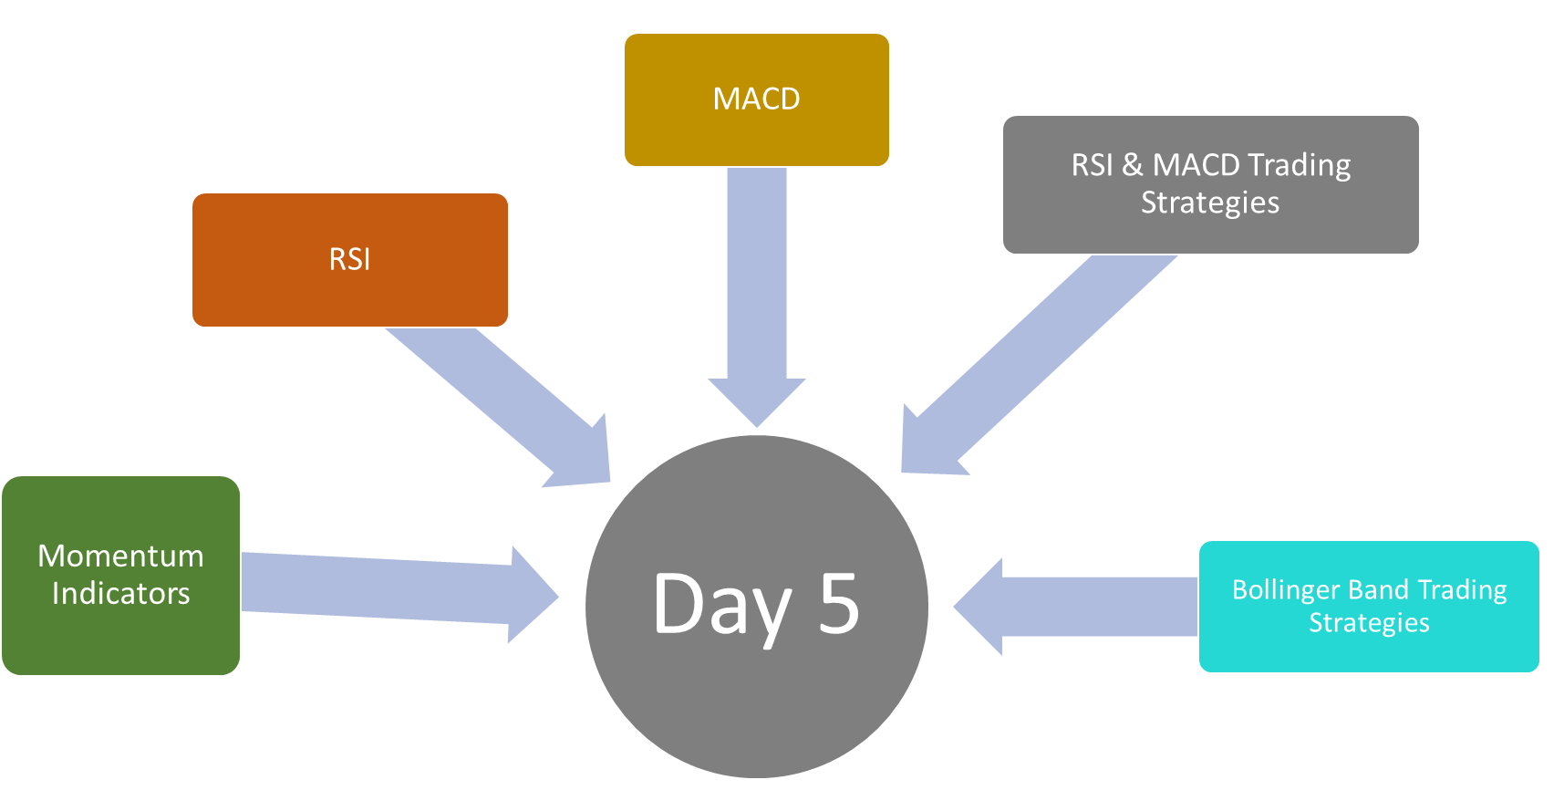

Day 6 - Price Action Training for Beginner to Intermediate Level Traders

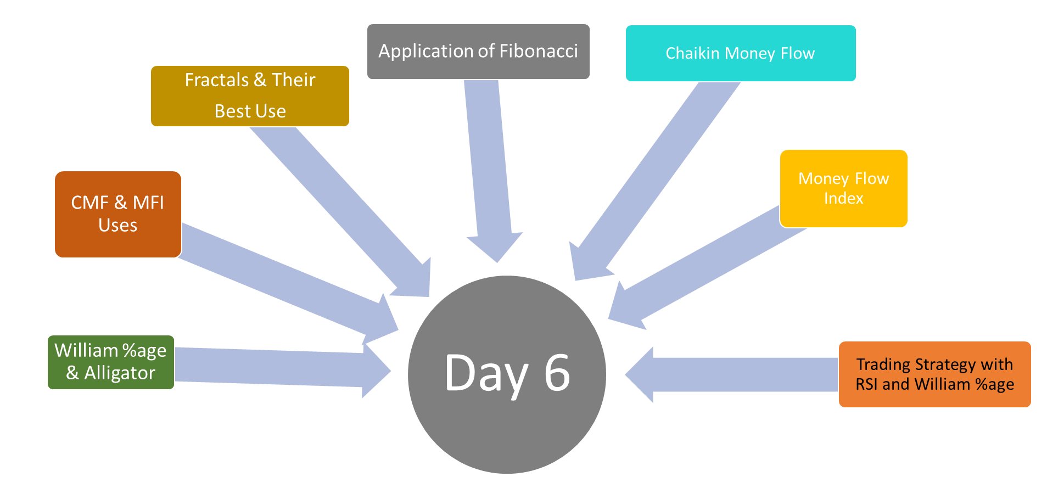

Day 7 - Price Action Training for Beginner to Intermediate Level Traders

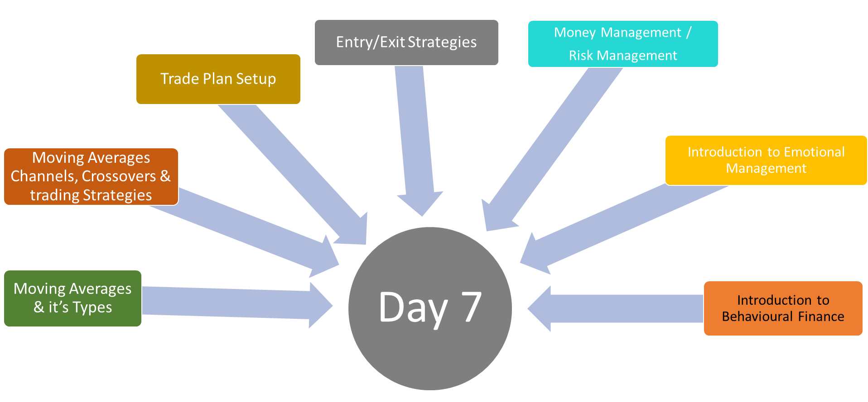

Day 8 - Price Action Training for Beginner to Intermediate Level Traders

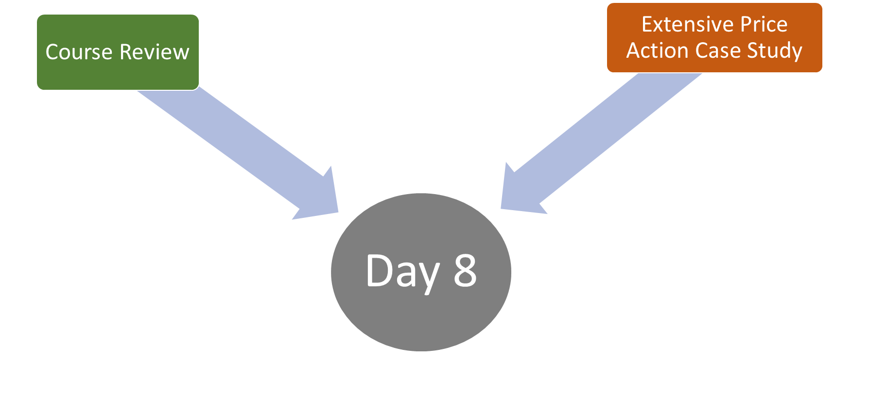

We conduct these trainings throughout the year. We also offer these trainings on demand. Please contact us for further details on [info@alviez.com](mailto:info@alviez.com)

## ACTS Starter Pack training for Beginners

ACTS Starter pack for beginners training is customised training designed keeping in view the basic and fundamentals essential required to begin trading

Starter pack for beginners training is 2 days intensive course based on real life scenarios

ACTS Starter pack for beginners training equips attendees to create account and start trading in PSX with basic knowledge

Course fee = PKR 10,000

Free Starter pack training for Beginners training for those who register for 1 year premium platinum support service

Training Structure is as follow:

Day 1 – ACT Starter Pack Training for Beginners

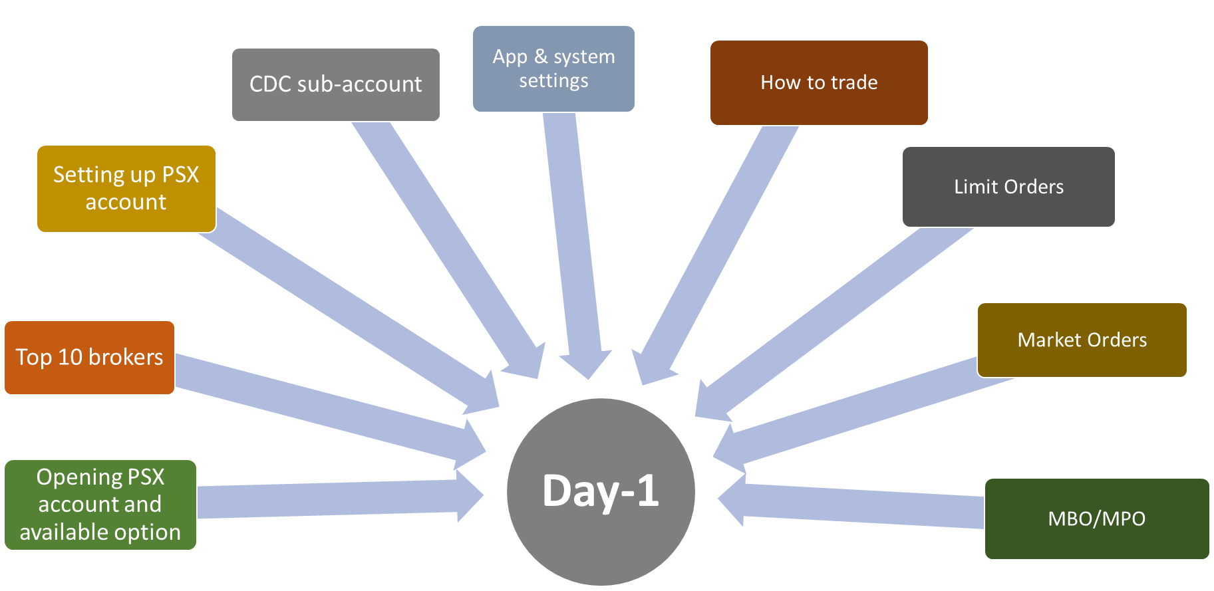

Day 2 – ACT Starter Pack Training for Beginners

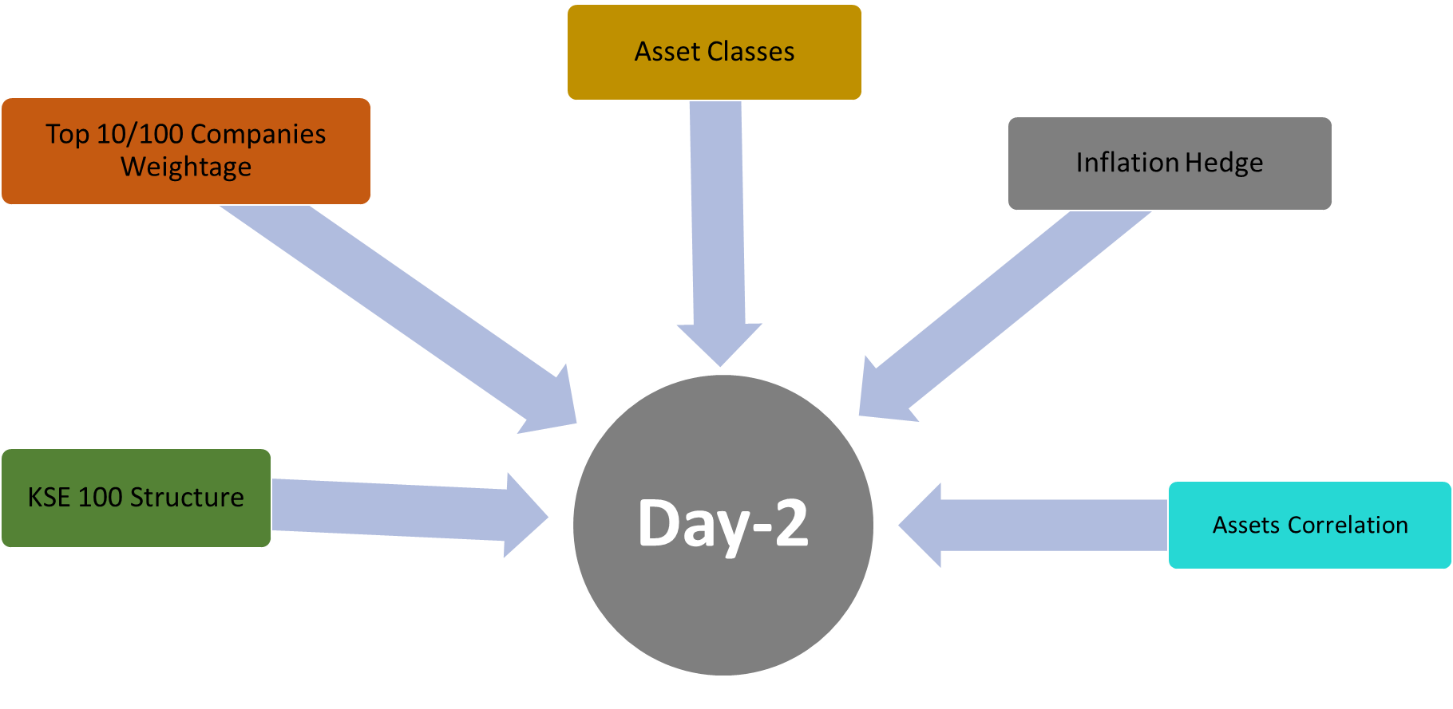

We conduct these trainings throughout the year. We also offer these trainings on demand. Please contact us for further details on [info@alviez.com](mailto:info@alviez.com)

# ACT Academy

ACT academy is structured to cover from foundation to expert level. One-year mentorship program is also offered in ACT academy.

Structure of ACT Academy is as follow

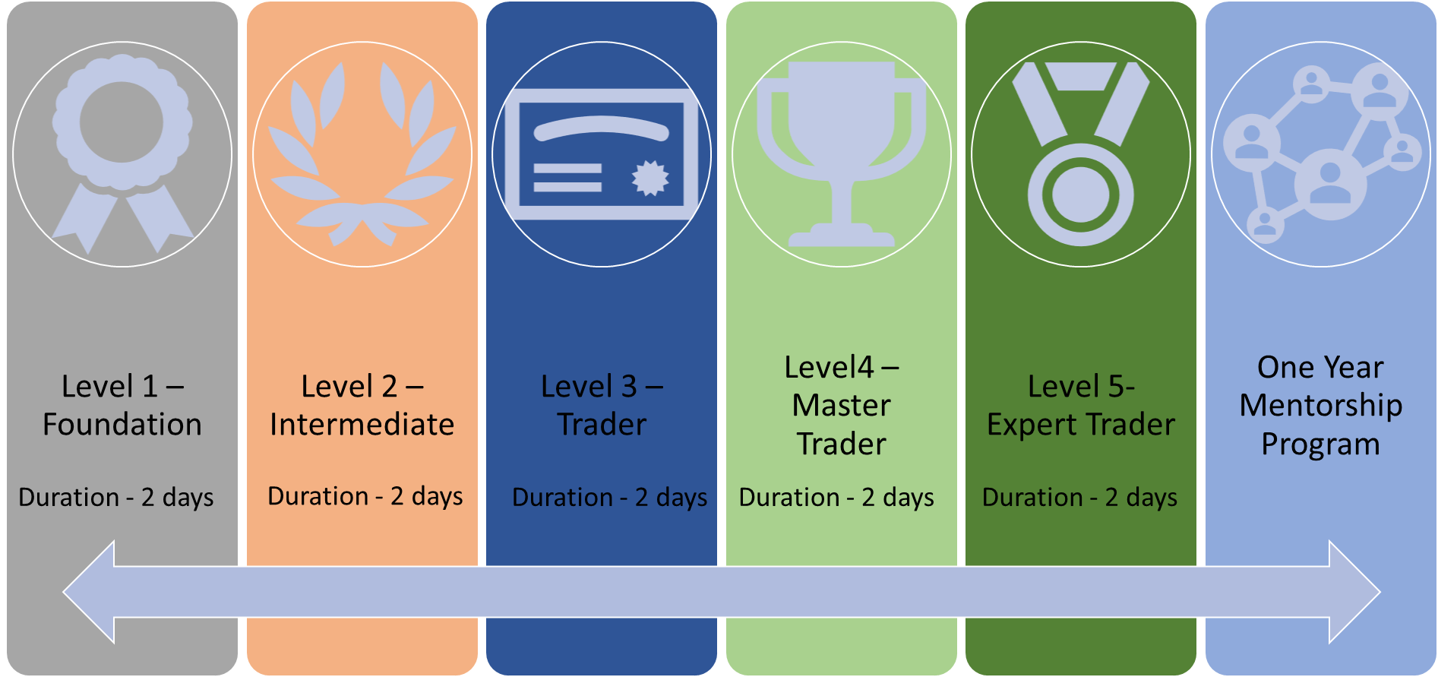

Details of charges and different options are as follow:

Options 1:

Level 1 – Level 5 without one year mentorship – PkR 99,000 (to be paid 2 weeks before start of program)

Option 2 :

Level 1 – Level 5 + One Year Mentorship – PkR 120,000 (to be paid 2 weeks before start of program)

Option 3:

We also offer on demand trainings for different levels. Minimum number of participants must be 12 to conduct different levels trainings. Charges details are as follow:

Level 1 – Foundation: PkR 25,000 (to be paid one week before start of training)

Level 2 – Intermediate: PkR 25,000 (to be paid one week before start of training)

Level 3 – Trader: PkR 30,000 (to be paid one week before start of training)

Level 4 – Master Trader: PkR 30,000 (to be paid one week before start of training)

Level 5 – Expert Trader: PkR 30,000 (to be paid one week before start of training)

One-year mentorship program is offered to only those trainees who register for Level 1 – Level 5 trainings. We provide following support during one-year mentorship program:

* 30 mins sessions every two weeks to review progress after course completion
* Daily Market briefs
* Live KSE 100 updates during trading session
* Call for upto 50 scrips in a month
* Market entry and exit brief
* Daily brief on gold
* Daily brief on crude oil
* Daily brief on major currency pairs
* Daily brief on NASDAQ
* Daily brief on DOW JONES
* Daily brief on S&P 500

Please feel free to contact us at [info@alviez.com](mailto:info@alviez.co.uk) for further information.

## Level 1 – Foundation

Level 1 – Foundation is first level of ACT academy series of Level 1 – Level 5 training program. Following areas are covered in Level 1 – Foundation:

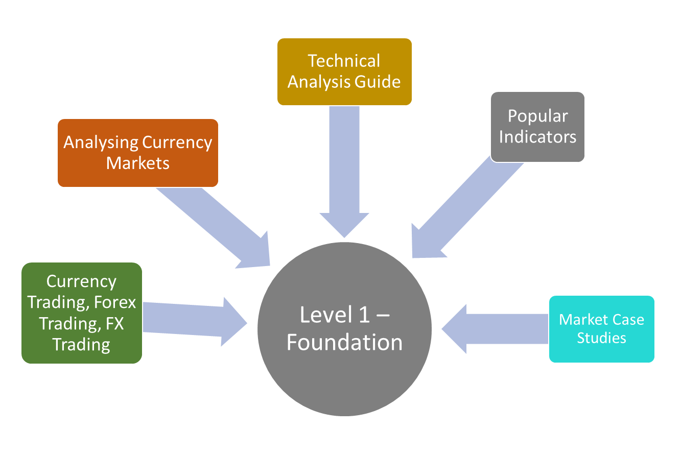

You can also register for level 1 – Level 5 program, we also offer 1-year mentorship program for trainees who register Level 1 to Level 5. Program structure is as follow:

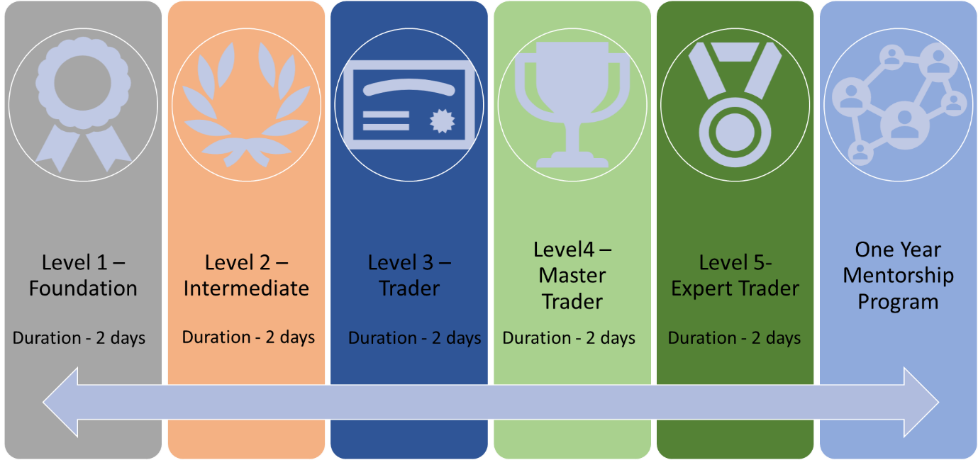

There are three options to avail, details are as follow:

Options 1:

Level 1 – Level 5 without one year mentorship – PkR 99,000 (to be paid 2 weeks before start of program)

Option 2 :

Level 1 – Level 5 + One Year Mentorship – PkR 120,000 (to be paid 2 weeks before start of program)

Option 3

Level 1 – Foundation Only: Course Fee – PkR 25,000

Option 4:

1-2-1 dedicated training for one person. Please contact us at [info@alviez.com](mailto:info@alviez.co.uk) for details

We also offer on demand trainings for Level 1 – Foundation. Minimum number of participants must be at least 12 to conduct training. Charges details are as follow:

Level 1 – Foundation: PkR 25,000 (to be paid one week before start of training)

Please feel free to contact us at [info@alviez.com](mailto:info@alviez.co.uk) for further information.

## Level 2 – Intermediate

Level 2 – Intermediate is 2nd level of ACT academy series of Level 1 – Level 5 training program. Following areas are covered in Level 2 – Intermediate:

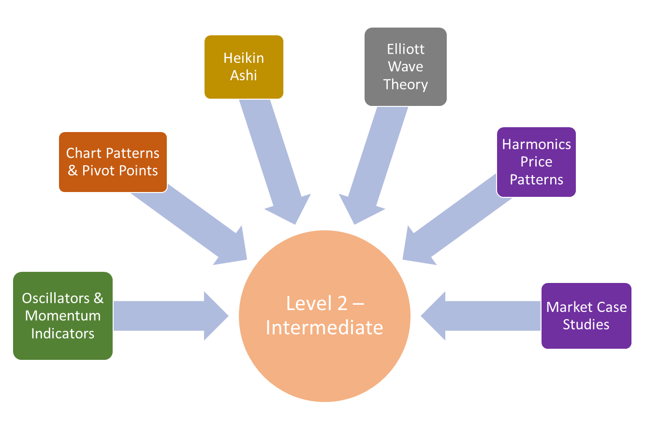

You can also register for level 1 – Level 5 program, we also offer 1-year mentorship program for trainees who register Level 1 to Level 5. Program structure is as follow:



There are three options to avail, details are as follow:

Options 1:

Level 1 – Level 5 without one yea mentorship – PkR 99,000 (to be paid 2 weeks before start of program)

Option 2 :

Level 1 – Level 5 + One Year Mentorship – PkR 120,000 (to be paid 2 weeks before start of program)

Option 3:

Level 2 – Intermediate Only – Course Fee PkR 25,000

We also offer on demand trainings for Level 2 – Intermediate. Minimum number of participants must be at least 12 to conduct training. Charges details are as follow:

Level 2 – Intermediate: PkR 25,000 (to be paid one week before start of training)

Option 4:

1-2-1 dedicated training for one person. Please contact us at [info@alviez.com](mailto:info@alviez.co.uk) for details

Please feel free to contact us at [info@alviez.com](mailto:info@alviez.co.uk) for further information.

## Level 3 – Trader

Level 3 – Trader is 3rd level of ACT academy series of Level 1 – Level 5 training program.. Following areas are covered in Level 3 – Trader:

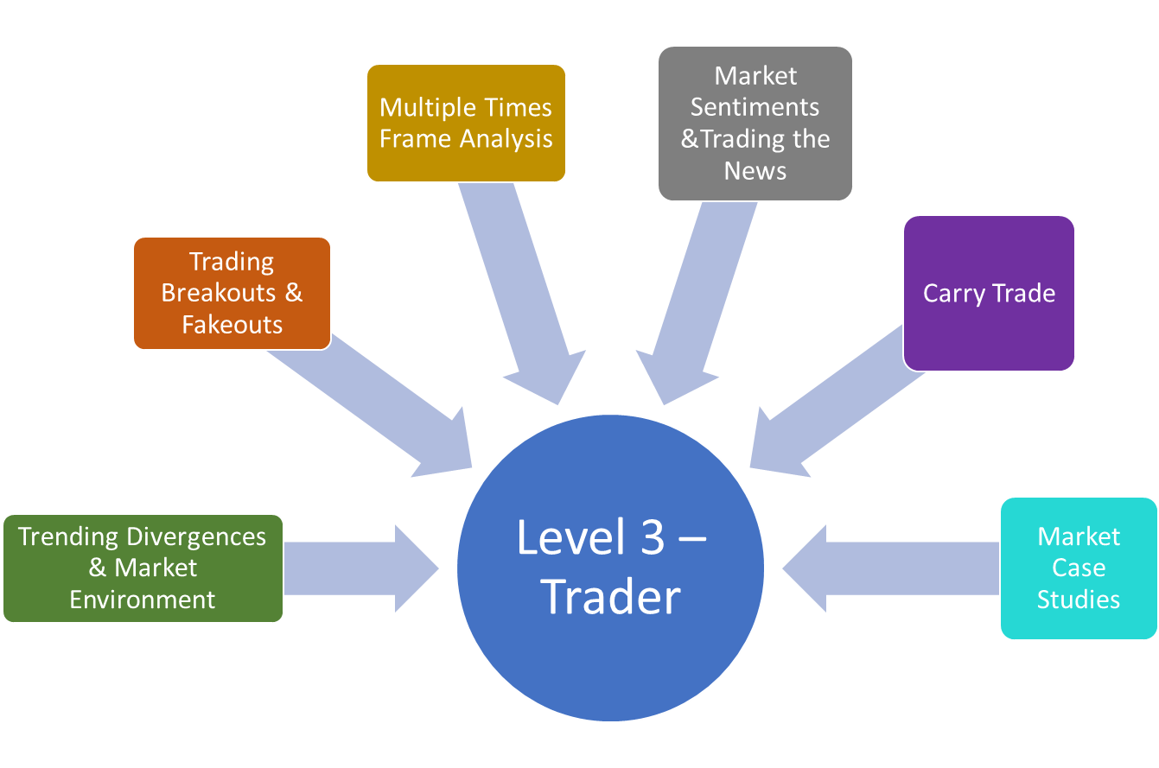

You can also register for level 1 – Level 5 program, we also offer 1-year mentorship program for trainees who register Level 1 to Level 5. Program structure is as follow:



There are three options to avail, details are as follow:

Options 1:

Level 1 – Level 5 without one yea mentorship – PkR 99,000 (to be paid 2 weeks before start of program)

Option 2 :

Level 1 – Level 5 + One Year Mentorship – PkR 120,000 (to be paid 2 weeks before start of program)

Option 3-

Level 3 – Trader Only: Course Fee – PkR 30,000

We also offer on demand trainings for Level 3 – Trader. Minimum number of participants must be at least 12 to conduct training. Charges details are as follow:

Level 3 – Trader: PkR 30,000 (to be paid one week before start of training)

Option 4:

1-2-1 dedicated training for one person. Please contact us at [info@alviez.com](mailto:info@alviez.co.uk) for details

Please feel free to contact us at [info@alviez.com](mailto:info@alviez.co.uk) for further information.

## Level 4 – Master Trader

Level 4 – Master Trader is 4th level of ACT academy series of Level 1 – Level 5 training program. Following areas are covered in Level 4 – Master Trader:

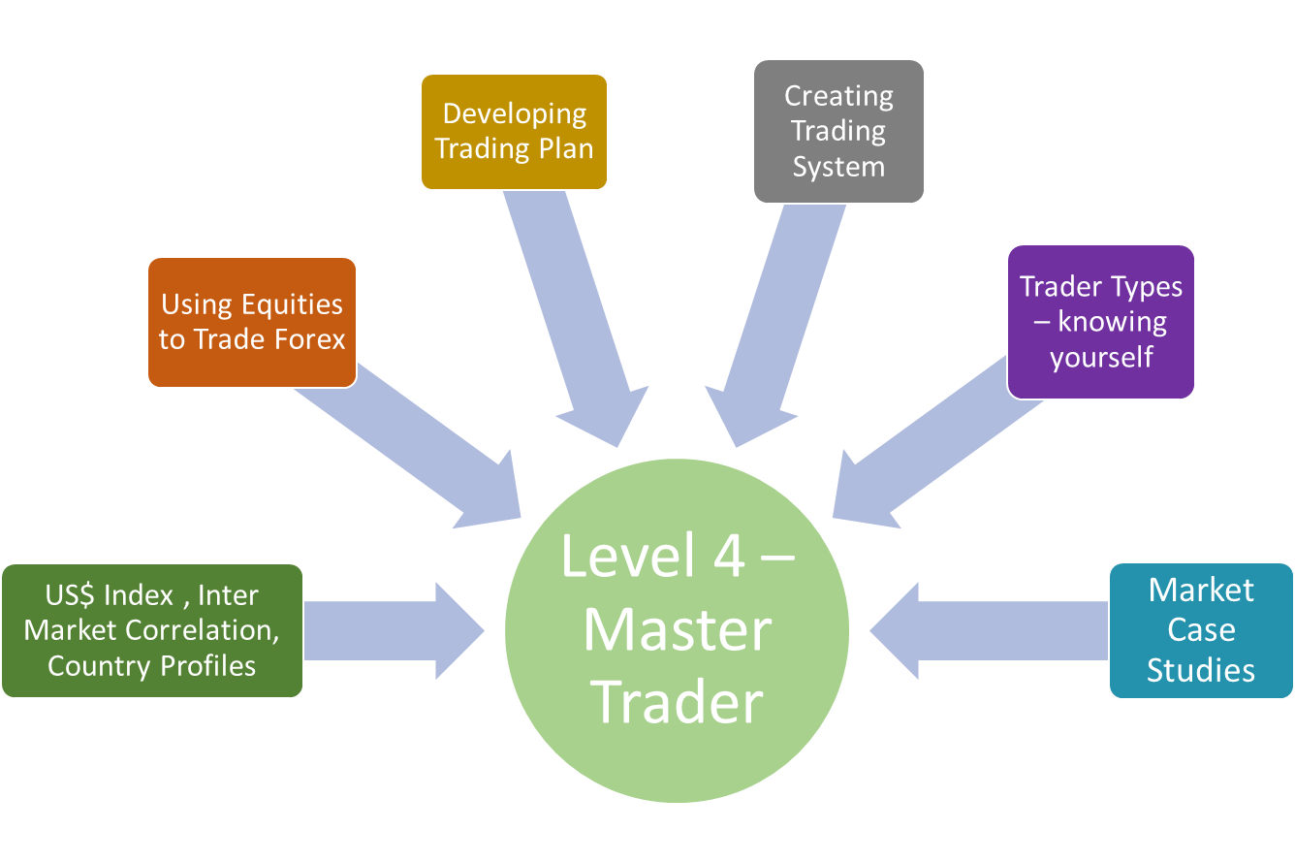

You can also register for level 1 – Level 5 program, we also offer 1-year mentorship program for trainees who register Level 1 to Level 5. Program structure is as follow:



There are three options to avail, details are as follow:

Options 1:

Level 1 – Level 5 without one yea mentorship – PkR 99,000 (to be paid 2 weeks before start of program)

Option 2 :

Level 1 – Level 5 + One Year Mentorship – PkR 120,000 (to be paid 2 weeks before start of program)

Option 3-

Level 4 – Master Trader Only: Course Fee PkR 30,000

We also offer on demand trainings for Level 4 – Master Trader. Minimum number of participants must be at least 12 to conduct training. Charges details are as follow:

Level 4 – Master Trader: PkR 30,000 (to be paid one week before start of training)

Option 4:

1-2-1 dedicated training for one person. Please contact us at [info@alviez.com](mailto:info@alviez.co.uk) for details

Please feel free to contact us at [info@alviez.com](mailto:info@alviez.co.uk) for further information.

## Level 5 – Expert Trader

Level 5 – Master Trader is 5th level of ACT academy series of Level 1 – Level 5 training program. Following areas are covered in Level 5 – Expert Trader:

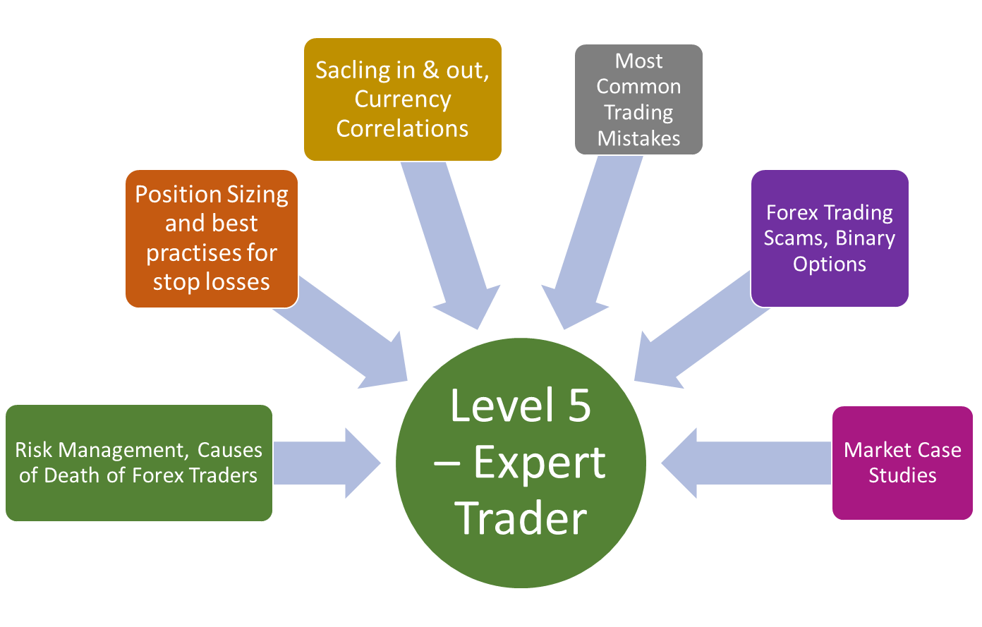

You can also register for level 1 – Level 5 program, we also offer 1-year mentorship program for trainees who register Level 1 to Level 5. Program structure is as follow:



There are three options to avail, details are as follow:

Options 1:

Level 1 – Level 5 without one yea mentorship – PkR 99,000 (to be paid 2 weeks before start of program)

Option 2 :

Level 1 – Level 5 + One Year Mentorship – PkR 120,000 (to be paid 2 weeks before start of program)

Option 3-

Level 5 – Expert Trader Only: Course Fee PkR 30,000

We also offer on demand trainings for Level 5 – Exert Trader. Minimum number of participants must be at least 12 to conduct training. Charges details are as follow:

Level 5 – Expert Trader: PkR 30,000 (to be paid one week before start of training)

Option 4:

1-2-1 dedicated training for one person. Please contact us at [info@alviez.com](mailto:info@alviez.co.uk) for details

Please feel free to contact us at [info@alviez.com](mailto:info@alviez.co.uk) for further information.

## One Year Mentorship

One-year mentorship program is offered to trainees who register for Level 1 to Level 5 program.

Structure of program is as follow:



We provide following support during one-year mentorship program:

* Free one year mentorship for individuals who sign up for level 1 – Level 5 course
* 30 mins sessions every two weeks to review progress after course completion
* Daily Market briefs
* Live KSE 100 updates during trading session
* Call for upto 50 scrips in a month
* Market entry and exit brief
* Daily brief on gold
* Daily brief on crude oil
* Daily brief on major currency pairs
* Daily brief on NASDAQ
* Daily brief on DOW JONES
* Daily brief on S&P 500

Please feel free to contact us at [info@alviez.com](mailto:info@alviez.co.uk) for further information.

# Careers

We are an equal opportunity employer, value the merit and professionalism. Our success as a company is built on the recognition of each employee's skills and efforts. Our primary goal is to promote a working atmosphere that emphasizes respect and provide family environment with maximum rewards & benefits that gives employees the opportunity to excel in their area of expertise.

We believe that employees are our most valuable assets and core to company success. Their enthusiasm, dedication and creativity give us the opportunity to achieve outstanding results which further distinguishes us in the market.

Our culture is created by our people, and together, we enjoy an environment where we all value Agility, Innovation, Trust, Expertise and Collaboration.

We are proud to say that we have the finest team. They are diverse, well exposed, bright and absolutely dedicated; which enables them to offer outstanding support, consultancy and service leading to our customers' satisfaction. We provide trainings and seminars to our employees and we ensure the continuous development of our selected team.

At Alviez Capital you will find the opportunity to excel at your job and develop your capabilities in a pleasant working environment.

We are always willing to hear from outstanding professionals. Please feel free to send us your resume. We will evaluate and contact you.

**Online form option to submit CV**

# Contact Us

**Online for to submit query**

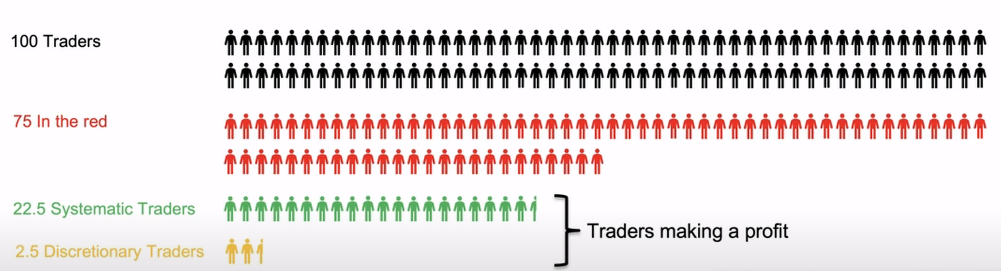

**Use Paid service main button**

Welcome (User Name) Questions Logout

User Profile as dropdown in user name button

**Side button on paid services**

Dashboard

Historical Data (same as Price Return in Market Makers)

NewsFeed

Heat Map

Technical Charts

PSX Analysis

PMEX Analysis

FIPI/LIPI

NDM & UIM Data

Future Markets

Fund Holding

Profile

PSX Analysis

Morning Call (All user profile)

Evening Call (All user profile)

Short Term Analysis (based on user profile)

Mid Term Analysis (based on user profile)

Long Term Analysis (based on user profile)

PMEX Analysis:

Gold

WTI Crude

Currency Pairs

NASDAQ

DOW Jones

S&P 500