PANDEMIC PREPAREDNESS AND RESPONSE PLAN
GOVERNMENT T. D. MEDICAL COLLEGE, ALAPPUZHA

10th February 2026

- INTRODUCTION:
Pandemics pose a recurrent and significant threat to public health systems worldwide, with the potential to overwhelm healthcare infrastructure, disrupt essential services, and cause substantial morbidity and mortality. The COVID-19 pandemic underscored the critical importance of advance preparedness, rapid response mechanisms, and coordinated institutional action in mitigating the impact of large-scale infectious disease outbreaks. Tertiary care institutions, particularly government medical colleges, play a pivotal role not only in clinical management but also in surveillance, training, research, and public health response during such emergencies.
Government T D Medical College, Alappuzha, as a tertiary care and teaching institution catering to a large population of Alappuzha district and neighbouring regions, has a crucial responsibility in pandemic preparedness and response. The institution serves as a referral centre with diverse clinical departments, diagnostic facilities, and a substantial healthcare workforce, making it central to the district and state-level health emergency framework. Given its location in a densely populated coastal region with unique environmental and socio-demographic characteristics, the college must be equipped to anticipate, prevent, and effectively manage public health emergencies.
  - Purpose
This Pandemic Preparedness Plan has been developed with the objective of strengthening institutional readiness to detect, respond to, and recover from pandemics in a systematic and coordinated manner. The plan outlines strategies for surveillance, triage, infection prevention and control, surge capacity management, human resource deployment, logistics and supply chain management, risk communication, and intersectoral coordination. It also emphasizes the integration of clinical services with public health principles, ensuring continuity of essential healthcare services while safeguarding patients, healthcare workers, and the community.
1.3 Scope
By establishing clear roles, responsibilities, and standard operating procedures, this plan aims to enhance resilience, ensure timely decision-making, and minimize the health, social, and economic impact of future pandemics. The document serves as a dynamic framework, to be periodically reviewed and updated in line with evolving evidence, national guidelines, and lessons learnt from past public health emergencies.
2. AIMS AND OBJECTIVES
2.1 Aim
- To strengthen the preparedness and response capacity of Government T D Medical College, Alappuzha, for effective prevention, early detection, and management of pandemics, while ensuring continuity of essential health services and protection of healthcare workers and the community.
2.2 Objectives
- To establish a coordinated institutional framework for pandemic preparedness and response
- To strengthen early warning and surveillance mechanisms through timely detection, reporting, and monitoring of infectious disease outbreaks
- To enhance infection prevention and control (IPC) practices
- To ensure surge capacity and resource readiness by planning for rapid expansion of clinical services, oxygen supply, essential medicines, and diagnostic services during pandemics.
- To optimize human resource preparedness through capacity building, training, task shifting, and rational deployment of healthcare personnel
- To ensure uninterrupted delivery of essential and emergency health services during pandemics.
- To establish effective risk communication and information dissemination systems for healthcare workers, patients, and the public, ensuring timely, accurate, and transparent communication during health emergencies.
- To strengthen coordination and referral linkages with district administration, public health institutions, local self-government bodies, and other healthcare facilities
- To promote monitoring, evaluation, and continuous improvement of preparedness measures through regular drills, audits, and periodic revision of the preparedness plan based on lessons learnt and evolving guidelines.
3.Current Preparedness, what we have done:
- IPC & PPE training completed for all cadres by Regional PEID Cell in collaboration with Hospital Infection Control Committee
- Surveillance & Reporting
  - Communicable disease surveillance and IHIP reporting mechanism in place
  - Coordination with DMO & District Surveillance Unit
- Preparing a plan document
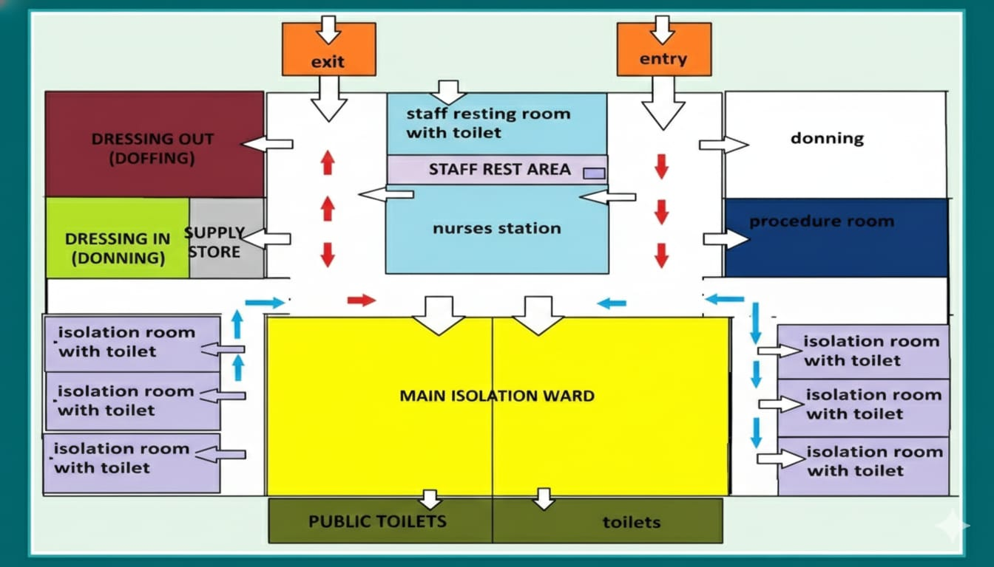
Fig 1: Isolation ward flow-diagram
4. GOVERNANCE & COMMAND STRUCTURE
Objective: Centralized decision making and decentralized implementation.
A. Medical Board (Strategic Decision Making)
Composition: Superintendent (Chair), RMO, HODs of Medicine/Infectious Disease/Pulmonology, Infection Control Team, Microbiology, RPEID Cell, Housekeeping, Nursing Superintendent, etc
Formulate Institutional Policy:
- Clear protocols for admission of patients to each tier
- Helplines to coordinate admissions, referrals & back referrals
- Realtime monitoring of bed occupancy status
- Define Clinical Management Protocols.
- Set criteria for Specimen Collection & Transportation.
- Establish Admission, Discharge, and Back Referral policies.
B. Hospital Infection Control Committee (HICC)
- Strict monitoring of Infection Prevention and Control (IPC) compliance.
Conducting daily rounds to audit PPE usage and environmental hygiene
Table: Hospital Incident Command Structure
Role | Key Responsibilities | Assigned Person | Deputy
Incident Commander | Overall leadership, intersectoral coordination | Medical Superintendent | RMO
Operations Lead | Clinical services, wards, ICUs, triage | Professor & Head – General Medicine | Professor Anesthesiology/pulmonology
Logistics Lead | Oxygen, PPE, equipment, transport | Deputy Medical Superintendent | ARMO
Planning Lead | Surge forecasting, bed expansion | Professor & Head – Community Medicine | RPEID cell Coordinator
Finance Lead | Emergency procurement, budgeting | Accounts Officer | Senior Accounts Assistant

5. CURRENT SITUATIONAL ANALYSIS Vs GAPS
5.1. Infrastructure: Current Status Vs Gaps
Domain | Existing Infrastructure (What We Have) | Identified Gaps | Action Required
Hospital Buildings | Separate OP & IP blocks | Space constraints, difficult to access due to no earmarked channel | Earmark Ward 15 & 19 exclusively during pandemics
Inpatient Beds | 1651 total beds (29) | Limited surge isolation beds | Convert Ward 19 into full isolation ward
Oxygen Beds | 898 oxygen beds | Oxygen surge planning not mapped | Oxygen mapping & cylinder augmentation
ICUs | 162 beds | Shortage of ICU beds during surge | Operationalize all ICUs + surge ICU
Ventilators | 126 available, 56 functional | Non-functional ventilators | Repair & AMC reactivation, condemnation
Fever ICU | No fever ICU | Only fever wards | Creation of Fever ICU
Operation Theatres | 32 functional OTs | Only 2 Negative Pressure OT (only 1 functional due to staff shortage) | Temporary conversion of EOT near Casualty
Patient Monitors | 430 available, functional status unknown | Shortage during surge | Procure monitors
Ventilators | 126 (56- functional) | Limited functional ventilators during surge | Training & commissioning
PPE & N95 | Previously trained staff | PPE & N95 out of stock | Emergency procurement & buffer stock
Ambulances | 5 ambulances | 2 not functional | Networking with district ambulance services

Infrastructure exists, but requires functionalization, repair, and earmarking during pandemics.

5.2 HUMAN RESOURCES: CURRENT STATUS VS GAPS

Category | Existing Strength | Gaps Identified | Mitigation Strategy
Doctors | 656 sanctioned, lesser than sanctioned | ICU & surge duty exhaustion | Shift-based duty & team rotation
Nursing officers | 357 | Severe shortage at present due to inadequate sanctioned post | Recruitment plan via HDS / NHM
ICU-trained Staff | Limited | Not adequate for full surge | Rapid ICU orientation training
Support Staff | 153 Nursing assistant | Severe shortage at present due to inadequate sanctioned post | Additional contractual staff
Staff Welfare | Informal arrangements | Burnout, accommodation issues | Pay wards for HCWs, rest areas

Human resource shortage, especially nursing & ICU-trained staff, is the most critical vulnerability.

5.3 EQUIPMENT & LOGISTICS: CURRENT STATUS VS GAPS
Category | Current Status (Available) | Gaps Identified | Action Required
Ventilators | 126 total | Only 56 functional | Repair & AMC activation for non-functional ventilators
ICU Beds | 162 beds | Limited surge ICU capacity | Operationalize all ICUs and create surge ICU
Patient Monitors | 430 available, functional status unknown | Not adequate for pandemic surge | Procure accessories to make all monitors functional
Infusion Pumps | 7 available | Insufficient | Additional procurement / redistribution
Syringe Pumps | 16 available | Only 8 working  Shortage for routine functioning | Repairment, Procure additional units
HFNC Units | 8 available | 6 working, shortage | Repair
NIV Units | 1 available, not working | Severe shortage | Additional procurement / redistribution, Buffer stock planning
Oxygen Supply | 3 KL & 13 KL Liquid oxygen tank, Liquid and Gas O2 supplied by Southern Air Products & Southern Gas Limited | PSA Oxygen Plant available but not used | Oxygen mapping, cylinder augmentation
Portable X-ray | 8 units, 5 functional | Limited coverage during surge | Plan shared use / additional unit
ECG Machines | 60 machines present, only 35 are functional | Limited for pandemic wards | Redistribution or additional procurement
Pulse Oximeters | 187 finger oximeters | Inadequate for screening & wards | Procure additional oximeters
Ambu Bags | Available | Insufficient for surge | Procure additional units
Ambulances | 5 ambulances | 2 not functional | Networking with district ambulance services
PPE Kits | Nil in stock | Critical shortage | Emergency procurement & buffer stock
N95 Masks | Nil in stock | Critical shortage | Immediate procurement
Biomedical Waste Mgmt. | BMW officer & system in place, KIEL | Increased load during pandemic | Additional BMW bags, transport & contracts

6. PANDEMIC PREPAREDNESS PLAN
PHASE I – PREDISASTER / EARLY WARNING PHASE
Trigger
- No confirmed cases OR
- Sporadic imported cases without evidence of local transmission
Objectives
- Institutional preparedness
- Training and capacity building
- Prevention of hospital acquired infection
- Early detection and early response readiness
Strategies
- Surveillance
- Daily reporting to the State Dashboard and Central Dashboard.
- Realtime data entry into IDSP (Integrated Disease Surveillance Programme) and IHIP (Integrated Health Information Platform).
- One Health Integration (Zoonotic Outbreaks)
- Coordination with Animal Husbandry if necessary
- Sharing data with Animal Husbandry departments to track the vector/reservoir.
- Contact Tracing:
- Maintain a detailed log of all visitors (name, address, phone) for immediate tracing if exposure occurs.
- Contact Log:
- Maintain a strict log of all healthcare personnel providing care to track potential occupational exposure.
- Early Detection
- ILI / SARI surveillance in OPD, IPD and emergency services
- Screening at all hospital entry points
- Creation of Red Channel for free flow of pandemic patients with:
- Separate entry point at Casualty
- Dedicated patient movement pathway
- Use of ramp for safe transportation of suspected/confirmed patients
- Mandatory IHIP reporting
- Sample collection will be done immediately in consultation with Microbiology Department.
- Transportation will be done ensuring triple layer package and sent to NIV Alappuzha, State Public Health Lab and Central Laboratory, TDMCH.
- Linkage with district/state surveillance units
- Resource Mobilization & Surge Capacity
Objective: Address the immediate reality that demand exceeds standard resources.
- Space: Immediate conversion of general wards to isolation units. Designation of "Clean" (Green), "Buffer" (Yellow), and "Contaminated" (Red) zones.
- Supplies: Unlocking of emergency stockpiles (PPE, N95 masks, antivirals, ventilators) and activation of fast track procurement channels.
- Staff
- Infrastructure Preparedness
- Identification and activation of surge areas:
  - Ward 1 – Pandemic OPD, swab collection and observation
  - Ward 19 – Dedicated isolation ward
- Establishment of 6 bedded Fever ICU for critical management
- Route maps and signage for patient movement
- Zoning of hospital areas (clean, buffer, contaminated zones)
- Training & Human Resource Development
Staff: Activation of the reserve pool. Cancellation of nonessential leave. Rotation schedules to prevent burnout.
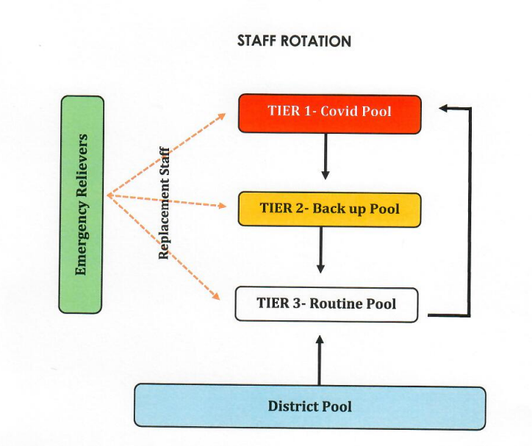
Human resource planning norms:
- ICU: 1 MO, 1 JR, 1 HS, 1 SNO, 1 Staff Nurse per 3 patients; 4 shifts/day
- Ward: 1 MO, 1 JR, 1 HS, 1 SNO, 2 Staff Nurses per 40 patients; 3 shifts/day
Identification of severe staff shortage and preparedness for:
- Recruitment of additional temporary doctors and nursing staff
- Deployment through HDS or government schemes
- Internal redeployment
Reinforcement training of:
- Clinical Staff: Refresher on clinical management protocols and intubation/ventilation for high-risk infectious cases.
- Support Staff: Refresher for Housekeeping, Security, and Ambulance drivers on PPE Donning/Doffing, safe waste handling, and vehicle disinfection.
Zero Exposure Policy: Ensure no healthcare worker enters the isolation zone without verified unprotected exposure checks. Mock drills and simulation exercises
Interdepartmental coordination training
- Logistics & Stores Planning
- Procurement and buffer stock maintenance of:
- PPE
- Essential drugs
- Disinfectants
- Oxygen mapping and oxygen supply planning
- Ventilator inventory and functionality assessment
- Biomedical waste management preparedness
- Emergency procurement protocols
- Standard Operating Procedures (SOPs) & Protocols
Objective: Standardized, safe workflows.
DOMAIN | KEY ACTION POINTS
Patient admission | Triage at entry; immediate isolation of suspects; designated transport corridors.
Biomedical Waste (BMW) | Strict adherence to color coding; double bagging for infectious waste; dedicated disposal pathway.
Dead Body Management | Strict Protocol: Leakproof body bags, deep burial/cremation guidelines, no embalming
Environmental Cleaning | Increased frequency of cleaning with high level disinfectants (e.g., 1% Hypochlorite).
Bystander Management | Strict prohibition of visitors in isolation; one designated caregiver (if absolutely necessary) with full PPE training

- Communication & Language Accessibility
Objective: Clear instruction to prevent panic and errors.
- Internal Communication: Daily briefings for staff.
- Public/Patient Communication (Localized)
- Instructions for Bystanders [in Malayalam].
- Instructions for Security Personnel [in Malayalam].
- Instructions for Support Staff (Nursing Assistants, Cleaners) [in Malayalam].
- Media communication to be handled solely by the designated Spokesperson/Superintendent.

PHASE II – CONTAINMENT & SURGE PREPAREDNESS PHASE
Trigger
- Evidence of local transmission
- Rising number of suspected cases in OPD and IPD
Objectives
- Interrupt transmission
- Prepare for surge capacity
- Maintain essential health services
- Prevent health system overload
Strategies
i) Hospital Reorganization
- Establishment of Dedicated Pandemic OPD in Ward 3
- Activation of Isolation wards in Ward 1
- Operationalization of 9 bedded ICU
- Barricaded triage entry and controlled access points
- Reduction of elective OP services and elective surgeries
Reverse Triage & Decongestion:
- Discharge: Immediate discharge of stable, recovering patients and nonserious cases to home care or lowerlevel facilities.
- Cessation of Electives: Immediate suspension of all elective surgeries and nonemergency admissions.
Adaptive Space Utilization:
- Conversion: Transform waiting areas, corridors, academic halls, and nonpatient care areas into makeshift wards.
- Surge Capacity Zones: Define specific surge targets for every department
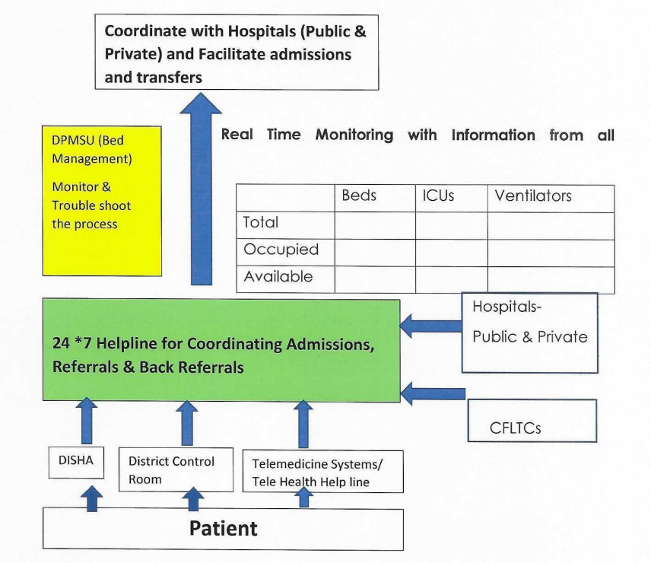
ii) Networking of Hospitals
- Coordination with taluk hospitals
- Ambulance networking
- ICU and ventilator resource pooling
- Referral and back referral mechanisms
- Interfacility patient transfer protocols
iii) Human Resource Management
- Shift based duty system (6–8 hour shifts)
- Team based deployment and rotation policy
- Surge staffing model
- Recruitment of additional temporary staff
- Staff welfare and fatigue prevention measures
A. Internal Redeployment
- Non- Clinical/Paraclinical Faculty: Doctors from Anatomy, Physiology, Pathology, etc., redeployed to triage, basic patient monitoring, or administrative command roles.
- Non- Medical Staff: Academic and administrative staff repurposed for logistics, data entry, crowd control, and family communication.
- Nursing Surge:
  - Nursing Superintendent to mobilize staff from noncritical areas (OPD, Elective OT) to ICU/ER.
  - Activation of the "Standby List" for immediate recall.
B. The "Reserve" Corps
- Retired healthcare professionals.
- Staff who have moved to nonclinical careers.
- Staff currently working in research/admin roles.
Psychosocial Support
- Staff Support: Monitoring for burnout; providing "decompression" zones.
- Patient/Family Support: Counselling for bereavement and trauma.
iv) External Collaboration & Networking
Objective: Resource sharing to prevent individual facility collapse.
- Hospital Networking (Hub & Spoke Model):
- Information: Realtime sharing of bed availability and clinical protocols.
- Materials: Interhospital loaning of ventilators, oxygen cylinders, and PPE.
- Manpower: Rotation of specialist teams between facilities.
Partnerships:
Intersectoral collaboration with LSGD, CSOs, NGOs, and Animal husbandry for supplies and community outreach.
V) Operations & Logistics: Essential Support
Objective: Keep the hospital running under high pressure.
A. Clinical Support Services
- Diagnostics: 24/7 continuous operation of Laboratory and Radiology services.
- Blood Bank: Emergency blood drive protocols and conservation strategies.
- Pharmacy: Fasttrack dispensing protocols; rationing of critical drugs if supply chains fail.
- Mortuary: Activation of mass fatality protocols (cold storage expansion, swift release procedures).
B. General Support Services
- Dietary (Kitchen): Simplified, high calorie meal plans for patients; hydration/food stations for overworked staff.
Sanitation & Laundry: Increased turnover rates for linen; enhanced biohazard waste clearance frequency
PHASE III – DISASTER / FULLSCALE PANDEMIC RESPONSE PHASE
Trigger
- Increasing number of confirmed cases requiring admission
- OP load crossing threshold capacity
- ICU surge and critical care overload
Objectives
- Comprehensive pandemic care
- Reduction of morbidity and mortality
- Staff safety and welfare
- Continuity of essential services
Strategies
- OP & IP Care Reorganization
- Suspension of General OP services
- Patient classification system:
  - Not suspect
  - Suspect – stable
  - Suspect – unstable
  - Confirmed – mild / moderate / severe
- Dedicated suspect wards
- Dedicated confirmed wards
- Surge bed capacity planning
- Patient flow zoning and segregation
- ICU & Critical Care Planning
- Separate ICUs for:
- Suspect unstable patients
- Confirmed unstable patients
- Stepdown care
- Ethical triage principles
- Critical care prioritization protocols
- Palliative care support services
- Utilization of Critical Care Block under construction as surge ICU facility if required

- Emergency & Essential Services Continuity
- Continuation of:
- Trauma services
- Dialysis services
- Antenatal services
- Neonatal services
- Dedicated OT and labour room for pandemic period
- Transit ICU in Casualty
- Emergency referral stabilization services
Risk communication
- Risk communication to the Concerned Peripheral Health institution, General Public, patient bystanders and contacts through IDSP, RPEID Cell, Mass Media.
• Realtime exchange of information, accurate information and actionable advice to affected communities.
• Experts, community leaders or officials will be consulted to get opinions.
• Effective risk communication strategies include a mix of public communication, community engagement, behaviour change communication, listening and public perception analysis, and rumour management as well as communication for partner coordination, deployed in a systematic manner, with adequate resources before, during and after emergencies.

Escalation Level 1 Vs Escalation Level 2

Component | Escalation Level 1 (Containment & Surge Prep) | Escalation Level 2 (Full Pandemic Response)
Trigger | Local transmission, rising suspected cases | ICU surge, OP overload, rising admissions
OP Services | Dedicated Pandemic OP in Ward 1 | General OP stopped
IP Services | Isolation ward in Ward 15 | Dedicated suspect & confirmed wards
Triage | Barricaded triage at Casualty | Strict triage & patient categorization
ICU Services | EMICU converted into 8 bedded ICU | Multiple ICUs (suspect, confirmed, step-down)
HDU Services | 8 bedded ICUs | Expanded HDU & ICU capacity
Elective Services | Reduced | Stopped
HR Strategy | Shift-based duty, limited staff | Large-scale recruitment of temporary staff & redeployment
Logistics | PPE procurement & oxygen mapping | Continuous supply chain & buffer stock
Hospital Networking | Referral linkages activated | Full district hospital & ICU pooling
Staff Welfare | Duty rotation | Accommodation, psychological support

7. COMMUNICATION & MONITORING
- Daily review by HPRT
- Mandatory IHIP reporting
- Internal communication:
  - Circulars
  - WhatsApp groups
- External communication:
  - Designated spokesperson
  - PEID Cell coordination

8. CONTINUITY OF ESSENTIAL SERVICES
- Non-pandemic emergency services
- Chronic disease care
- Maternal and child health services
- Blood bank and laboratory continuity
- Telemedicine services where feasible

9. CONTROL ROOM ACTIVITIES

Communication and coordination of patient arrival through district

Patient data collection inpatient and outpatient

Preparing and updating of Daily Status Reports

Addressing concerns of public through phone calls and providing necessary directions

Assigning and Coordinating duties and responsibilities of staff

Coordinating daily review meetings

Coordination and arrangement of training programme for various category of staff within the institution and from other institutions in the district, public and other voluntary agencies

Arranging transport services for the discharged patients

Coordination of sample dispatching
10. SERVICES – COMPONENTS
Services | Care
Control Room | Co -ordination of entire operations
Triage Service | Barricaded entry controlled by Security and housekeeping staff
Screening | 24x7
Intensive Care Service | Intensive Care Teams 24x7
Regular Patient Care Services | Medicine/Paediatrics/Psychiatry
Ventilator Services | Ventilator services
Radiological Services | Portable X- ray, USG
Antenatal Services | Obstetrics and Gynaecology
Patient Transport services  Ambulance  In hospital Transport  Special Protocol for in hospital transport | Done in coordination between District Surveillance Officer, Public relation Officer and Security Officer
Super speciality services | CATH lab, Stroke ICU, 24x7

11. CONCLUSION
- This Pandemic Preparedness Plan aims to ensure that GTDMC Alappuzha remains resilient, responsive, and capable of delivering essential healthcare during pandemics while safeguarding the health and well-being of patients and health care workers.

RPEID CELL
Govt. T.D Medical College, Alappuzha

