**Feedback Management System**

Project by-

Shivani Mane

Tanmay Bhardwaj

Shekhar Kankale

Uma Shankar Bhagat

**Use Case Diagram:**

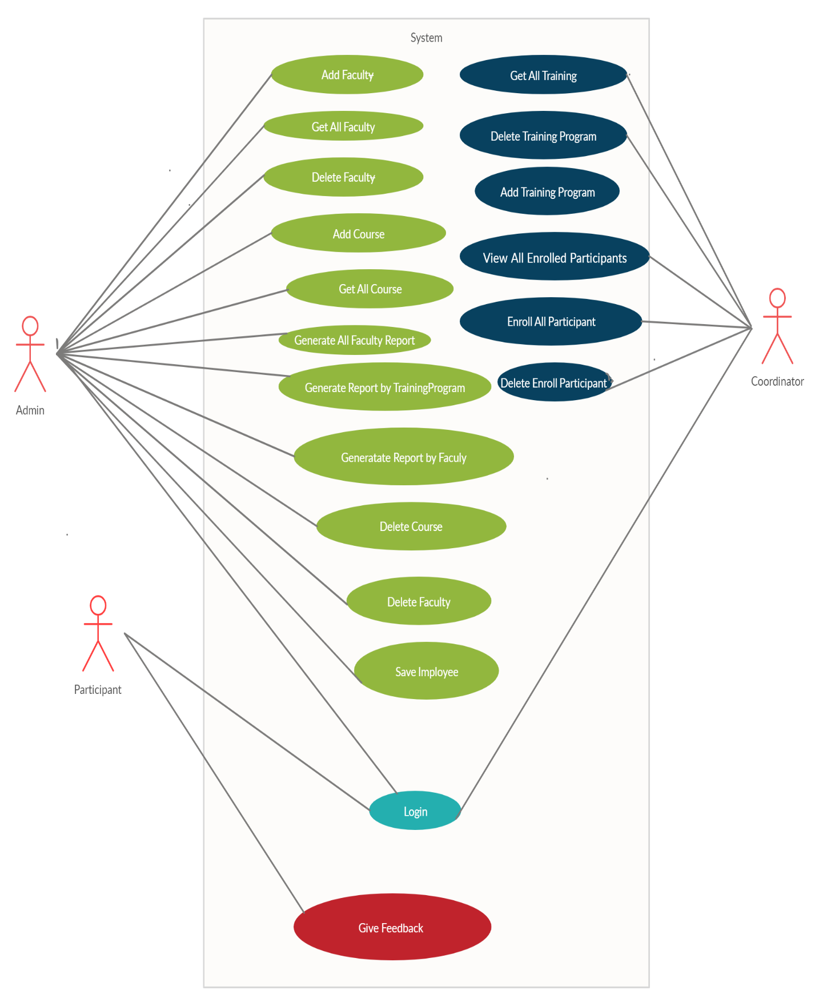

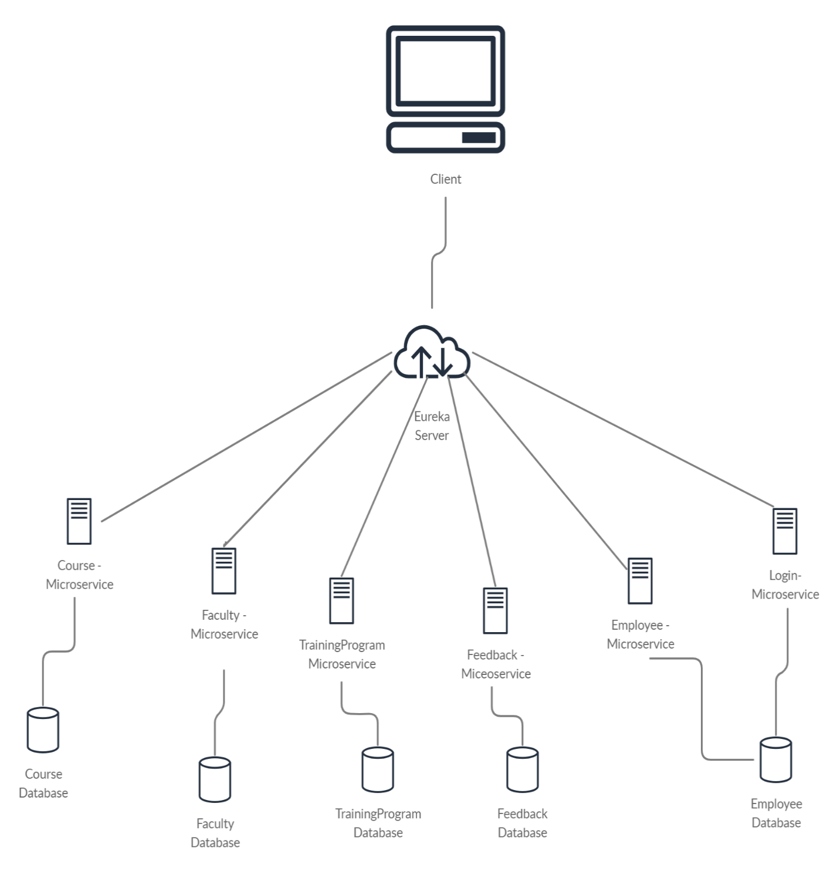**Microservice Division:**

**Course Microservice:**

List All Courses

Get Course by Id

Add Course

Delete Course

**Faculty Microservice**

Add Faculty

List All Faculty

Get Faculty by Id

Delete Faculty by Id

**Feedback Microservice**

Add Feedback

Get All Feedbacks

Get Feedback by FacultyId

Get Feedback by TrainingCode

**Login Microservice**

Validate Login

**Employee Microservice**

Add Employee

Delete Employee

Check Role

Get All Participant

**Training Program Microservice**

Get All Training

Get Training Program by Id

Add Training Program

Delete Training Program

Enroll Participant

Get Training Program by Participant Id

Get All EnrolledParticipant  
Delete All Enrolled Participants by TrainingCode