**BLINK**

This example shows the simplest thing you can do with an Chipkit UNO32 to see physical output: it blinks an LED.

**Hardware Required:**

* Chipkit UNO32 Board
* LED

**Circuit:**

To build the circuit, attach a 220-ohm resistor to pin 13. Then attach the long leg of an LED (the positive leg, called the anode) to the resistor. Attach the short leg (the negative leg, called the cathode) to ground. Then plug your Chipkit UNO32 board into your computer, start the Chipkit UNO32 program, and enter the code below.

Most Chipkit UNO32 boards already have an LED attached to pin 13 on the board itself. If you run this example with no hardware attached, you should see that LED blinks.

**Schematic:**

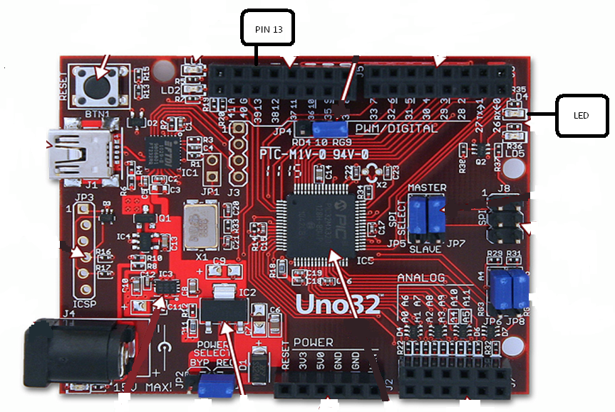

**Code:**

In the program below, the first thing you do is to initialize pin 13 as an output pin with the line

pinMode(13, OUTPUT);

In the main loop, you turn the LED on with the line:

digitalWrite(13, HIGH);

This supplies 5 volts to pin 13. That creates a voltage difference across the pins of the LED, and lights it up. Then you turn it off with the line:

digitalWrite(13, LOW);

That takes pin 13 back to 0 volts, and turns the LED off. In between the on and the off, you want enough time for a person to see the change, so the delay() commands tell the Chipkit UNO32 to do nothing for 1000 milliseconds, or one second. When you use the delay() command, nothing else happens for that amount of time.

*/*  
  Blink  
  Turns on an LED on for one second, then off for one second, repeatedly.*

*\*/*  
   
*// Pin 13 has an LED connected on most Chipkit UNO32 boards.*  
*// give it a name:*  
int led = 13;  
  
*// the setup routine runs once when you press reset:*  
void **setup**() {                  
  *// initialize the digital pin as an output.*  
  pinMode(led, OUTPUT);       
}  
  
*// the loop routine runs over and over again forever:*  
void **loop**() {  
  digitalWrite(led, HIGH);   *// turn the LED on (HIGH is the voltage level)*  
  delay(1000);               *// wait for a second*  
  digitalWrite(led, LOW);    *// turn the LED off by making the voltage LOW*  
  delay(1000);               *// wait for a second*  
}