**FADING**

Demonstrates the use of the [analogWrite()](http://arduino.cc/en/Reference/AnalogWrite) function in fading an LED off and on. AnalogWrite uses [pulse width modulation (PWM)](http://arduino.cc/en/Tutorial/PWM), turning a digital pin on and off very quickly, to create a fading effect.

**Hardware Required:**

* Arduino board
* Breadboard
* a LED
* a 220 ohm resistor

**Circuit:**

Connect the **anode** (the longer, positive leg) of your LED to digital output pin 9 on your Arduino through a 220-ohm resistor. Connect the **cathode** (the shorter, negative leg) directly to ground.



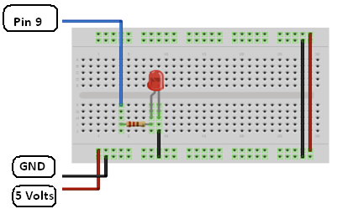

**Code:**

After declaring pin 9 to be your ledPin, there is nothing to do in the setup() function of your code.

The analogWrite() function that you will be using in the main loop of your code requires two arguments: One telling the function which pin to write to, and one indicating what [PWM](http://arduino.cc/en/Tutorial/PWM) value to write.

In order to fade your LED off and on, gradually increase your PWM value from 0 (all the way off) to 255 (all the way on), and then back to 0 once again to complete the cycle. In the sketch below, the PWM value is set using a variable calledbrightness. Each time through the loop, it increases by the value of the variable fadeAmount.

If brightness is at either extreme of its value (either 0 or 255), then fadeAmount is changed to its negative. In other words, if fadeAmount is 5, then it is set to -5. If it's 55, then it's set to 5. The next time through the loop, this change causesbrightness to change direction as well.

analogWrite() can change the PWM value very fast, so the delay at the end of the sketch controls the speed of the fade. Try changing the value of the delay and see how it changes the program.

*/*  
 Fade  
   
 This example shows how to fade an LED on pin 9  
 using the analogWrite() function.  
   
 This example code is in the public domain.  
 */*  
  
int led = 9;           *// the pin that the LED is attached to*  
int brightness = 0;    *// how bright the LED is*  
int fadeAmount = 5;    *// how many points to fade the LED by*  
  
*// the setup routine runs once when you press reset:*  
void **setup**()  {   
  *// declare pin 9 to be an output:*  
  pinMode(led, OUTPUT);  
}   
  
*// the loop routine runs over and over again forever:*  
void **loop**()  {   
  *// set the brightness of pin 9:*  
  analogWrite(led, brightness);      
  
  *// change the brightness for next time through the loop:*  
  brightness = brightness + fadeAmount;  
  
  *// reverse the direction of the fading at the ends of the fade:*  
  if (brightness == 0 || brightness == 255) {  
    fadeAmount = -fadeAmount ;   
  }       
  *// wait for 30 milliseconds to see the dimming effect*  
  delay(30);                              
}