**BUTTON**

Pushbuttons or switches connect two points in a circuit when you press them. This example turns on the built-in LED on pin 13 when you press the button.

**Hardware:**

* Chipkit UNO32 Board
* momentary button or switch
* 10K ohm resistor
* breadboard
* hook-up wire

**Circuit:**

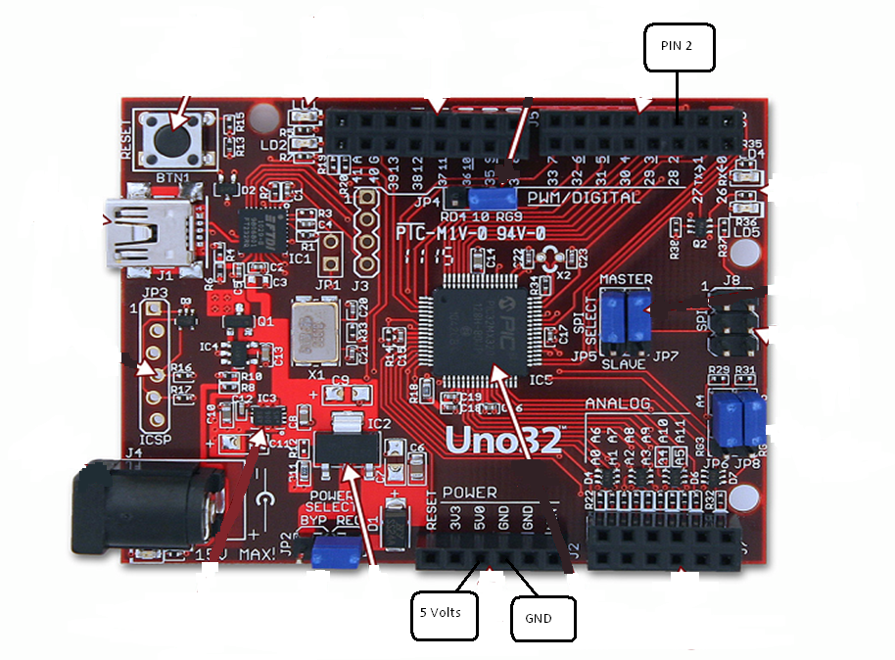

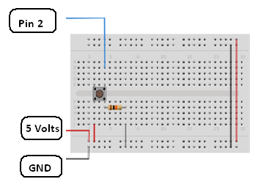

Connect three wires to the Chipkit UNO32 board. The first two, red and black, connect to the two long vertical rows on the side of the breadboard to provide access to the 5 volt supply and ground. The third wire goes from digital pin 2 to one leg of the pushbutton. That same leg of the button connects through a pull-down resistor (here 10K Ohms) to ground. The other leg of the button connects to the 5 volt supply.

When the pushbutton is open (unpressed) there is no connection between the two legs of the pushbutton, so the pin is connected to ground (through the pull-down resistor) and we read a LOW. When the button is closed (pressed), it makes a connection between its two legs, connecting the pin to 5 volts, so that we read a HIGH.

You can also wire this circuit the opposite way, with a pullup resistor keeping the input HIGH, and going LOW when the button is pressed. If so, the behavior of the sketch will be reversed, with the LED normally on and turning off when you press the button.

If you disconnect the digital i/o pin from everything, the LED may blink erratically. This is because the input is "floating" - that is, it will randomly return either HIGH or LOW. That's why you need a pull-up or pull-down resistor in the circuit.

**Code:**

*/*  
  Button  
   
 Turns on and off a light emitting diode(LED) connected to digital    
 pin 13, when pressing a pushbutton attached to pin 2.   
   
   
 The circuit:  
 * LED attached from pin 13 to ground   
 * pushbutton attached to pin 2 from +5V  
 * 10K resistor attached to pin 2 from ground  
   
 * Note: on most Chipkit UNO32s there is already an LED on the board  
 attached to pin 13.  
  */*  
  
*// constants won't change. They're used here to*  
*// set pin numbers:*  
const int buttonPin = 2;     *// the number of the pushbutton pin*  
const int ledPin =  13;      *// the number of the LED pin*  
  
*// variables will change:*  
int buttonState = 0;         *// variable for reading the pushbutton status*  
  
void **setup**() {  
  *// initialize the LED pin as an output:*  
  pinMode(ledPin, OUTPUT);        
  *// initialize the pushbutton pin as an input:*  
  pinMode(buttonPin, INPUT);       
}  
  
void **loop**(){  
  *// read the state of the pushbutton value:*  
  buttonState = digitalRead(buttonPin);  
  
  *// check if the pushbutton is pressed.*  
  *// if it is, the buttonState is HIGH:*  
  if (buttonState == HIGH) {       
    *// turn LED on:*  
    digitalWrite(ledPin, HIGH);    
  }   
  else {  
    *// turn LED off:*  
    digitalWrite(ledPin, LOW);   
  }  
}