

**UMA VYSHNAVI G 231501176**

**SUBHASHINI 231501161**

BLOG MANAGEMENT SYSTEM

**MACHINE LEARNING**

**TABLE OF CONTENTS**

**1. INTRODUCTION**

1.1 INTRODUCTION……………………………………………………………….

1.2 OBJECTIVES……………………………………………………………………

1.3 MODULES………………………………………………………………………

**2. SURVEY OF TECHNOLOGIES**

2.1 SOFTWARE DESCRIPTION…………………………………………………..

2.2 LANGUAGES…………………………………………………………………..

2.2.1 MySQL………………………………………………………....

2.2.2 Java jdk …………………………………………..…

**3. REQUIREMENTS AND ANALYSIS**

3.1 REQUIREMENT SPECIFICATION………………………………….……

3.2 HARDWARE AND SOFTWARE REQUIREMENTS………………….

3.3 DATA DICTIONARY……………………………………………………

**4.PROGRAM CODE ……………………………………………………….…………………**

**5. RESULTS AND DISCUSSIONS……………………………………………..………....**

**6. CONCLUSION…………………………………………………………………..............**

**7. REFERENCES……………………………………………………………………………..**

**ABSTRACT**

A Blog Management System (BMS) is a web-based platform designed to facilitate the creation, organization, and management of blogs. It provides an intuitive interface for authors, editors, and administrators to publish, edit, and categorize blog posts seamlessly. The system includes features like user authentication, customizable themes, multimedia integration, comment sections, and content moderation to enhance user engagement and interaction. Additionally, BMS allows administrators to manage user roles, monitor analytics, and ensure smooth operation through security measures and backup systems. This system streamlines the entire blogging process, enabling content creators to focus on writing, while automating backend functions, ensuring optimal performance and scalability. It is ideal for individuals or organizations looking to establish an online presence and manage blog-related tasks efficiently.

A **Blog Management System (BMS)** is a powerful tool designed to assist individuals, businesses, or organizations in efficiently managing and publishing blog content online. It serves as an integrated solution for handling the entire blogging workflow, from content creation and editing to user engagement and performance analysis. A well-designed BMS simplifies the administrative and technical complexities associated with running a blog, enabling users to focus on creating high-quality content.

A Blog Management System is a comprehensive tool for anyone looking to create, manage, and optimize a blog. It makes blogging easier, faster, and more effective by providing an all-in-one platform that handles content creation, publishing, security, user engagement, and performance analysis. Whether you are a solo blogger, part of a team, or running a corporate blog, a BMS can streamline the process, increase your audience engagement, and improve the overall user experience.

**INTRODUCTION**

**1.1 Introduction**

A **Blog Management System (BMS)** is a software platform that facilitates the creation, organization, and administration of blog content in an efficient and user-friendly manner. With the rapid growth of blogging as a tool for personal expression, business promotion, and communication, managing a blog can quickly become overwhelming without the right systems in place. A BMS offers a comprehensive solution by streamlining tasks such as content creation, publication, categorization, user interaction, and performance tracking.

At its core, a Blog Management System simplifies the entire blogging process for both individual bloggers and organizations. It provides tools to write and publish blog posts, manage media content (such as images and videos), customize blog themes, moderate comments, and monitor visitor analytics. It also supports SEO optimization to increase visibility on search engines, and offers a secure environment for storing and backing up content.

Whether you are a solo blogger, a content team, or part of a large-scale organization, a BMS makes it easier to maintain an engaging and dynamic blog. It automates many repetitive tasks and provides intuitive interfaces for content management, ensuring that users can focus on what truly matters—creating high-quality content and engaging their audience effectively.

At its core, a Blog Management System simplifies the entire blogging process for both individual bloggers and organizations. It provides tools to write and publish blog posts, manage media content (such as images and videos), customize blog themes, moderate comments, and monitor visitor analytics. It also supports SEO optimization to increase visibility on search engines, and offers a secure environment for storing and backing up content.

Whether you are a solo blogger, a content team, or part of a large-scale organization, a BMS makes it easier to maintain an engaging and dynamic blog. It automates many repetitive tasks and provides intuitive interfaces for content management, ensuring that users can focus on what truly matters—creating high-quality content and engaging their audience effectively.

**1.2 OBJECTIVES**

**Primary Objectives**

* A user is an individual who interacts with the system. There are various types of users, such as administrators, authors, editors, and readers, each with specific roles and permissions.
* A blog post is the primary content that is created, edited, and published on the blog.
* Categories help in organizing blog posts by topic, making it easier for readers to navigate the content.
* Tags are keywords associated with blog posts to make them discoverable and improve searchability.
* A comment is a user-generated response or feedback posted under a blog post.
* Media refers to images, videos, audio files, or other multimedia content used within blog posts.
* Analytics provide insights into how blog posts and the site as a whole are performing, offering data on traffic, engagement, and user behavior.
* Notifications alert users about important updates or activities, such as new comments, new posts, or changes to posts.
* The theme or template controls the look and feel of the blog, defining its layout, colors, fonts, and other visual elements.

**Business Objectives**

* To improve the efficiency of content creation, publication, and management, enabling businesses to produce and deliver high-quality blog content more quickly and consistently.
* To foster greater user engagement by providing features such as comment sections, social media sharing, and personalized notifications.
* To foster greater user engagement by providing features such as comment sections, social media sharing, and personalized notifications.
* To simplify and automate content workflows, allowing teams to collaborate more effectively, with role-based access, content approvals, and scheduling features.
* To maintain consistency in the tone, style, and quality of content, and to ensure that all posts align with the business's brand guidelines.
* To gather and analyze data on blog performance, including traffic, engagement, SEO rankings, and audience demographics.

**MODULES**

**1. User Management Module**

* **Purpose**: Manages users and their roles within the system, ensuring role-based access control.
* **Features**:
  + **User Registration/Login**: New users can register and existing users can log in.
  + **User Roles & Permissions**: Defines roles (admin, author, editor, reader) with different levels of access.
  + **User Profile**: Allows users to manage their profiles (e.g., change passwords, update bio, etc.).
  + **Authentication and Authorization**: Ensures that users are properly authenticated before accessing restricted sections.

**2. Content Creation & Management Module**

* **Purpose**: Handles the creation, editing, categorization, and scheduling of blog posts.
* **Features**:
  + **Content Editor**: A WYSIWYG (What You See Is What You Get) editor for creating and formatting blog posts with text, images, videos, and other multimedia.
  + **Post Drafts**: Users can save posts as drafts before publishing them.
  + **Post Scheduling**: Schedule posts to be published at a future time.
  + **Categories and Tags**: Organize blog posts into categories and assign relevant tags for easier navigation and SEO.
  + **Content Review and Approval**: Editors can review, approve, or reject posts before publication.

**3. SEO Management Module**

* **Purpose**: Helps optimize the content for search engines to improve visibility and rankings.
* **Features**:
  + **Meta Tags Management**: Allows users to add/edit meta titles, descriptions, and keywords for each post.
  + **URL Optimization**: Generates SEO-friendly URLs based on post titles or custom structure.
  + **SEO Analysis**: Provides SEO suggestions to improve keyword optimization, readability, and meta descriptions.
  + **Sitemap Generation**: Automatically generates an XML sitemap to help search engines index content efficiently.

**4. Media Management Module**

* **Purpose**: Manages all media (images, videos, documents) uploaded within the blog system.
* **Features**:
  + **Media Library**: Centralized location for all uploaded media files.
  + **Upload and Organize**: Users can upload media files (images, videos, etc.) and organize them into folders or galleries.
  + **Media Insertion**: Easy integration of media into blog posts.
  + **Image Optimization**: Automatically resize or compress images for faster loading times.

**5. Comment and Interaction Module**

* **Purpose**: Manages user interactions on blog posts through comments, likes, and sharing.
* **Features**:
  + **Comment Section**: Allows readers to post comments under each blog post.
  + **Comment Moderation**: Admins or editors can approve, reject, or flag comments for spam.
  + **Reply System**: Enables users to reply to individual comments.
  + **Social Media Sharing**: Share blog posts directly to social media platforms (Facebook, Twitter, etc.).
  + **Ratings/Like Buttons**: Allows readers to rate or like posts to show appreciation.

**6. Analytics and Reporting Module**

* **Purpose**: Provides detailed insights into blog performance and user behavior.
* **Features**:
  + **Traffic Analysis**: Tracks the number of visitors, page views, and traffic sources.
  + **Engagement Metrics**: Measures how users interact with blog posts (e.g., average time spent, bounce rate).
  + **Conversion Tracking**: Tracks conversion actions, such as newsletter signups, downloads, or purchases originating from blog posts.
  + **SEO Analytics**: Monitors the ranking of blog posts on search engines.
  + **Audience Insights**: Provides demographic information, such as user location, devices, and browsing habits.

**7. Subscription and Newsletter Module**

* **Purpose**: Manages user subscriptions and sends regular newsletters with new content.
* **Features**:
  + **Email Subscriptions**: Allows visitors to subscribe to updates, either site-wide or specific categories.
  + **Newsletter Creation**: Create and send newsletters with the latest blog posts, promotions, or announcements.
  + **Mailing List Management**: Maintain and manage email subscriber lists.
  + **Automated Campaigns**: Set up automated email sequences or campaigns based on user actions (e.g., welcome emails, post-purchase emails).

**8. Security and Backup Module**

* **Purpose**: Ensures the system’s security and protects data from loss or unauthorized access.
* **Features**:
  + **User Authentication**: Secure login system with options for two-factor authentication (2FA).
  + **Data Encryption**: Secure storage of sensitive data such as user information and passwords.
  + **Backup and Restore**: Automatic and manual backups of blog content, media, and settings.
  + **Firewall and Security Checks**: Protects against potential vulnerabilities, attacks, and unauthorized access.

**9. Monetization Module**

* **Purpose**: Provides features to monetize blog content through ads, affiliate links, and sponsored posts.
* **Features**:
  + **Ad Management**: Integration with ad networks like Google AdSense or manual ad placements within posts.
  + **Affiliate Marketing**: Embed affiliate links within posts to earn commissions on sales or leads.
  + **Sponsored Content**: Create and manage sponsored posts or collaborations with brands.
  + **Revenue Tracking**: Monitors the performance and revenue generated from monetization efforts.

**10. Admin Dashboard and System Management Module**

* **Purpose**: Provides an overview of the entire blog system’s performance and management tools for administrators.
* **Features**:
  + **Dashboard**: A summary of key metrics like post views, user activity, comments, and system health.
  + **System Configuration**: Manage system settings, themes, and plugins.
  + **User Management**: Add, remove, or edit users and assign roles.
  + **Audit Log**: Track system activities such as user logins, post updates, and comment moderation.
  + **Notification Settings**: Configure alerts for new posts, comments, and updates.

**11. Content Distribution and Syndication Module**

* **Purpose**: Facilitates the distribution of blog content to external platforms or feeds.
* **Features**:
  + **RSS Feeds**: Provide RSS feeds for blog content, allowing users to subscribe and receive updates automatically.
  + **Cross-Platform Sharing**: Integrate with platforms like Medium, LinkedIn, or other content syndication channels.
  + **Content Republishing**: Allow selected posts to be republished on partner websites or platforms to increase reach.

**12. Feedback and Survey Module**

* **Purpose**: Collects feedback from users and visitors to improve blog content and user experience.
* **Features**:
  + **Surveys and Polls**: Embed surveys or polls in posts to gather audience opinions.
  + **Feedback Forms**: Allow users to submit feedback or suggestions regarding the content.
  + **Ratings and Reviews**: Enable users to rate individual blog posts or articles.

**II. SURVEY OF TECHNOLOGY**

**2.1 Software Description**

**Java JDK (Java Development Kit)**

The Java Development Kit (JDK) is a software development environment used to develop Java applications. It provides the necessary tools, libraries, and runtime environment for developing Java programs. The JDK includes the Java Runtime Environment (JRE), an interpreter/loader (Java), a compiler (javac), an archiver (jar), a documentation generator (Javadoc), and various other tools for Java development.

**Key Features of Java JDK:**

* **Cross-Platform:** Java programs, once written, can be run on any platform that supports the Java Runtime Environment (JRE), making it platform-independent.
* **Object-Oriented:** Java follows the object-oriented programming paradigm, making it easy to structure and maintain code.
* **Robust Libraries:** The JDK comes with a rich set of libraries for handling file I/O, networking, security, GUI development, and much more.
* **Automatic Memory Management:** Java handles memory management through automatic garbage collection, reducing the risk of memory leaks.
* **Multithreading:** Java supports multithreading, which allows multiple threads to run concurrently, improving the performance of applications.

In this project, Java JDK is used as the primary programming language for developing the back-end functionality of the Library Management System. It is used to create the server-side logic for user management, book management, and database interaction.

**XAMPP (Windows Version 8.0.30-0-VS16-Installer)**

XAMPP is an open-source, cross-platform web server solution stack package. It contains Apache, MySQL, PHP, and Perl, providing everything needed to set up a local server environment on a system for web development and database management. In this project, XAMPP is used to host the MySQL database locally, allowing for efficient and easy access to the back-end database.

**Key Features of XAMPP:**

* **Easy Installation:** XAMPP offers a simple, one-click installation for setting up a local server environment with Apache and MySQL.
* **Local Hosting:** Provides local web server capabilities, allowing developers to test and run websites and applications locally before deployment.
* **Cross-Platform:** Available for Windows, macOS, and Linux, making it suitable for various development environments.
* **Preconfigured Software:** Comes preconfigured with all necessary software components, making it ready to use out of the box.

In this project, XAMPP serves as the local server platform to host the MySQL database, ensuring smooth interaction between the Java-based front-end application and the back-end database.

**MySQL 8.4**

MySQL is an open-source relational database management system (RDBMS) based on Structured Query Language (SQL). It is widely used in many applications to store and manage data. MySQL 8.4 is the version used in this project for storing library data such as user information, book details, and transaction records.

**Key Features of MySQL 8.4:**

* **ACID Compliance:** MySQL ensures data integrity through ACID-compliant transactions (Atomicity, Consistency, Isolation, Durability).
* **High Performance:** MySQL is optimized for high-performance querying and can handle large datasets efficiently.
* **Security Features:** MySQL 8.4 includes advanced security features like data encryption, user authentication, and authorization.
* **Data Consistency:** The system supports complex queries, joins, and transactions to maintain data consistency across the database.
* **Scalability:** MySQL can scale to handle large databases and high volumes of queries, making it ideal for growing systems.

In this project, MySQL 8.4 is used to manage all blog data, transactions, enabling efficient data retrieval, insertion, and updates.

**MySQL Connector 9.1**

MySQL Connector is a Java library that allows Java applications to connect to a MySQL database. The MySQL Connector 9.1 version is used in this project to enable the Java-based front-end application to communicate with the MySQL database, ensuring smooth data exchange between the application and the database.

**Key Features of MySQL Connector 9.1:**

* **Seamless Integration:** MySQL Connector 9.1 provides seamless integration between Java applications and MySQL databases, allowing for easy communication between the two.
* **JDBC Support:** The connector is based on Java Database Connectivity (JDBC) API, providing standard methods for querying and manipulating MySQL databases from Java.
* **Efficient Data Handling:** It allows for fast data transfer between Java and MySQL, supporting high-performance applications.
* **Platform Independence:** Being a Java-based connector, it works across all platforms that support Java, ensuring compatibility in cross-platform development environments.
* **Security Features:** Supports SSL connections to MySQL databases for secure data transmission.

In this project, MySQL Connector 9.1 is used to establish a secure and efficient connection between the Java-based Library Management System and the MySQL database, enabling operations such as user registration, book management, and transaction logging.

**Integration of Java, XAMPP, MySQL, and MySQL Connector**

This project integrates **Java** for the front-end user interface and back-end logic, **XAMPP** to host the MySQL database, and **MySQL Connector** for database communication. The integration allows for seamless interaction between the front-end (user interface) and back-end (database), where users can register, search for books, and manage transactions, while administrators can add books, view user data, and generate reports. The combination of Java’s power for back-end processing, MySQL’s robust data management, and the ease of local hosting with XAMPP makes the system efficient, reliable, and scalable.

This breakdown describes the technologies used in your **Library Management System** project and how they integrate to provide a smooth, user-friendly, and efficient system.

**III. REQUIREMENTS AND ANALYSIS**

**3.1 Requirements Specification**

**User Requirements:**

1. **User Registration:** The system should allow users (both library staff and members) to register their accounts with basic personal details like name, contact information, and membership status.
2. **Book Management (for Librarians):** Librarians should be able to add, edit, or remove books from the system, including details such as title, author, genre, and availability.
3. **Book Browsing & Search (for Users):** The system should allow users to browse and search the book catalog by title, author, or genre. The search results should display available books in a user-friendly table format.
4. **User Authentication:** The system should require secure login for users, with role-based access control (admin, librarian, or member) ensuring appropriate access to different features (e.g., only librarians can add or edit books).
5. **View Added Books:** Once a book is added by the librarian, it should immediately appear in the book inventory table, ensuring that the catalog is up-to-date.
6. **Report Generation (for Administrators):** The system should allow administrators to generate reports on user registrations, book inventory, and transaction histories.
7. **Data Security:** The system should implement encryption to protect sensitive user information and transaction data, ensuring compliance with privacy regulations.

**System Requirements:**

1. **Programming Language:** The system will be developed using **Java** for both front-end and back-end functionality.
2. **Database:** **MySQL** will be used to store the library's data, such as user accounts, book details, and transaction records.
3. **Database Connector:** **MySQL Connector (Java)** will be used to establish the connection between the Java application and the MySQL database.
4. **Server:** The **XAMPP** software (Windows version) will be used to host the local MySQL database and facilitate communication between the front-end and back-end components.
5. **Operating System Compatibility:** The system will run on **Windows**, **macOS**, and **Linux** operating systems.
6. **Security:** The system will use secure login functionality and encrypt sensitive user and transaction data, ensuring security and privacy.

**3.2 HARDWARE AND SOFTWARE REQUIREMENTS**

**Software Requirements:**

* **Operating System:**
  + **Windows 10/11**, **macOS**, **Linux** (for server and client applications)
* **Front End:**
  + **Java (JDK 8 or higher)**: Used for developing the graphical user interface (GUI) and back-end logic of the system.
* **Back End:**
  + **MySQL 8.4**: Used as the database to store user, book, and transaction data.
  + **MySQL Connector 9.1**: Enables communication between the Java application and the MySQL database.
* **Database Server:**
  + **XAMPP (Windows version 8.0.30-0-VS16)**: Used for setting up the local MySQL server environment.

**Hardware Requirements:**

* **System Type:**
  + **Desktop PC or Laptop** with sufficient resources for development and running the system.
* **Processor:**
  + **Intel® Core™ i3-6006U CPU** or equivalent (minimum requirement).
* **Memory:**
  + **4.00 GB RAM** or higher for smooth operation.
* **Storage:**
  + At least **500 MB** of free disk space for the operating system, software, and database storage.
* **Operating System:**
  + **Windows 10/11** or any other supported OS (macOS/Linux).
* **Monitor:**
  + **1024 x 768** resolution or higher to ensure proper display of the graphical interface.
* **Input Devices:**
  + **Keyboard** and **Mouse** for system navigation and interaction

**IV. PROGRAM CODE**

**USER REGISTATION:**

import javax.swing.;

import java.awt.;

import java.awt.event.;

import java.sql.;

public class BlogManagementApp {

// Database connection details

private static final String URL = "jdbc:mysql://localhost:3306/blog_management"; // Your database name

private static final String USER = "root"; // XAMPP default username

private static final String PASSWORD = ""; // Leave blank if no password is set

// Method to get a connection to the database

public static Connection getConnection() {

try {

return DriverManager.getConnection(URL, USER, PASSWORD);

} catch (SQLException e) {

System.out.println("Connection Failed!");

e.printStackTrace();

return null;

}

}

// Method to create the popup window for entering blog details

public static void showBlogEntryPopup() {

// Creating a JFrame for the popup

JFrame frame = new JFrame("Enter Blog Information");

frame.setDefaultCloseOperation(JFrame.EXIT_ON_CLOSE);

frame.setSize(400, 600);

// Creating the form elements

JLabel titleLabel = new JLabel("Title:");

JTextField titleField = new JTextField(15);

JLabel authorLabel = new JLabel("Author:");

JTextField authorField = new JTextField(15);

JLabel tagsLabel = new JLabel("Tags:");

JTextField tagsField = new JTextField(15);

JLabel contentLabel = new JLabel("Content:");

JTextArea contentArea = new JTextArea(5, 15);

contentArea.setLineWrap(true);

contentArea.setWrapStyleWord(true);

JButton submitButton = new JButton("Submit");

// Adding an action listener to the submit button

submitButton.addActionListener(new ActionListener() {

public void actionPerformed(ActionEvent e) {

String title = titleField.getText();

String author = authorField.getText();

String tags = tagsField.getText();

String content = contentArea.getText();

// Validate input fields

if (title.isEmpty() || author.isEmpty() || tags.isEmpty() || content.isEmpty()) {

JOptionPane.showMessageDialog(frame, "Please fill all fields.", "Error", JOptionPane.ERROR_MESSAGE);

return;

}

// Call method to insert into database

insertBlogEntry(title, author, tags, content);

JOptionPane.showMessageDialog(frame, "Blog entry added successfully!");

// Clear the input fields after successful insertion

titleField.setText("");

authorField.setText("");

tagsField.setText("");

contentArea.setText("");

}

});

// Adding the components to the frame

frame.setLayout(new GridLayout(6, 2));

frame.add(titleLabel);

frame.add(titleField);

frame.add(authorLabel);

frame.add(authorField);

frame.add(tagsLabel);

frame.add(tagsField);

frame.add(contentLabel);

frame.add(new JScrollPane(contentArea));

frame.add(submitButton);

frame.setVisible(true); // Display the popup

}

// Method to insert a blog entry into the database

public static void insertBlogEntry(String title, String author, String tags, String content) {

String insertQuery = "INSERT INTO blogs (title, author, tags, content) VALUES (?, ?, ?, ?)";

try (Connection conn = getConnection(); PreparedStatement pstmt = conn.prepareStatement(insertQuery)) {

pstmt.setString(1, title);

pstmt.setString(2, author);

pstmt.setString(3, tags);

pstmt.setString(4, content);

pstmt.executeUpdate();

System.out.println("Blog entry inserted successfully.");

} catch (SQLException e) {

System.out.println("Error inserting blog entry.");

e.printStackTrace();

}

}

public static void main(String[] args) {

// Show the popup to enter blog details

showBlogEntryPopup();

    }

}

**ADD TABLE :**

import java.sql.*;

public class BlogDatabaseCreation {

// Database connection details

private static final String URL = "jdbc:mysql://localhost:3306/blog_management"; // Your database name

private static final String USER = "root"; // XAMPP default username

private static final String PASSWORD = ""; // Leave blank if no password is set

// Method to get a connection to the database

public static Connection getConnection() {

try {

return DriverManager.getConnection(URL, USER, PASSWORD);

} catch (SQLException e) {

System.out.println("Connection Failed!");

e.printStackTrace();

return null;

}

}

// Method to create the blogs table if it doesn't exist

public static void createBlogsTable() {

String createTableQuery = "CREATE TABLE IF NOT EXISTS blogs ("

+ "id INT PRIMARY KEY AUTO_INCREMENT, "

+ "title VARCHAR(255) NOT NULL, "

+ "author VARCHAR(100) NOT NULL, "

+ "tags VARCHAR(255), "

+ "content TEXT NOT NULL"

+ ");";

try (Connection conn = getConnection();

Statement stmt = conn.createStatement()) {

stmt.executeUpdate(createTableQuery);

System.out.println("Blogs table created or already exists.");

} catch (SQLException e) {

System.out.println("Error creating blogs table.");

e.printStackTrace();

}

}

public static void main(String[] args) {

// Create the blogs table if it doesn't already exist

createBlogsTable();

    }

}

**V. RESULT AND DISCUSSION**

**USER REGISTRATION FORM**

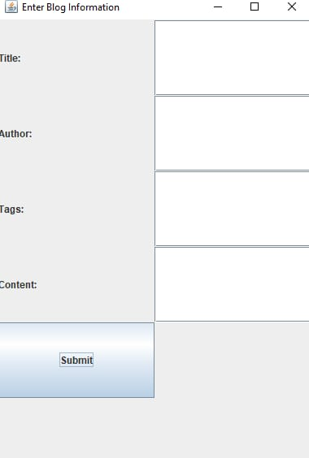

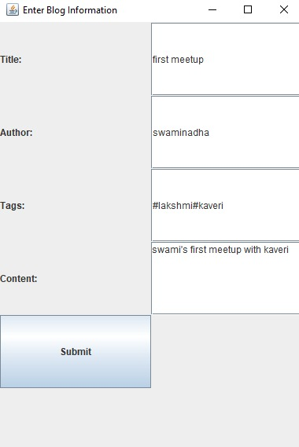

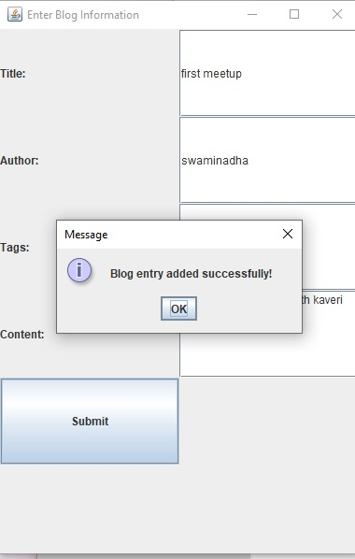

**DATABASE TABLE:**

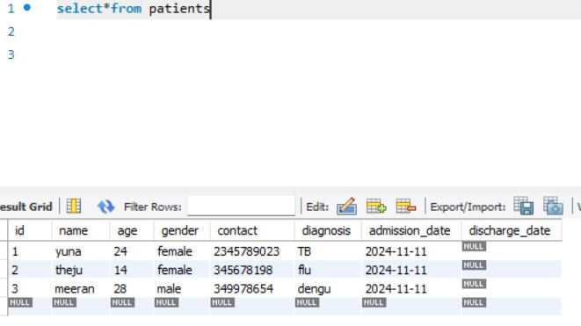

**RESULTS**

**1. Content Creation and Management**

* **Post Editor**: A rich text editor for writing and formatting blog posts (e.g., with options for inserting images, links, videos, etc.).
* **Categories/Tags**: Users can organize posts by topics or keywords.
* **Draft Mode**: Allows users to save posts as drafts before publishing them.

**2. User Management**

* **User Roles and Permissions**: Different access levels (e.g., Admin, Author, Editor) to manage who can write, edit, or publish content.
* **Authentication**: User login and registration systems.

**3. SEO Optimization**

* **Meta Tags**: Ability to add custom titles, descriptions, and keywords for SEO.
* **SEO-Friendly URLs**: Automatically generates clean, keyword-friendly URLs for blog posts.

**4. Comments and Feedback**

* **Comment System**: Visitors can leave feedback, and admins can moderate them.
* **Spam Protection**: Features like CAPTCHA or automated filters to reduce spam.

**5. Content Scheduling**

* **Post Scheduling**: Option to write posts ahead of time and schedule them to be published at a later date/time.

**6. Analytics and Reporting**

* **Visitor Stats**: Tracks page views, user engagement, and popular posts.
* **Traffic Sources**: Identifies where blog visitors are coming from.

**7. Design Customization**

* **Themes and Templates**: Options for users to choose or customize themes for the blog.
* **Responsive Design**: Ensures the blog is accessible and looks good on all devices (desktop, mobile, tablet).

**8. Monetization**

* **Advertising Integration**: Support for ads (e.g., Google AdSense) or affiliate marketing links.
* **Subscription/Paywall**: Allow users to subscribe to content or access premium posts.

**9. Social Media Integration**

* **Sharing Buttons**: Easily share blog posts on social media platforms.
* **Auto-publishing**: Automatically post to social media accounts when new content is published.

**VII. REFERENCES**

**Java Development and Backend Resources:**

* **Java Documentation:** Official Java documentation for learning and implementing Java-based applications. Available at: <https://docs.oracle.com/en/java/>

**Database Management:**

* **MySQL Documentation:** Official documentation for MySQL, covering database setup, queries, and best practices. Available at: <https://dev.mysql.com/doc>
* **MySQL Connector:** Documentation for MySQL Connector/J, which allows Java applications to communicate with MySQL databases. Available at: <https://dev.mysql.com/doc/connector-j/>

**Frontend Development and User Interface:**

* **Java Swing Documentation:** Resources for building GUI applications using Java Swing for creating the user interface. Available at: <https://docs.oracle.com/javase/8/docs/api/javax/swing/package-summary.html>

**Project Management and Development Tools:**

* **GitHub:** For version control and collaboration during the development process. Documentation available at: <https://docs.github.com>