NAME: Mahalakshmi

COLLEGE CODE: 9530

PROBLEM SOLUTION:

Our goal is to design a smart water fountain that can monitor the water quality and

automatically replace water when polluted(not healthy) or running out. We will use sensors

to measure the water quality. Common water quality measurement factors include

temperature, Ph-value, conductance, turbidity and hardness. Considering the pollution at

home can only affect limited factors, we choose temperature, Ph-value and conductance to

be the three properties used for calculating water quality in our water fountain. These data

will be collected, calculated, and reflected to the user in terms of “Good”, “Average” and

“Bad”. The water fountain is also designed to self-filter the water every time when water is

pumped through the submersible water pump.

FLOW CHART:













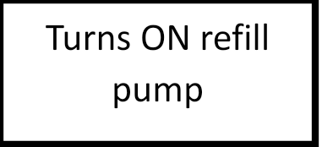



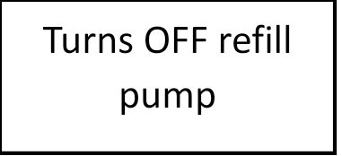



**Gitup link:**